Spring 2026 Advanced Program Completer Employers Survey IUP
March 27th 2026
This survey was distributed to 25 administrators and stakeholders. To complete the survey, respondents must employ recent advanced program completers. N=8
Q1 - What is your role?
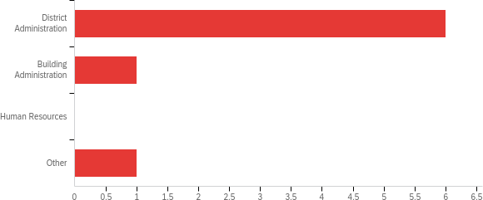

# | Answer | % | Count
1 | District Administration | 75.00% | 6
2 | Building Administration | 12.50% | 1
3 | Human Resources | 0.00% | 0
4 | Other | 12.50% | 1
 | Total | 100% | 8

Q2 - In what area(s) are recent (within approximately the last seven years) IUP Advanced Program graduate(s) employed in your school or district? Select all that apply.
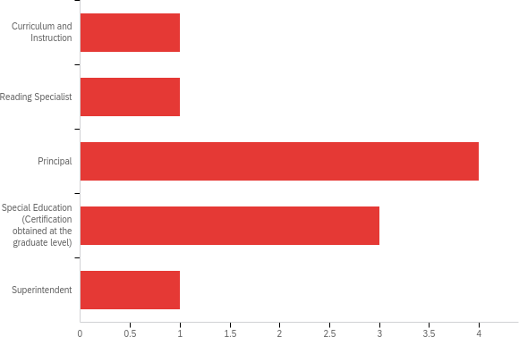

# | Answer | % | Count
1 | Curriculum and Instruction | 10.00% | 1
2 | Reading Specialist | 10.00% | 1
3 | Principal | 40.00% | 4
4 | Special Education (Certification obtained at the graduate level) | 30.00% | 3
5 | Superintendent | 10.00% | 1
 | Total | 100% | 10

Q3 - How well do you believe your supervisee(s) who graduated from IUP is (are) prepared to:
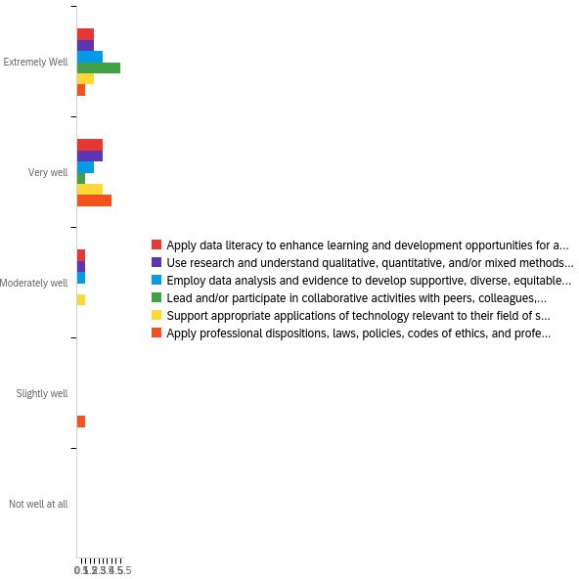

# | Question | Extremely  Well |  | Very well |  | Moderately  well |  | Slightly  well |  | Not well at  all |  | Total
1 | Apply data literacy to enhance learning and development opportunities for all P-12 students? (RA1.1) | 33.33% | 2 | 50.00% | 3 | 16.67% | 1 | 0.00% | 0 | 0.00% | 0 | 6
2 | Use research and understand qualitative, quantitative, and/or mixed methods research methodologies in their field? (RA1.1) | 33.33% | 2 | 50.00% | 3 | 16.67% | 1 | 0.00% | 0 | 0.00% | 0 | 6
3 | Employ data analysis and evidence to develop supportive, diverse, equitable, and inclusive school environments? (RA1.1) | 50.00% | 3 | 33.33% | 2 | 16.67% | 1 | 0.00% | 0 | 0.00% | 0 | 6
4 | Lead and/or participate in collaborative activities with peers, colleagues, teachers, administrators, teachers, community organizations,  and parents? (RA1.1) | 83.33% | 5 | 16.67% | 1 | 0.00% | 0 | 0.00% | 0 | 0.00% | 0 | 6
5 | Support appropriate applications of technology relevant to their field of  specialization? (RA1.1) | 33.33% | 2 | 50.00% | 3 | 16.67% | 1 | 0.00% | 0 | 0.00% | 0 | 6
6 | Apply professional dispositions, laws, policies, codes of ethics, and professional standards relevant to their field of  specialization? (RA1.1) | 16.67% | 1 | 66.67% | 4 | 0.00% | 0 | 16.67% | 1 | 0.00% | 0 | 6

Q4 - Overall, how satisfied are you with the supervisee’s preparation from IUP for their assigned responsibilities? (RA4.2)
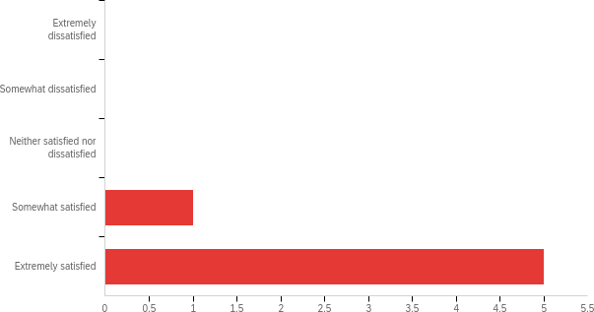

#
Field Minimum Maximum Mean
Std
Deviation
Variance Count
1
Overall, how satisfied are you with the
supervisee’s preparation from IUP for their assigned responsibilities? (RA4.2)
4.00
5.00 4.83
0.37
0.14
6

# | Answer | % | Count
1 | Extremely dissatisfied | 0.00% | 0
2 | Somewhat dissatisfied | 0.00% | 0
3 | Neither satisfied nor dissatisfied | 0.00% | 0
4 | Somewhat satisfied | 16.67% | 1
5 | Extremely satisfied | 83.33% | 5
 | Total | 100% | 6

Q5 - Please share any additional comments or suggestions on how the program could better prepare future candidates.

Overall, I am highly satisfied with the performance, professionalism, and leadership demonstrated by graduates of IUP’s Advanced Educator Preparation Programs. In my experience, these practitioners enter the field with a high level of competency and a strong work ethic that reflects IUP’s rigorous standards. The graduates from the Special Education and Principal Certificate programs are particularly solid.. Special Education graduates consistently demonstrate a deep understanding of compliance, individualized instruction, and the complex needs of diverse learners. Principal candidates emerge as "day-one ready" leaders who possess the organizational and interpersonal skills necessary to navigate the complexities of school administration. While I value the partnership with the Reading Specialist program, I believe there is a critical need for curriculum updates in this area. To remain competitive and compliant, the program must align more closely with Pennsylvania Laws regarding Structured Literacy. Students from this program report not being allowed to use the data tools or programs that we employ at  for their projects, while the tools we use are recommended by the state and the Reading League as best practice. Evidence- based practices rooted in the Science of Reading are now a legislative and instructional mandate in PA. For IUP graduates to continue their strong tradition of excellence in literacy, the program must pivot away from older models and integrate explicit, systematic instruction in phonological awareness, phonics, and the other pillars of
Structured Literacy.

