2023-2024 Initial Level Employer Survey
IUP Completer Employer Survey 2023-2024
April 17th 2026, 8:39 am MDT

Q3 - Select the choice that best describes your role:
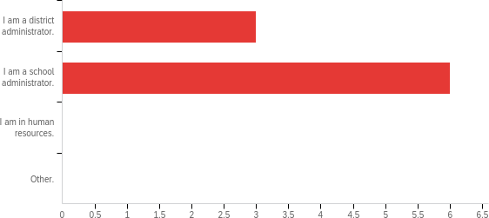

# | Field | Minimum | Maximum | Mean | Std Deviation | Variance | Count
1 | Select the choice that best describes your  role: | 4.00 | 5.00 | 4.67 | 0.47 | 0.22 | 9

# | Answer | % | Count
4 | I am a district administrator. | 33.33% | 3
5 | I am a school administrator. | 66.67% | 6
6 | I am in human resources. | 0.00% | 0
7 | Other. | 0.00% | 0
 | Total | 100% | 9

Q4 - In what area(s) are recent (within the last three years) IUP graduate(s) employed full time in your school or district?
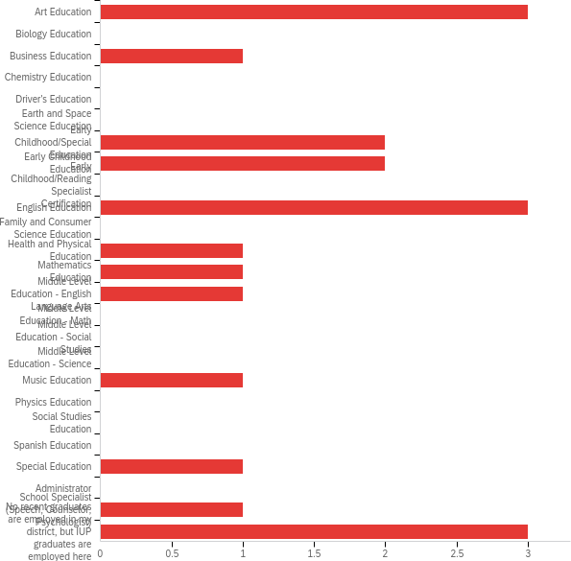

# | Answer | % | Count
1 | Art Education | 15.00% | 3
2 | Biology Education | 0.00% | 0
3 | Business Education | 5.00% | 1
4 | Chemistry Education | 0.00% | 0

5 | Driver's Education | 0.00% | 0
6 | Earth and Space Science Education | 0.00% | 0
7 | Early Childhood/Special Education | 10.00% | 2
8 | Early Childhood Education | 10.00% | 2
9 | Early Childhood/Reading Specialist Certification | 0.00% | 0
10 | English Education | 15.00% | 3
11 | Family and Consumer Science Education | 0.00% | 0
12 | Health and Physical Education | 5.00% | 1
13 | Mathematics Education | 5.00% | 1
14 | Middle Level Education - English Language Arts | 5.00% | 1
15 | Middle Level Education - Math | 0.00% | 0
16 | Middle Level Education - Social Studies | 0.00% | 0
17 | Middle Level Education - Science | 0.00% | 0
18 | Music Education | 5.00% | 1
19 | Physics Education | 0.00% | 0
22 | Social Studies Education | 0.00% | 0
24 | Spanish Education | 0.00% | 0
25 | Special Education | 5.00% | 1
27 | Administrator | 0.00% | 0
28 | School Specialist (Speech, Counselor, Psychologist) | 5.00% | 1
29 | No recent graduates are employed in my district, but IUP graduates are employed here | 15.00% | 3
 | Total | 100% | 20

Q5 - How well do you believe your teacher(s) who graduated from IUP is (are) prepared to:
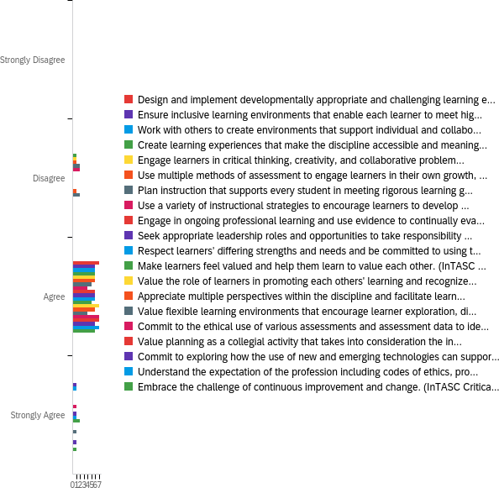

# | Field | Minimum | Maximum | Mean | Std Deviation | Variance | Count
1 | Design and implement developmentally appropriate and challenging learning experiences based on an understanding of how learners grow and develop across cognitive, linguistic, social, emotional, and  physical domains. (InTASC 1; CAEP R1.1) | 3.00 | 3.00 | 3.00 | 0.00 | 0.00 | 7
2 | Ensure inclusive learning environments that enable each learner to meet high standards. | 3.00 | 4.00 | 3.14 | 0.35 | 0.12 | 7

 | (InTASC 2; CAEP R1.1)
3 | Work with others to create environments that support individual and collaborative learning, and that encourage positive social interaction, active engagement in learning, and self- motivation. (InTASC 3; CAEP R1.1) | 3.00 | 4.00 | 3.14 | 0.35 | 0.12 | 7
4 | Create learning experiences that make the discipline accessible and meaningful for learners to assure mastery of the content.  (InTASC 4; CAEP R1.2) | 2.00 | 3.00 | 2.86 | 0.35 | 0.12 | 7
5 | Engage learners in critical thinking, creativity, and collaborative problem solving related to authentic local and global issues. (InTASC 5;  CAEP R1.2) | 2.00 | 3.00 | 2.86 | 0.35 | 0.12 | 7
6 | Use multiple methods of assessment to engage learners in their own growth, to monitor learner progress, and to guide the teacher’s and learners’ decision making.  (InTASC 6; CAEP R1.3) | 2.00 | 3.00 | 2.86 | 0.35 | 0.12 | 7
7 | Plan instruction that supports every student in meeting rigorous learning goals by drawing upon knowledge of content areas, curriculum, cross-disciplinary skills, and pedagogy, as well as knowledge of learners and the community  context. (InTASC 7; CAEP R1.3) | 2.00 | 3.00 | 2.71 | 0.45 | 0.20 | 7
8 | Use a variety of instructional strategies to encourage learners to develop deep understanding of content areas and their connections, and to build skills to apply knowledge in meaningful ways. (InTASC 8;  CAEP R1.3) | 2.00 | 4.00 | 2.86 | 0.64 | 0.41 | 7
9 | Engage in ongoing professional learning and use evidence to continually evaluate your practice, particularly the effects of your choices and actions on others, and adapt practice to meet the needs of each learner.  (InTASC 9; CAEP R1.4) | 3.00 | 3.00 | 3.00 | 0.00 | 0.00 | 6
10 | Seek appropriate leadership roles and opportunities to take responsibility for student learning, and to collaborate with learners, families, colleagues, other school professionals, and community members to ensure learner growth, and to advance the  profession. (InTASC 10; CAEP R1.4) | 3.00 | 4.00 | 3.14 | 0.35 | 0.12 | 7
11 | Respect learners’ differing strengths and needs and be committed to using this information to further each learner’s development. (InTASC Critical Disposition 1(h);  CAEP R1.1) | 3.00 | 4.00 | 3.14 | 0.35 | 0.12 | 7
12 | Make learners feel valued and help them learn | 3.00 | 4.00 | 3.29 | 0.45 | 0.20 | 7

to value each other. (InTASC Critical
Disposition 2(n); CAEP R1.1)
13 | Value the role of learners in promoting each others' learning and recognizes the importance of peer relationships in establishing a climate of learning. (InTASC Critical Disposition 3(o); CAEP R1.1) | 3.00 | 3.00 | 3.00 | 0.00 | 0.00 | 7
14 | Appreciate multiple perspectives within the discipline and facilitate learners’ critical analyses of these perspectives. (InTASC Critical  Disposition 4(p); CAEP R1.2) | 2.00 | 3.00 | 2.86 | 0.35 | 0.12 | 7
15 | Value flexible learning environments that encourage learner exploration, discovery, and expression across content areas. (InTASC Critical Disposition 5(r); CAEP R1.2) | 2.00 | 4.00 | 2.86 | 0.64 | 0.41 | 7
16 | Commit to the ethical use of various assessments and assessment data to identify learner strengths and needs to promote learner growth. (InTASC Critical Disposition  6(v); CAEP R1.3) | 3.00 | 3.00 | 3.00 | 0.00 | 0.00 | 7
17 | Value planning as a collegial activity that takes into consideration the input of learners, colleagues, families, and the larger community. (InTASC Critical Disposition 7(q);  CAEP R1.3) | 3.00 | 3.00 | 3.00 | 0.00 | 0.00 | 7
18 | Commit to exploring how the use of new and emerging technologies can support and promote student learning. (InTASC Critical  Disposition 8(r); CAEP R1.3) | 3.00 | 4.00 | 3.14 | 0.35 | 0.12 | 7
19 | Understand the expectation of the profession including codes of ethics, professional standards of practice, and relevant law and policy. (InTASC Critical Disposition 9(o); CAEP  R1.4) | 3.00 | 3.00 | 3.00 | 0.00 | 0.00 | 7
20 | Embrace the challenge of continuous improvement and change. (InTASC Critical  Disposition 10(t); CAEP R1.4) | 3.00 | 4.00 | 3.14 | 0.35 | 0.12 | 7

# | Question | Strongly Disagree |  | Disagree |  | Agree |  | Strongly Agree | Total
1 | Design and implement developmentally appropriate and challenging learning experiences based on an understanding of how learners grow and develop across cognitive, linguistic, social, emotional, and  physical domains. (InTASC 1; CAEP R1.1) | 0.00% | 0 | 0.00% | 0 | 100.00% | 7 | 0.00% | 0 | 7

2 | Ensure inclusive learning environments that enable each learner to meet high standards.  (InTASC 2; CAEP R1.1) | 0.00% | 0 | 0.00% | 0 | 85.71% | 6 | 14.29% | 1 | 7
3 | Work with others to create environments that support individual and collaborative learning, and that encourage positive social interaction, active engagement in learning, and self-motivation. (InTASC 3; CAEP R1.1) | 0.00% | 0 | 0.00% | 0 | 85.71% | 6 | 14.29% | 1 | 7
4 | Create learning experiences that make the discipline accessible and meaningful for learners to assure mastery of the content.  (InTASC 4; CAEP R1.2) | 0.00% | 0 | 14.29% | 1 | 85.71% | 6 | 0.00% | 0 | 7
5 | Engage learners in critical thinking, creativity, and collaborative problem solving related to authentic local and global  issues. (InTASC 5; CAEP R1.2) | 0.00% | 0 | 14.29% | 1 | 85.71% | 6 | 0.00% | 0 | 7
6 | Use multiple methods of assessment to engage learners in their own growth, to monitor learner progress, and to guide the teacher’s and learners’ decision making.  (InTASC 6; CAEP R1.3) | 0.00% | 0 | 14.29% | 1 | 85.71% | 6 | 0.00% | 0 | 7
7 | Plan instruction that supports every student in meeting rigorous learning goals by drawing upon knowledge of content areas, curriculum, cross-disciplinary skills, and pedagogy, as well as knowledge of learners and the community context. (InTASC 7;  CAEP R1.3) | 0.00% | 0 | 28.57% | 2 | 71.43% | 5 | 0.00% | 0 | 7
8 | Use a variety of instructional strategies to encourage learners to develop deep understanding of content areas and their connections, and to build skills to apply knowledge in meaningful ways. (InTASC 8;  CAEP R1.3) | 0.00% | 0 | 28.57% | 2 | 57.14% | 4 | 14.29% | 1 | 7
9 | Engage in ongoing professional learning and use evidence to continually evaluate your practice, particularly the effects of your choices and actions on others, and adapt practice to meet the needs of each learner.  (InTASC 9; CAEP R1.4) | 0.00% | 0 | 0.00% | 0 | 100.00% | 6 | 0.00% | 0 | 6
10 | Seek appropriate leadership roles and opportunities to take responsibility for student learning, and to collaborate with learners, families, colleagues, other school professionals, and community members to ensure learner growth, and to advance the  profession. (InTASC 10; CAEP R1.4) | 0.00% | 0 | 0.00% | 0 | 85.71% | 6 | 14.29% | 1 | 7
11 | Respect learners’ differing strengths and needs and be committed to using this information to further each learner’s development. (InTASC Critical Disposition | 0.00% | 0 | 0.00% | 0 | 85.71% | 6 | 14.29% | 1 | 7

 | 1(h); CAEP R1.1)
12 | Make learners feel valued and help them learn to value each other. (InTASC Critical  Disposition 2(n); CAEP R1.1) | 0.00% | 0 | 0.00% | 0 | 71.43% | 5 | 28.57% | 2 | 7
13 | Value the role of learners in promoting each others' learning and recognizes the importance of peer relationships in establishing a climate of learning. (InTASC Critical Disposition 3(o); CAEP R1.1) | 0.00% | 0 | 0.00% | 0 | 100.00% | 7 | 0.00% | 0 | 7
14 | Appreciate multiple perspectives within the discipline and facilitate learners’ critical analyses of these perspectives. (InTASC Critical Disposition 4(p); CAEP R1.2) | 0.00% | 0 | 14.29% | 1 | 85.71% | 6 | 0.00% | 0 | 7
15 | Value flexible learning environments that encourage learner exploration, discovery, and expression across content areas. (InTASC Critical Disposition 5(r); CAEP R1.2) | 0.00% | 0 | 28.57% | 2 | 57.14% | 4 | 14.29% | 1 | 7
16 | Commit to the ethical use of various assessments and assessment data to identify learner strengths and needs to promote learner growth. (InTASC Critical  Disposition 6(v); CAEP R1.3) | 0.00% | 0 | 0.00% | 0 | 100.00% | 7 | 0.00% | 0 | 7
17 | Value planning as a collegial activity that takes into consideration the input of learners, colleagues, families, and the larger community. (InTASC Critical Disposition  7(q); CAEP R1.3) | 0.00% | 0 | 0.00% | 0 | 100.00% | 7 | 0.00% | 0 | 7
18 | Commit to exploring how the use of new and emerging technologies can support and promote student learning. (InTASC Critical  Disposition 8(r); CAEP R1.3) | 0.00% | 0 | 0.00% | 0 | 85.71% | 6 | 14.29% | 1 | 7
19 | Understand the expectation of the profession including codes of ethics, professional standards of practice, and relevant law and policy. (InTASC Critical Disposition 9(o); CAEP R1.4) | 0.00% | 0 | 0.00% | 0 | 100.00% | 7 | 0.00% | 0 | 7
20 | Embrace the challenge of continuous improvement and change. (InTASC Critical  Disposition 10(t); CAEP R1.4) | 0.00% | 0 | 0.00% | 0 | 85.71% | 6 | 14.29% | 1 | 7

Q6 - Overall, are you satisfied with the teacher's(s') preparation for his/her/their assigned responsibilities? Why or why not?

Overall, are you satisfied with the teacher's(s') preparation for his/her/their assigned responsibilities? Why or why
not?
Yes - your graduates tend to do very well in our interview process.
Yes, the incoming teacher's need to understand restorative practices and science of reading better.
Yes, the recent hires, full-tome and long-term-substitute teachers, are well prepared and enthused to instruct and care for students.
We have been very satisfied overall with the hires we have made from IUP over the past 3 years. They are typically very cognizant of the task at hand, well informed about the challenges they face, and skilled in approaches to addressing those challenges.
I am very satisfied. I believe teachers entering our professional our more prepared than ever before. My ranking on agree indicates they are entering at a strong starting point and I have found they move to multiple category of strongly agree quickly. The grow is also influenced by assigning a committed and patient mentor with a strong induction plan in place.
Yes, students are prepared to taking on teaching responsibilities.

Q7 - If not addressed above, what specific strengths do you believe the teachers who graduate from IUP possess?

If not addressed above, what specific strengths do you believe the teachers who graduate from IUP possess?
The people coming in have a great understanding of their subject area and work well with others.
n/a
They typically have a wide knowledge base related to pedagogical approaches, integrating technology, and tend to be positive and enthusiastic about the task for which they are hired.
I greater understanding of the standards associated with their discipline and a better grasp of how to use instructional technology to enhance learning and delivery of instruction.

Q8 - What advice do you have to improve IUP's educator preparation programs in order to prepare our candidates for today's classroom?

What advice do you have to improve IUP's educator preparation programs in order to prepare our candidates for
today's classroom?
In an Early Childhood setting, the bulk of instruction falls in the area of language arts and math. I am not sure of the number of preparation classes they have in these two areas vs. those of science/social studies, but there should be a noticable difference. If they have the same number, that is an area to improve. In addition, the science of reading needs to be a focus area.
Please let the candidates know that teaching is only part of the job, there are many other responsibilities.
To provide recent graduates with knowledge and experience to provide targeted interventions to increase academic achievement and growth
New teachers (from IUP and from other schools as well) need to be more prepared for classroom management techniques, responding to explosive behaviors that may occur in the classroom, engaging parents in meaningful ways, and the most current research on practices within the classroom. A specific example of the application of current research is the lack of real knowledge around structured literacy and assessment procedures. We have had several teachers who we hired who indicated that they had to unlearn some of the practices that they had come to rely on because they are not endorsed by our district's vision, and relearn the science behind how students learn to
read, write, etc, or how to approach classroom activities to support students who come from trauma.
I think using both formative and summative data to GUIDE next day/future instructional decisions. I find even seasoned teachers know the data, but not sure what to do with it to enhance instruction. A quick example is a teacher gives a ticket out the door (a formative assessment/check for understanding by each student of meeting the lesson goals) do we use this information to determine if students achieved the lesson objective, if they did then
what does that mean to my lesson tomorrow, if they did not, what does that do to my lesson tomorrow?

Q9 - Would you consider hiring IUP's educator program's graduates in the future? Why or why not?

Would you consider hiring IUP's educator program's graduates in the future? Why or why not?
yes - Hired in the past and will continue to hire in the future.
Yes, the candidates we have hired have been strong.
Yes. past success is a provides a high level of confidence in the programs and graduates.
Absolutely. Overall, IUP continues to produce well-prepared professionals who we rely upon to get the job done. We have had a lot of success with many of our recent hires, and that is due in no small part to the preparation they received at IUP.
Yes. The vast majority our well trained, professional and eager to perform.
yes

