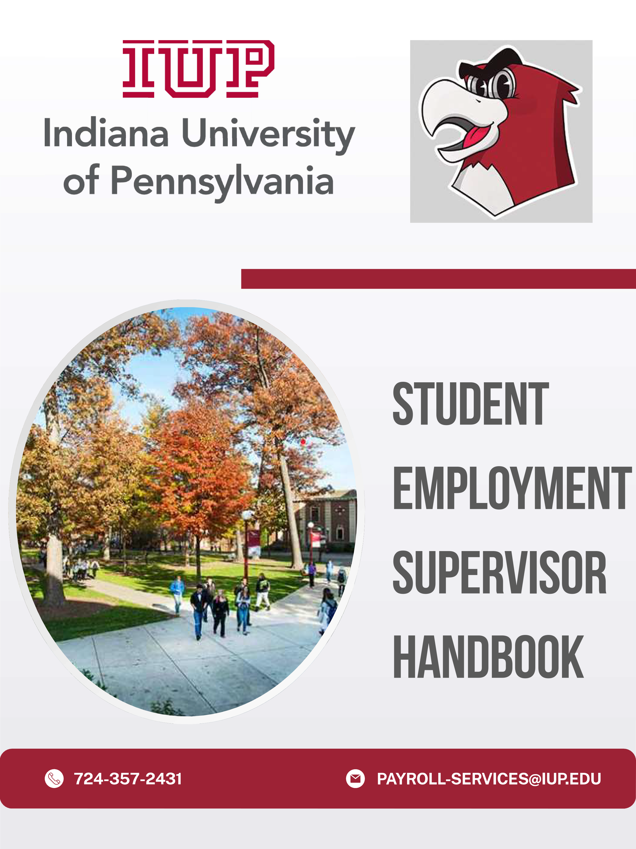

.
Table of Contents
I. Student | Page 3
A. Mission
B. Benefits of Student Employment
C. Educational Benefits of Student Employment
II. Student Expectations | Page 4
111. Procedures for Employing Student Workers | Page 4
IV. Student Employment Hiring Roadmap | Page 5
V. Student Employment Work Study Programs | Page 6
A. Federal Work Study (FWS)
B. State Funded Student Employment
VI. Eligibility for Student Employment | Page 6
VII. Student Employment Process | Page 7
VIII. E-Time | Page 7
IX. Compensation of Pay | Page 7-8
X. Interviewing | Page 8-9
XI. University Employment Procedures & Policies | Page 10-11
A. Resolutions of Disputes
B. Terminating Student Employees
C. Discrimination Complaints
D. Work Related Injuries
E. Sexual Harassment & Sexual Assault Policy
F. Drug Free Workplace

.
.
.
.

.
.
.
.
.
.

Student Employment at IUP

Mission:
To treat on campus student employment as a "High Impact Practice" that provides students with opportunities to gain educational experiences outside of the classroom and transferable skills to use in their future careers.

Benefits of Student Employment:
    - Aids in recruitment and retention
    - Builds relationships with university faculty, staff, and peers
    - Provides opportunities for development and exploration
    - Enhances educational growth and often improves scholastic performance
    - Provides access to professional role models and advice, networking opportunities, and references
    - Establishes an employment history
    - Aids in reducing financial stress
    - Allows for flexible hours that fit class schedules
    - Provides offices assistance with carrying out daily operations
    - Enhances education outside of the classroom
    - Provides the opportunity to gain a strong professional work ethic
    - Influences preparedness for professional careers

Educational Benefits of Student Employment:
    - Ability to manage and balance school, work, social and personal responsibilities
    - Develop effective verbal and written communication skills
    - Learn the importance of working as a team
    - Build self-confidence and work ethic
    - Further develop interpersonal skills
    - Learn the importance of customer service
    - Develop multitasking skills needed for success in a busy work environment
    - Understand the importance of taking initiative, being flexible, and being adaptable
    - Learn to work collaboratively with other office staff members to accomplish common goals
    - Complete work assignments in a timely manner
    - Learn the significance of office politics and how to interact positively with supervisors and co­ workers
    - Develop computer proficiency in Word, Access, Excel, and any specialty software used by specific offices
    - Learn how to problem-solve, think analytically, and take initiative
    - Understand the importance of being punctual and bringing a positive attitude to the workplace
    - Learn how to dress appropriately for the work environment
    - Acquire time management skills by learning how to balance academics, employment, and social life

Student/Supervisor Expectations
Students should understand that working on campus is a privilege afforded to those students who agree to comply fully with the following:

- The student must arrange a work schedule with their supervisor that is compatible with their class schedule within the first week of employment.
- The student will report regularly and promptly to work. Absences should be arranged in advance with the supervisor, by calling or emailing the supervisor directly prior to the start of their scheduled shift to report if they will be late or absent.
- The student will maintain the confidentiality of departmental records and student records when he/she has access to such records, and sign a confidentiality agreement.
- The student's work schedule will not exceed 25 hrs. per week during the academic year; 37.5 hrs. per week during breaks (summer, winter, etc.).
- The student will complete online timesheets according to the payroll schedule through eTime and follow any specific requirements supervisors have stated about time entry.
- The student will regard on-campus positions as a professional experience.
- The student will attempt to resolve any employment issues with his/her supervisor. If an issue cannot be resolved, the student is responsible for notifying the Office of Human Resources.
- The student will report to work only when the University is open. The student will not report to work on University holidays or inclement weather closures.
- Students who fail to meet these expectations may lose their eligibility to apply for future positions.

Upon acceptance of an on-campus employment position, the student is responsible for reading all materials associated with their employment and completing all required paperwork with the Office of Human Resources (paperwork must be completed before the student starts their new position).

Procedures for Employing Student Workers
All positions must be advertised through Hire-A-Hawk.
See Appendix A for detailed instructions on creating your position for Hire-A-Hawk.

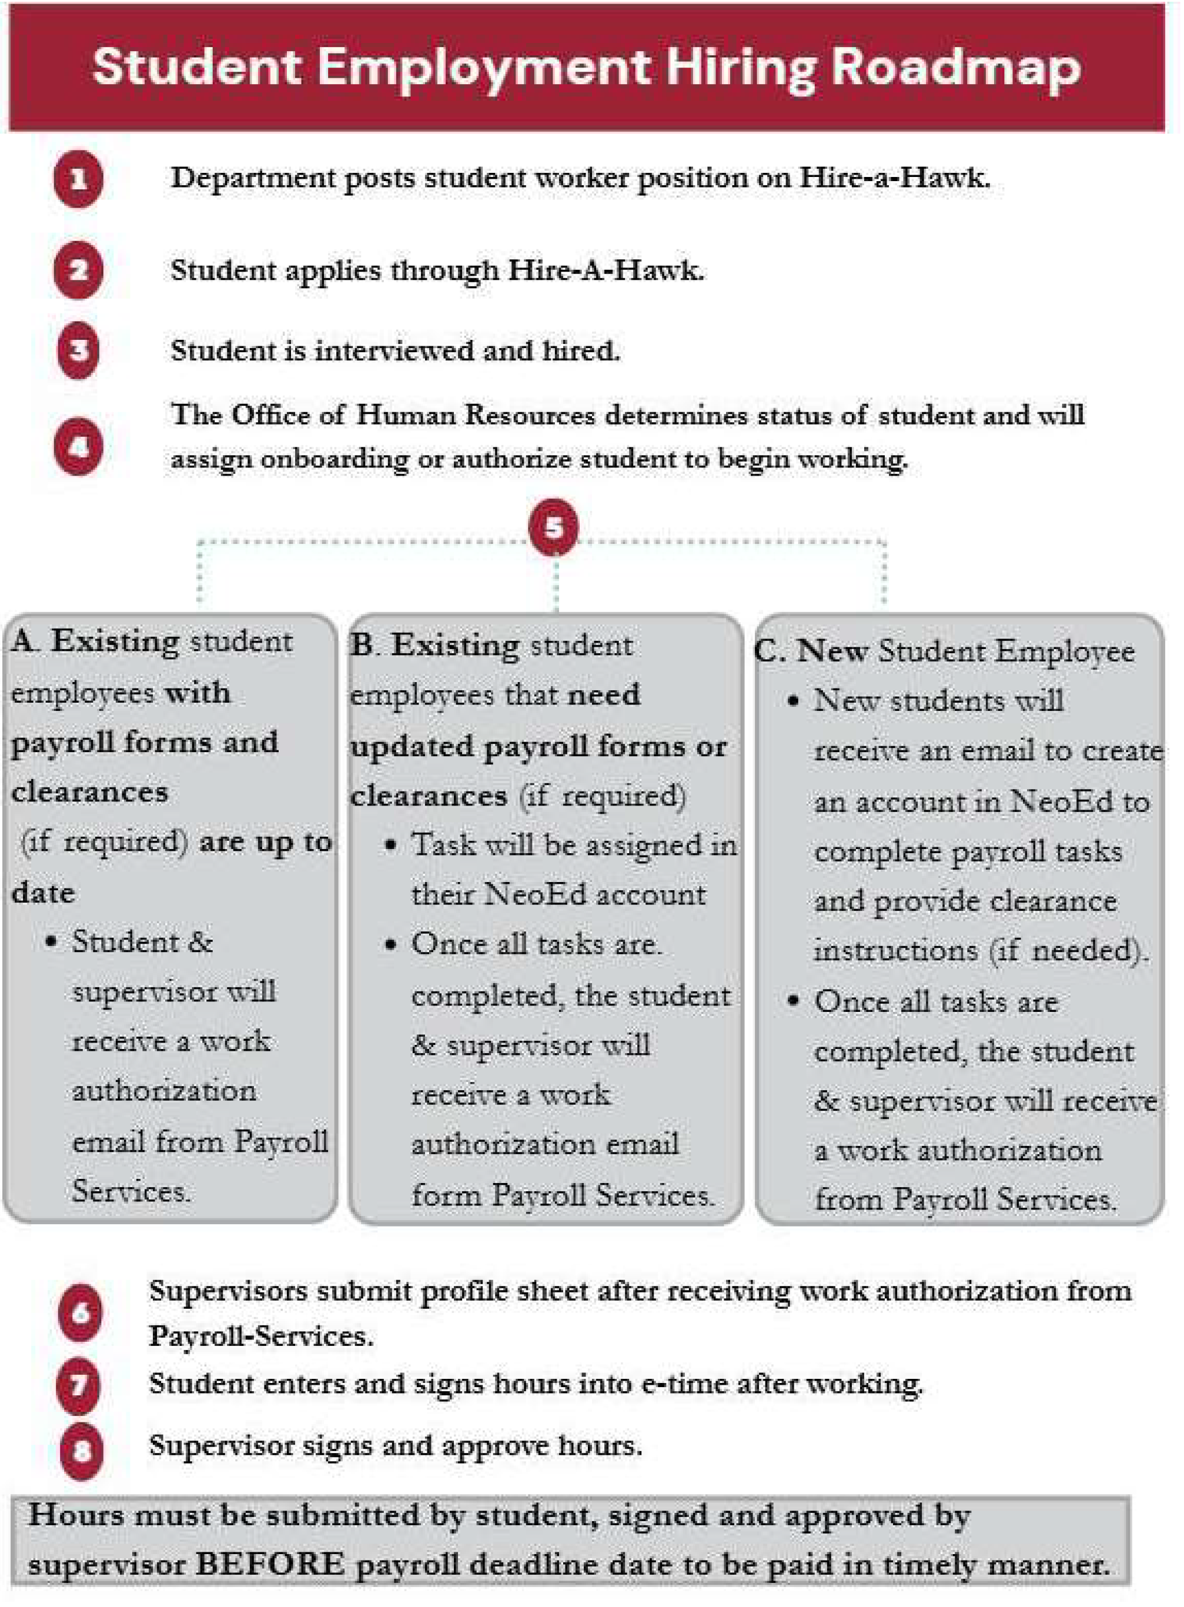

Student Employment Work Study Programs
Work Study is a form of financial aid that is earned by the student working on campus and is paid in the form of a paycheck. The program is either federally funded or state funded. The funds are intended to help offset the students' educational and living expenses.
Students are responsible for seeking on-campus employment.
No student is guaranteed a job whether they have a work-study award or not.

Federal Work Study (FWS):
A program funded by the federal government to help students with financial need earn money to offset their educational and living expenses. Many departments across campus hire ONLY student employees who qualify for FWS.
To qualify for federal work study, the student must fill out the FAFSA each year and indicate that they are interested in this program. They may then see a Federal Work Study award amount on their financial aid award from IUP. This does not guarantee that they will receive this amount of money. Students are responsible for finding and securing their own jobs and will then earn wages as a result. This award simply means that they qualify for the program and may help your chances of being offered a part-time, on-campus job.

Am I eligible for the federal work study (FWS) program?
  - Students must demonstrate financial need as determined by the Free Application for Federal Student Aid (FAFSA) and meet eligibility requirements to be considered for FWS. In order to verify their FWS eligibility, view their Financial Aid Awards on MyIUP or for any questions, please contact the Financial Aid Office at 724-357-2218.

  - State Funded Student Employment: Many departments across campus hire student
employees and use institutional funds to pay their salaries. These positions are based on the availability of funds in each department and do not require students to have any financial need.

Eligibility for Student Employment
No student may work for and be supervised by an immediate member of his/her family
Academic Year: Normally, students must be enrolled for at least 6 credits each semester as a regular IUP student. However, graduate assistants by the terms of their individual contract, may be employed as graduate assistants and only enroll for 3 credits.

Summer: To be eligible for summer student employment a student must be an IUP degree-seeking student and meet one of the following:
- Enrolled for at least 6 credits in the spring and at least 6 credits in the following fall semester.
- Enrolled for at least 6 credits in the summer.
- Incoming freshman, transfer, or graduate student; offered and accepted admission for the upcoming fall semester.

Student Employment Process
l. The student must apply for a job through Hire-A-Hawk.
- Interview the student
- Offer the Job!!
- Hire the Student in NeoEd
- Student begins onboarding process in NeoEd-Assigned by HR.
- Student completes Child Abuse Clearance.
- Student registers for Fingerprinting through ldentogo.
- Student schedules Fingerprinting Appointment at the University Police Station.
- Student completes Payroll Forms in NeoEd and brings original 19 verification documents to Human Resources
- Supervisor/Student receives Authorization to Work Email from HR to begin working. The student MUST complete the hiring process and apply for all clearance BEFORE the authorization will be sent. STUDENTS MAY NOT BEGIN WORK UNTIL WORK AUTHORIZATION IS RECEIVED.
- The following information must be submitted to payroll-services@iup.edu in order for the student to be placed on payroll and be given E-Time access:
  - Photo ID (presented with 1-9 verification task in NeoEd)
  - Submit a copy of their social security card (attached to W4 task in NeoEd).
  - A copy of their child abuse clearance results (emailed to payroll-services@iup.edu).
  - Work Supervisor MUST submit a completed profile sheet, which is found on MyIUP in the Hiring A Student Worker card.
o The student will not be able to enter hours worked until this is completed and processed by Payroll Services.
- Students will have 45 days from the first day worked to email the results of the FBI Fingerprint Clearance to HR. Failure to comply with this requirement will result in termination of employment.

e-Time:
A daily record of time worked must be maintained on the web-based eTime student payroll system.

- Hours posted in eTime should accurately reflect all hours worked. Storing hours and reporting them on subsequent pay periods is not permitted.
- When completing eTime, please make sure the student enters their office hours under the correct department.
- Report any changes of address to Student Payroll.

Compensation of Pay

Wage Rates:
Undergraduate student wages will vary by position but will not be less than the federal minimum wage of $7.25 per hour. Students are paid every other Friday.

Student Hour Limitations:

Supervisors should be aware that a student's first priority is to their academic work. The recommended hour limitations have been established to ensure that students achieve balance in work and school.

- During the fall and spring semesters when classes are in session, students may work no more than 25 hours per week during the semester (20 hours for international students).
- During breaks and summer months, students may work 7.5 hours per day but may NOT exceed
37.5 hours per week.
- Students may work in more than one campus location. Supervisors should adjust work schedules to ensure that students do not exceed the recommended work hour limits.
- Hours approved on eTime should accurately reflect all hours worked. Timekeepers are required to wait until the shift is worked before approving student hours in eTime. Storing hours and reporting them on subsequent pay periods is not permitted.

Criteria | Hour Limits-Academic Year | Hour Limits - Breaks (Summer, Winter,  Spring, etc)
Undergraduate | 25 hrs per week (20 hrs for international  students) | 37.5 hrs per week
Graduate | 20 hrs per week (includes assistantship) | 37.5 hrs per week (includes assistantship)

Payment Compensation:
- IUP requires direct deposit for all university employees, including student workers.
- Pay schedule can be found at https://www.iup.edu/payroll/forms/index.html.

Interviewing
Conducting a good interview involves planning ahead and organizing your thoughts and questions. The following steps should lead to a productive interview:

Plan ahead.
Review any information you may have on the student (application, resume) before the interview. It is helpful to know the full name, and class year, major and prior work experience.

Create a friendly environment.
Whether this is the student's first interview or 10th, interviewing creates anxiety and stress. Start with small talk to put the student at ease. Conduct the interview in a private place so that you can give the student your undivided attention.

Verify basic information.
Check the information you have and update where necessary.

Discover interests and viewpoints.
Use open-ended questions to elicit more information instead of questions that lead to "Yes" or "No" answers.
- Do not ask personal questions. Put aside personal agendas, biases, or political positions so each candidate has an honest and fair evaluation.

Try to start your questions with "What, Why, How, or When or Where"
Such as:

What did you like most about your last job? What did you like least about your last job?
What was the most important thing you learned while working?

Provide information and perspective.
Inform the student about the position, the mission/philosophy of the department and your expectations.
- Share the job description with the student and answer any questions he/she may have about the job.

Bring closure.
Summarize the interview and allow the student to provide or clarify previous information.
9) Thank the student for taking the time to come in for the interview. Tell the student when the decision will be made and how notification will occur (phone, mail, etc.).

Sample Interview Questions
The following questions may be helpful as you consider the information you would like to obtain during the interview:
- Tell me about your previous work experiences.
- What do you perceive as your strengths? What do you perceive as your weakness?
- How do you manage your time?
- How would you describe yourself or your personality?
- Why did you apply for this job?
- How would previous supervisors describe your work?
- In what professional-related organizations are you a member?

Avoid these Questions
- Are you married?
- Do you have children?
- What is your age?
- Where is your spouse employed?
- Have you ever been arrested?
- Were you in the military?
- What is your religion?
- Are you in good health?
- Have you ever had an injury or physical or mental illness?
- Have you ever had a drug problem?
- Have you ever had a drinking problem?

Training Ideas
- Provide an orientation session for student employees before each semester.
- Set aside time during the semester to provide on-going training.
- Discuss acceptable ethical behavior in the workplace-for some students, this may be their first formal job.
- Proper dress is critical to making a good impression-encourage students to dress appropriate of an employee in your office.

- Communicate the importance for students to develop a sense of responsibility and "ownership" toward their work.
- Stress the importance of confidentiality of information.
- Invite students to participate in staff meetings, when appropriate.
- Schedule student employee staff meetings.
- Ask for suggestions from your student employees.
- Conduct a safety training program where appropriate.

University Employment Procedures & Policies

Resolutions of Disputes:
Students must bring concerns about their employment to the attention of their supervisor as soon as possible.

    - Supervisors are expected to make good faith efforts at fair and equitable resolution, which includes informing the student of their decision.
    - If an issue is unable to be resolved between the student and the supervisor, Human Resources should be notified immediately in order to proceed with the appropriate course of action.

Terminating Student Employees:
While all efforts should be made to make working on campus a mutually beneficial and enjoyable experience for both student employees and supervisors, supervisors may terminate a student for poor performance, misconduct, or lack of available work.

    - A student employee who resigns or is terminated must receive wages due for services rendered
    - A 2 week written notice for resignation not due to graduation is expected from a student employee
    - Student Employees are at will and serve at the discretion of the employing unit at IUP
    - The supervisor or department head should give two weeks advance notice of termination. A student employee who is found in violation of university rules or polices or has engaged in misconduct may be terminated immediately without advanced notice.

Discrimination Complaints:
IUP does not discriminate on the basis of race, color, sex, sexual orientation, gender identity, gender expression, national origin, religion, age, disability, age/or veteran status in its programs or activities in accordance with Title IX of the Educational Amendments of 1972, the Americans with Disabilities Act of 1990, Section 504 of the Rehabilitation Act of 1973, Title VII of the Civil Rights Act of 1964, and other applicable statutes and University policies.

Work-Related Injuries:
Should a student employee require emergency medical attention, the University Police should be contacted by calling 724-357-2104 for assistance. Injuries of a non-emergency nature should be directed to the Student Health Center for treatment. If off-campus treatment is deemed necessary following evaluation at the Student Health Center, injured student employees must be accompanied to the treating facility by their supervisor or other university staff member. All injuries must be reported to department managers or administrators as soon as it practical to do so, but at least within

24 hours of the incident. Following notification, a University Accident/Injury Report should be filled out and submitted to the Office of Human Resources.

Sexual Harassment and Sexual Assault Policy:
IUP's sexual harassment and sexual assault policy and procedures seek to ensure an environment that is free from sexual harassment and sexual assault. Such conduct is costly in human terms and seriously undermines the atmosphere of trust and respect that is essential to work and study for all members of the academic community. All employees, students, and vendors are to comply with both the spirit and intent of federal and state laws and regulations that relate to sexual harassment and sexual assault. The coverage of this policy extends to all persons visiting the campus. The university will take action to prevent sexual harassment, including, if necessary, disciplining those individuals whose behavior violates university policy. Discipline may include, but is not limited to, oral or written warning, transfer, suspension, or dismissal. Harassment, exploitation, and intimidation have no place in an educational setting and will not be tolerated.

Drug-Free Workplace:
IUP is committed to the education and development of students, faculty, and staff regarding alcohol and other drug use. Any misuse or dependency on alcohol and other drugs has detrimental effects and concerns for the University community as well as our society at large. It is prohibited to manufacture, distribute, sell, dispense, posses, or use any controlled substance in the workplace, on campus, or in any facility owned, leased, or otherwise controlled by IUP. This includes, but is not limited to, University-related events, programs, or activities which occur on campus and off campus, under authority of the Board of Governors.

