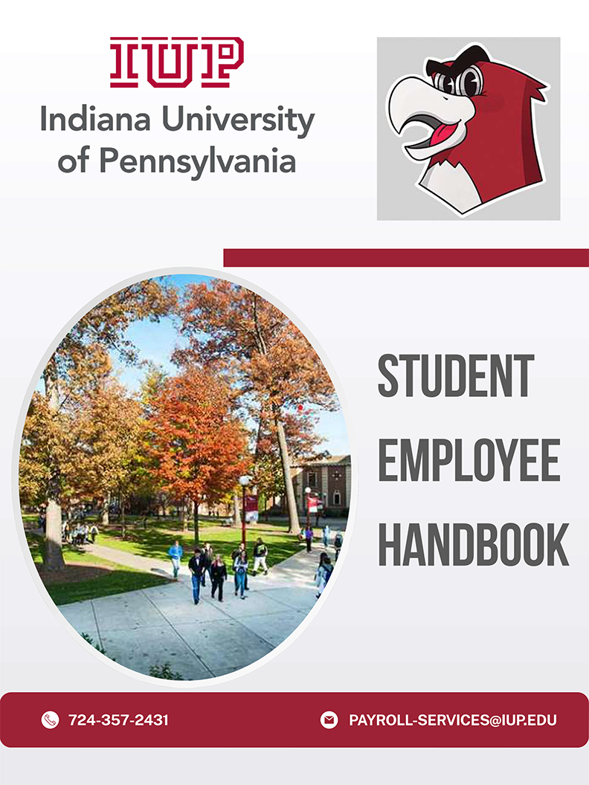
Table of Contents
I. Student Employment at IUP | Page 3
A. Mission
B. Benefits of Student Employment
C. Educational Benefits of Student Employment
II. Student Expectations | Page4
Ill. Student Employment Work Study Programs | Page 4-5
A. Federal Work Study (FWS)
B. State Funded Student Employment
IV. Eligibility for Student Employment | Page 5
V. Student Employment Process | Page 5- 6
VI. Student Employment Hiring Roadmap | Page 7
VII. Definitions of Payroll Forms | Page 8
VIII. E-Time | Page 8-9
IX. Compensation of Pay | Page 9
X. University Employment Procedures & Policies | Page 10-11
A. Resolutions of Disputes
B. Terminating Student Employees
C. Discrimination Complaints
D. Work Related Injuries
E. Sexual Harassment & Sexual Assault Policy
F. Drug Free Workplace
XI. FAQ's | Page 11-12

Student Employment at IUP

Mission:
To treat on-campus student employment as a "High Impact Practice" that provides students with opportunities to gain educational experiences outside of the classroom and transferable skills to use in their future careers.

Benefits of Student Employment:
    - Aids in recruitment and retention
    - Builds relationships with university faculty, staff, and peers
    - Provides opportunities for development and exploration
    - Enhances educational growth and often improves scholastic performance
    - Provides access to professional role models and advice, networking opportunities, and references
    - Establishes an employment history
    - Aids in reducing financial stress
    - Allows for flexible hours that fit class schedules
    - Provides offices with assistance in carrying out daily operations
    - Enhances education outside of the classroom
    - Provides the opportunity to gain a strong professional work ethic
    - Influences preparedness for professional careers

Educational Benefits of Student Employment:
    - Ability to manage and balance school, work, social, and personal responsibilities
    - Develop effective verbal and written communication skills
    - Learn the importance of working as a team
    - Build self-confidence and work ethic
    - Further develop interpersonal skills
    - Learn the importance of customer service
    - Develop multitasking skills needed for success in a busy work environment
    - Understand the importance of taking initiative, being flexible, and being adaptable
    - Learn to work collaboratively with other office staff members to accomplish common goals
    - Complete work assignments promptly
    - Learn the significance of office politics and how to interact positively with supervisors and co­ workers
    - Develop computer proficiency in Word, Access, Excel, and any specialty software used by specific offices
    - Learn how to problem-solve, think analytically, and take initiative
    - Understand the importance of being punctual and bringing a positive attitude to the workplace
    - Learn how to dress appropriately for the work environment
    - Acquire time management skills by learning how to balance academics, employment, and social life

Student Expectations
Students should understand that working on campus is a privilege afforded to those students who agree to comply fully with the following:

- The student must arrange a work schedule with their supervisor that is compatible with their class schedule within the first week of employment.
- The student will report regularly and promptly to work. Absences should be arranged in advance with the supervisor, by calling or emailing the supervisor directly prior to the start of their scheduled shift to report if they will be late or absent.
- The student will maintain the confidentiality of departmental records and student records when they have access to such records, and sign a confidentiality agreement.
- The student's work schedule will not exceed 20 hrs. per week during the academic year; 37.5 hrs. per week during breaks (summer, winter, etc.).
- The student will complete online timesheets according to the payroll schedule through eTime and follow any specific requirements supervisors have stated about time entry.
- The student will regard on-campus positions as a professional experience.
- The student will attempt to resolve any employment issues with their supervisor. If an issue cannot be resolved, the student is responsible for notifying the Office of Human Resources.
- The student will report to work only when the University is open. The student will not report to work on University holidays or inclement weather closures.
- Students who fail to meet these expectations may lose their eligibility to apply for future positions.

Upon acceptance of an on-campus employment position, the student is responsible for reading all materials associated with their employment and completing all required paperwork with the Office of Human Resources (paperwork must be completed before the student starts their new position).

Student Employment Work Study Programs
Work Study is a form of financial aid that is earned by the student working on campus and is paid in the form of a paycheck. The program is either federally funded or state-funded. The funds are intended to help offset your educational and living expenses.
Students are responsible for seeking on-campus employment. No student is guaranteed a job, whether they have a work-study award or not.

Federal Work Study (FWS):
A program funded by the federal government to help students with financial need earn money to offset their educational and living expenses. Many departments across campus hire ONLY student employees who qualify for FWS.
To qualify for federal work study, you must fill out the FAFSA each year and indicate that you are interested in this program. You may then see a Federal Work Study award amount on your financial aid award from IUP. This does not guarantee that you will receive this amount of money. Students are responsible for finding and securing their own jobs and will then earn wages as a result. This award simply means that you qualify for the program and may help your chances of being offered a part-time, on-campus job.

Am I eligible for the federal work-study (FWS) program?

  - Students must demonstrate financial need as determined by the Free Application for Federal Student Aid (FAFSA) and meet eligibility requirements to be considered for FWS. In order to verify your FWS eligibility, view your Financial Aid Awards on MyIUP, or for any questions, please contact the Financial Aid Office at 724-357-2218.

  - State Funded Student Employment: Many departments across campus hire student employees and use institutional funds to pay their salaries. These positions are based on the availability of funds in each department and do not require students to have any financial need.

Eligibility for Student Employment
Academic Year: Normally, students must be enrolled for at least 6 credits each semester as a regular IUP student. However, graduate assistants, by the terms of their individual contract, may be employed as graduate assistants and only enroll for 3 credits.

Summer: To be eligible for summer student employment, a student must be an IUP degree-seeking student and meet one of the following:
- Enrolled for at least 6 credits in the spring and at least 6 credits in the following fall semester.
- Enrolled for at least 6 credits in the summer.
- Incoming freshman, transfer, or graduate student; offered and accepted admission for the upcoming fall semester.

Student Employment Process
- Apply for a job through Hire-A-Hawk
  - Click on a job title to view more details of the position
  - Click the green "apply" button in the top right corner
  - Follow the online steps to "create an account" or "sign in"
  - Complete/Review each section and click on the "next" button at the bottom or the page
  - Click "accept & submit" to finalize your application
- Get the Job!!
- The office of Human Resources will assign tasks in NeoEd for you to begin the onboarding process.
  - Complete payroll forms
  - Complete the required child abuse clearances if required. Instructions and payment code will be assigned in your NeoEd onboarding.
    - Apply online at COMPASS https://www.compass.dhs.pa.gov/cwis
    - Register for Fingerprinting through Identogo and schedule your fingerprinting appointment. Photo ID is required to be figure printed. Instructions for this will be in your NeoEd tasks.
      - Students will have 45 days from the day they were fingerprinted to email the results of FBI fingerprint clearance to HR. Failure to comply with this requirement will result in termination of employment. worked to email the results of the FBI Fingerprint Clearance to HR. Failure to comply with this requirement will result in termination of employment.

  - Come to the Office of Human Resources, Sutton Hall, G8, and present your original 1-9 verification documents.
- Receive your Authorization to Work Email from Payroll Services to begin working. YOU CANNOT WORK UNTIL YOU RECEIVE YOUR WORK AUTHORIZATION EMAIL!
- The following information must be submitted to payroll-services@iup.edu in order to be placed on payroll and be given E-Time access:
  - Photo ID (presented with your 1-9 verification task in NeoEd)
  - Student's social security card (attached to your W4 task in NeoED)
  - Copies of your child abuse clearance results. (emailed to payroll services)
  - Work Supervisor MUST submit your completed profile sheet which is found on MyIUP in the Hiring A Student Worker card

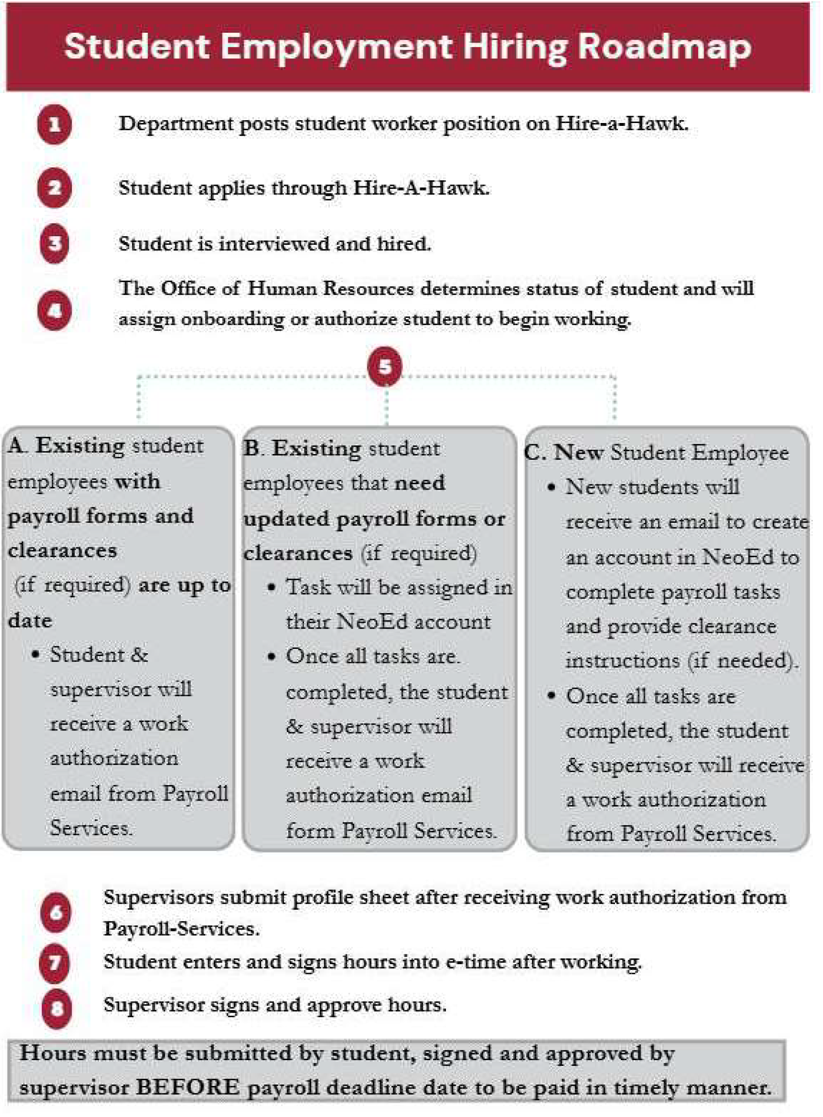

Definition of Payroll Forms
1-9 Employment Eligibility Verification Form - To verify the identity and employment authorization of individuals hired for employment in the United States.

Direct Deposit Form - Authorization for IUP to directly deposit pay into your bank account directly. It is important to correctly enter your routing and account number. The number on your debit card is NOT your bank account number. You will need to collect this information from the bottom of your checks or verify with your financial institution.

Local Service Tax (LST) - Exempts an employee from paying a tax levied by a local government's jurisdiction. Generally, employees that make less than $12,000 a year, or have the tax taken from a second job, or are active military, or military disability apply for this exemption.

Residency Form - To report essential information for the collection and distribution of Local Earned Income Taxes (EIT).

Rev-419 - Completed by an employee that is exempted from Pennsylvania's personal income tax liability. This form is completed by an individual that lives in a reciprocal state, incurs no liability in preceding and current tax year, spouse of active-duty service member, or qualify for 100% tax forgiveness.

Statement of Citizenship and Taxation Form - Completed by international students. This is used to declare individual's citizenship and tax status. This form will be assigned and completed yearly while working at the university.

W4- Used to determine the correct amount of federal income tax to withhold from your pay. Everyone is required to complete this form.

e-Time:
A daily record of time worked must be maintained on the web-based eTime student payroll system.

- Hours posted in eTime should accurately reflect all hours worked. Storing hours and reporting them on subsequent pay periods is not permitted.
- When completing eTime, please make sure you enter and sign your work hours under the correct department.
- Report any changes of address to Payroll Services.

How to Access Employee Self-Service (ESS) and eTime

- Go to MyIUP
- Find the "My Information, Data, and Accounts" card
- Click on Employee Self-Service (ESS)
- Choose Indiana University of PA in the drop down menu, then click continue
- Click on the eTime tab
- Follow the instructions at to add you time
eTime - Help Adding Time

- Follow the instructions at to sign you time
eTime - Help Adding Time

Instructions for entering time are available in the Help link located in the top right comer within eTime or by visiting https://etime.passhe.edu/help/. Please note that hours must be entered and signed in order to be processed for payment.

The pay schedule which lists the pay periods as well as the deadlines for entering and signing time can be found at Forms in the Office of Payroll Services - IUP under Student Payroll Documents.

Compensation of Pay

Wage Rates:
Undergraduate student wages vary by position but will not be less than the federal minimum wage of $7.25. Students are paid every other Friday.

Student Hour Limitations:
Supervisors should be aware that a student's first priority is to their academic work. The recommended hour limitations have been established to ensure that students achieve balance in work and school.

- During the fall and spring semesters when classes are in session, students work no more than 25 hours per week during the semester, international student may work no more than 20 hours per week during the semester.
- During May breaks and summer months, students may work 7.5 hours per day but may NOT exceed 37.5 hours per week.
- Students may work in more than one campus location. Supervisors should adjust work schedules to ensure that students do not exceed the recommended work hour limits.
- Hours approved on eTime should accurately reflect all hours worked. Timekeepers are required to wait until the shift is worked before approving student hours in eTime. Storing hours and reporting them on subsequent pay periods is not permitted.

Criteria | Hour Limits-Academic Year | Hour Limits - Breaks (Summer, Winter,  Spring, etc)
Undergraduate | 25 hrs per week | 37.5 hrs per week
Graduate | 20 hrs per week (includes assistantship) | 37.5 hrs per week (includes assistantship)

Payment Compensation:
IUP requires direct deposit for all university employees, including student workers. Pay statements are available on eTime under the "Employee Self Service" tab.

- To view pay statements, click on "Payroll" then select "My PayStub." On the right of the Pay Date row, select download, print, or the > to view pay statement. Statement will not appear in the Google Chrome browser. Edge and Firefox browser are compatible with ESS and will show your statements.
- Pay schedule can be found at https://www.iup.edu/payroll/forms/index.html.

University Employment Procedures & Policies

Resolutions of Disputes:
Students must bring concerns about their employment to the attention of their supervisor as soon as possible.

    - Supervisors are expected to make good faith efforts at fair and equitable resolution, which includes informing the student of their decision.
    - If an issue is unable to be resolved between the student and the supervisor, Human Resources should be notified immediately in order to proceed with the appropriate course of action.

Terminating Student Employees:
While all efforts should be made to make working on campus a mutually beneficial and enjoyable experience for both student employees and supervisors, supervisors may terminate a student for poor performance, misconduct, or lack of available work.

    - A student employee who resigns or is terminated must receive wages due for services rendered
    - A 2-week written notice for resignation not due to graduation is expected from a student employee
    - Student Employees are at will and serve at the discretion of the employing unit at IUP
    - The supervisor or department head should give two weeks advance notice of termination. A student employee who is found in violation of university rules or polices or has engaged in misconduct may be terminated immediately without advanced notice.

Discrimination Complaints:
IUP does not discriminate on the basis of race, color, sex, sexual orientation, gender identity, gender expression, national origin, religion, age, disability, age/or veteran status in its programs or activities in accordance with Title IX of the Educational Amendments of 1972, the Americans with Disabilities Act of 1990, Section 504 of the Rehabilitation Act of 1973, Title VII of the Civil Rights Act of 1964, and other applicable statutes and University policies.

Work Related Injuries:
Should a student employee require emergency medical attention, University Police should be contacted by calling 724-357-2104 for assistance. Injuries of a non-emergency nature should be directed to the Student Health Center for treatment. If off-campus treatment is deemed necessary following evaluation at the Student Health Center, injured student employees must be accompanied to the treating facility by their supervisor or other university staff member. All injuries must be reported to department managers or administrators as soon as it practical to do so, but at least within 24 hours of the incident. Following notification, a University Accident/Injury Report should be filled out and submitted to the Office of Human Resources.

Sexual Harassment and Sexual Assault Policy:
IUP's sexual harassment and sexual assault policy and procedures seek to ensure an environment that is free from sexual harassment and sexual assault. Such conduct is costly in human terms and seriously undermines the atmosphere of trust and respect that is essential to work and study for all members of the academic community. All employees, students, and vendors are to comply with both the spirit and intent of federal and state laws and regulations that relate to sexual harassment and sexual assault. The coverage

of this policy extends to all persons visiting the campus. The university will take action to prevent sexual harassment, including, if necessary, disciplining those individuals whose behavior violates university policy. Discipline may include, but is not limited to, oral or written warning, transfer, suspension, or dismissal. Harassment, exploitation, and intimidation have no place in an educational setting and will not be tolerated.

Drug-Free Workplace:
IUP is committed to the education and development of students, faculty, and staff regarding alcohol and other drug use. Any misuse or dependency on alcohol and other drugs has detrimental effects and concerns for the University community as well as our society at large. It is prohibited to manufacture, distribute, sell, dispense, possess, or use any controlled substance in the workplace, on campus, or in any facility owned, leased, or otherwise controlled by IUP. This includes, but is not limited to, University-related events, programs, or activities which occur on campus and off campus, under the authority of the Board of Governors.

- FAQ's

How do I search for on campus employment opportunities?
Visit Student Employment - IUP or scan the QR code below to see IUP student worker opportunities.


Does having a Federal Work Study Award guarantee that I will receive a job on campus?
No, it does not guarantee employment.

Can I get a job even if I am not eligible for Federal Work Study?
You can be employed without federal work study. When viewing employment opportunities, be sure to take note if the position requires federal work study and only apply to those that do not require federal work study.

When can I start working?
You cannot start working until you receive an authorization email from payroll-services@iup.edu.

If I have two jobs, do I need a Student Work Authorization for each one?
Yes, you need a separate work authorization for each student worker position you are hired for.

If I completely withdraw from the semester, can I continue working on campus?
No, if you are not enrolled, you are not able to continue working in your student worker position.

If I terminate my job, do I need to complete any paperwork?
You need to notify your supervisor if you choose to terminate your student worker employment.

If I have a question about a position I applied to, who do I contact?
Please email payroll-services@iup.edu with any questions regarding positions you have applied to.

If I need help navigating HIRE A HAWK for on campus employment opportunities, who do I contact?
Please email payroll-services@iup.edu with any questions regarding Hire-A-Hawk.

Do I need clearances?
Clearances are needed for student worker positions that have contact with minors. If clearances are required, instructions and payment code will be assigned in your NeoEd account.

