1ST STEP TO HIRING A STUDENT WORKER

YOU MUST Request a Requisition Number prior creating a job posting by emailing: payroll- services@iup.edu.
Please provide the following information when sending the email.
- Division:
- Department:
- Title – Student Worker:
- Who will be the hiring manager?
- Do you want anyone else to access the req to view applicants and edit the posting?
- Will this position have contact with minors*? (See deﬁnition of minors below)
- Does this apply to all future students who apply?
- Is federal work study required for this role?
*Who’s considered a minor: Background clearances are required for your student worker if he/she will provide care, supervision, guidance/control or have routine interaction with a minor. For this purpose, a minor is deﬁned as someone under the age of 18 who is NOT enrolled as a full-time student at the university working to earn a degree and IS enrolled as a full-time student in K-12 school or not of school age.

CREATING JOB POSTING

- Log into your NeoEd account at https://login.neoed.com/signin?sitecode=US&returnUrl=https://uniﬁed.neoed.com/dashboard

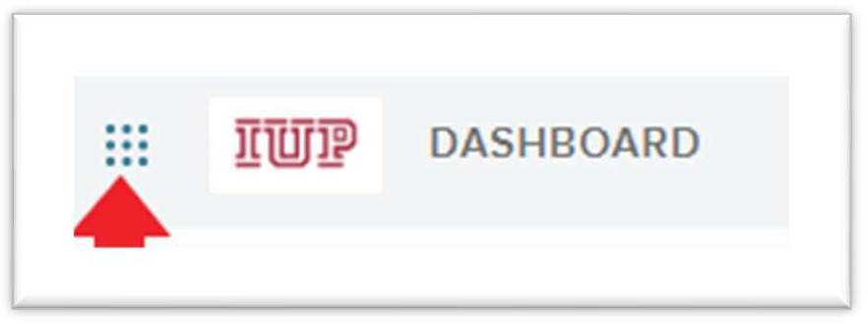
- At the top left of the screen, navigate to Dashboard –
select the dots navigation icon

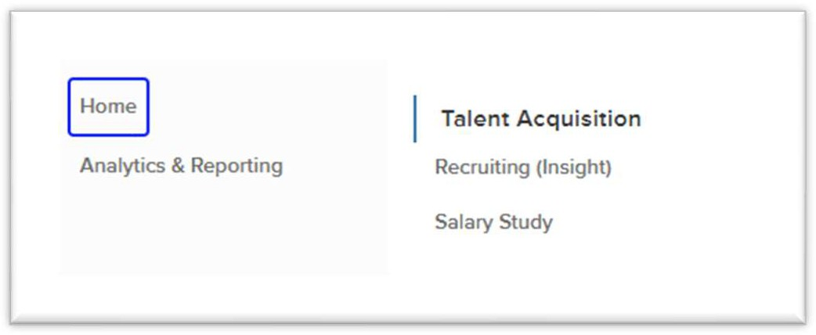
- Under Talent Acquisition – select Recruiting (Insight)

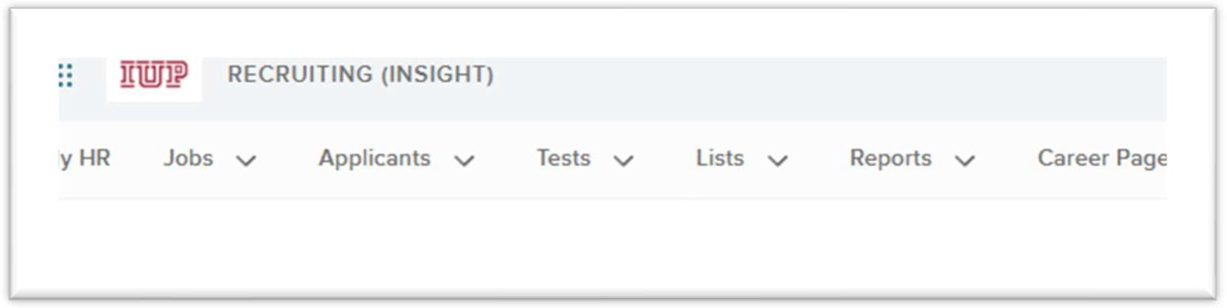
- Select jobs

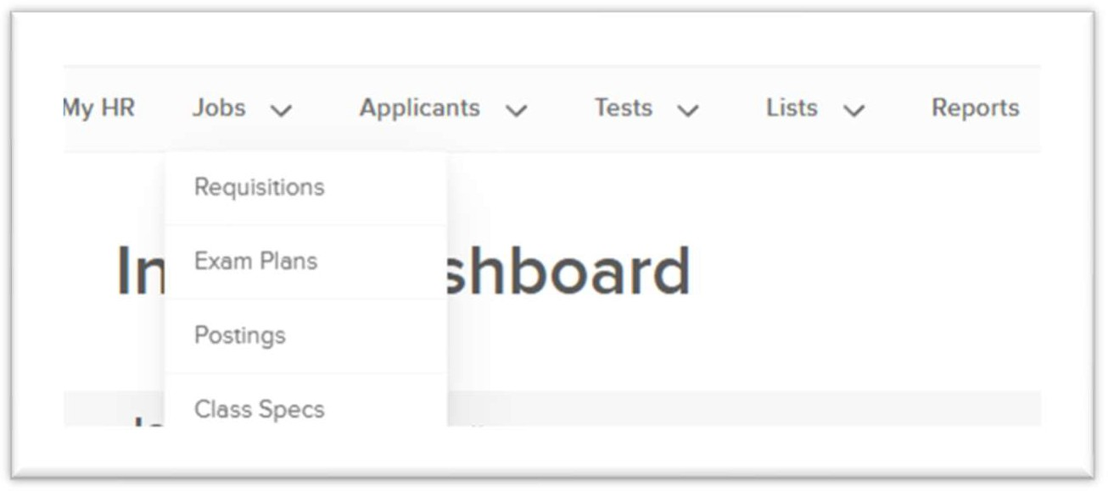
- Under jobs – select Exam plans

- Enter your requisition number in Exam plan # search box

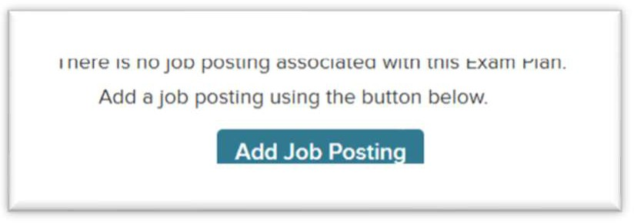
- Select Add Job Posting

- Decide your time frame of the post. You can make the post active in 2 diﬀerent ways.
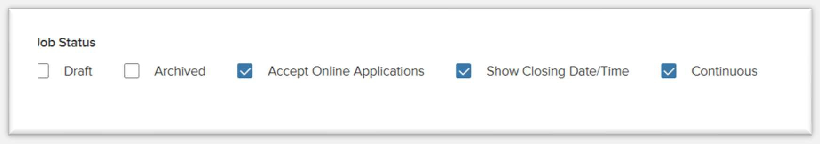
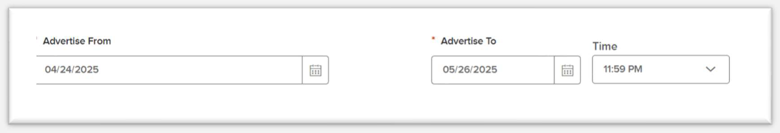
- Continuous – You will have to go back into the post, uncheck continuous and put it into draft to pull it down from the website.
  - Uncheck draft and select continuous.

OR
- Time Frame for Post to be Active – You won’t have to go back in and pull the posting down as it will come down on the date you enter.
  - Uncheck draft (do not check continuous) and in the body of the posting,
  - Put the date you want the posting to go live in the Advertise From box
  - Put the day you want the posting to come down in the Advertise To box

- Verify pre-populated items are correct (Department can be left blank; Job Number is the requisition number)
- Complete any blank * asterisks
- Job Title – This will be the same as the requisition that was sent to you from HR or Payroll-Services
- Job Type - Student
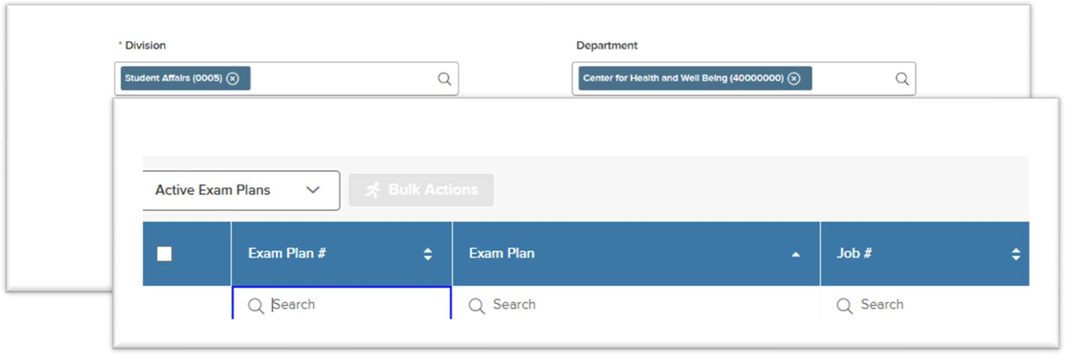
- Job List – Transfer Jobs (this is a crucial step)
- Exam Type – Open

- Advertise From – This is the date is the date the posting will go live on the Hire-a-Hawk website.
- Advertise To will not appear if you choose “continuous”
- Enable Maximum Number of Applicants – Do NOT check
- Category – Student Employment
- Reapply Period (Days) – Pre-populates
- Location on Job Posting Display – Indiana Main Campus
- Physical Address – Use 1011 South Dr., Indiana, PA 15705
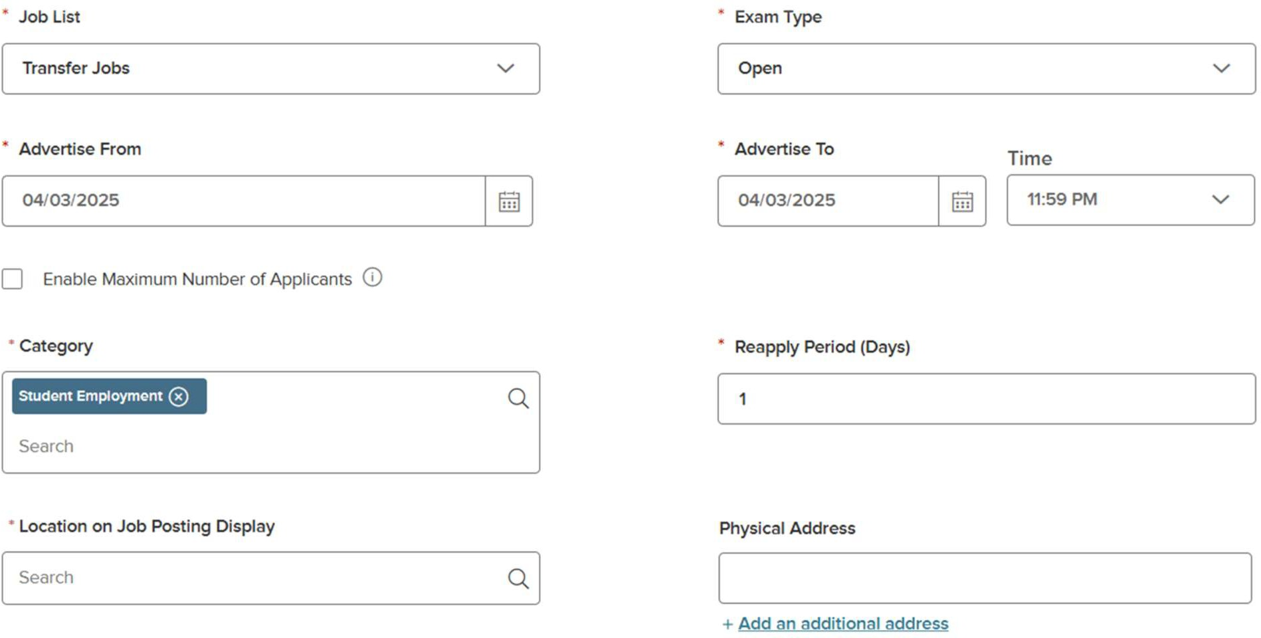

- EEO / Census Data Template – Leave blank
- Advertise Remote Employment – Leave blank
- Application Template – Student
- Assigned To – Hiring Manager’s name
- Position Summary & Description – Type in job description
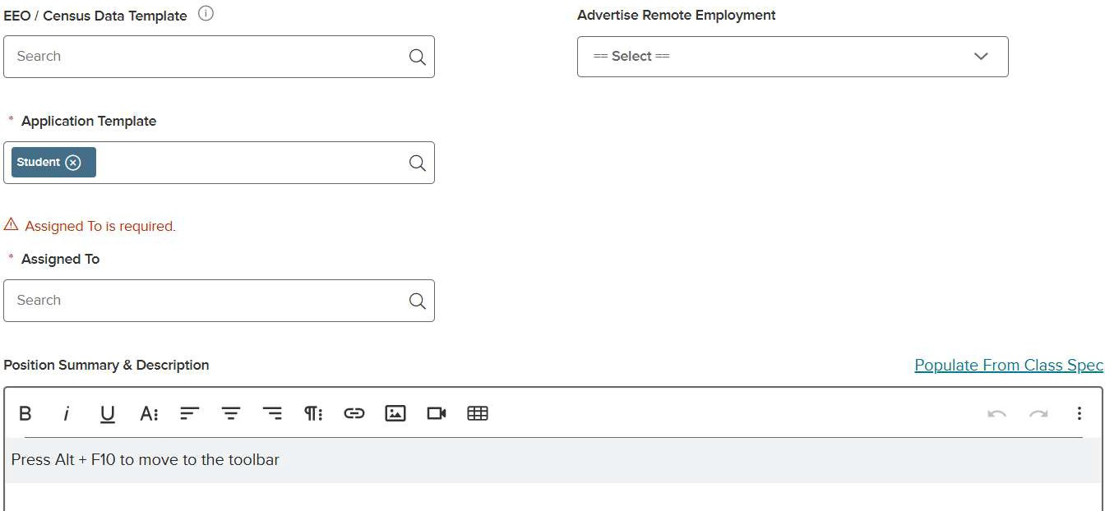

- Complete Position Qualiﬁcations, Essential Functions, and Special Instructions to Applicants.
  - Use can select Populate From Class Spec for standard posting language.

- Complete Education Level & Minimum Qualiﬁcations. Choose from the drop-down boxes
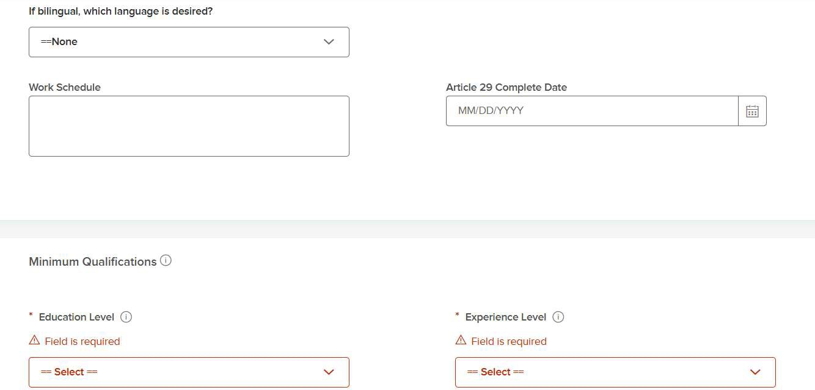

- Under Salary Information…
  - Uncheck Auto Update
  - Type wage in Minimum Salary
  - * Per – Hourly
  - * Based On – Leave what pre-populates

  - * Show Salary Breakdown – Leave Hourly checked & Uncheck Annually
  - Show Alternate Salary Text – Leave oﬀ
  - Alternate Salary Text – Leave blank

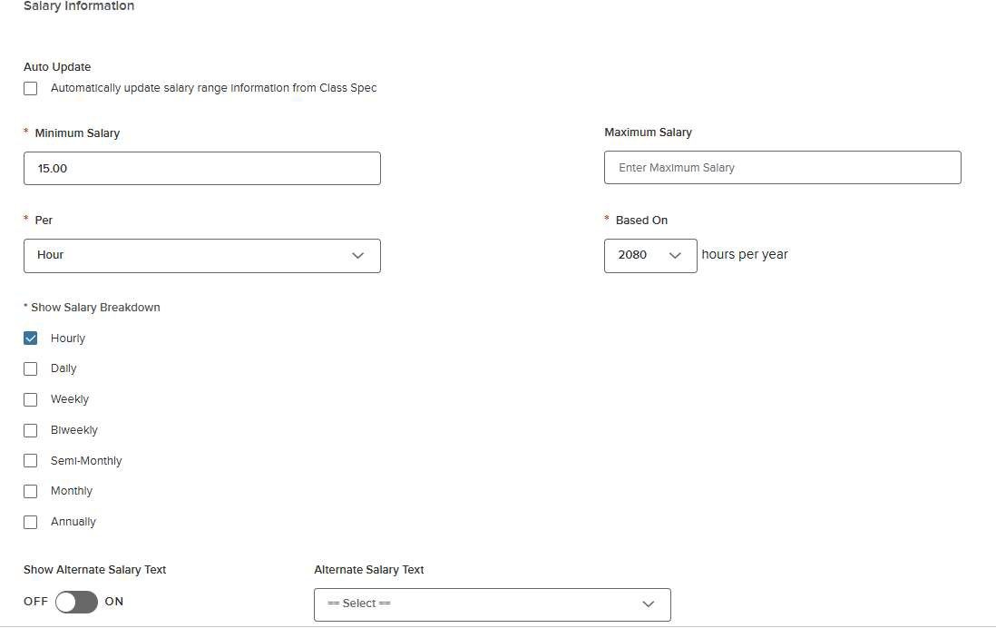

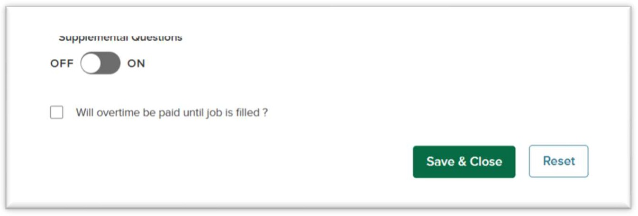
- Supplemental Questions –

LEAVE OFF
- Will overtime be paid…. – Leave unchecked

Save & Close

Referring Students to be Hired

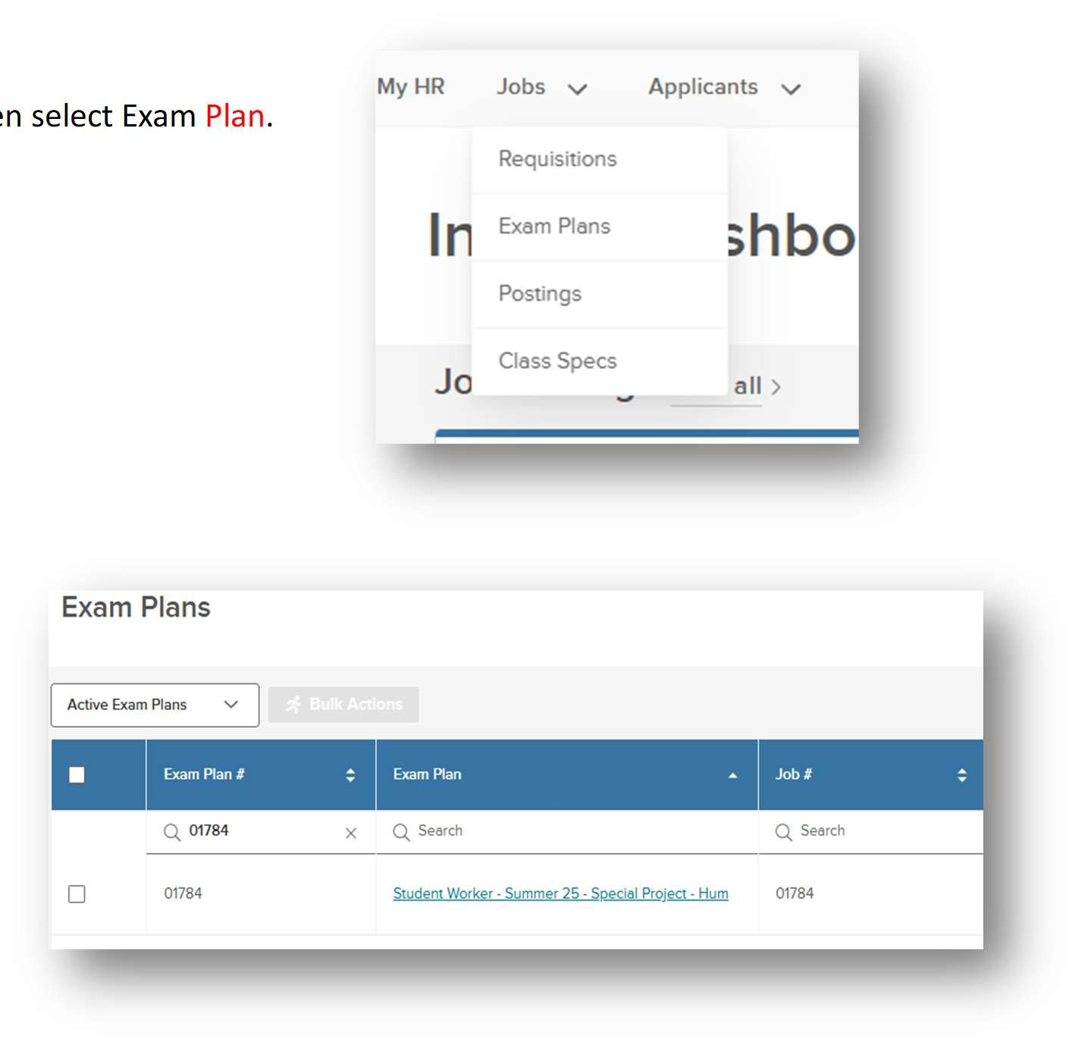
- On your Dashboard, click on Jobs and then select Exam Plan.

- Input your requisition number in the Exam Plan# ﬁeld and choose the corresponding position under Exam Plan.

- Go to the Eligible Lists section
- Select View Candidates
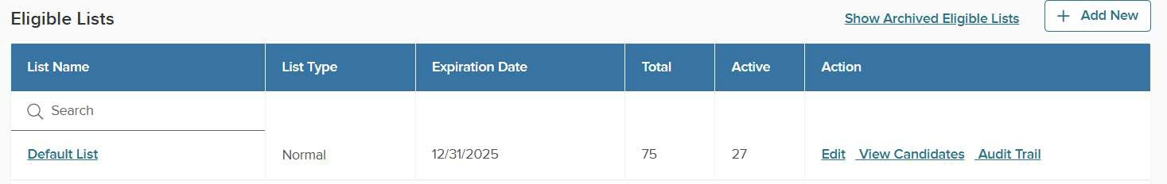

- Select student(s) you are hiring
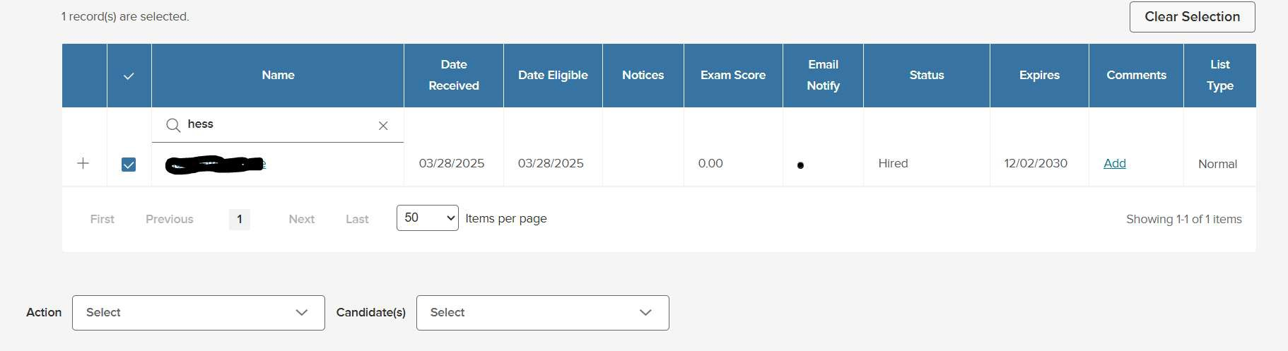

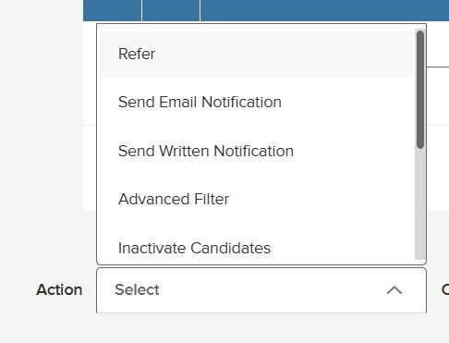
- Scroll to the bottom of the list and from the Action
drop-down menu select Refer

- Select the arrow on the Candidates and from the drop-down menu select Selected Candidates
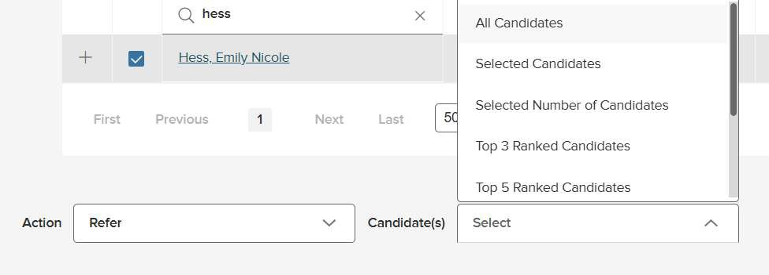

- Select Go
- From the pop-up box, select the requisition you are hiring under and Submit
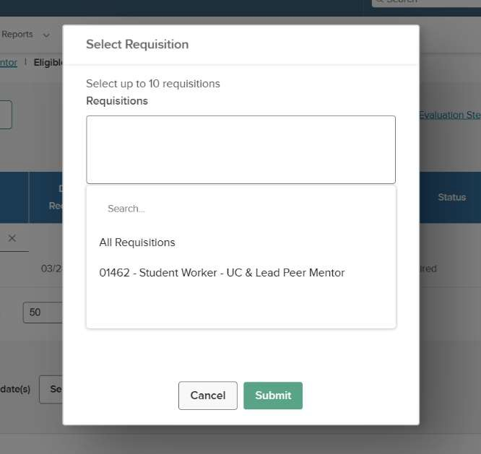
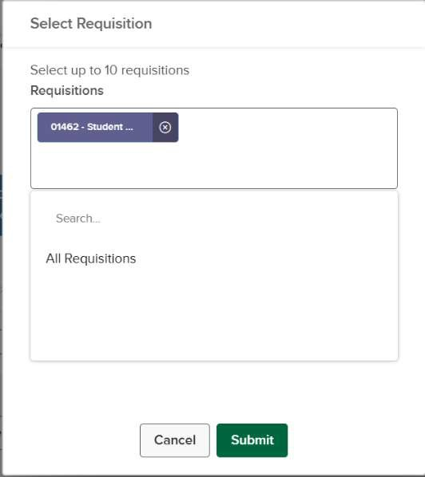


Hiring a Student Worker

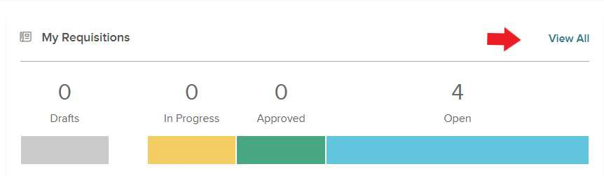
  - Log into your NeoEd account at https://login.neoed.com/signin?sitecode=US&returnUrl=https://uniﬁed.neoed.com/dashbo ard

  - Next to My Requistions, click View All

  - Select the requisition you are hiring for by clicking on the title of the position

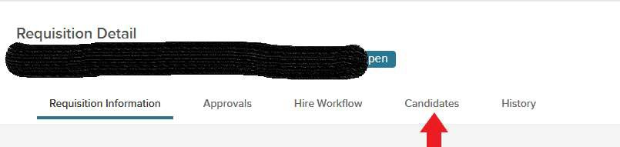
  - Click Candidates

  - Click in the box of the student you want to hire, click the arrown next to Actions, and choose Move to Hire
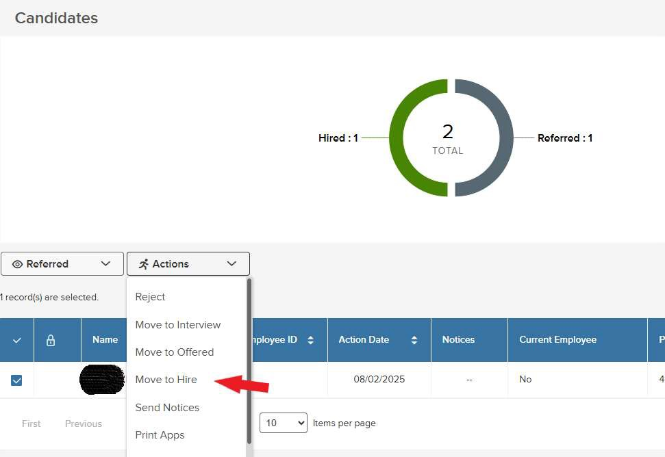

  - Complete the information as shown below.
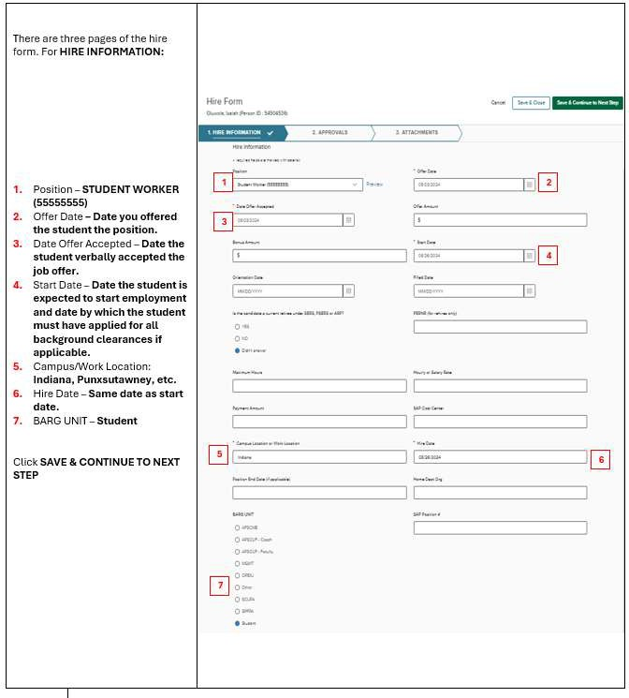

  - Add approval group – add Human Resources (Req)
  - Add approvers – Add Tina Kinter, Cindy Sisko, and Heather Hood

  - Click the green add approval step

  - Click Save and Continue to Next Step

  - Click Save and Submit on the attachment page (no attachments are required).

  - Send the hire notice to your student worker
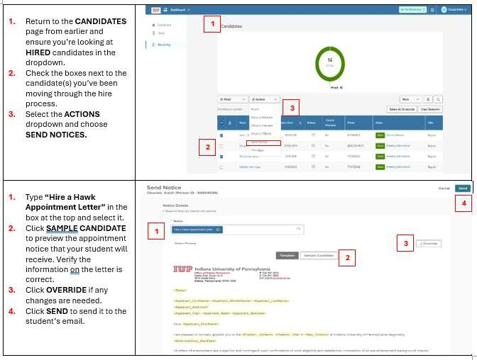
  - Payroll Services will begin onboarding your student worker. Please have them watch their IUP email for a notiﬁcation from DoNotReply@NeoEd.com to activate their NeoEd account

  - Once the student has completed their onboarding, a work authorization email will be sent. STUDENTS MAY NOT BEGIN WORKING UNTIL THIS EMAIL HAS BEEN
SENT. Once you, the supervisor, receive this email, please complete the proﬁle sheet, which can be found on MyIUP, in the “Hiring a Student Worker” card.
  - Once they have been hired, the student will be able to access ESS to enter their time. Please direct your student to the Student Employment Guide with any questions. This guide can be found on the Student Employment webpage.

