Introduction and Rationale
In order to comply with SSHE reporting requirements, a separate section must be created for every faculty member who chairs a thesis or dissertation. This process will more appropriately represent the distribution of credits among the faculty chairs.
A faculty member may be assigned to multiple sections of thesis and/or dissertation, where credit values are variable, and/or when also assigned to a section of Extended Credit. In the following example, several dissertation sections have been created and assigned to three faculty members. A letter is used as the first character of the section designation for each set assigned to an individual faculty member, while the numeric portion of the section number corresponds to the number of credits for which the students will register. Sections 101, 102, and 103 are designated as Extended Credit sections, each carrying 1 credit.
It is not necessary to create a section for every possible credit value for each faculty member.
Only create sections for which you anticipate enrollment.

ENGL 995 Dissertation
SEC TITLE CREDITS INSTRUCTOR
A01 Dissertation 1.00 Dandurand K
A02 Dissertation 2.00 Dandurand K
A03 Dissertation 3.00 Dandurand K
A04 Dissertation 4.00 Dandurand K
A05 Dissertation 5.00 Dandurand K
A06 Dissertation 6.00 Dandurand K
A07 Dissertation 7.00 Dandurand K
A08 Dissertation 8.00 Dandurand K
A09 Dissertation 9.00 Dandurand K
A10 Dissertation 10.00 Dandurand K
A11 Dissertation 11.00 Dandurand K
A12 Dissertation 12.00 Dandurand K
101 Extended Credit 1.00 Dandurand K
B02 Dissertation 2.00 Gebhard J
B04 Dissertation 4.00 Gebhard J
B06 Dissertation 6.00 Gebhard J
B09 Dissertation 9.00 Gebhard J
B10 Dissertation 10.00 Gebhard J
B12 Dissertation 12.00 Gebhard J
102 Extended Credit 1.00 Gebhard J
C03 Dissertation 3.00 Bencich C
C06 Dissertation 6.00 Bencich C
C09 Dissertation 9.00 Bencich C
C12 Dissertation 12.00 Bencich C
103 Extended Credit 1.00 Bencich C
Students will register for the thesis or dissertation section which carries the appropriate number of credits, and to which their chair is assigned.
ART 795 Thesis

ART-MFA students are required to register for 1 credit continuous thesis course work (ART 795) each term following the completion of all required courses, including the required number of thesis credits. The section building process provided herein for dissertation sections should be followed in creating sections of ART 795 specifically for ART-MFA (not ART-MA) students.
All section numbers for MFA students should begin with the letter “F.” Sections for ART-MA students should not begin with the letter “F.”

Sections of ART 795 for ART-MFA students:
ART 795 Thesis
SEC TITLE CREDITS INSTRUCTOR
F01 Thesis 3.00 Smith M
F02 Thesis 1.00 Smith M
F03 Thesis 3.00 Greene M
F04 Thesis 1.00 Greene M
All ART-MFA sections of ART 795 (1 or 3 credits) should begin with the letter "F," and be restricted to ART-MFA students. It will be necessary to build multiple sections to accommodate for each combination of instructor and credits (3 credits for the initial/regular section and 1 credit for continuous thesis sections). The title for the continuous thesis sections must be modified to Extended Credit.

ART 795 Thesis
SEC TITLE CREDITS INSTRUCTOR
001 Thesis 3.00 Smith M
002 Thesis 3.00 Jones T
003 Thesis 3.00 Doe J
Sections of ART 795 for ART-MA students:
All ART-MA sections of ART 795 are 3 credits and should not begin with the letter "F." Multiple sections will be necessary to accommodate for multiple instructors. However, multiple sections for various credits will not be necessary since the ART 795, Thesis (for MA students) is only approved for 3 credits.
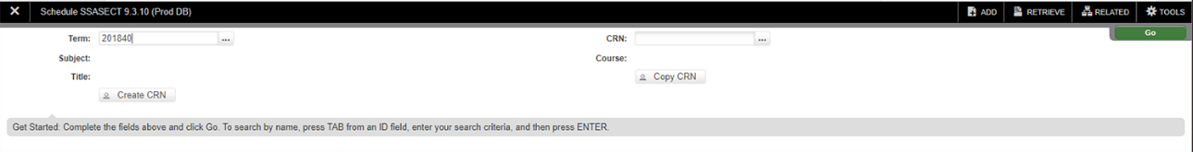
- Navigate to SSASECT in Banner
SSASECT builds the term’s section.
- Enter the term and click create CRN to add a new section. Click Go.
- The highlighted information in the image below is necessary to be completed.
- Title only changes for Extended Credit.
- Section Numbers are 3-character fields that correspond to the section credit value. H and W are reserved and should only be used as the first character of a section number where the section is for Honors College students or writing intensive. Neither apply to graduate sections!
    - SECTION IDENTIFIERS:
1xx Extended Credit 6xx Dixon Center
2xx Armstrong Branch 7xx CCAC
3xx Punxsutawney Branch 8xx Distance Education
5xx Off Campus:
Monroeville/Pittsburgh/Johnstown

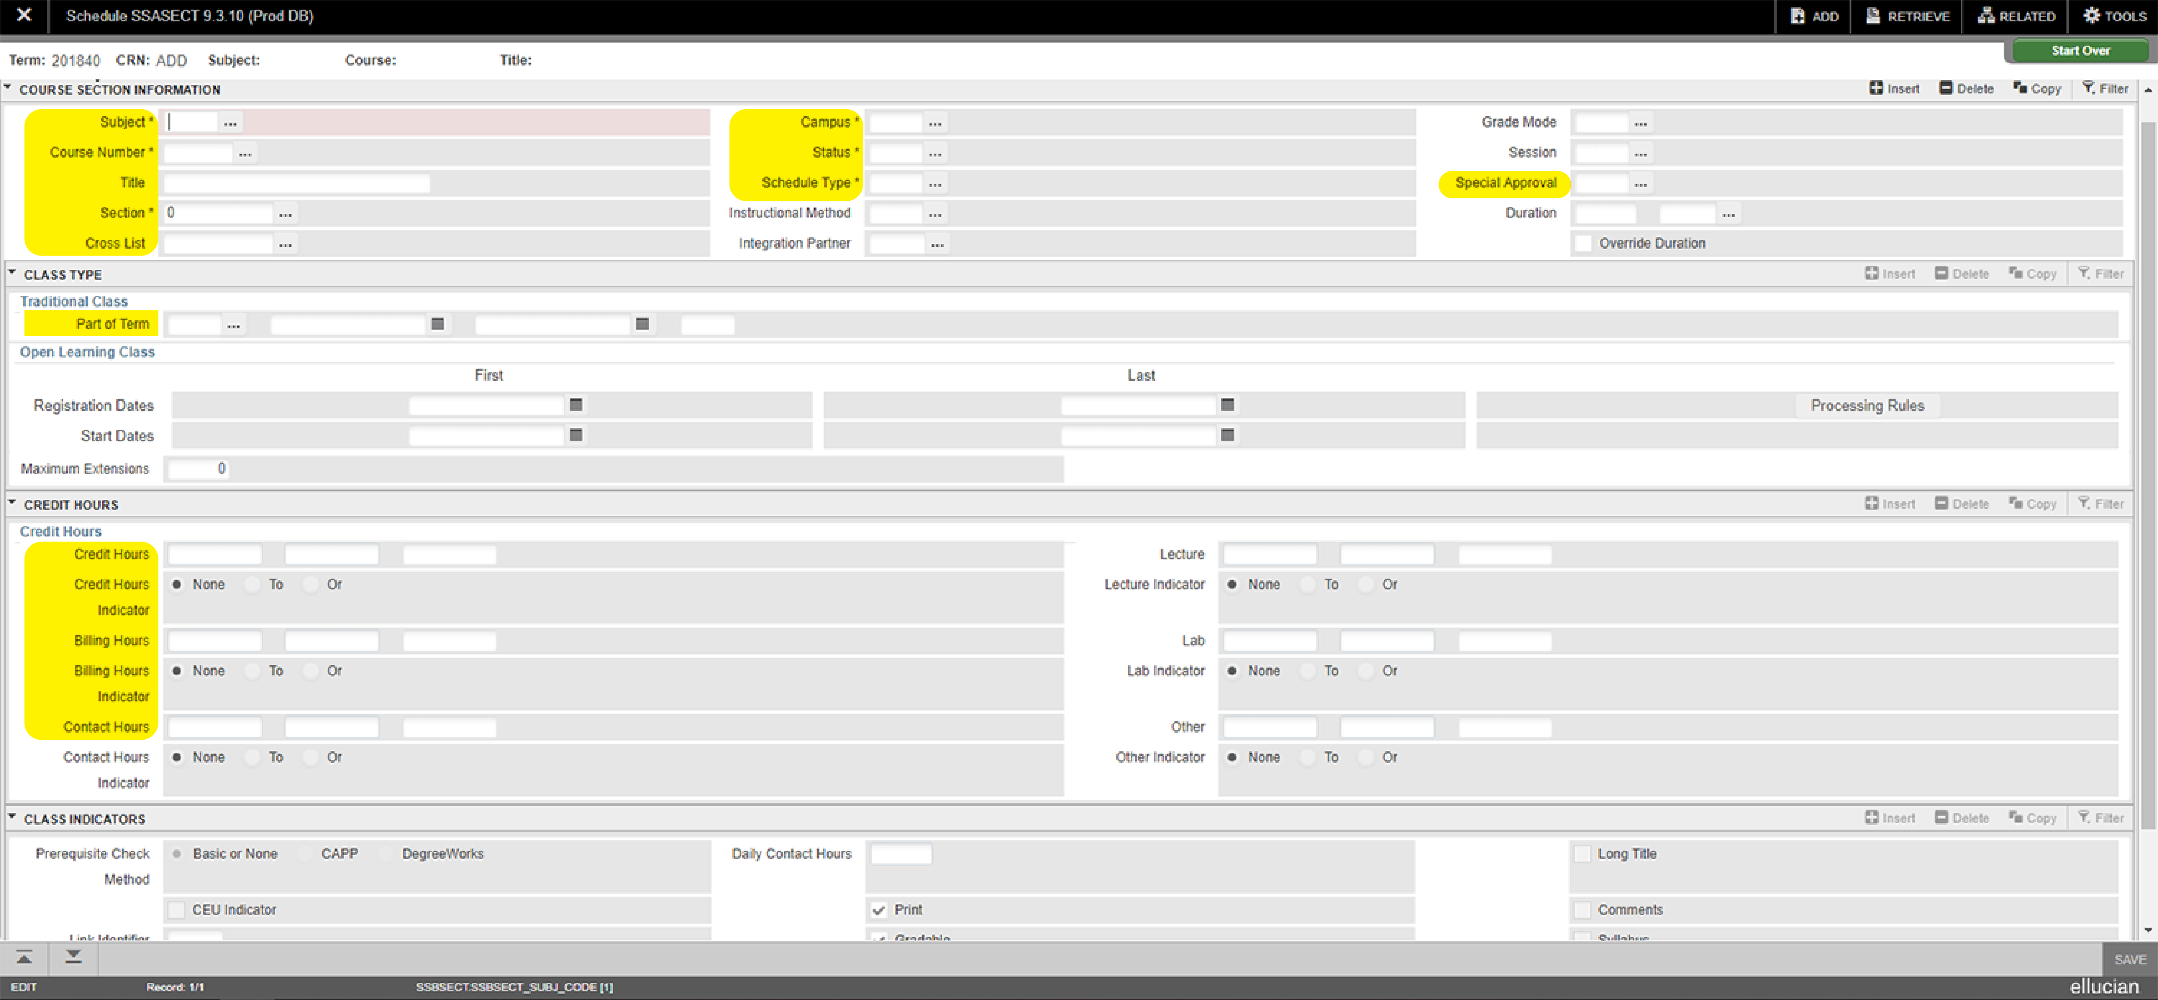
- Credits, Billing, and Contact Hours: Variable credit courses MUST be defined when each section is created.
For accuracy in both registration and billing, Credits and Billing must match.
- To ensure that only approved students can register for Thesis and Dissertation sections, it is recommended that you assign
a Special Approval code to each section.
4. After the required information is entered on the base screen, SAVE.
5. Establish maximum seats for the section under the Section Enrollment Info tab. SAVE.
6. Under the Meeting Times and Instructor tab, tab through the fields to populate defaults. Hours per Week must be populated (enter 0 if appropriate) but days and times are not needed.
7. Proceed to Instructor tab and enter faculty ID. SAVE.
8. Rollback to return to SSASECT.

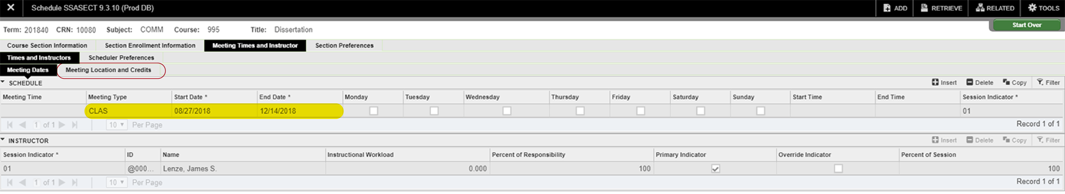
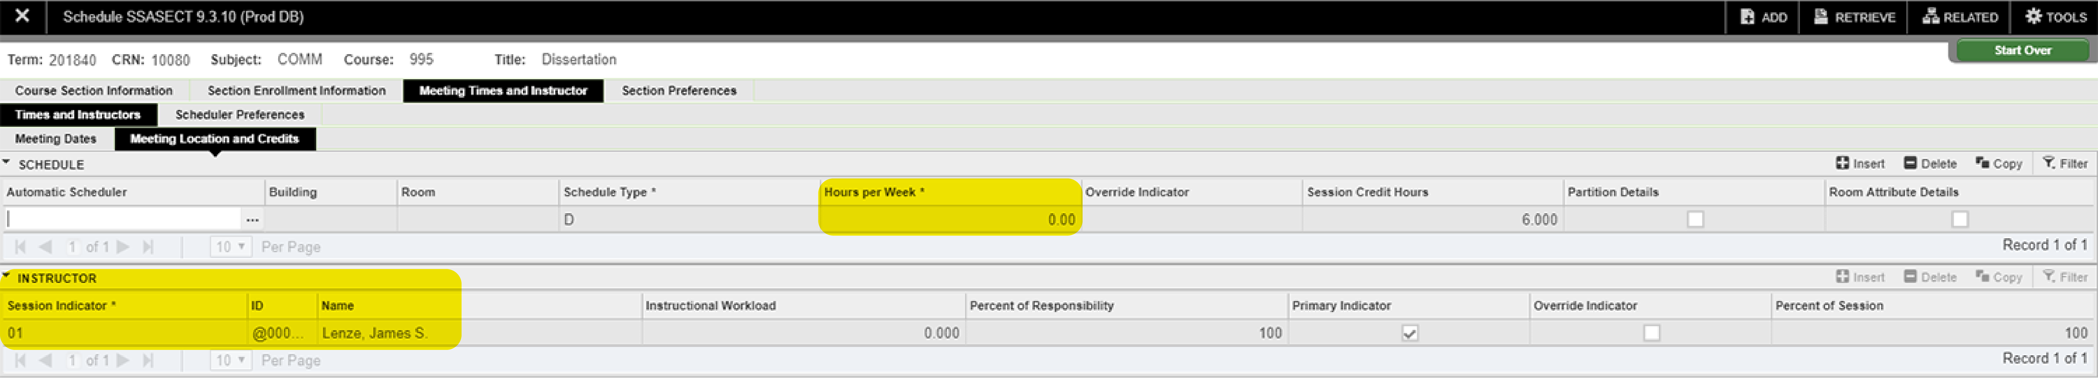

Canceling Sections
After drop/add for the term or part-of-term has ended, these sections need evaluated to determine if sections need to be cancelled due to zero enrollment.
To change status from O to X, complete the following steps in order:
- Section Enrollment Information - change maximum to 0 then Save
- Instructor – delete instructor then Save
- Meeting Times and Instructor – delete existing times and building/rooms then Save
- Course Section Information – change status from O to X then Save
