Assessing Woman Battering  in Mental Health Services  Author: Edward W Gondolf  Mid-Atlantic Addiction Training Institute (MAATI)  Indiana University of Pennsylvania  Publisher: SAGE Publications, Thousand Oaks, CA  Pages: 208 | 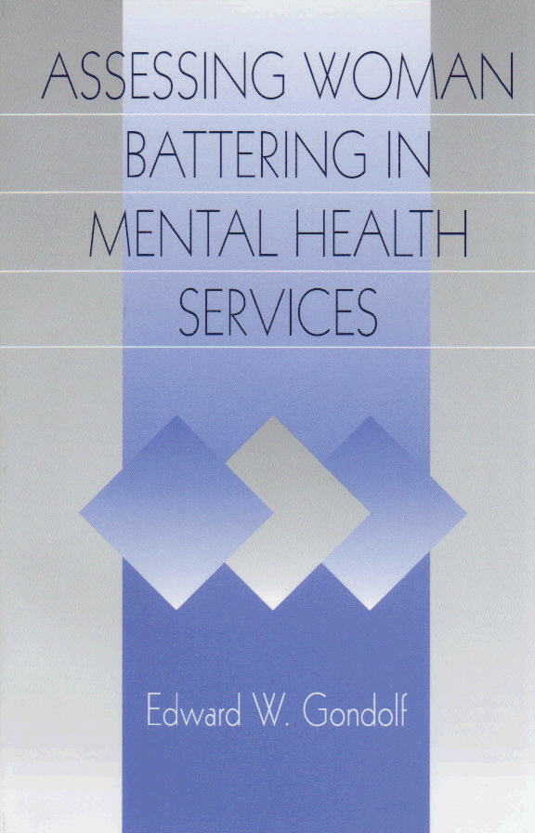
  Paperback | (0761911081): | November, 1997 | $34.95
  Hardcover | (0761911073): | November, 1997 | $74.95
I found ASSESSING WOMAN BATTERING to be very well written, accessible, informative, and a contribution to both fields targeted, as well as useful to many other related fields. The author does an artistic job of relaying information thoroughly while consistently providing tables and figures that increase the clarity of the presented information… The book does a respectful job of recognizing the critical necessity of organizational and systemic change rather than pose superficial remedies.—Laura van Dernoot, King County Domestic Violence Project and Harborview Hospital, in Journal of Interpersonal Violence

Description: Assessing Woman Battering challenges traditional mental health approaches to domestic violence and offers alternative strategies and procedures to improve the response to battered women. The book is a guide to the conceptual and practical issues associated with identifying and assessing battered women in mental health services. Edward W. Gondolf draws from research on mental health assessment and his own surveys of battered women’s services to illustrate these issues. The expertise of battered women advocates is used to develop answers to critical assessment issues. Beyond a how-to book, Assessing Woman Battering discusses the issues underlying the identification and assessment of battered women and assists clinicians in providing an appropriate and safe response for them. It presents ways to build collaboration that improves assessment and referrals, and establishes a supportive environment that enhances disclosure of woman battering, identifying potential strengths and further safety rather than increasing risks. Concluding chapters consider issues involved in assessing women of different racial backgrounds and men who battered their female partners. This timely and well-written book is directed to mental health practitioners and domestic violence workers as well as academics, researchers, and students in the helping professions. Academics, researchers, mental health practitioners, domestic violence workers, and professionals in violence against women, interpersonal violence, social work, clinical/counseling psychology, sociology, gender studies, family studies, public health, criminology, and nursing will find this book useful.
Table Of Contents:
I. Underlying Issues Facing Assessment // 1. Addressing Differences and Barriers / 2. Moving Toward Collaboration // II. Tools for Improved Assessment // 3. Case Studies of Mental Health Evaluations / 4. Procedures for Assessing Woman Battering / 5. Recognizing the Strengths of Battered Women // III. Other Considerations // 6. Appreciating Diversity Among Battered Women / 7. Identifying and Assessing Men Who Batter / Appendix / Recommended Bibliography / References

To Order:
Sage Publications, Inc.;
2455 Teller Road; Thousand Oaks, CA 91320
Phone: 1.805.499.0721; Fax: 1.805.499.0871
Email: info@sagepub.com; Website: www.sagepub.com

