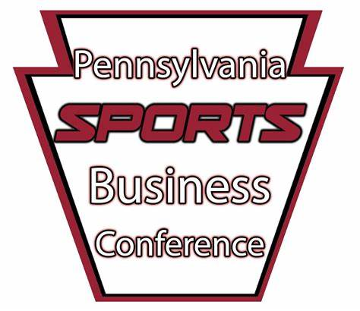
Pennsylvania Sports Business Conference
Outstanding Student Award 2022 Application
Application Deadline: March 11th 2022

General Description:
This award is to recognize a student for their outstanding academic achievement in the classroom, desire to gain industry experience, and commitment to volunteering in their community.
This award is open to Sports Administration or equivalent majors.
All completed applications and current resume should be sent to zullorh@westminster.edu

Eligibility:
All students of Pennsylvania institutions of higher education or who have a residency in Pennsylvania are encouraged to apply.

Evaluation of Candidates
The Pennsylvania Sports Business Conference Committee will evaluate applications based on the following:

Criteria
- Academic achievement
- Extra-curricular activities
- Industry experience
- Community service
Procedure
A rubric will be used along with committee discussion to make their decision

Name: ________________________________________________ Phone: _________________
Address:______________________________________________________________________
City:______________________________________State:___________Zip Code:___________
Email:____________________________________University:__________________________
Class Standing:____________________________Major:_________________ GPA:________
Faculty GPA Verification Signature:______________________________________________

What academic honors and awards have you received?:____________________________________
__________________________________________________________________________________________________________________________________________________________________________
How active are you in the department including clubs and leadership positions?:_____________________________________________________________________________________________________________________________________________________________________________________________________________________________________________________
What relevant experience do you have including, but not limited to, internships, job shadowing, volunteer experience?:____________________________________________________________________________________________________________________________________________________________________________________________________________________________________________________
Describe any volunteer service you provide to the community?:____________________________________________________________________________________________________________________________________________________________________________________________________________________________________________________________________________
Is there anything you would like the committee to know?_________________________________________________________________________________________________________________________________________________________________________________________________________________________________________________________________________________

Applicant Signature______________________________________________________________Date:_________

