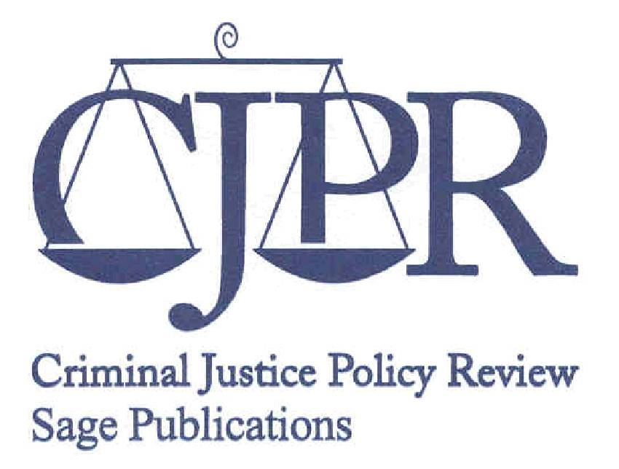
Criminal Justice Policy Review
Department of Criminology
Indiana University of Pennsylvania
G-13 Wilson Hall
Indiana, Pennsylvania 15705-1002
Phone: (724) 357-1247
Fax: (724) 357-2121
Web-site: http://cjp.sagepub.com

CALL FOR PAPERS – SPECIAL ISSUE

OFFENDER REENTRY AND REINTEGRATION

Submission Deadline: June 1, 2011

Criminal Justice Policy Review (SAGE Publications) is a multidisciplinary peer-reviewed journal committed to the study of criminal justice policy through quantitative, qualitative, and mixed-methodological approaches. The journal is published quarterly and accepts appropriate articles, essays, research notes, and book reviews. It also provides a forum for occasional special issues on notable topics in crime and justice. The journal appeals to criminologists, sociologists, political scientists, and practitioners with an interest in criminal justice policy. For more information about Criminal Justice Policy Review, please go to http://cjp.sagepub.com.

The journal is currently soliciting manuscripts for a special issue on offender reentry and reintegration. Manuscripts considered for publication in this special issue could focus on a variety of topics, including (but not limited to): (a) recent trends in prison populations and community-based supervision; (b) federal, state, and local policies on offender reentry and reintegration; (c) survey research on the use of reentry and reintegration policies and programs; (d) barriers to effective reentry and reintegration; (e) process evaluations and impact assessments of reentry and reintegration programs; and (f) collaborative and strategic partnerships for enhancing reentry and reintegration. All submitted manuscripts should contain discussion of relevant implications for criminal justice policy and practice.

An online submission and review system for Criminal Justice Policy Review is available at http://mc.manuscriptcentral.com/cjpr. Manuscripts should be submitted in current APA format. For additional information, please contact Jeremy Olson, Assistant Managing Editor, Criminal Justice Policy Review, at j.a.olson2@iup.edu or call (724) 357-1247.

