

I N D I A N A U N I V E R S I T Y O F P E N N S Y L V A N I A D E P A R T M E N T O F C O U N S E L I N G

The Counseling Chronicle
I S S U E N O . 2 | D E C E M B E R 2 0 2 2


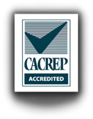
Welcome to the Department of Counseling Newsletter
The mission of the Department of Counseling at Indiana University of Pennsylvania is to prepare culturally responsive school counselors, clinical mental health counselors, and counselor educators and supervisors who will facilitate holistic client/student improvement through exemplary individual and group counseling skills and sustained engagement in ethical practice, scholarship, and leadership.

In this issue:
  - Letter from the Chair p. 19
  - Letter from the Assistant Chair p. 20-21
p. 4-7 Departmental News p. 22
p. 8-13 Faculty News p. 23
p. 14-17 Counselors in Action p. 24

Conference Spotlight: CSI Dissertation Defenses Counselors for Social Justice Chi Sigma Iota

Reminders & What's Ahead

p. 18 Conference Spotlight: PCA p. 25 Get in Touch


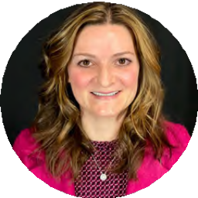
Letter from the Chair
It is hard to believe we are completing the fall semester and looking onto the semester break. I enjoy writing this newsletter welcome because it reminds me of all we have done in the past year. I could write about all our collective accomplishments; it would be quite easy to do. Instead, I would like to say that the Department of Counseling faculty have come together, stepped up for students, and gone above and beyond more than any year I can remember since starting 16 years ago. I have recently agreed to continue chairing the Department for another three years, and while I enjoy the work, I like collaborating with my colleagues even more.
We are proud to say that our applications for admissions are higher than they ever have been. Assistant chairperson, Dr. Brittany Pollard-Kosidowski, is their first point of contact and she conveys her pride in IUP with every communication. I have no doubt that her skill set in this role has facilitated completed applications and a competitive admissions process. Fortunately for all of us, she has agreed to serve as Assistant Chairperson for three more years!


I am also appreciative of the work of our doctoral coordinator, Dr. Holly Branthoover. IUP has been ranked as an R2 Doctoral University–High Research Activity (R2) by the National Center for Postsecondary Research’s 2021 Carnegie Classification. Our accredited
Counselor Education and Supervision Ph.D. program is a point of pride for the university. Our graduates are accepting positions in academia and as leadership in community agencies. I have no doubt that through Dr. Branthoover’s leadership we are graduating
high quality doctoral students who will make a significant contribution to the profession.


As I am sure we are all too aware, the need for counselors is higher now than it ever has been. We are glad that our practicum and field students are helping to fill some of the gaps. We are also eternally grateful to all the site supervisors who give of their time to train the next generation of counselors.

In conclusion, this edition of the newsletter would not be possible without a dedicated group of graduate students. Thank you for helping to keep the Department of Counseling connected to our students, alumni, supervisors, and supporters.

On behalf of our current dedicated team of students and faculty we wish you all the best in the upcoming year.


Warmly,
Dr. Desmond



Letter from the Assistant Chair
Hello everybody!

As I sit to write this letter, I find myself reflecting on all that the past year has brought. New challenges, new triumphs, new opportunities, and new transitions have all characterized 2022 and we, as a community, have tackled each new experience in the way we do best – together. In this year’s letter, I’d like to share what I’ve been most grateful for in my role as Assistant Chair throughout 2022.

- Resilience – This word speaks to me on both personal and professional levels and I’m fortunate to witness resilience in action every single day at IUP. Our students, faculty, and staff have demonstrated their capacity to persevere time and time again this past year as we’ve been consistently asked to do more with less. I’ve seen us all become increasingly creative, intentional, and thoughtful in our pursuits and I truly believe that our collective community and its subsets have been strengthened as a result.

- Leadership – I appreciate and am especially heartened by the leadership that IUP Counseling represents at every turn. We are fortunate to have consistently strong departmental leadership in Dr. Desmond and in a faculty comprised of members that show up as leaders every day throughout our college, our university, and our surrounding communities. I have been so proud this past year to work with so many developing student leaders at both the master’s and doctoral levels – watching you shine has
renewed my spirit and reminded me that we are, collectively, truly capable of promoting change for the better.
- Growth – I’ve found myself increasingly grateful this year for growth opportunities, painful as they may often be. As someone who isn’t generally a fan of surprises or unexpected change, 2022 has taught me to embrace all possibilities and look for underlying chances to grow as both a person and a professional. All of us in this field work to empower and support the growth of others; 2022 has also brought several opportunities for me to turn inward and nurture that process within myself.
In closing, I’m proud that we’ve not only survived 2022, but also that we have collectively thrived. I wish you all the best as we head into another year full of possibility and promise. Thank you for allowing me to be a part of your journey and also for playing such a fundamental role in mine.

Warmly,
Dr. PK

Departmental News (continued)

Leadership
IUP master’s alum, Ashley Deurlein, was elected to be the next PCA President (below, left)

Dr. Nice led a successful PCA Conference as PCA President (below, center)

- Dr. Branthoover took on the role of editor-in-chief for the Journal of the Pennsylvania Counseling Association (below, right)
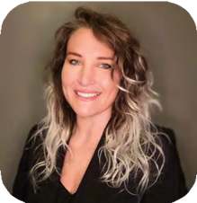
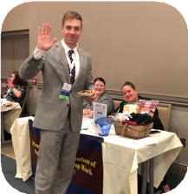
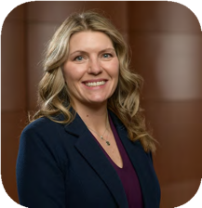

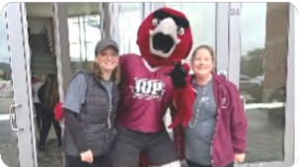
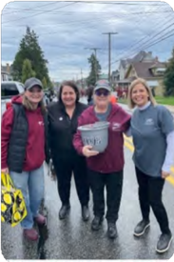
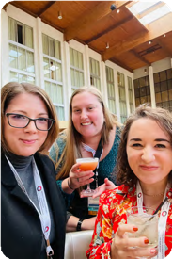
Fun Stuff

Drs. Desmond and Guth with Norm

Dr. Desmond, Provost Luetkehans, Dr. Guth, and Interim Dean Rieg at the 2022 Homecoming Parade

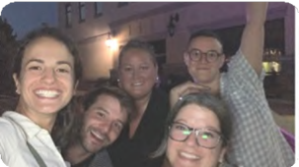
Dr. PK with master's GAs
Doc students enjoying a break after sessions




Dr. Holly Branthoover

Faculty News


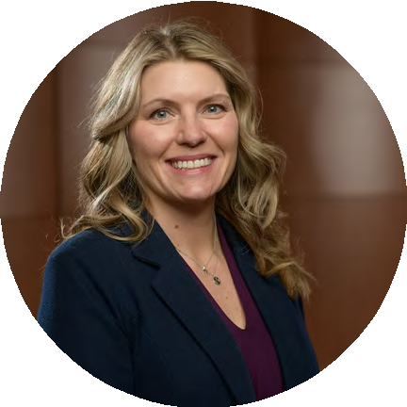
Dr. Branthoover is currently in her 18th year as a Department of Counseling faculty member and continues to serve as the department’s Doctoral Coordinator. In December 2021, Dr.
Branthoover left her service as the ACES Conference Coordinator, a position she held since 2015. As of January 1, 2023, Dr.
Branthoover will embark on a new endeavor as editor for the Journal of the Pennsylvania Counseling Association (JPCA).

In November 2022, Dr. Branthoover co-presented twice at the NARACES conference. The first presentation, with doctoral candidate Jen Kennedy, was titled, “What diagnosis?” Ethical mandates and broaching conversations about culture during diagnosis." In addition, she presented, “Conceptualizing the role of dissertation chair through the lens of the Discrimination Model” with Dr. Kim Desmond and doctoral candidate Todd Vermileon. Dr. Branthoover and her husband are planning a spring visit to Italy. They continue to enjoy being dog parents to Jester, who turned one in August.

Dr. Stacy Carone (she/her/hers)



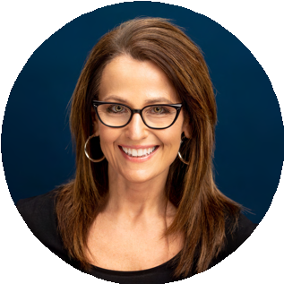
Dr. Carone is in her 16th year as a faculty member in the Department of Counseling. She is the department’s Graduate Assistantship coordinator and manages the budget and assignment of 38 graduate assistants. She serves on the College of Education and Communications Diversity and Inclusion Standing Committee (DISC) where she is collaborating on a survey for faculty in the college regarding their diversity training needs and feedback on the DISC D2L faculty resource page. She is also on the Department of Counseling Student Development, Doctoral Planning, and Department Evaluation committees.


Recently, she presented “Creative Strategies in Telehealth Group Counseling with Children” at the Association for Specialists in Group Work in Atlantic Beach, Florida. She also did a poster presentation, “Counselor Education Challenges in Uganda and Third World Countries: Bridging Theory with Practice,” with doctoral students Racheal Nuwagaba-K and Claire Rusoke at the Northeastern Association of Counselor Education and Supervision in November. On a personal note, Dr. Carone is proud of her daughter, a 3rd year IUP student and Biology major/Music minor, who released her first self-produced album, “New Eyes” that features several motivational and empowerment songs. She is also happy that her father, Sam, turned 93 this year!! In her free time, Dr. Carone enjoys spending time with family and dog, Daisy!

Faculty News (continued)

Dr. Kimberly Desmond
Dr. Desmond has been staying busy with her two children, now ages 15 and 12. They are looking forward to the holidays with family at the beach. Her husband, James, is in private practice as a Licensed Professional Counselor in Indiana. This fall, Dr. Desmond and her family have been fortunate to spend time with her 98-year-old grandfather while he stayed with them following hurricane Ian’s aftermath. It was a joy to have this quality time together.

Professionally, Dr. Desmond started her 16th year at IUP. She continues to serve as chairperson in the Department of Counseling and has just been elected to another three-year term. She is honored to serve the Department in this capacity and is proud of the three CACREP accredited programs (Clinical Mental Health Counseling, M.A., School Counseling, M.Ed., and Counselor Education and Supervision, Ph.D.). Nationally, she remains a CACREP site team chair reviewing standard compliance for counseling programs across the country.

Recently, Dr. Desmond collaborated with two IUP alumni, Drs. Stephanie McHugh and Kyle Bellinger on a new book chapter titled Individual Counseling in the book Foundations of School Counseling: Innovation in Professional Practice (https://www.springerpub.com/foundations-of-school-counseling-9780826187529.html). Dr. Desmond is appreciative of the strong connection alumni have to the department and their willingness to collaborate on projects.

Dr. Desmond also attended several professional conferences this fall and had the opportunity to connect with students and graduates. If you see IUP faculty, please stop us and say hello. We love to hear about what our alumni and students are up to!
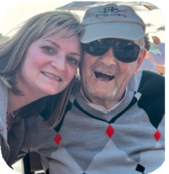
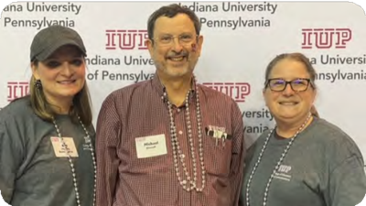

Dr. Desmond and her grandfather, Harry
Drs. Desmond and Guth with IUP President Michael Driscoll at Homecoming


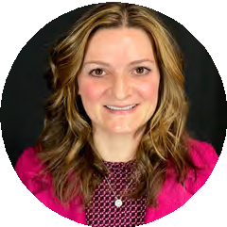


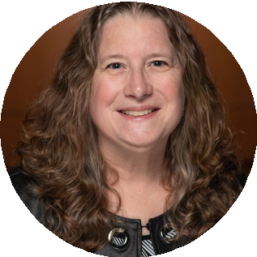





Faculty News (continued)

Dr. Lorraine Guth (she/her/hers)
Dr. Guth is celebrating her 25th year in the IUP Counseling Department. She was honored to receive the 2022 IUP Distinguished Faculty Award for Research. She has made significant scholarly contributions that include co-authoring the article “Perceived impact of Hurricane Maria on students and educators in Puerto Rico” that was published in the Centro Journal (2021). She also published, “Animal-assisted counseling for young children: Evidence base, best practices, and future prospects” in the Early Childhood Education Journal (2022).

Dr. Guth along with current students Megan Homer, Justin McDonald, Katrina McAninch, and Moirin Reynolds delivered presentations at the North Atlantic Regional Association for Counselor Education and Supervision Conference in Pittsburgh, PA. The presentation topics were “Counselor educator's guide to sex positivity” and “Building bridges between supervision and mentoring in a basic skills course.” She also has an upcoming presentation at the 2023 American Counseling Association Conference in Toronto, Ontario.

Dr. Guth is now serving as the Past President of the Association for Specialists in Group Work (ASGW). She has been the host for several ASGW podcasts with group work leaders that can be accessed at https://anchor.fm/marty-jencius3. She is also the co-chair of the IUP University Senate Research Committee.

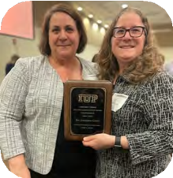
Dr. Guth's two children are attending IUP as undergraduate students and plan to graduate in May. In her spare time, she likes to be a background actor for productions that are filmed in Pittsburgh. Dr. Guth also loves spending time with her family and two dogs.

Congratulations to Dr. Guth, pictured here with IUP Provost Lara Luetkehans, for being awarded the 2022 IUP Distinguished Faculty Award for Research

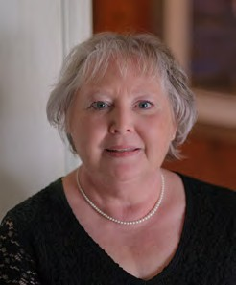
Faculty News (continued)

Dr. Nadene L'Amoreaux (she/her/hers)
Dr. L’Amoreaux is in her 24th year as a Department of Counseling faculty member. She recently co-presented with Amy Siler, CES doctoral student at the NARACES conference in Pittsburgh. Their presentation, entitled “Welcoming Generation Z Students and Intergenerational Considerations for Counselor Educators”, focused on the different experiences, world views and expectations that generational cohorts bring to counseling graduate programs.
She is also continuing her sabbatical research on the topic of hoarding as a symptom of unresolved grief.

In addition to teaching and conducting research, Dr. L’Amoreaux serves the profession as a CACREP site team leader and member, which is an important step in the accreditation process for counseling training programs. She has a private counseling practice in addition to her IUP position.

In her personal life, Dr. L’Amoreaux lives with her husband and three cats (Willow, Romeo and Frankie). Her daughters are IUP students. Emma graduates in May with two degrees-Environmental Engineering and Biology with an Ecology focus. She is in the process of applying to graduate programs (yikes!). Callie is a sophomore/junior majoring in Anthropology and Political Science. In December, Dr. L’Amoreaux and her husband are taking their first vacation (without kids in 21 years!) to the Southern Caribbean. She’s trying to talk her husband into ziplining on the cruise ship, but so far no luck. In her free time, Dr. L’Amoreaux enjoys gardening, cooking, reading and trying to learn how to play the ukulele.
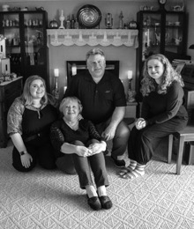
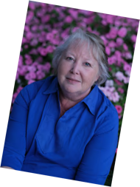
Callie (L) & Emma (R)

Dr. L'Amoreaux and her family
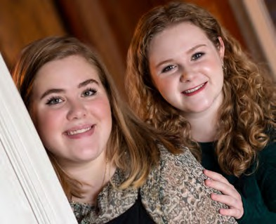

Faculty News (continued)

Dr. Matthew Nice
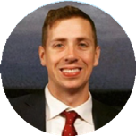
Dr. Nice is in his third year in the Department of Counseling at IUP. He is the Chapter Faculty Advisor of IUP's Chi Sigma Iota, Iota Upsilon Pi Chapter honor society. He is very excited to work with the CSI leadership to bring the 11th Annual Chi Sigma Iota Pennsylvania Statewide Conference to IUP this Spring. He has had a productive semester presenting at AARC in St. Louis, MO, PCA and NARACES in Pittsburgh, and the European Branch of ACA conference in Athens, Greece.
Dr. Nice is also the current Pennsylvania Counseling Association President, and is actively working to promote the Counseling Compact to give all professional counselors reciprocity across state lines with their licensure. He has published five peer-reviewed articles this past year, and has several out for review. Dr. Nice is extremely excited to teach Assessment, Diagnosis, and Doc Research Methods this upcoming Spring 2023 semester.

This past year, he has been humbled with several awards, including his undergraduate alma mater's (King's College) 2022 Leo Award, which is awarded to an outstanding alumni graduated from the university in the past 15 years and his Masters alma mater's (Marywood University) 2022 Outstanding Recent Alumni Award, also awarded to an alumni of the university graduated in the past 15 years. In the profession, he was also honored with the 2022 NARACES New Professional Award, and the Pennsylvania School Counseling Association's (PSCA) 2022 Counselor Educator of the Year award.

Although he lives alone in his apartment in Shadyside and doesn't have any fun family updates like his colleagues, he did have fun this past summer traveling to visit friends and completed the Palmerton Spartan Obstacle Race in July, ranked the 4th most difficult Spartan Obstacle Race in the country. Also, Dr. Nice finally got a girlfriend this past year.


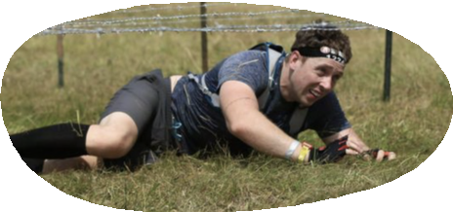
Looking forward to a exciting Spring 2023 semester with you all!
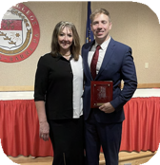
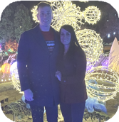
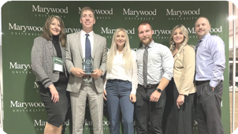
From left: Dr. Nice and his mom, Lorraine, as he receives the 2022 Leo Award for Outstanding Recent Alumni; Dr. Nice and his new partner; Dr. Nice and his family receiving the Marywood Outstanding Recent Alumni Award; participating in a Spartan Obstacle Race

Faculty News (continued)

Dr. Brittany-Pollard Kosidowski (she/her/hers)

Dr. PK can’t believe she’s in Year 8 as a member of IUP’s Counseling faculty, but she’s still looking forward to coming to work every single day! She’s stayed busy this past year with teaching responsibilities, admissions work, and keeping up with her small army of dedicated GAs and FWS students. She’s also remained active in professional organizations, co-presenting with master’s and doctoral students at the ASGW, ACA, CSI, PCA, and NARACES conferences in 2022. She’s looking ahead to the ACA and CSI conferences coming up this spring, as well as the one-day social justice conference she’s coordinating with Dr. Branthoover, Dr. Desmond, and several current doc students.
Dr. PK has stayed engaged in the Association for Specialists in Group Work (ASGW), serving as this year’s Strategic Communications Committee Chair and President of its state branch, PASGW. She’s also got three manuscripts currently under review for publication and another three in the works. Most recently, she went up for promotion to Full professor and is anxiously awaiting the outcome of her application.

On a personal note, Dr. PK’s nephew, Michael, is now 15 and keeps her on her toes daily. She and her husband, Tom, are looking to move to the country within the next year and can’t wait to enjoy fresh air, no noise, and beautiful scenery! Most importantly, Dr. PK looks forward to welcoming a furry new family member to enjoy the new house with. Stay tuned…

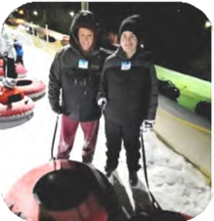
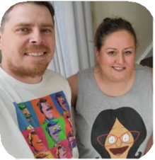
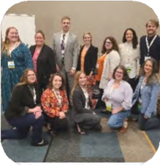

Dr. PK and her nephew Dr. PK and her husband,
Tom
Dr. PK with counseling students and faculty at PCA



Dr. Sibyl West

Faculty News (continued)
Dr. West is in her 13th year as a member of the Department of Counseling faculty. Most recently, she partnered with IUP alumni, Andrea (Stewart) Szolna, on a book chapter about incorporating diversity and multiculturalism in research methods, which should come out in 2023.

Dr. West was selected to be part of the President's Commission on Diversity, Equity, and Inclusion, a committee which focuses on elevating diversity, equity, and inclusion efforts at IUP. She will also be participating in a winter teaching academy, which will focus on incorporating more DEI instructional strategies in the classroom.


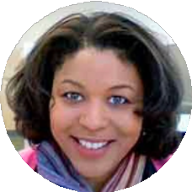

Dr. West continues to collaborate with Ruling our Experiences (ROX), a national organization which provides innovative evidence-based programming, large-scale national research on girls' issues, and training and professional development to educators across the country. In this role, she assists with diversity-related national research and training on issues impacting girls.

As has already been shared earlier this semester, Dr. West and her husband welcomed their son, Neo Zane into the world in September. He is two months old now and loves to make clean diapers dirty and coo along with Mariah Carey's Christmas album. He's truly been a miracle and a blessing.


Dr. West and her family are looking forward to a relaxing winter break.

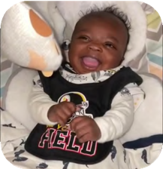
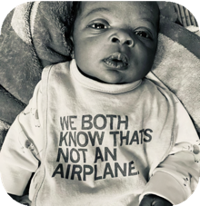
Baby Neo Zane!


Counselors in Action
Special Section
14
Welcome to a special section about how counseling students and educators are getting involved in advocacy, movements for social justice, and helping others in their communities.

Legislative Updates
Mental Health Access Improvement Act
For the first time in over a decade, the U.S. House of Representatives and the U.S. Senate are seriously considering passing the Mental Health Access Improvement Act (H.R. 432/ S. 828). This bill would close the gap in federal law that prevents mental health counselors from being recognized as Medicare providers.
- TAKE ACTION: Visit the American Counseling Association's Government Affairs page to send a message to your legislators.

Counseling Compact
The Counseling Compact is an interstate compact, or a contract among states, allowing professional counselors licensed and residing in a compact member state to practice in other compact member states without the need for multiple licenses. The Pennsylvania House and Senate currently have bills in committee.

- LEARN MORE: Check out the Compact map and sign up for updates at counselingcompact.org. The ACA is also sharing legislative updates at counseling.org
Ban Conversion Therapy
In August, Gov. Wolf signed an executive order to protect LGBTQIA+ Pennsylvanians from conversion therapy. This is a step in the right direction but there is more work to do.
- TAKE ACTION: Contact your state legislators to ban conversion therapy across the state. Learn more about the Pennsylvania Counseling Association's statewide advocacy efforts at pacounseling.org.


SAIGE - Society for Sexual, Affectional, Intersex, and Gender Expansive Identities SAIGE, a division of the ACA, has several educational and policy initiatives on issues like police brutality and systemic racism, anti-trans legislation, gender identity and expression, and more.
- LEARN MORE: Get involved in advocacy efforts at saigecounseling.org

ACA Divisions
ACA has 19 chartered divisions that provide leadership, resources and information unique to specialized areas and/or principles of counseling. Learn more about divisions like the Association for Child and Adolescent Counseling, Counselors for Social Justice, and more at counseling.org.



Counselors in Action (continued)
Special Section
15

Ask the Professors: Advocacy

Dr. Guth: I led a team that created a timely ASGW document titled, Ten Strategies to Intentionally Use Group Work to Transform Hate, Facilitate Courageous Conversations, and Enhance Community Building.
This document is available in English and Spanish at https://asgw.org/resources/#tab-guidinggroupworkdocuments. Locally, I am part of a sex therapy supervision group at CALM Pittsburgh where we promote sex positivity through advocacy and conference presentations.

Dr. Carone: I am on the Advisory Board of the Family Outreach program at the Armstrong Indiana Intermediate Unit---I help them brainstorm resources and also ideas for collaboration with IUP's Department of Counseling.
How do you get involved in advocacy?

In the past, I've been on several advisory boards, including the North Carolina Mental Health Association, Indiana County School Counselor Advisory Board; and the Christian Home in Johnstown. These experiences allowed me to advocate for children, families, and recipients of mental health services while connecting with other community professionals.

I also do personal advocacy for my 93 year old father. We struggle to navigate the health care system and coordination of care. I contact his various physician offices to help with coordination services that would have fallen through the cracks. I alert such offices about discrepancies or omissions that could cause my dad and other patients to miss medication, appointments, and services. I also alert medical offices to read depression, anxiety, and other screenings to patients who have hearing loss or difficulty writing rather than giving screenings to patients to complete as part of their administrative paperwork.

Dr. PK: I engage in a good deal of scholarship focused on advocacy. I’m currently working on a manuscript about leadership and advocacy training in Counselor Education and Supervision. I present regularly on decolonization and other advocacy-adjacent issues with students. I co-facilitate IUP’s chapter of Counselors for Social Justice with Dr. West.

And I have developed two new relevant electives recently: Social Justice Advocacy in Counseling and Multicultural and Social Justice Theory Applications.

(continued on next page)


Counselors in Action (continued)
Special Section
16
Dr. PK (continued): In recent years, I have been involved with the Association for Specialists in Group Work (ASGW) as co-chair of the Special Initiatives Committee and now chair of Strategic Communications. Through the SIC, I was involved in service-based advocacy with JASMYN, an LGBTQ+ service organization in Jacksonville, FL. We designed a day of group work training for their providers and facilitated it last year during our conference in FL. I continue to be involved as a member of the SIC.

As current President of the PA division of ASGW (PASGW), we work to provide a free monthly webinar series that routinely addresses social justice issues and the responsibilities of practitioners to engage clients/students in self-advocacy initiatives. We also facilitated a panel discussion at this year’s PCA conference about empowering clients and students to engage in advocacy through group work.


IUP in Action
Learn about how some IUP counseling students, alumni, and faculty help others in their communities and work in movements for social justice.

Ellen Giarusso, master's alum: My family has been involved with The Education Partnership for years. My husband chaired their board, and all of my kids and I have been regular volunteers. It is a fabulous organization that supports Title 1 public schools with basic school supplies. It can be a really valuable resource for school counselors working in underserved communities.

Courtney Milstead, master's student: I have volunteered with the Emma Munson Foundation, an organization dedicated to a student of mine, Emma Munson, in loving memory. Her parents, Denise and Mike, have made it a mission to make the world a better place through beach clean-up, tree planting, Halloween costume giveaways across the Pittsburgh neighborhoods, and much more!

Dr. Desmond: I see pro bono clients through my private practice.


Sarah Tucker (Tucker), master's student: I am a union member, organizing committee member, and regional action team leader at my Starbucks store where I am a manager. My coworkers and I are volunteering our time to help make life better and easier for workers all across the country by fighting for our right to a union.

Laura Phillips, master's student: I volunteer with the National Crisis Text line, as well as with the National S.E.E.D. Project leading workshops on equity and diversity in the educational environment.

(continued on next page)


Counselors in Action (continued)
Special Section
17

IUP in Action (continued)
Kadidja Macina, master's student: October was Domestic Violence Awareness Month. During this month, Crisis Center North Holds its annual awareness event called Hearing the Whispers and Roars. The event is a gallery night located at the North Hills Art Center. The goal is to showcase artwork done by survivors of DV and show how art can heal.

Dr. Carone: Lobbying that involved making calls, writing letters, and meeting state legislators at the capitol in North Carolina to keep a master's of rehabilitation counseling program at the University of North Carolina at Chapel Hill from being closed. The program is now thriving as it was supported by the legislators, and it now has tracks for mental health and counseling persons with developmental disabilities. I was working in the counseling program at the time I did the lobbying and it should be noted that any lobbying can NOT be done on days one is being paid for a state job. My colleagues and I took formal vacation days from our jobs to lobby for the program.

Rachel Dingfelder, master's student: I volunteer on a crisis line, providing support to individuals who have been impacted by sexual violence.

Katie Shaw, master's student: Katie is the President of the Women's Club of Mt. Lebanon, a group that offers service and volunteer activities for its members, as well as raises money for nonprofits in the south hills and greater Pittsburgh area. She has worked with Foster Love Project, Connecting Champions, PAAR, The Women's Center and Shelter of Greater Pittsburgh, Boys and Girls Club of Western PA, and the Alexis Joy Foundation among other worthy organizations.

Dr. Guth: Most recently, I was part of the ASGW Day of Service initiative in Jacksonville, Florida where we partnered with JASMYN. This organization supports the empowerment of LGBTQIA+ young people through leadership, advocacy, resources, and a safe and affirming community. Previously, I engaged in service activities in Puerto Rico to help with rebuilding efforts after Hurricane Maria.



These are just some of the ways IUP counseling students, alumni, and faculty get involved in their communities.
The department recognizes the many ways that you make a positive impact on your community.


18

Conference Spotlight - PCA

PCA Conference
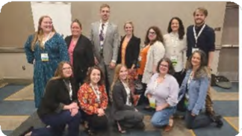
The Pennsylvania Counseling Association (PCA) welcomed counselors, educators, and students for its 54th annual conference held October 14-16, 2022 in Pittsburgh.
Congratulations to all IUP Counseling students, faculty, and alumni who attended, presented, and/or volunteered!

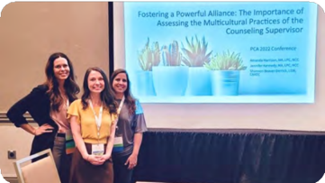
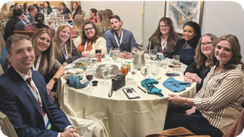
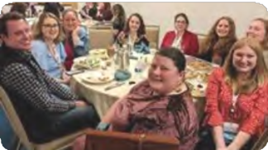
Dr. Matthew Nice, IUP Counseling faculty and current PCA President, pulled off a tremendously successful conference event, with a record-breaking 300+ attendees! Dr. Holly Branthoover planned a dinner for IUP Counseling faculty, doctoral alumni, and current doctoral students, with 25+ attending this special event. It was a great weekend to reconnect! Stay tuned for information about next year’s conference.

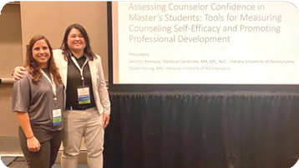
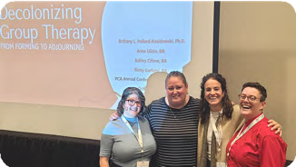
Presenter photos (from top left to bottom right): Amanda Harrison, Shannon Beaver-Derrick, Jennifer Kennedy, Quyen Vuong, Ashley Cifone, Dr. PK, Anne Ulizio, Remy Garland

CSI Conference

Conference Spotlight - CSI

Chi Sigma Iota (CSI), the counseling academic and professional honor society international, hosted its 10th annual Pennsylvania statewide conference on April 23, 2022 at Villanova University.
Congratulations to all IUP Counseling students, faculty, and alumni who presented. IUP doctoral students and faculty also presented at the pre-conference event sponsored by the Pennsylvania Association for Counselor Education and Supervision (PACES). IUP was so well-represented!
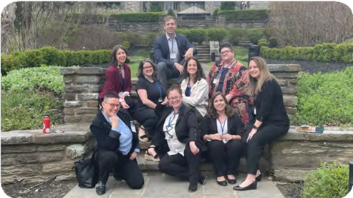

From top left: Rachel Dingfelder, Ashley Cifone, Dr. Nice, Anne Ulizio, Chris Burd, Remy Garland, Rachel Rectenwald,
Jennifer Wilde
IUP will host the next CSI conference at the Kovalchick Center on April 22, 2023.

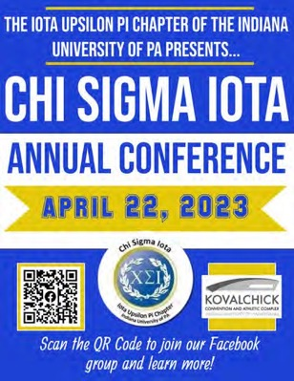
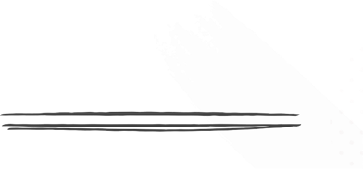
There will be opportunities for students to present!

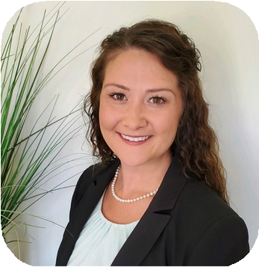
Dissertation Defenses
Congratulations to the doctoral students who successfully defended their dissertations this year!

Dr. Monica Kaule
Dissertation: “Professional Identity Development Among First-Year Doctoral Students in Counselor Education and Supervision: A Qualitative Investigation”
“The dissertation process was an incredibly challenging and demanding process that took significant self-dedication and time management. However, successfully defending with the support of my chair, committee, friends and family was a monumental moment that I would not trade for anything."


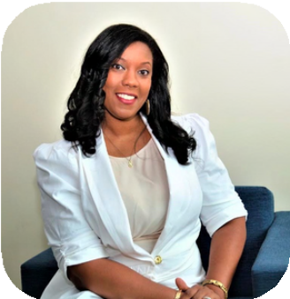
Dr. Shala Darwin-Howard
Dissertation: “School Counselors’ Experiences with Supervision: Exploring Perceptions of Professional Identity, Self-Efficacy, and Professional Competence”
"After successfully defending my dissertation, I experienced a multitude of feelings (i.e. relief, elation, anxious). More so
than anything, I was overwhelmed with humility. I am incredibly proud to finally be introduced as Dr. Darwin- Howard."

Dr. Jessica Cosby
Dissertation: “Preparation for Counseling Children with Adverse Childhood Experiences in CACREP Clinical Mental Health Counseling Programs: A Qualitative Study”
“Successfully defending my dissertation was gratifying. It was also somewhat surreal. Since everything moved to Zoom in my second semester, it was my last and final visit to the doctoral classroom. Lastly, it was exciting to reconnect with my committee members in person after two years.”

(continued on next page)


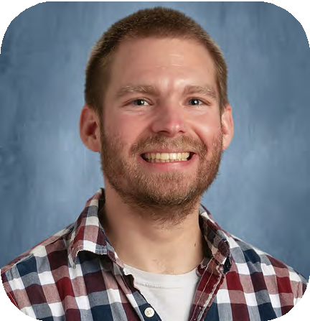
Dissertation Defenses (continued)

Dr. Kyle Bellinger
Dissertation: “The Implementation Of A Gestalt Therapy Play Group In A Rural School And The Percevied Effect On Student Emotional Regulation”
“Defending the dissertation was not as anxiety provoking as I thought it would be. By the time the defense came, I felt confident and knew my topic extremely well. Looking back on the process now that it’s over, I realize the hard work was done in all of the steps leading up to the defense. It doesn’t get old being called Dr. Bellinger either!”

Dr. Heather Uphold
Dissertation: "Adventure-Based Counseling with Combat Veterans: Experiences, Perceptions, and Its Impact on Mental Health Symptomology”
“I have long held onto this goal since I was 18 years old. On the day of the defense, my heart did a double flip, my eyes got teary, my body sagged for a brief moment, and I breathed a sigh of relief. My work was finally done. I could finally rest. It took four years, but it was worth it all, both the good and the bad.”

Dr. Samantha Baillie
Dissertation: “A Qualitative Study of Retention and the Lived Experiences of Female Student-Mothers in CACREP Accredited Clinical Mental Health Counseling Programs”
"It is absolutely okay to want to quit your dissertation as many times as you need. This process pushes many of us to the brink of what we think we can manage. More than anything, I have realized I absolutely got in my own way throughout the dissertation process. Wanting things to move faster, to have less edits, wishing I didn't have so many other responsibilities all impacted my ability to stay focused. Through it all, I have learned my ability to push through difficult things is much stronger than I realized."

Dr. Stephanie Vitolo Keane
Dissertation: “The Impact of Social Media Use on State Self-Esteem and Differences Between Gender Identities”

