Central Storeroom
Robertshaw Building
650 South Thirteenth Street Indiana, PA 15705
Phone: 724-357-4074
Fax: 724-357-2515

Receiving – View Delivery Confirmation and Notes from material document

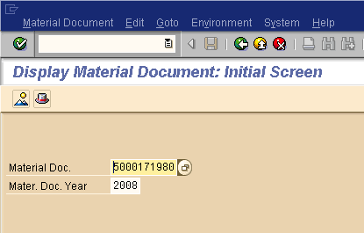
Display Material Document
SAP Transaction MB03
Enter the material document number from the top of the goods receipt (material document)
5000xxxxxx
Hit Enter or Click green circle with check

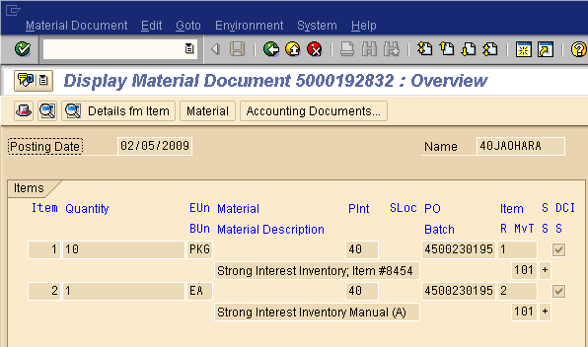
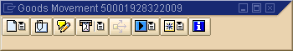
You will now see the items received by this material document (as a display)
Click the document overview icon Pop-up window will appear

Click on attachment list
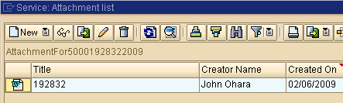
A window will appear showing all documents available
Double Click on the document you want to view

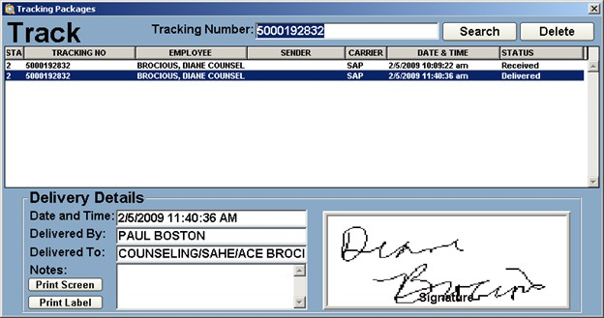
A windows document will appear showing you:
When the item was receiving at Shipping & Receiving
Date and Time delivered to department Delivered by: Driver
Delivered to: Address (unless otherwise noted)
Signed for by: Actual signature of department recipient

