Central Storeroom / Shipping and Receiving
Robertshaw Building
650 South Thirteenth Street
Indiana, PA 15705
Phone: 724-357-4074
Fax: 724-357-2515

Receiving – View Delivery Confirmation and Notes on a Purchase Order

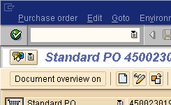
SAP Transaction ME23n (view a standard purchase order)
Choose Purchase Order
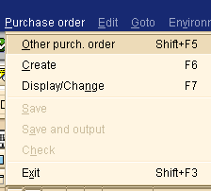
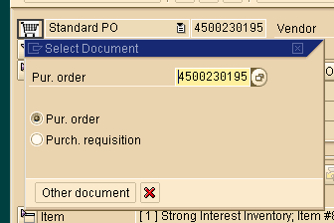

You will see a window
Choose Other purch. Order

Insert the Purchase Order Number
Hit Enter

You will now see the SAP Purchase Order
The Purchase order history tab will show items that have been received
You can scroll down through the items on the PO using the arrows
To view misc. notes concerning the PO; click on the overview icon; a pop-up will appear
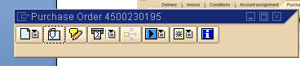
Click on Attachment List Icon
A list of available documents will appear; such as packing slip, delivery slip, invoice, notes, etc.

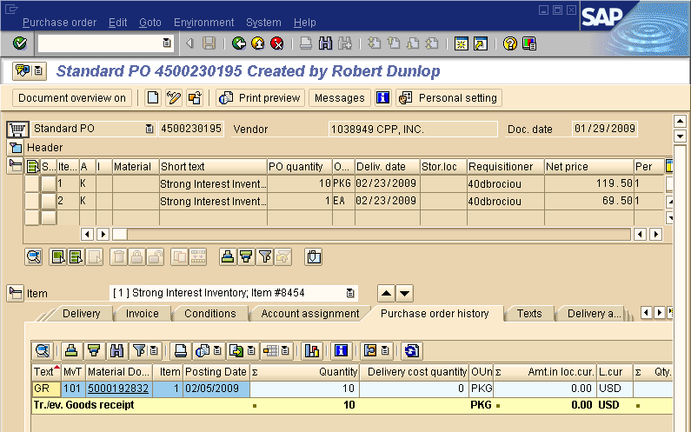

To view Material Document information; such as delivery acknowledgement Click on the Material Document
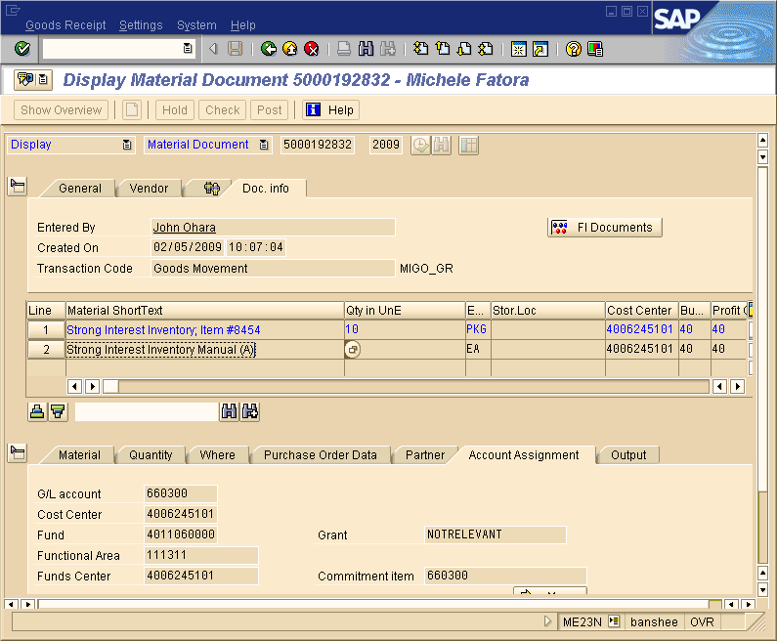
The Goods Receipt Material Document will now appear
click on the overview icon; a pop-up will appear
Click on Attachment List Icon
A list of available documents will appear;
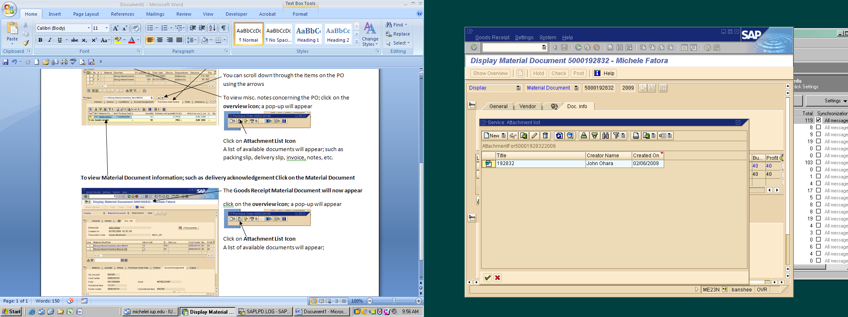
Double Click on the item you wish to view

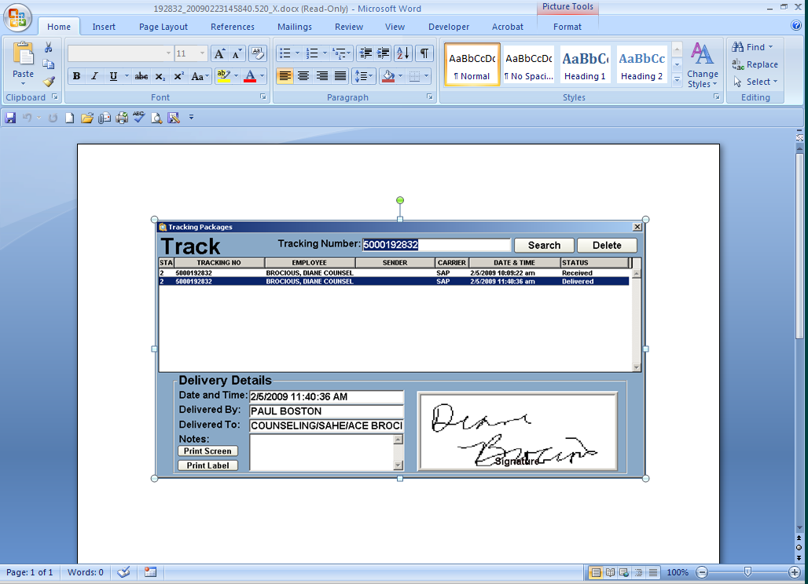
A word document will now appear that contains the delivery information
When it was receiving at Shipping and Receiving
Date/Time delivered to department
Delivered by: Driver
Delivered to: Address (unless otherwise noted)
Signed for by: Actual signature of department recipient

