Central Storeroom
Robertshaw Building
650 South Thirteenth Street
Indiana, PA 15705
Phone: 724-357-4074
Fax: 724-357-2515
Storeroom – Display a Goods Issue Material Document
(Storeroom Reservation document)

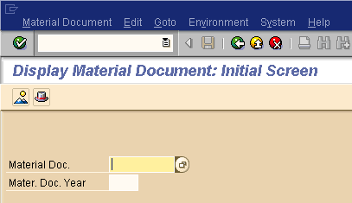
Display Material Document
SAP Transaction MB03
Enter the material document number from the top of you goods issues (material document)
4900xxxxxx
Hit Enter or Click green circle with check

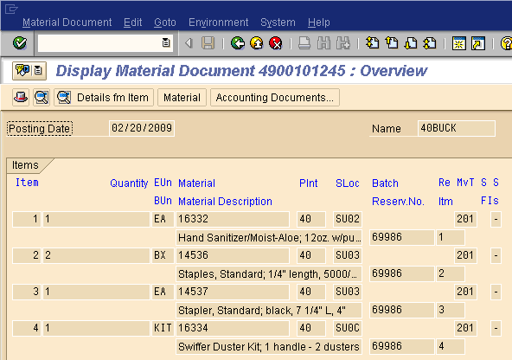

You will now see the items you ordered (as a display)

Place your cursor on one of the materials

To see what has actually been delivered
Click on Environment
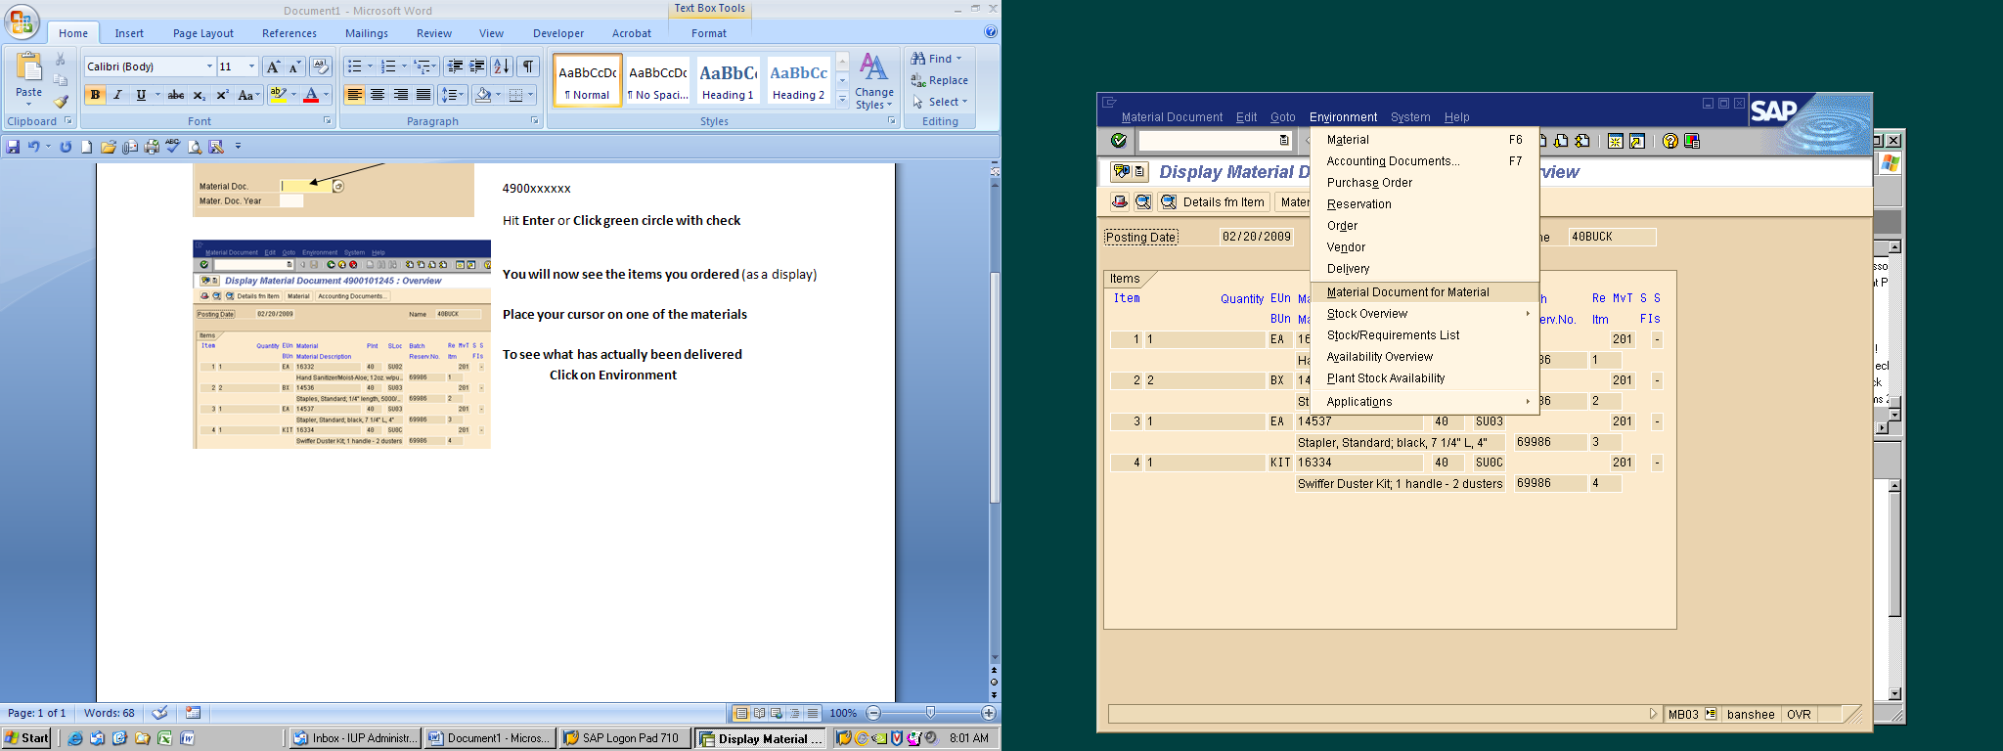

Choose Material Document for Material
You can also go straight to the accounting document from this point

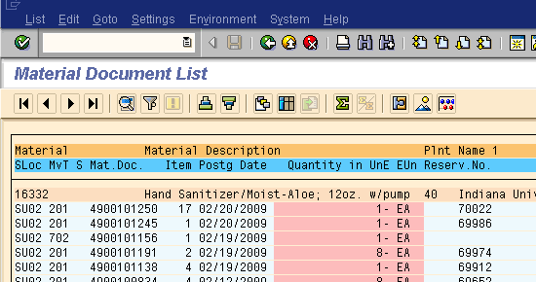
You will now see a history list for the material you chose from your reservation
Find Your Reservation
Double Click on the Material Document (Mat.Doc.) that is in line with your reservation number
Your Goods Issue Material Document is now displayed
Any material on this form has been issued on SAP and you should have received or will be receiving.
It will show:
Who in the storeroom issued the res.
When it was issued
What items were issued (you can scroll down for more materials
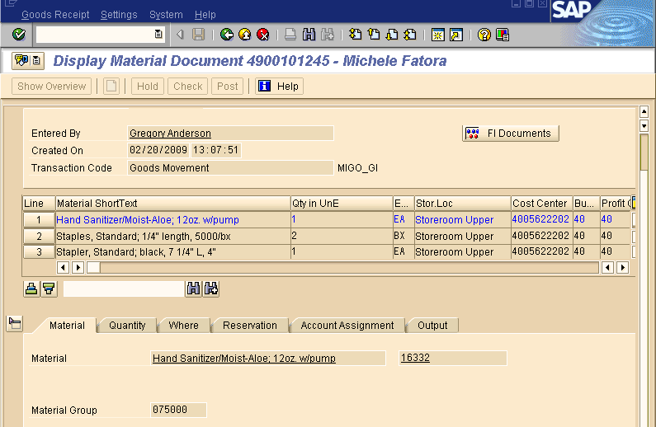2/23/09

