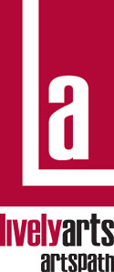
ArtsPath
Arts-In-Education Program

Observation of Artist Evaluation Form

HOST SITE NAME: ___________________________________________________________________

TEACHER(S): ________________________________________________________________________

SITE TYPE: ____HIGH SCHOOL ____JR HIGH SCHOOL ____MIDDLE ____ELEM _____OTHER

PATICIPANT’S GRADE/AGE: ________________________ COUNTY: ________________________

ARTIST: ____________________________________________________________________________

DATE of OBSERVATION: _______________ RESIDENCY DATES: __________________________

Please circle the number that best expresses your reaction:

Lowest Highest Comments

1. | Overall artist rating | 1 | 2 | 3 | 4 | N/A
2. | Artistic quality of project | 1 | 2 | 3 | 4 | N/A
3. | Communication skills | 1 | 2 | 3 | 4 | N/A
4. | Modeling (dress, language,  deportment, friendliness) | 1 | 2 | 3 | 4 | N/A
5. | Evidence of preparation | 1 | 2 | 3 | 4 | N/A
6. | Schedule of events | 1 | 2 | 3 | 4 | N/A
7. | Organization of core groups | 1 | 2 | 3 | 4 | N/A
8. | Content | 1 | 2 | 3 | 4 | N/A
9. | Pace | 1 | 2 | 3 | 4 | N/A
10. | Age-appropriateness | 1 | 2 | 3 | 4 | N/A
11. | Students directly involved in  creative process (hands-on) | 1 | 2 | 3 | 4 | N/A
12. | Audience reaction | 1 | 2 | 3 | 4 | N/A

Lowest Highest Comments

13. | Environment conducive  to art education | 1 | 2 | 3 | 4 | N/A
14. | Availability of resources  (classroom/artist materials) | 1 | 2 | 3 | 4 | N/A
15. | Staff relationships | 1 | 2 | 3 | 4 | N/A
16. | Evidence of artists work displayed | 1 | 2 | 3 | 4 | N/A
17. | Evidence of cross-curricular  activity/learning | 1 | 2 | 3 | 4 | N/A
18. | Discipline specific language | 1 | 2 | 3 | 4 | N/A

ADDITIONAL COMMENTS:

Name of person completing form Title Phone Number Date

Please return this form to: Jeff Wacker Wacker, Associate Director, Lively Arts | ArtsPath
Indiana University of Pennsylvania  202 Performing Arts Center  403 S. 11th St. Indiana, PA 15705-1008
Phone 724-357-2787 (ARTS)  Fax 724-357-7899

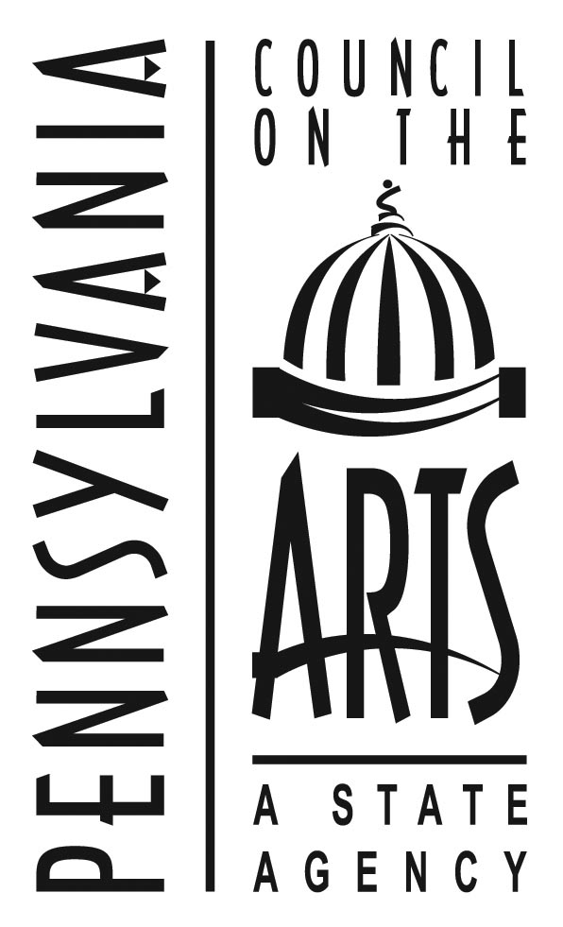
This project was made possible through the AIE Partnership of the Pennsylvania Council on the Arts, a state agency. It is funded by the citizens of Pennsylvania through an annual legislative appropriation and administered locally by ArtsPath through the college of Fine Arts at Indiana University of Pennsylvania. The Pennsylvania Council on the Arts is additionally supported by the national Endowment for the Arts, a federal agency.

