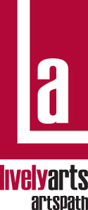
ArtsPath

Arts-in-Education Program

Artist’s Post Residency Evaluation Form

To be completed by artist(s)s immediately following the residency,
and REQUIRED in order to ensure proper payment.

HOST SITE NAME: ___________________________________________________________________

TEACHER(S): ________________________________________________________________________

SITE TYPE: ____HIGH SCHOOL ____JR HIGH SCHOOL ____MIDDLE ____ELEM ____OTHER

PARTICIPANT’S GRADE/AGE: _______________ RESIDENCY DATES: ______________________

NAME OF COMPANY, ARTIST(S), OR ENSEMBLE: _______________________________________

DISCIPLINE / ART FORM: _____________________________________________________________

Please circle the number that best expresses your reaction:

Lowest Highest Comments

1. | Overall residency rating | 1 | 2 | 3 | 4 | N/A
2. | Goals were met | 1 | 2 | 3 | 4 | N/A
3. | Residency planning process | 1 | 2 | 3 | 4 | N/A
4. | Schedule of events | 1 | 2 | 3 | 4 | N/A
5. | Length of residency | 1 | 2 | 3 | 4 | N/A
6. | Students directly involved in  creative process (hands on) | 1 | 2 | 3 | 4 | N/A
7. | Organization of core group(s) | 1 | 2 | 3 | 4 | N/A
8. | Age-appropriateness | 1 | 2 | 3 | 4 | N/A
9. | Support of academic standards | 1 | 2 | 3 | 4 | N/A
10. | Environment conducive  to art education | 1 | 2 | 3 | 4 | N/A
11. | Availability of resources  (classroom/artist materials) | 1 | 2 | 3 | 4 | N/A

Please respond to the following:

- How did the residency planning form assist you?

- If culturally specific, what art forms were presented?

- Were teacher, parents and/or the community involved? How?

- What were the most useful things you learned?

- What focus will future residencies include?

- If you were to repeat this residency, what would you do differently?

Please provide the following numerical information:

Total number of students benefiting ___ Number of Minority ___ Number of Disabled ___
Total number of core students benefiting ___ Number of Minority ___ Number of Disabled ___
Total number of teachers benefiting ___ Number of Minority ___ Number of Disabled ___

Total hours spent in: _____ Residency Preparation _____Core Student Teaching _____ At Host School

When returning the form to ArtsPath, please include any publicity,
examples of student work, slides, and/or photos of this residency.

_____________________________________________________________________________________
Artist Name Phone number Date

Please return this form to: Jeff Wacker, Associate Director, Lively Arts |ArtsPath
Indiana University of Pennsylvania  202 Performing Arts Center  403 S. 11th St.  Indiana, PA 15705-1008
Phone 724-357-2787 (ARTS)  Fax 724-357-7899

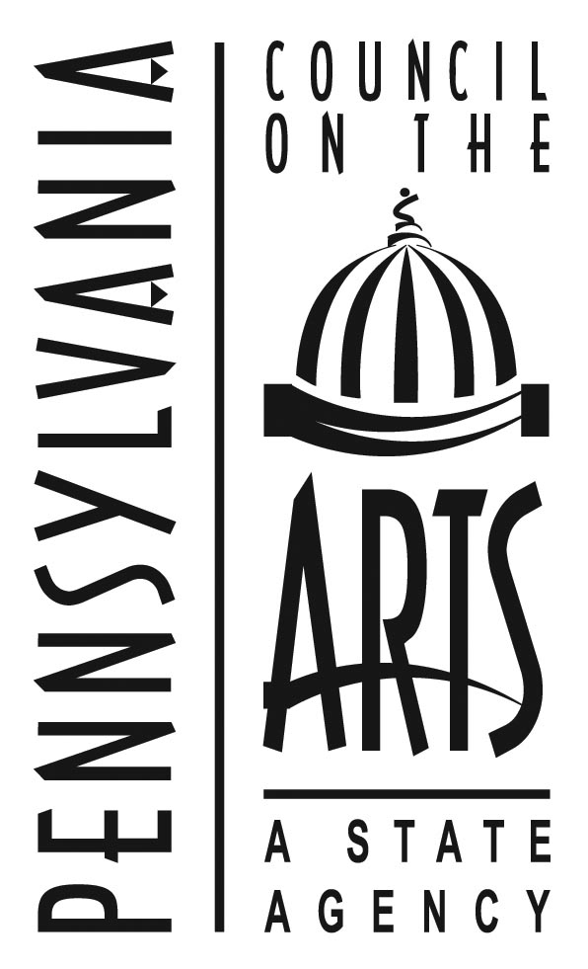
This project was made possible through the AIE Partnership of the Pennsylvania Council on the Arts, a state agency. It is funded by the citizens of Pennsylvania through an annual legislative appropriation and administered locally by ArtsPath through the college of Fine Arts at Indiana University of Pennsylvania. The Pennsylvania Council on the Arts is additionally supported by the national Endowment for the Arts, a federal agency.

