

Allied and Public Health Department
FOOD AND NUTRITION PROGRAM

Undergraduate Student handbook

2025 - 2026

Visit: https://www.iup.edu/alliedpublichealth/faculty/index.html
Call: 724-357-4440

Email: allied-publichealth@iup.edu
Office: 102 Ackerman Hall

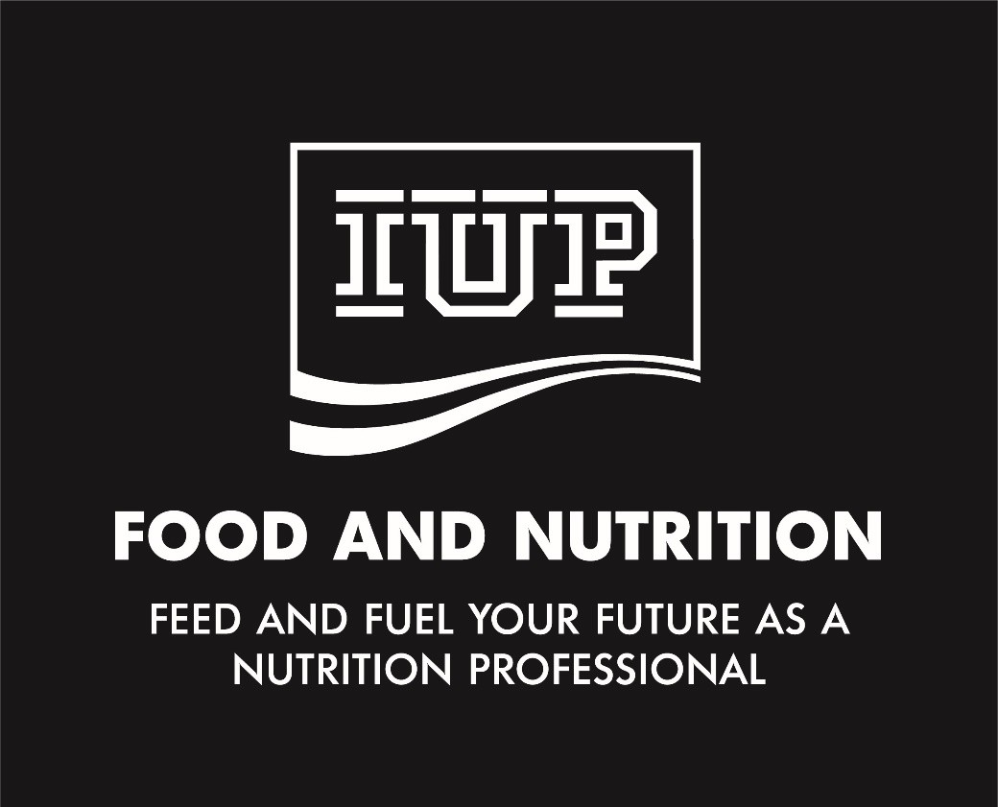

Name:

Academic Advisor: Email:
Office Location:

(Each student is provided one copy. A nominal fee of $5 will be charged for a replacement.)

Contents
Purpose of the Undergraduate Handbook¹ 9
IUP Civility Statement 9
Department Mission, Vision and Values 10
Department overview 11
Faculty and Staff 11
Graduates of a Bachelor of Science in Nutrition: 14
What Career Opportunities are available to students who earn a Bachelor of Science in Nutrition? 14
What if a Student would like to Combine Nutrition with other Career Goals? 15
Majors and Minors that Complement Nutrition 16
Dietetics Track 16
Mission of the Dietetics Track 16
Program Goals and Outcomes of the Dietetics Program: 18
Dietetics Track Curriculum Sheet (revised June 2023) 21
Academic Progression and Graduation Policy: Dietetics Program 19
Admission requirements for the Dietetics track 21
Remediation Statement 21
Formal Assessment of Students Learning and Progress 22
Nutrition Track Error! Bookmark not defined.
Mission of Nutrition Track Error! Bookmark not defined.
Program Goals and Outcomes of the Nutrition Track 24
Nutrition Track Curriculum 25
Academic progression and graduation policy: Nutrition track 29
Liberal Studies Error! Bookmark not defined.
Minors – Certificates – Elective Courses – Second Majors 30
Preparing for Graduation 32
Introduction 32
Graduation Requirements 34
University Policies and Procedures 34
Academic Calendar 34
Academic and Scheduling policy 35
Academic Standards 35
Career and Professional Development Center 35
Disciplinary Procedures and Academic Integrity University 35
Financial Aid 35
Email Contact 35
Internship Approval for Undergraduate Students Error! Bookmark not defined.
Leaves of absence 35
Library Services 35
Maximum time Allowed to Earn a Degree 35
Diversity, Inclusion, and Equity: Title IX and Sexual Misconduct, and Preferred First Name Policies 36
Refund Policy 36
Retention and Remediation of Students 36
Student Rights, Freedoms, and Responsibilities 36
Student Rights Under the Family Education Rights and Privacy (FERPA) 36
Student Programs and Services 36
Student Protection of Privacy and Access to Personal Files 37
Student Technology Services and Policies 37
Tutorial Support 37
Undergraduate Catalog 37
University Policies and Procedures 38
Withdrawal policies 38
Department Policies 38
Advising 38
Evaluation of prior education or experience 38
Food laboratories 38
Dress Code 38
Laboratory Participation and Tasting Policies 39
Possible costs in addition to tuition and fees for nutrition majors 39
Student Association of Nutrition and Dietetics (SAND) 41
Additional Resources for Students 42
Your Advisor 42
Food and Nutrition Department Office Error! Bookmark not defined.
Dean’s Associate for Academic Affairs 43
The Dean of the College of Health and Human Services 44
Office of the Student Advocate – Academic Success Center (ASC@IUP) 44
Dietetics Track: Additional Information 45
Information for Students in the Dietetics Track 45
Accreditation Council for Education in Nutrition and Dietetics 45
Verification Statements 45
Complaints Related to the DPD Program 46
Complaints Relative to Program Compliance 47
Department Undergraduate Dietetics Program Director 47
Academy of Nutrition and Dietetics Supervised Practice (Post Baccalaureate) 48
Code of Ethics for the Profession of Dietetics 48
Glossary of Terms 49
The Dietetics Profession 52
Career Options for students not pursuing a career as a Registered Dietitian Nutritionist (RD, RDN) 53
Frequently Asked Questions 55
APPENDICES 58
Appendix A: KRDN Student Learning Outcomes (SLO) Assessment Plan Error! Bookmark not defined.
Appendix B: Graduate Degree Registration Eligibility Requirement: FAQ’s 59
Appendix C: Routes to Meeting Eligibility Requirements for the Registration Exam for Dietitians PRIOR TO January 1, 2024 70
Appendix D: Routes to Meeting Eligibility Requirements for the Registration Exam for Dietitians AFTER January 1, 2024 71
Appendix E: What Salary Might I Expect as a Registered Dietitian?¹ 72
Appendix F: Code of Ethics for the Nutrition and Dietetics Profession 73
Appendix G: Careers in Dietetics: Becoming a Registered Dietitian Nutritionist 75
Appendix H: Careers in Dietetics: Becoming a Dietetic Technician, Registered 77
Appendix I: Dietetics Career Development Guide: Job Description for CDM’s 78
Appendix J: Discover the Power of the Credential: CDM, CFPP Error! Bookmark not defined.
Appendix K: Signature Page 79

Purpose of the Undergraduate Handbook¹

- Provide a guide to help students understand department and university procedures.
- Provide an advising tool for students to plan their curriculum and keep their academic records.
- Provide an easy-to-use guide for the most-asked questions by students in the Department of Food and Nutrition.
- Complement other tools provided to freshmen by the Department for Disability Access and Advising.
- Show how the Dietetics Track curriculum fulfills the requirements of the Accreditation Council for Education in Nutrition and Dietetics (accrediting agency for the Academy of Nutrition and Dietetics) – http://www.eatrightpro.org/acend
- List the names and credentials of Food and Nutrition Program faculty, their contact information, and interests.

IUP Civility Statement
As a university of different peoples and perspectives, IUP aspires to promote the growth of all people in their academic, professional, social, and personal lives. Students, faculty, and staff collaborate to create a community where people exchange ideas, listen to one another with consideration and respect, and are committed to fostering civility through university structures, policies, and procedures. (www.iup.edu/studentconduct/policies/iup-civility-statement/ )

We, as members of the university, strive to achieve the following individual commitments:

  - To strengthen the university for academic success, I will act honestly, take responsibility for my behavior and continuous learning, and respect the freedom of others to express their views.
  - To foster an environment for personal growth, I will honor and take care of my body, mind, and character. I will be helpful to others and respect their rights. I will discourage intolerance, hatred, and injustice, and promote constructive resolution of conflict.
  - To contribute to the future, I will strive for betterment of the community: myself, my university, the nation, and world.

1This guide does not replace any policies or procedures specified in the IUP Undergraduate Catalog www.iup.edu/registrar/catalog/ or in the IUP Student Policy Guide (The Source) available at www.iup.edu/studentconduct/thesource

Department Mission, Vision and Values

Mission statement

The Mission of the Food and Nutrition Program is to provide superior educational opportunities combining theory and practice while challenging students to achieve their goals, promote health in themselves and others, and advance the profession.

Vision

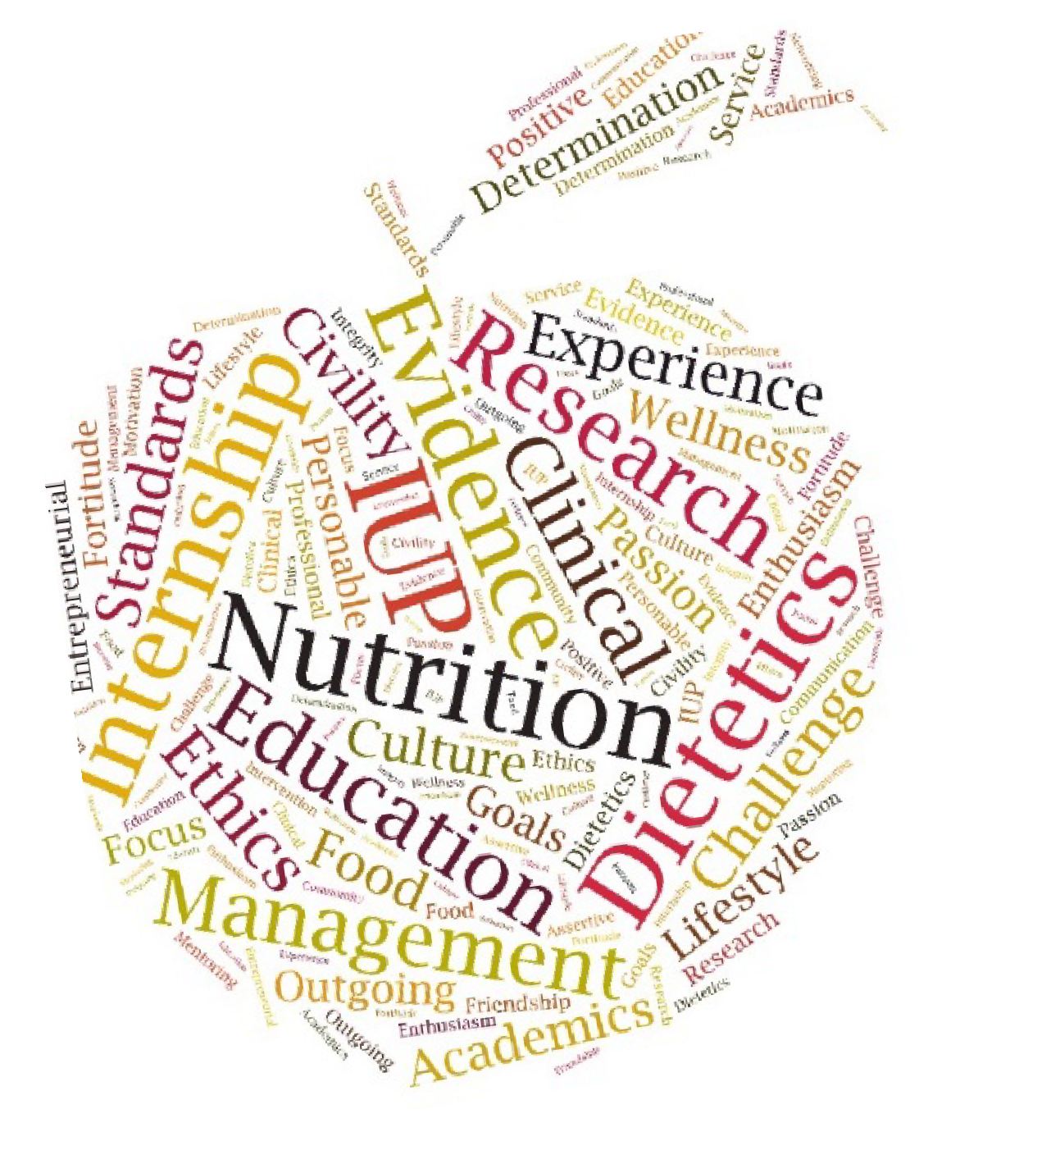
The Food and Nutrition Program enables students and alumni to be leaders and stewards across disciplines that positively impact nutrition and health for themselves, their communities, and the world.

Values
Collaborative Community and Culture
Effective Teamwork and Communication Evidence-based
Leadership Experiential Learning
Professional Development Student-Centered

Department overview
The Food and Nutrition Program offers a Bachelor of Science in Nutrition with two tracks: Dietetics and Food and Health Promotion. Within the degree program, students select a natural science option determined by their academic preparation and career goals. The nutrition curriculum prepares students as professionals for a diversity of career opportunities in health care, nutrition education, food service, and food and nutrition research. The department also has a minor in nutrition available. In addition, the department provides Crimson Corecourses which are available to all university students. At the graduate level, the department offers a Master of Science in Food and Nutrition and a Dietitian-Nutritionist Program.
Faculty in the department are committed to assisting students in applying their classroom learning by providing: Hands-on Learning; Service Learning; Interactive Instruction; Applied Experiences in the Laboratory and Classroom; Field-based Practicums; Learning opportunities; Living-Learning; Simulation; Problem-based learning; Case Studies; and, Online or Technology-based Modules.

Faculty and Staff

STEPHANIE A. TAYLOR-DAVIS, PHD, RDN, LDN
Professor
Office: 101 Ackerman Hall
Phone: 724-357-7733
Email: stdavis@iup.edu

Degree | Institution | Program of Study
PhD | The Pennsylvania State University | Human Nutrition
MS | Case Western Reserve University | Public Health Nutrition
BS | Lock Haven University | Management Science
BS | Lock Haven University | Recreation/Fitness Management

Courses Taught: FONU 110 Careers in Food and Nutrition; FONU 145 Introduction to Nutrition; FONU 212 Nutrition; FONU 213 Lifecycle Nutrition; FONU 255 Medical Terminology and Assessment; FONU 465 Nutrition Counseling and Education; FONU 470 Human Food Consumption Patterns; FONU 493 Internship

Interests: Nutrition Education; Food and Culture; Distance Education; Public Health; Community Nutrition; Consumer Behavior, Survey Research Methodology

NICOLE A. CLARK, DCN, MS, RDN, LDN, CDCES
Associate Professor
Food and Nutrition Program Coordinator
Didactic Program in Dietetics Director until January 20, 2026
Office: 105 Ackerman Hall
Email: nclark@iup.edu

Degree | Institution | Program of Study
DCN | University of Medicine and Dentistry of New  Jersey | Clinical Nutrition

MS | Indiana University of Pennsylvania | Food and Nutrition
BS | The Pennsylvania State University | Applied Nutrition

Courses Taught: FONU 110 Careers in Food and Nutrition; FONU 143 Current Issues in Nutrition and Wellness; FONU 145 Introduction to Nutrition; FONU 212 Nutrition; FONU 255 Nutrition Assessment and Medical Terminology, FONU 430 Professional Topics in Food and Nutrition; FONU 455 Medical Nutrition Therapy II; FONU 465 Nutrition Counseling and Education; FONU 466 Nutrition Counseling and Education Laboratory, FONU 471 Integrative Nutrition in Complementary & Alternative Healthcare; FONU 484 Senior Seminar

Interests: Diabetes (currently a Certified Diabetes Care and Educator Specialist); Sports Nutrition, Integrative Nutrition

PAO YING HSIAO, PHD, MS, RD, LDN
Professor
Didactic Program inDietetics Director
Office: 103 Ackerman Hall Email: pyhsiao@iup.edu

Degree | Institution | Program of Study
PhD | The Pennsylvania State University | Nutrition Sciences
MS | Indiana University of Pennsylvania | Food and Nutrition
BS | The Florida State University | Food and Nutrition: Dietetics
AA | Gulf Coast Community College | General Education

Courses Taught: FONU 143 Current Issues in Health and Wellness; FONU 150-Foods Lecture FONU 151-Foods Laboratory, FONU 212 Nutrition; FONU 355 Medical Nutrition Therapy I; FONU 410 Food, Nutrition and Aging; FONU 422 Public Health, Nutrition & Epidemiology

Interests: Dietary Assessment Methodology; Nutritional Epidemiology; Diet and Obesity-related Chronic Diseases; Clinical Diabetes

JODIE M. SEYBOLD, PHD, RD, LDN
Assistant Professor
Dietitian Nutritionist Program Director Office: 104 Ackerman Hall
Email: jseybold@iup.edu

Degree | Institution | Program of Study
PHD | Indiana University of Pennsylvania | Administrative & Leadership Studies
MS | Indiana University of Pennsylvania | Food and Nutrition
BS | Indiana University of Pennsylvania | Nutrition/ Dietetics

Courses Taught: FONU 143 Current Issues in Nutrition and Wellness; FONU 150 Foods; 151 Foods Lab; FONU 362 Experimental Foods; FONU 370, FONU 402 Community Nutrition; FONU 415 Sustainable Nutrition; FONU 470 Human Food Consumption Patterns

Interests: Oncology; Adult Weight Management; Sports Nutrition; Food Preparation and Recipe Modification; Community Nutrition

Graduates of a Bachelor of Science in Food and Nutrition:

  - Have an in-depth knowledge of food, nutrition, and behavioral sciences.
  - Draw upon theories and models, and engage in problem-solving and critical thinking to improve the quantity and quality of food and nutrition for people now and in the future
  - Synthesize relationships among academic disciplines (i.e., the natural sciences, including chemistry, physiology, and biochemistry; and the social sciences, including psychology, sociology and anthropology) and apply these scientific principles to the practice of nutrition and dietetics
  - Translate the role of nutrients and healthy food preparation for health and well-being
  - Provide effective nutrition education to individuals and groups
  - Assume roles, responsibilities, and competencies to function in therapeutic, administrative, and community nutrition settings
  - Exhibit leadership and team-building skills
  - Use research and technology in order to perform effectively in the workplace and as citizens in a world increasingly shaped by technology and faced with social dilemmas stemming from scientific advances
  - Utilize appropriate technologies within the discipline
  - Think critically, communicate effectively both orally and in writing, analyze information, make decisions, and solve problems in a rapidly changing nation and world
  - Work with diverse populations in a global economy
  - Continue in lifelong learning
  - Meet the basic requirements for graduate study in nutrition and related areas

What Career Opportunities are available to students who earn a Bachelor of Science in Nutrition?
There are many opportunities open to students who graduate with a Bachelor of Science degree in Nutrition. Some careers may require the RD or RDN credential or additional education; others may not. Here is a list of potential careers:

Armed forces dietitian | Food product developer | Food buyer/ distributor
Extension nutrition educator | Pharmaceutical representative | Menu planner
Chef | Public health nutritionist | Food photographer
Clinical trial coordinator | Food demonstrator | Entrepreneur
Community nutritionist | Recipe developer | Nutrition educator
Community health educator | Grocery store nutritionist | Food service director
Diabetes educator | Teacher/ professor | Freelance writer
Research nutritionist | Consultant dietitian | Health inspector
Food product marketing specialist | Medical nutrition therapy dietitian | Restaurant chain manager

Health insurance specialist | Family & Consumer Science | Consumer educator/ advocate
Equipment demonstrator | Administrative dietitian | Sports nutritionist
Certified Dietary Manager, Certified Food Protection  Professional | WIC Nutritionist | Health and wellness coach

What if a Student would like to Combine Nutrition with other Career Goals?
Having a Bachelor of Science in Nutrition is a stepping stone to a variety of other professions. Most will require more education either at the undergraduate or graduate level. Here is a list of potential careers for students who obtain further education:

Author (books, magazines articles, nutrition education materials) | Botanical medicine practitioner | Business administrator
Chiropractor | Nurse | Exercise physiologist
Clinical informatics professional | Federal government/ survey technical or inspector | Food product developer, tester, advertiser, wholesaler, retailer
Food service/ Hospitality management | Caterer or healthy cooking instructor | K-12 teacher (health, science, math, consumer sciences)
Physical therapist | Occupational therapist | Pharmaceutical sales
Nutrition counselor, commercial weight loss program | Physician, Physician’s Assistant | Public health educator

Majors and Minors that Complement Nutrition
Majors | Minors
Exercise Science, Physical Education and Sport | Psychology
Community Health Education, Health and Physical Education, BSED | Chemistry
Sport Administration, Physical Education and Sport | Sustainability Studies
Journalism and Public Relations | Global Health
Family and Consumer Science Education | Hospitality Management
 | Restaurant and Food Service

Human Development and Family Science | Exercise Science
Natural Science, BS | Child Development and Family Studies
Public Health | Community Health
 | Teamwork

Dietetics Track
Mission of the Dietetics Track
The mission of the Dietetics Track/ Didactic Program in Dietetics (DPD) at Indiana University of Pennsylvania is to provide superior educational opportunities combining theory and practice and prepare graduates for supervised practice leading to eligibility for the CDR Credentialing Exam to Become a Registered Dietitian Nutritionist.
Students who complete either the Food and Health Promotion concentration or the Culinary Nutrition concentration meet the academic requirements of the Accreditation Council for Education in Nutrition and Dietetics (ACEND), the accrediting agency of the Academy of Nutrition and Dietetics. Graduates qualify to apply to ACEND-accredited supervised practice experience or dietetic internships in pursuit of becoming a Registered Dietitian, who are then eligible to be “Licensed Dietitian Nutritionist” in the Commonwealth of Pennsylvania (or other states with licensure).


Effective January 1, 2024, the Commission on Dietetic Registration (CDR) will require a minimum of a master’s degree to be eligible to take the credentialing exam to become a registered dietitian nutritionist (RDN). In order to be approved for registration examination eligibility with a bachelor’s degree, an individual must meet all eligibility requirements and be submitted into CDR’s Registration Eligibility Processing System (REPS) before 12:00 midnight Central Time, December 31,
2023. For more information about this requirement visit CDR’s
website: https://www.cdrnet.org/graduatedegree. In addition, CDR requires that individuals complete coursework and supervised practice in program(s) accredited by the Accreditation Council for Education in Nutrition and Dietetics (ACEND). Graduates who successfully complete the ACEND-accredited Dietetic Internship Certificate program at Indiana University of Pennsylvania are eligible to apply to take the CDR credentialing exam prior to become an RDN. In most states, graduates also must obtain licensure or certification to practice. ACEND exists to serve the public by establishing and enforcing eligibility requirements and accreditation standards that ensure the quality and continued improvement of nutrition and dietetics education programs.

The Indiana University of Pennsylvania DPD program has been granted accreditation by the
Accreditation Council for Education in Nutrition and Dietetics (ACEND) of the Academy of Nutrition and Dietetics until June 30, 2029. The next Accreditation Review is scheduled for Fall 2028.
ACEND can be contacted using the information below:

Email: ACEND@eatright.org | Mail: 120 South Riverside Plaza
Phone: 800/877-1600, ext. 5400 | Suite 2190, Chicago, IL 60606-6995

Program Goals and Outcomes of the Dietetics Program:
The mission of the Dietetics Program

The Mission of IUP Didactic Program in Dietetics is to provide superior educational opportunities combining theory and practice in an intellectually challenging and diverse environment to help prepare students for supervised practice leading to eligibility for the CDR Credentialing Exam to become a Registered Dietitian Nutritionist.
Goal #1: Graduates will be prepared for entry into supervised practice, other post-graduate programs, or the food and nutrition-related workforce.
Objectives:
- At least 80% of students complete program requirements within 6 years (150% of planned program length).
- At least 50% of program graduates apply for admission to a supervised practice program prior to or within 12 months of graduation.
- Of program graduates who apply to a supervised practice program, at least 50% percent will be admitted within 12 months of graduation
- The program’s one-year pass rate (graduates who pass the registration exam within one year of first attempt) on the CDR credentialing exam for dietitian nutritionists is at least 80%.
- At least 80% of the dietetic supervised practice program directors or their designee will agree that the program graduates are well prepared for their current assignment.
Goal #2 – The graduate will be academically prepared for employment and/or graduate education in a food and nutrition or related field.
Objective:
- At least 80% of the DPD graduates who respond to a survey within one year of graduation will “agree” that they were well-prepared for their current position in food and nutrition.
- At least 80% of those who respond to a survey within one year of graduation who are currently in a graduate education program will “agree” that their undergraduate academics prepared them for a graduate school education in nutrition or a related field.
Program Outcomes Data
Complete outcomes data for the program are available upon request. Individuals may request this information from the DPD director, Nicole A. Clark, DCN, RDN, LDN, CDE, nclark@iup.edu

Food and Health Promotion Concentration
Students in the Food and Health Promotion concentration are educated in food and nutrition science, nutrition education and counseling, community health and intervention, and food service systems management.

Culinary Nutrition Concentration
Within the DPD, students may choose the Culinary Nutrition concentration where they are educated in advanced food preparation and management skills in a culinary arts background in addition to the area encompassed by the dietetics profession. This track uniquely prepares graduates to incorporate health nutrition into classical cuisine, manage food service operations focused on nutrition needs, and integrate culinary arts into hospital, extended care, and school food service facilities.
The Culinary Nutrition concentration allows students to combine academic preparation in nutrition with extensive hands-on learning experiences in culinary arts by one of two routes: (1) Preferred: Students who earn a culinary certificate prior to admission to the dietetics program will receive 32 credits toward the degree. (2) Students who have completed a minimum of 28 credits toward the baccalaureate degree will have the opportunity to enroll in the Culinary Arts program at the Punxsutawney regional campus, where the three semester program (fall, spring, summer) will transfer into the Department of Food and Nutrition; 32 credits will be applied to the Bachelor the Science degree. Students may complete the culinary arts externship in the summer between the junior and senior years.
Culinary Students’ Transition from Indiana Campus to the Punxsutawney Campus
Prior to spring break of your first year at the Indiana campus, you must contact the IUP Culinary Academy at 800-438-6424 and ask to speak to the Director of Culinary Admissions. Identify yourself as a Culinary Dietetics major at the Indiana campus and state your intent to attend the Culinary Academy during the next academic year. Please do the following:
    - Schedule a visit to the culinary campus. Students can attend a Saturday open house, a weekday buffet tour, or schedule a personal tour. A visit as a recruit prior to enrolling at IUP can satisfy this requirement.
    - Complete a culinary application for admission for the term you will begin culinary classes. Paper and electronic forms are available at www.iup.edu/admission/culinary. The application fee and tuition deposit will be waived for culinary dietetics major.
    - Schedule a financial aid counseling session with Culinary Admissions. This session can be done in person or by phone. The coordinator will talk about the differences in financial aid and registration between the Indiana campus and the Culinary Academy. Housing on the Punxsutawney campus is limited and is offered to incoming students on a first-come basis in early March.
    - Attend the Culinary Arts Orientation on the Indiana campus. The Culinary Admissions office will provide the date.
    - Attend the Culinary Arts Development classes on Move-In Weekend in Punxsutawney. The Culinary Admission office will provide the date.
    - Optional: Spend a day in a culinary kitchen lab class. Students are welcome to visit as often as they like to become familiar with the program.
Culinary Students’ Transition from the Culinary Academy to the Indiana Campus for the Following Summer and/or Fall Semester
Prior to the spring break on the Indiana campus, email your Food and Nutrition Programacademic advisor for the date and time of the department scheduling night and plan to attend or talk with your advisor so that you will receive all the necessary information to schedule for the fall semester. Use this handbook to help you decide what courses you should take and be ready to discuss this with your advisor. Don’t forget to obtain your alternate PIN which you will need to register for classes. If you are denied registration for any FONU courses that your advisor recommends, contact him/her immediately via email. If you are denied registration for non-Nutrition courses, call the department that teaches the course and ask for an explanation or request to be put on a waiting list. Contact your advisor and tell her about the issue with this course. If you do not schedule your fall semester courses as soon as you are allowed, you may not be able to have a schedule that leads to graduating in eight semesters. It is your responsibility to carry out these directions to have a smooth transition back to the Indiana campus.
Dual Degree Option for Culinary Students Associate in Applied Science in Culinary Arts and Bachelor of Science in Nutrition
Students who gone through the Culinary Academy have the option to earn a Dual Degree: Associate in Applied in Science (AAS) and Bachelor of Science (BS) in Nutrition. Any students articulating from the ACA with their certificate in Culinary Arts and/or Baking & Pastry Arts would be able to obtain the AAS in Culinary Arts or Baking and Pastry Arts.
Dr. Lynn Pike, ACA Director, will provide the student with a double major form. The completed form is then given to the department chairperson, who forwards it to the Dean’s office for processing.
For the AAS, the student is required to complete the 4 classes (highlighted in the AAS course outline below). Note that they can apply to graduate with the AAS before they have completed the BSRequirements for Associate in Applied Science in Culinary Arts

Liberal Studies: As outline in the Crimson Core Section with the following specifications | 21-22 credits
Mathematics: MATH 101 | 3 credits
English: ENGL 101 Composition I | 3 credits
Natural Science: One Laboratory or One non-laboratory course | 3 – 4 credits
 | 60 credits

Dietetics Track Curriculum Sheet (revised 2025)
Crimson Core 41 Cr | Credits | Semester | Grade
FLY Freshman Yr
UNIV 101 | 3
SOAR Sophomore Yr.
 | 1 | Fall
Written Communication (per placement)
 | 3
Quantitative, Reasoning, and Data Analysis
Math 117 | 3
Oral Communication
 | 3
Human and Creative
 | 3
Scientific Reasoning
CHEM 101 | 4 | Fall
Value and Ethics
NO FONU | 3
Civic Readiness
SOC 151 | 3
Global Learning
 | 3
Leadership, Teamwork, and Project Development
 | 3
Crimson Core Elective (9)
PSYC 101 | 3
NO FONU | 3
NO FONU | 3
Major Required Courses 39 Cr | Credits | Semester | Grade
FONU 212 Nutrition | 3
FONU 213 Life Cycle Nutrition | 3 | Spring
FONU 255 Nutrn Assess/Med Terminology | 3 | Spring
FONU 355 Medical Nutrition Therapy | 3 | Fall
FONU 362 Experimental Foods | 3 | Spring
FONU 363 Ex Foods Lab | 1 | Spring
FONU 370 Human Food Cmsp. Patterns | 3 | Fall
FONU 402 Community Nutrition | 3 | Spring
FONU 415 Sustainable Nutrition | 3 | Fall
FONU 430 Professional Topics in F & N | 3 | Fall
FONU 455 Medical Nutrition Therapy II | 3 | Spring
FONU 458 Adv. Human Nutrition | 4 | Fall
FONU 465 Nutrition Counseling/Education | 3 | Fall
FONU 466 Nutrition Counseling/Ed. Lab | 1 | Fall
Select One of Two Options
- Culinary Nutrition: Certificate in Culinary Arts Required (3,4)
or
- Food Management: Required Courses 14 Cr
 | Credits | Semester | Grade
FONU 150 Foods | 3 | Spring
FONU 151 Foods Laboratory | 1 | Fall
HOSP 256 Human Res. Hosp. Indust. | 3 | Fall
HOSP 259 Hospitality Purchasing | 3 | Fall
HOSP 330 App of Food Prod & Serv | 4 | Spring

Natural Sciences 19 Cr | Credits | Semester | Grade
CHEM 102 College Chemistry II | 4 | Spring
BIOL 150 Human Anatomy | 4
BIOL 240 Human Physiology | 4
CHEM 255 Biochem/ Hlth Sciences | 3 | Spring
BIOL 241 Medical Microbiology | 4

Free Electives 7 Cr | Credits | Semester | Grade

TOTAL CREDITS FOR GRADUATION: 120

- Students who complete the IUP Certificate in Culinary Arts transfer FONU 145 Personal Nutrition as a substitute for FONU 212 Nutrition.
- Completion of an IUP culinary certificate is required to select this concentration. To transfer a culinary certificate from an outside institution, it must be earned from an accredited (ACF), post-secondary program to be considered for this concentration.
- Choose with your advisor's approval

- For students pursuing a Teamwork minor, SOC 161 should be selected instead of SOC 151.
- An additional 3-credit course is needed to fulfill social science requirements.
- CHEM 103 may substitute for CHEM 101/102. For students who wish to pursue a Dietetic Internship or DNP, selection of CHEM 101 and 102 is highly recommended.
- Students who elect to pursue a more advanced Chemistry sequence, CHEM 231 is required.
- Completion of an IUP culinary certificate is required to select this concentration. To transfer a culinary certificate from an outside institution, it must be earned from an accredited (ACF), post-secondary program to be considered for this concentration.
- Because the culinary certificate includes considerable additional preparation in foods, the 32cr include hours of work can be considered in fulfillment of concentration requirements and controlled/ free electives.
- Required for all students to earn a Verification Statement, which is required if a students desires a Dietetic Internship.

Academic Progression and Graduation Policy: Dietetics Program

Minimum Science Sequence
Option I | Option II | Option III
CHEM 101 College Chemistry I  (Inorganic) | CHEM 111 General Chemistry I | CHEM 103 Intro- Chem for Health  Sciences
CHEM 102 College Chemistry II (Inorganic) | CHEM 112 General Chemistry II | CHEM 255 Biochemistry/ Health Sciences
CHEM 255 Biochemistry/ Health  Sciences | CHEM 231 Organic Chemistry I | BIOL 150 Human Anatomy
BIOL 150 Human Anatomy | BIOL 150 Human Anatomy | BIOL 240 Human Physiology
BIOL 240 Human Physiology | BIOL 240 Human Physiology | BIOL 241 Medical Microbiology
BIOL 241 Medical Microbiology | BIOL 241 Medical Microbiology

Students must complete any of the following chemistry sequences to meet dietetics program requirements. Students who desire to apply for IUP’s Dietitian-Nutritionist Program must take CHEM 101/111 and 102/112.
Sequence 1: CHEM 101 → CHEM 102 → CHEM 255
Sequence 2: CHEM 111→CHEM 112 → CHEM 231/232 → CHEM 351 Sequence 3: CHEM 101 or 111 → CHEM 102 → CHEM 255

Dietetics Progression
To progress to each course below, students must achieve a ≥C in the prerequisite course (or a
pre-approved equivalent), as follows. See undergraduate catalog for full details.

Course | Final Grade ≥C | Prerequisite
FONU 150 | √ | CHEM 101 or 103 or 111 or BIOL 104
FONU 151 | √ | CHEM 101 or 103 or 111 or BIOL 104
FONU 212 | √ | CHEM 102 or 103 or 112 or BIOL 104 and 106
FONU 213 | √ | FONU 212
FONU 255 |  | BIOL 150
FONU 355 | √ | FONU 212 and BIOL 150 and 240
FONU 362/363 |  | FONU 150, 151 and 355, or concurrently, MATH 217
FONU 402 |  | FONU 212
FONU 430 |  | FONU 355 with a "C" or better, and Senior status
FONU 455 | √ | FONU 355
FONU 459 & 460 |  | FONU 355, CHEM 255 (or CHEM 251), and MATH 217
FONU 465/466 |  | FONU 213 and 355 and PSYC 101

Admission requirements for the Dietetics track
The following are the requirements to enter the dietetics track:

  - Entering Freshman
    - High School GPA ≥3.0
  - Transfer Students
    - GPA ≥3.0
    - Earn ≥C in the following equivalent courses prior to admission to IUP: CHEM 101 or 111; BIOL 150 or 240
  - Current IUP students who wish to change their major to the Dietetics track
    - GPA ≥3.0
    - Grade of ≥C in CHEM 101 (or 111) and CHEM 102 (or 112)
    - Grade of ≥C in one course equivalent to or higher than BIOL 150 and 240
    - If students do not meet the requirements, then they will be admitted to the Food and Health Promotion Concentration
  - Change of major from Nutrition track to Dietetics track
    - GPA ≥3.0
b. Grade ≥ C in FONU 110, 150, 151, CHEM 101 (or 111), and CHEM 102 (or 112)

Remediation Statement
The Food and Nutrition Program is invested in our student’s academic and professional success. To help guide students and faculty, assignments, activities, and events are identified throughout the nutrition curriculum as success markers, in which all students must meet the minimum requirements for passing as outlined in the IUP undergraduate handbook https://www.iup.edu/registrar/catalog/. A remediation plan will be developed for any dietetic/culinary dietetic student who does not meet the minimum requirements for the IUP KRDN Student Learning Objective (See Appendix. A) The remediation plan will be developed by the student, student’s advisor, faculty of the course(s) and the DPD director.

Formal Assessment of Students Learning and Progress

Students are assessed in a variety of ways throughout their years at IUP. Formal assessment in classes will be through exams, quizzes, projects, class assignments, presentations, midterm course grades, final course grades, and other measure of student ability and learning. Many opportunities occur for informal feedback about performance. These opportunities need to be viewed as positive opportunities to gain insight and adjust performance. Students are required to meet at least one time a semester with their academic advisor to discuss their progress towards graduation. In addition, students can see a record of all academic coursework taken thus far in their academic career through their MYIUP DegreeWorks. Each semester, the DPD Director will review student performance (grades) - overall performance in the course and on specific assignments that are linked to the Student Learning Objectives (SLO ).
Food and Health Promotion Concentration
Mission of Food and Health Promotion Concentration
The mission of the Food and Health Promotion Concentration is to provide superior educational opportunities combining theory and practice and prepare students to serve as a translator of food and nutrition science information for consumers and the general public. This concentration uniquely prepares students to develop expertise in food preparation and healthy eating behaviors and to combine these knowledge and skills with another discipline through choice of a minor, certificate, or second major. The Food and Health Promotion Concentration provides the student with the ability to plan a curriculum with their academic advisor that is tailored to their career goals other than becoming a Registered Dietitian.
Pairing Food and Health Promotion coursework with education in exercise and fitness, gerontology, business management, communications, natural sciences, psychology or technology opens a variety of career options for students. The department prepares these students for the following opportunities: public health, food service administration, journalism, business, communications, gerontology, wellness education and planning, culinary arts, and as an advocate for nutrition programming and planning.
Students who wish to pursue preparation for graduate education in food and nutrition should discuss this plan with their academic advisor to be sure courses are selected to acquire a background in the basic sciences that give a solid foundation for theoretical and applied nutrition science. For example, Natural Sciences Option II (see Dietetics track) plus the Food and Health Promotion Concentration would acquire a background in the basic sciences that give a solid foundation for theoretical and applied nutrition science. This option meets the needs of students who wish to enter careers in food and nutrition, and biological or medical sciences that require graduate education.
This concentration can lead to a Graduate Program + Supervised Practice Program if courses are selected that provide the nutrition course, management courses and science courses that are required for many of the Graduate Program + Supervised Practice Program which lead to the ability to take the RDN exam. If this is your goal, please work with your advisor to select courses.

Program Goals and Outcomes of the Food and Health Promotion Concentration
Graduates of the Food and Health Promotion Concentration will be able to:
- Demonstrate effective and professional oral and written communication.
- Apply nutrition theory to people throughout the lifecycle.
- Education diverse communities and cultures about healthy eating habits.
- Apply population-based dietary recommendations.
Food and Health Promotion Concentration Curriculum (revised 2025)
Crimson Core 41 Cr | Credits | Semester | Grade
FLY Freshman Yr
UNIV 101 | 3
SOAR Sophomore Yr.
 | 1 | Fall
Written Communication (per placement)
 | 3
Quantitative, Reasoning, and Data Analysis
MATH 117 | 3
Oral Communication
 | 3
Human and Creative
 | 3
Scientific Reasoning
Choose: CHEM 101 or BIOL 104 & BIOL 114 | 4 | Fall
Value and Ethics
NO FONU | 3
Civic Readiness
SOC 151 | 3
Global Learning
 | 3
Leadership, Teamwork, and Project Development
 | 3
Crimson Core Elective (9)
PSYC 101 | 3
NO FONU | 3
NO FONU | 3

Major 55-60 Cr (1,2,3)
Required Courses 45-54 Cr  (1,2,3) | Credits | Semester | Grade
BIOL 106 Human Genetics and Health And | 3
BIOL 116 Human Genetics and Health Lab Or | 1
CHEM 102 College Chemistry II | 4 | Spring
FONU 150 Foods | 3 | Spring
FONU 151 Foods Lab | 1 | Fall
FONU 212 Nutrition | 3
FONU 213 Life Cycle Nutrition | 3 | Spring
FONU 255 Nutrition Assess/Med Terminology | 3 | Spring
FONU 335 Nut, Lifestyle Medicine, and Health | 3 | Spring
FONU 355 Medical Nutrition Therapy | 3 | Fall
FONU 370 Human Food Consumption Patterns | 3 | Fall
FONU 402 Community Nutrition | 3 | Spring
FONU 415 Sustainable Nutrition | 3 | Fall
FONU 422 Public Health Nutrition and Epidemiology | 3 | Fall
FONU 465 Nutrition Counseling/Education | 3 | Fall
FONU 466 Nutrition Counseling/Ed. Lab | 1 | Fall
FONU 471 Integrative Nutrition | 3 | Fall
FONU 493 Internship | 1-12
(1) Selected in consultation with advisor.
(2) Students that choose the Exercise Science or Community Health minor must take
FONU 245 - Sports Nutrition.
(3) Students that desire certification as a Certified Health Education Specialist (CHES) must
also choose KINS 341 -Evaluations and Analytics in Kinesiology and
NURS 410– Health Promotion and Social Issues.

Controlled Electives 6-13 Cr (1,2,3) | Credits | Semester | Grade
ANTH 240 Introduction to Global Health | 3
ANTH 430 Anthropology of Food | 3
ANTH 450 Health Disparities | 3
BIOL 241 Medical Microbiology | 4
ECON 360 Health Economics | 3
ECON 362 Global Poverty and Health | 3
FONU 245 Sports Nutrition | 3
FONU 362 Experimental Foods | 3 | Spring
FONU 363 Experimental Foods Lab | 1 | Spring
FONU 431 Career Advancement in Dietetics | 3
FONU 455 Medical Nutrition Therapy II | 3 | Spring
FONU 458 Advanced Human Nutrition | 3 | Fall
FONU 484 Senior Seminar | 3
FONU 493 Internship | 1-12
HLPE 325 School and Community Health | 3
HDFS 330 Consumer Economics and Family | 3
HOSP 130 Food Service Sanitation | 3
HOSP 256 Human Resources in Hospitality | 3 | Fall
HOSP 259 Hospitality Purchasing | 3 | Fall
HOSP 330 Applications of Food Production | 3 | Spring
KINS 251 Foundations of Safety & Emer. | 3
KINS 343 Physiology of Exercise | 3
MKTG 320 Principles of Marketing | 3
MKTG 321 Consumer Behavior | 3
PBH 101 Foundations of Public Health | 3
POLI 250 Public Policy | 3
PSYC 215 Developmental Psychology | 3
PSYC 377 Interpersonal Skills and Group Dyn | 3
SOCI 357 Sociology of Aging and the Life | 3
SOCI 442 Medical Sociology | 3
SOCI 454 Dimensions of Rural Public H. | 3
THEA 361 Performance of Caring | 3
GNDW 200 Introduction to Women’s & G | 3

Minor, Certificate, Concentration, dual major, double major: 18-21 Cr  (1,2,3) | Credits | Semester | Grade

Free Electives 0-14 Cr | Credits | Semester | Grade

TOTAL CREDITS FOR GRADUATION: 120

Notes:
- Depending upon career goals, different chemistry and biology coursework may be needed in addition to the Natural Science Crimson Core requirements. Students who desire to change to the dietetics track should select CHEM 101/102.
- FCSE 450 may be substituted, with permission of the Human Development, Fashion and Interior Design department chairperson.
- Number of FONU electives depends upon number of credits in the minor, certificate, or concentration. Students that choose the exercise science or community health minor must take FONU 245 Sports Nutrition.
- Select one of the following:
  - Minor in anthropology, biochemistry, biology, biomedical sciences, business administration, chemistry, child development and family relation, communications media, community health, exercise science, global health, hospitality management, journalism and public relations, psychology, sociology, or sustainability studies. Other minors with Food and Nutrition department chairperson permission.
  - Certificate in culinary arts. Other certificates with Food and Nutrition department chairperson permission.
- Students that desire certification as a Certified Health Education Specialist (CHES) must also choose KHSS 341 Evaluation in Health and Physical Education and NURS 410 Health Promotion and Social Issues.

Academic progression and graduation policy: Food and Health Promotion Concentration
- For students to enroll in and remain in the Food and Health Promotion Concentration, a GPA of 2.0 must be maintained.
- To progress to each course below, students must achieve ≥C in prerequisite courses (or a
pre-approved equivalent), as follows:¹

Course | Final Grade ≥C | Prerequisite
FONU 150² |  | CHEM 101 or 111
FONU 151² |  | CHEM 101 or 111
FONU 212 |  | CHEM 102, 103 or 112 or BIOL 104 and BIOL 106
FONU 213 | √ | FONU 212
FONU 355 | √ | FONU 212 & BIOL 150 and BIOL 240
FONU 402 |  | FONU 212
FONU 465 |  | FONU 355, PSYC 101, FONU 455 or concurrently
FONU 493 |  | Must have earned at least 60 credits
- Department elective (6 credits required) will be approved, as appropriate to the student’s career goals, from the following list. Students must achieve a ≥C in prerequisite courses (or a pre-approved elective), as follows:

Course | Final Grade ≥C | Prerequisite
FONU 245 |  | FONU 145 or 212
FONU 402 |  | FONU 212
FONU 422 |  | FONU 145 or 212 and MATH 217
FONU 445 |  | FONU 212
FONU 455³ | √ | FONU 355
FONU 471 |  | FONU 145 or 212

¹See the Undergraduate Catalog for more details.
²FONU 150 and 151 are co-requisites, therefore, they must both be taken during the same spring semester.
3The State of Pennsylvania requires all nutritionists working at WIC to have taken both FONU 355 and 455
Crimson Core
https://www.iup.edu/crimsoncore/index.html
Crimson Core is a common core curriculum required by all undergraduate students that includes subjects related to the humanities, arts, and sciences.
The Crimson Corecurriculum consists of a broad exploration of courses in English, mathematics, social sciences, natural sciences, humanities, the arts, and the dimensions of wellness, preparing all of IUP’s undergraduate students for success in work and life. In Crimson Corecourses, students pursue knowledge in these different areas, often learning to synthesize what they learn into a coherent whole that serves their life goals. Students will learn to communicate effectively; understand and respect a variety of cultures; develop critical thinking, problem solving, and reasoning skills; and become more self-aware. The Crimson Coreprogram is designed to meet the goals of the university by offering innovative courses that are aligned with the needs of students and society.
All students must fulfill the requirements of the university’s Crimson Coreprogram in order to graduate.
The curriculum involves a range of 40 to 48 credits, divided among Learning Skills and Knowledge Areas, and is arranged in 10 categories. To fulfill the requirements, you must complete courses in each. Although in some categories a course is specified for all students, in most instances there is a list of approved courses from which you can select. Sometimes, depending on your major, certain choices are required or recommended by colleges or departments. Your advisor will provide a convenient checklist which will make it easy to record your progress. For further clarification about Crimson Corerequirements for graduation visit: www.iup.edu/liberal/categories

Transfer and change of major students will need to work carefully with their advisors to be sure the Crimson Core requirements have been fulfilled.

Minors – Certificates – Elective Courses – Second Majors
Planning Your Courses → Planning Your Career!

Your probably have a lot of interest in addition to food and nutrition. You can expand your knowledge in these areas by carefully considering your electives or adding enough additional courses in another field to earn a minor, or even a second major. Talk to your advisor about minors, certificates, and elective courses that complement a major in the Food and Nutrition Department.
You can also look through the undergraduate catalog or search “minors” on the IUP website.

Approved Minors: anthropology, biochemistry, biology, biomedical sciences, business administration, chemistry, child development and family relations, communications media, community health, exercise science, global health, hospitality management, journalism and public relations, psychology, sociology, sustainability studies, and teamwork. Other minors by permission of the Food and Nutrition department chairperson.
Approved Certificates: Certified Health Education Specialist (CHES), culinary arts and gerontology. Other certificates by permission of the Food and Nutrition department chairperson.

Dual Baccalaureate Degree vs Double Major

What’s the difference? The number of credits: 150 for a dual baccalaureate degree; 120 for a double major
- Do students have to complete the same degree requirements for both? Yes, the only difference is the number of credits.
- How does a student apply for a dual baccalaureate degree? Complete a “Dual Baccalaureate Degree Application” form in the Assistant Dean’s office of the College(s) of the dual degree.
- How many diplomas does a student receive for a dual baccalaureate degree? Two, one for each degree; i.e., Political Science (B.A.) and Computer Science (B.S.)
- Is it possible that a student will get two diplomas, both with a B.A.? Yes, if both degrees are B.A.’s, e.g., Political Science (B.A.) and Criminology (B.A.)
- How many diplomas does a student receive for a double major? One
- If a student has a double major, what determines if she or he will receive a B.A. or B.S.? The major which he or she declares as the primary major.
- How does a student apply for a double major? The student files a “Double Major Application” form in the department office of his/ her double major.
- How does a double major student apply for graduation? Apply online or can complete one graduation application with the assistant dean of the college of his/her primary major.
- What if a double-major student meets the requirements for a dual baccalaureate degree? In other words, the student will have completed all the coursework required for both majors and will have earned 150 credits? The student would be eligible to graduate with a dual baccalaureate degree and receive two diplomas. Prior to graduation, the student will need to apply for the dual baccalaureate degree as explained in both questions 3 and 9 above.

Preparing for Graduation
Introduction
Preparing for graduation begins the first day of your freshman year! Your academic record in every class, your relationships with your academic advisor and department faculty, your relationships with your peers, and your involvement with the IUP community are all important to planning your career.
Be an active student! Ask questions in class – don’t hide in the back of the room or come to class late. Take advantage of faculty office hours; stop by if you need help. Visit your advisor to introduce yourself; plan to meet with him/her at least once each semester. Advisors are a great resource. Join a service organization and take on a leadership role. Join the Student Association of Nutrition and Dietetics (SAND), which is the student organization for all nutrition majors and minors. Become a FONU Ambassador and become the face of the department for visiting high school students. Practice professional skills in your verbal and written communications. Remember, you want to be noticed for your positive professional knowledge and skills.

As your graduation date gets closer, plan to look back at your IUP career as a student who stands out in front, not one that sits in the back!
Graduation Requirements
Graduation requirements for the University can be found at this link. https://catalog.iup.edu/content.php?catoid=6&navoid=834#:~:text=Each%20student%20must%20complete%20a,major%20and%2For%20minor%20field.

To graduate from the Food and Nutrition Program at Indiana University of Pennsylvania, a student must meet all the graduation requirements, which are found on the curriculum sheets in this handbook and used by your advisor to keep track of your progress. Students are also responsible for keeping track of their own progress in this handbook, see curriculum sheets. Please monitor your DegreeWorks on MYIUP to make sure you fulfil your requirements for graduation. You must apply for Graduation by the deadline listed below.
How to apply for graduation can be found at this link: https://www.iup.edu/commencement/undergraduate/how-to-apply-for-graduation.html

Graduation Month | Deadline to Apply
May | November 15
August | April 1
December | April 1
January | December 1

For a complete checklist of graduation requirements, visit: https://www.iup.edu/commencement/university-ceremony/graduation-checklist.html

University Policies and Procedures
Academic Calendar
- See www.iup.edu/academiccalendar

Academic and Scheduling Policy
- See https://www.iup.edu/university-college/support-services/students-role-in-academic-advising/index.html

Academic Standards
- See https://www.iup.edu/registrar/catalog/ – section “Academic Policies”

Career and Professional Development Center
- See www.iup.edu/career

Disciplinary Procedures and Academic Integrity University
- See: https://catalog.iup.edu/content.php?catoid=7&navoid=965

Financial Aid
- See: www.iup.edu/financialaid

Email Contact
Faculty and staff in the Food and Nutrition Program check their email regularly and communicate with students using their IUP email addresses (your four-letters). Be sure that you check your email regularly so as not to miss important information and that it is working properly. If you need assistance, please log an i-help ticket through your MyIUP. The IT Support Center is located on the ground floor of Delaney Hall, Suite G35, and their hours are M-F, 8:00am – 4:30pm.
Leaves of absence
For information about types of leaves of absence, please see the University Attendance Policy in the IUP Undergraduate Catalog. https://catalog.iup.edu/content.php?catoid=7&navoid=1035
Library Services
- See, www.iup.edu/library

Maximum time Allowed to Earn a Degree
- Financial Aid dictates that students have a maximum of 6 years to complete the requirements for a Bachelor of Science degree in Nutrition.
- See : https://catalog.iup.edu/content.php?catoid=6&navoid=834#:~:text=Each%20student%20must%20complete%20a,major%20and%2For%20minor%20field. -- section, “Requirements for Graduation”
- The applicability of coursework completed more than ten years prior to the degree date is subject to review by the dean or designee for evaluation on a course-by-course basis.
- Students who change majors are governed by the requirements of the major and/or college at the time of acceptance, without a change in the Crimson Core requirements, unless the requirements are different in the new major.
Diversity, Inclusion, and Equity: Title IX and Sexual Misconduct, and Preferred First Name Policies
- See, www.iup.edu/socialequity/policies

Refund Policy
For a copy of IUP’s Refund Policy or a sample refund calculation, please contact the Office of Student Billing at 724-357-2207. The Refund Policy is also available at https://www.iup.edu/student-billing/ .

Retention and Remediation of Students
- Students must earn ≥C in courses specified in course descriptions to progress to future courses.
- The university has extensive resources to assist students whose GPA ≤2.0. Talk with your
academic advisor or visit www.iup.edu/success

Student Rights, Freedoms, and Responsibilities
- See, https://catalog.iup.edu/content.php?catoid=10&navoid=1276
Student Rights Under the Family Education Rights and Privacy (FERPA)
- See: https://www.iup.edu/registrar/policies/ferpa/ferpa-rights-for-students.html
Student Programs and Services
Through collaboration focused on student learning and success, IUP’s Student Affairs Division offers student-centered services, programs, and experiences that promote excellence, stimulate discovery, celebrate diversity, and motivate students’ development, involvement, and personal and professional achievement. https://www.iup.edu/studentlife/support/index.html
- Alcohol, Tobacco, and Other Drugs; see www.iup.edu/atod
- Athletics; see www.iupathletics.com
- The Counseling Center; see www.iup.edu/counselingcenter and www.iup.edu/haven
- Department for Disability Access and Advising; see www.iup.edu/disabilitysupport
- Center for Health and Well-Being; see www.iup.edu/chwb
- Health and Wellness Promotion; see www.iup.edu/health-wellness
- Health Service; see www.iup.edu/healthservice
- Nutrition Connection; see www.iup.edu/foodnutrition/nutritionconnection
- Housing, Residential Living, and Dining Information; see www.iup.edu/housing
- LGBTQIA Support, see, https://www.iup.edu/mcsle/lgbtqia-support/
- Military and Veterans Resource Center; see www.iup.edu/veterans/resource-center
- Office of Student Conduct; see www.iup.edu/studentconduct
- Student Cooperative Association; see www.coop.iup.edu
- Center for Multicultural Student Leadership and Engagement; see www.iup.edu/mcsle

Student Protection of Privacy and Access to Personal Files
- See. https://www.iup.edu/registrar/policies/ – section “Student Programs and Services”

Student Technology Services and Policies
  - See www.iup.edu/itsupportcenter

Tutorial Support
Students in the Food and Nutrition Program have access to numerous support resources on campus: Academic Success Center; Department for Disability Access and Advising; College of Health and Human Services; IUP Writing Center; Graduates Assistants within Department of Food and Nutrition.
- Tutoring offered by Graduate Assistants in the Department of Food and Nutrition, located in Ackerman 117A. Schedule posted on door and bulletin board located on first floor near women’s restroom.
- Tutoring offered by College of Health and Human Services. Call 724-357-2650 for complete schedule.
- Tutoring offered by biology departments. Contact for your instructor for a schedule.
- Tutoring offered by the Academic Success Center. Please call 724-357-2215 for more information or visit https://www.iup.edu/university-college/success-programs/tutoring-schedules/index.html .
- Take advantage of the Kathleen Jones Writing Center, located in Eicher Hall. Visit www.iup.edu/writingcenter/ for details.
Undergraduate Catalog
  - See, https://www.iup.edu/registrar/catalog/

University Policies and Procedures
  - See, www.iup.edu/academicaffairs
  - or https://www.iup.edu/registrar/catalog/

Withdrawal policies
https://www.iup.edu/registrar/policies/withdrawals/index.html
Department Policies
Advising
The Food and Nutrition Program is committed to assist both faculty advisors and student advisees in the advisement process within the department. Advisement in the College of Health and Human Services has the following four objectives.
- Establish a relationship of trust between the advisee and the advisor.
- Identify the strengths, skills, passions and the dreams of the advisees.
- Develop a plan of academic, professional and personal activities to accomplish advisee educational goals.
- Follow-up on plan activities and motivate students to be the best they can be.

The Food and Nutrition Program is committed to student growth and development. Each semester you will schedule an academic advising appointment with your advisor. No registration pin will be given unless you meet with your advisor.

Evaluation of prior education or experience
The Food and Nutrition Program follows established IUP university established criteria; see www.iup.edu/creditevaluation.
Food laboratories Dress Code
All students who enroll in either FONU 151 and/ or 362 (a foods laboratory course) must adhere to the dress code defined below:
- Chef’s apron, black pants, and plain white t-shirt
- Pocket food thermometer
- Hair restricted by hair net or ball cap
- White or black leather shoes (non-slip, flat sole with enclosed toe). No sandals or open-toed shoes
- No jewelry, including any face piercings
- No fingernail polish or artificial fingernails
- Visible tattoos covered

All students who enroll in HOSP 330 Applications of Food Production and Service (lab course offered by the Hospitality Department and required by Dietetics majors) must wear black pants, a black button-down shirt and black shoes. Students will also be required to purchase a chef’s jacket and an apron. Aprons are available to be borrowed from the department office; contact the support staff at the beginning of the semester.
Laboratory Participation and Tasting Policies
All students will prepare and taste ALL foods for the lab. Documentation MUST be provided for a student to be exempt from preparing and/or tasting a food before the cooking class begins. If the excuse is medical, documentation must be provided from a physician. If the excuse is based on religious beliefs, you must submit documentation from your religious leader that you are a practitioner of that faith. In both cases, contact information for the verifying party must be provided on the documentation.

Possible costs in addition to tuition and fees for nutrition majors
Expenses | Approximate Cost
Books | Around $1000/academic year
Foods/Experimental Lab Uniform | $30.00
Uniform for HOSP 330 (Chef coat and red skull cap) | $72.00
Academy of Nutrition & Dietetics Student Membership | $58.00/year
Pittsburgh Academy of Nutrition & Dietetics Membership | $10.00/year

Policy Internet and Email Access

Reliable internet service at home and on a mobile device for the purposes of email communication and access to D2L is a requirement of this Program. In addition, you should have a backup plan for uninterrupted access--such as familiarity with public libraries, IUP computing facilities, etc.
Students MUST use their IUP email (I-mail) account.

Code of Ethics and Standards of Practice (SOP)and Standards of Professional Performance for Professionals (SOPP) in Dietetics

Procedure
Students are responsible for reading and understanding the A.N.D. Code of Ethics, SOP, and SOPP:

See: https://www.eatrightpro.org/practice/code-of-ethics and https://www.cdrnet.org/scope

Code of Ethics for the Profession of Dietetics (Updated 2018, by the AND Board of Directors, House of Delegates and Commission on Dietetic Registration).

“Preamble. When providing services, the nutrition and dietetics practitioner adheres to the core values of customer focus, integrity, innovation, social responsibility, and diversity. Science-based decisions, derived from the best available research and evidence, are the underpinnings of ethical conduct and practice. This Code applies to nutrition and dietetics practitioners who act in a wide variety of capacities and provides general principles and specific ethical standards for situations frequently encountered in daily practice. The primary goal is the protection of the individuals, groups, organizations, communities, or populations with whom the practitioner works and interacts. The nutrition and dietetics practitioner supports and promotes high standards of professional practice, accepting the obligation to protect clients, the public and the profession; upholds the Academy of Nutrition and Dietetics (Academy) and its credentialing agency the Commission on Dietetic Registration (CDR) Code of Ethics for the Nutrition and Dietetics Profession; and shall report perceived violations of the Code through established processes. The Academy/CDR Code of Ethics for the Nutrition and Dietetics Profession establishes the principles and ethical standards that underlie the nutrition and dietetics practitioner’s roles and conduct. All individuals to whom the Code applies are referred to as “nutrition and dietetics practitioners”. By accepting membership in the Academy and/or accepting and maintaining CDR credentials, all nutrition and dietetics practitioners agree to abide by the Code.”

Application. The Code of Ethics applies to the following practitioners:

(a) In its entirety to members of the Academy of Nutrition and Dietetics who are Registered Dietitians (RDs), Registered Dietitian-Nutritionists (RDNs), or Dietetic Technicians, Registered (DTRs). (b) Except for sections solely dealing with the credential, to all members of the Academy of Nutrition and Dietetics who are not RDs/RDNs or DTRs; and (c) Except for aspects solely dealing with membership, to all RDs and DTRs who are not members of the Academy of Nutrition and Dietetics.
All individuals to whom the Code applies are referred to as "dietetics practitioners," and all such individuals who are RDs and DTRs shall be known as “credentialed practitioners.” By accepting membership in The Academy of Nutrition and Dietetics and/or accepting and maintaining Commission on Dietetic Registration credentials, all members of The Academy of Nutrition and Dietetics and credentialed dietetics practitioners agree to abide by the Code.”
Principles and Standards – see https://jandonline.org/article/S2212-2672(18)30863-3/pdf
Distance Education
Most courses in the DPD program will be in-person onsite at the IUP main campus. These are the required course that are 100% asynchronous online-FONU 415-Sustainable Nutrition, HOSP 130- Food Safety and Sanitation, and HOSP 256-Human Resource Management. Other 100% asynchronous electives can be taken, FONU 422-Public Health Nutrition and Epidemiology and FONU 471-Integrative Nutrition. Other courses such as FONU 212-Nutrition, can be taken 100% online but each Fall and Spring an in-person section is taught and the department highly recommends Food and Health Promotion and Dietetic students take this course in person.
Other required FONU courses may have an asynchronous assignment or project or module. Please speak with your instructor if there are concerns.
Distance Education Cost
No additional fees or cost to the students is assessed for Distance Education courses in the Department of Food and Nutrition. Student fees that are already assessed by the University maintain access to D2L (IUP learning management system), Zoom (video conference program) and IT Support which is offered 24/7.
Distance Education Required Technology
Students enrolled in a distance education course will need to have access to D2L (learning management system), Zoom ( video conference program), and internet access.
IT support for the above-required technology can be found at https://www.iup.edu/itsupportcenter/index.html.

Online Academic Integrity
IT Services provides security and verification of IP address and student activity when warranted. For online learning, students complete an honor statement, which outlines that they are required to complete their own original work unless group work is assigned. University Academic Integrity policy clearly states what is considered technological misconduct and can be found at https://catalog.iup.edu/content.php?catoid=7&navoid=965 .

Student Privacy and Distance Education
The Department of Food and Nutrition, as well as IUP, maintains protection of privacy of student information and distance education. IUP is bound by federal law called the Family Education Rights and Privacy Act (FERPA). The University policy can be found at this link. https://www.iup.edu/privacy/index.html
Student Association of Nutrition and Dietetics (SAND)
The Student Association of Nutrition and Dietetics (SAND) is a professionally affiliated student organization supported by the Department of Food and Nutrition. The purpose of SAND is to provide members with professional involvement in food and nutrition activities as they develop their career potential.
The goals of SAND are to:
  - Increase involvement in food and nutrition activities through educational and community experiences
  - Provide peer mentoring and tutoring
  - Serve as a liaison with the Academy of Nutrition and Dietetics
  - Educate the community with current food and nutrition information.

Membership is open to all nutrition majors and minors. Check out the SAND bulletin board outside Ackerman 116. And connect with them on social media: Facebook, Instagram and Twitter.
- Facebook: iupsand
- Twitter: IupSAND
- Instagram: iupSAND

Additional Resources for Students
Additional resources are available in the Department and the College of Health Science to assist you. These include your advisor, instructors, department chairperson and secretary, Dean’s Associate for Academic Affairs, and the Dean of the College of Health and Human Services.
Your Advisor
Your advisor is available to help you with your academic planning and progress toward graduation. Be sure to check with him or her first about any academic issues or problems. You must set up a meeting with your advisor prior to scheduling for the upcoming semester. He or she can help with:
  - Course registration permission forms/ numbers
  - Course selection and scheduling issues
  - Suggestions and electives
  - Double majors or dual degrees
  - Choosing a minor on certificate to complement your major
  - Advice about career opportunities and letters of recommendation
  - Internships
  - Graduation check out
  - Advice on ramifications of dropping or withdrawing from a course
  - Grade appeals
  - Waiving a course
  - Course substitutions
  - Graduate program opportunities

Department of Allied and Health Science
Lori Lombard Ann Marie Schweitzer
Professor & Chairperson Department Support Staff
212 Davis Hall Uhler Hall
724-357-5680 734-357-4440
llombard@iup.edu

The department chairperson is an additional resource for matter that relate to your major. She is responsible for:
  - Scheduling and enrollment for all courses within Food and Nutrition (FONU prefix)
  - Approval of all course additions with the FONU prefix if the course is closed or restricted.
  - Course substitution recommendations, after advisor approval
  - Student complaints and grade appeals for FONU courses
  - Approval of change of major from one Concentration to another

Dean’s Associate for Academic Affairs
The Dean’s Associate for Academic Affairs offers a variety of services designed to facilitate your development while you are at IUP. Both the Associate Dean and her Administrative Assistant are concerned with your academic success and are prepared to support you towards that end. The Associate Dean makes decisions about:
  - Academic good standing
  - Probation status
  - Dismissal and readmission
  - Permission to withdraw from a course after the close of the prescribed deadline
  - Total withdrawal from the university
Dr. Lisa Newell
newell@iup.edu
101 Uhler Hall
724-357-7849

The Dean of the College of Health Science
The Dean is responsible for the overall administration of the college. This includes all faculty, personnel, budgetary matters, and curriculum.
Dr. Hilary Creely
Interim Dean
101 Uhler Hall
724-357-1409
hcreely@iup.edu

Office of the Student Advocate – Academic Success Center (ASC@IUP)
The goal of the student advocate is to create a supportive environment for our students and to offer high quality services to the entire university community in relation to student success. They student advocate can help with topics such as: attendance notification, mentoring, parent orientation, peer mentoring, total university withdrawal, and cancellation of future enrollment.
Megan McCue
- Student Advocate/ Assistant Director of the Academic Support Center Academic Success Center @ IUP
- B01 Stabley Library
431 South 11th Street
Indiana, PA 15705
- Phone: 724-357-4070

Dietetics Track: Additional Information
Information for Students in the Dietetics Track
This portion of the handbook is intended to acquaint declared dietetics track majors with important information regarding:
- The Accreditation Council for Education in Nutrition and Dietetics (ACEND)
- Verification Statements
- The Didactic Program (DPD) at IUP
- Preparing for a Dietetic Internship
- Program goals and outcomes
- Code of Ethics
- Glossary of Terms
- The Dietetics Profession
- Career Options for students not pursuing a career as a Registered Dietitian
- Frequently Asked Questions

Accreditation Council for Education in Nutrition and Dietetics
The Dietetics and Culinary Dietetics tracks are accredited by the Accreditation Council for

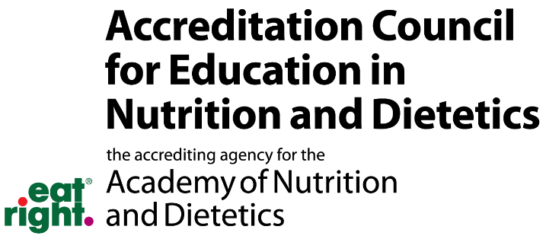
Education in Nutrition and Dietetics of The Academy of Nutrition and Dietetics.
  - Email: ACEND@eatright.org
  - Phone: 800/877-1600, ext. 5400
  - Mail: 120 South Riverside Plaza
  - Suite 2190, Chicago, IL 60606- 6995

Verification Statements
All individuals who graduate with a concentration in Dietetics or Culinary Dietetics will receive a verification statement, which certifies that they have completed the requirements of a nutrition and dietetics education program accredited by the Accreditation Council for Education in Nutrition and Dietetics (ACEND). Five signed copies will be mailed to you once your degree is conferred, usually about 3-4 weeks. The department will retain two signed copies; you may contact them for additional copies. Please allow up to two weeks for processing.
This verification statement allows an individual:

    - To establish eligibility for a Dietetic Internship program
    - To establish eligibility to take the registration examination for dietitian nutritionist and nutrition and dietetic technicians.
Complaints Related to the DPD Program
A student enrolled in the IUP DPD program who has a complaint related to the program can file a complaint with the DPD Director. The complaint should be in writing and submitted in a sealed envelope to the DPD Director. The complaint must be signed by the person submitting it.
The DPD director will meet with the student and pursue avenues to resolve the complaint. If the student is not satisfied the DPD director will present the complaint to the Department Chair. The Chair then will attempt to resolve the issue and then if not satisfied the complaint will be presented to the Dean of the College.
The student can confidently bring these concerns being assured that retaliation will not occur in any way to the student. The department chair will coordinate these activities, gaining assurance from affected parties that no retaliation will occur.
Grade appeal information can be found at the following website.
https://www.iup.edu/academicaffairs/for-faculty/academic-integrity/student-grade-appeal/index.html
Complaints Relative to Program Compliance

The Accreditation Council for Education in Nutrition and Dietetics (ACEND) will review complaints that relate to a program’s compliance with the accreditation/approval standards. The Council is interested in the sustained quality and continued improvement of dietetics education programs but does not intervene on behalf of individuals or act as a court of appeal for individuals in matters of admission, appointment, promotion or dismissal of faculty, staff, or students. See this link for more information. https://www.eatrightpro.org/acend/public-notices-and-announcements/filing-a-complaint-with-acend

A copy of the accreditation standards and/or the Council’s policy and procedure for submission of complaints may be obtained by completing the steps listed at this website. https://www.eatrightpro.org/acend/public-notices-and-announcements/filing-a-complaint-with-acend/procedure-for-complaints-against-accredited-programs

Department Undergraduate Dietetics Program Director
The accredited curriculum of the dietetics track is monitored by the undergraduate dietetics program director, who can assist you with questions that relate to the Dietetics track. She is responsible for:
- Preliminary graduation approval for students in the Didactic Program in Nutrition Dietetics (DPD)
- AND Intent for Program Completion form
- AND Program Completion Verification form
- Outcomes Assessment
- Supervised practice options and advice

Dr . Nicole Clark, DCN, RDN, LDN, CDCES-DPD Director Fall 2025
nclark@iup.edu
724-357-4440
Dr. Pao Ying Hsiao, PhD, RDN, LDN- DPD Director Spring 2026
pyhsiao@iup.edu
724.357.7917

Academy of Nutrition and Dietetics Supervised Practice (Post Baccalaureate)
In FONU 430 Professional Topics in Food and Nutrition, information and assistance will be provided on how to apply for a supervised practice + Master Degree

Code of Ethics for the Profession of Dietetics
Approved by the American Dietetic Association’s Board of Directors, House of Delegates, and Commission on Dietetic Registration, February 2018, the Code of Ethics can be found at the end of the handbook in the Appendix. All students within the Food and Nutrition Program are expected to follow the university standards of academic integrity as well as the Code of Ethics for the Profession of Dietetics.

Glossary of Terms

Academy of Nutrition and Dietetics (AND)
www.eatrightpro.org

With more than 70,000 members, the Academy of Nutrition and Dietetics is the largest professional organization for dietitians, dietetic technicians and dietetic professionals. AND members represent a diverse mix of professionals who work in settings ranging from health care facilities and universities to businesses and government or community agencies to private practice. Most dietetic professionals choose to belong to AND because of the variety and quality of membership benefits, including skill-building, networking, legislative involvement, and public relations. AND strives to improve the nation’s health and advance the profession of dietetics through research, education, and advocacy. Application information is available on department bulletin boards.
Accreditation Council for Education in Nutrition and Dietetics (ACEND)
www.eatright.org/acend

The Accreditation Council for Education in Nutrition and Dietetics, a specialized accrediting body recognized by the Council for Higher Education Accreditation and the United States Department of Education, is AND’s education accrediting agency. The ACEND exists to serve the public by establishing and enforcing eligibility requirements and accreditation standards that ensure the quality and continued improvement of nutrition and dietetics education programs. Programs meeting ACEND standards are accredited.
ACT
With locations in every state, ACT provides a nationwide network of more than 230 computer- based testing facilities in which to complete the National Registration Examination for Dietetics.
Commission on Dietetic Registration (CDR)
www.cdrnet.org

The Commission on Dietetic Registration is the credentialing agency for the Academy of Nutrition and Dietetics. This agency is responsible for protecting the public’s nutrition health and welfare by establishing and enforcing minimum competency for entry-level practice, and standards and qualifications for dietetic registration. Registration is a voluntary credential. The components for dietetic registration include meeting eligibility requirements, earning a passing score on the registration examination, and participating in continuing professional education. Registration assists in insuring entry-level competency as well as continuing competency and development of dietetic professionals.
Coordinated Program in Dietetics (CP)
The Coordinated Program in Dietetics combines required dietetics coursework and at least 1200 hours of supervised practice within an academic program leading to a bachelor’s or master’s degree. Graduates of CP’s who are verified by the program director are eligible to complete the CDR Registration Exam for Dietitians.

Didactic Program in Nutrition and Dietetics (DPD)
The Didactic Program in Nutrition and Dietetics provides required dietetic coursework leading to a bachelor’s or master’s degree. Graduates of DPD programs receive verification statements from the program directors confirming that they have completed the required dietetic coursework. They may then apply for dietetic internships to establish eligibility to complete the CDR registration examination for dietitians.
Dietetic Technician Program (DT)
The Dietetic Technician Program must provide required DT coursework and at least 450 hours of supervised practice within an academic program leading to an Associate’s degree.
Future Education Model
There are some exciting changes coming to nutrition and dietetics education. ACEND believes that a minimum of a master’s degree is needed to adequately prepare graduates with the complexity, depth and breadth of knowledge, skill and judgement needed for future practice as a register dietitian nutritionist – aligning with the Commission on Dietetic Registration’s January 1, 2024, requirement that applicants taking the Registration Examination for Dietitians will need a master’s degree. The current DPD program at IUP will continue in its current state as we move toward the Future Education Model. More information about the Future Education Model can be found in the Appendices.
Pennsylvania Academy of Nutrition and Dietetics (PAND)
www.eatrightpa.org

The Pennsylvania Academy of Nutrition and Dietetics (PAND), an affiliate of the Academy of Nutrition and Dietetics, is the advocate of the dietetics profession serving the public through the promotion of optimal nutrition, health and well-being. There are over 3400 members throughout the Commonwealth of Pennsylvania. Members also can also join one of our six districts that represent their geographical locations in Pennsylvania.

Society for Nutrition Education and Behavior (SNEB)
www.sneb.org
The Society for Nutrition Education and Behavior (SNEB) represents the unique professional interests of nutrition educators in the United States and worldwide. SNEB is dedicated to promoting healthy, sustainable food choices and has a vision of healthy people in healthy communities. SNE provides forums for sharing innovative strategies for nutrition education, expressing a range of views on important issues, and disseminating research findings. Members of SNEB educate individuals, families, fellow professionals, and students, and influence policy makers about nutrition, food, and health. Visit their website for information about how can become a student member.

The Dietetics Profession
Dietetics is the branch of knowledge concerned with the diet and its effect on health, especially with the practical application of a scientific understanding of nutrition. The dietetics profession affords a food and nutrition professional the opportunity to combine an interest in food, nutrition, fitness, health and management with meeting the needs of individuals or groups in wellness, illness, physical performance, and by providing leadership. Food and nutrition professionals are employed in medical facilities such as hospitals, clinics, and long-term care communities providing nutrition care. They also manage food service organizations in school districts, cities and counties. In private practice, many food and nutrition professionals provide nutrition counseling for clients concerned with better health and nutrition and for those who have modified dietary needs. Some food and nutrition professionals work for state, national, and government agencies or work in education teaching dietetics, nutrition and food service management courses.
According the Occupational Outlook Handbook¹, “employment of dietitians and nutritionists is projected to grow 11 percent from 2018 to 2028, much faster than the average for all occupations. In recent years, interest in the role of food and nutrition in promoting health and wellness has increased, particularly as a part of preventative healthcare in medical settings.
“According to the Centers for Disease Control, more than one-third of U.S. adults are obese. Many diseases, such as diabetes and heart disease, are associated with obesity. The importance of diet in preventing and treating illnesses is now well known. More dietitians and nutritionists will be needed to provide care for people with these conditions.
“Moreover, as the baby-boom generation grows older and looks for ways to stay healthy, there will be more demand for dietetic and nutrition services. In addition, there will be demand for dietitians and nutritionists in grocery stores to help consumer make healthy food choices.”
After meeting a certain knowledge and skill requirements, a graduate from an accredited program can become a Registered Dietitian (RD) or Registered Dietitian Nutritionist (RDN). Registration is a voluntary credential. Without registration, though, dietetic professionals cannot call themselves a Registered Dietitian or Registered Dietitian Nutritionist, nor can they use the acronyms.
The median annual wage for dietitians and nutritionists was $60,370 in May 2018.

1 US. Bureau of Labor Statistics, Employment Projections program

RDs and RDNs are food and nutrition experts who have:
- Completed the minimum of a Masters Degree and Supervised Practice granted by a U.S. regionally accredited college or university, or foreign equivalent;
- Met current minimum academic requirements as approved by the Accreditation Council for Education in Nutrition and Dietetics (ACEND) of the Academy of Nutrition and Dietetics;
- Completed a least 1000-hour minimum supervised practice program accredited by ACEND;
- Successfully completed the registration examination for dietitians;
- Remitted the annual registration fee; and
- Completed the Professional Development Portfolio recertification requirements.


Effective January 1, 2024, the Commission on Dietetic Registration (CDR) will require a minimum of a master’s degree to be eligible to take the credentialing exam to become a registered dietitian nutritionist (RDN). In order to be approved for registration examination eligibility with a bachelor’s degree, an individual must meet all eligibility requirements and be submitted into CDR’s Registration Eligibility Processing System (REPS) before 12:00 midnight Central Time, December 31, 2023. For more information about this requirement visit CDR’s
website: https://www.cdrnet.org/graduatedegree. In addition, CDR requires that individuals complete coursework and supervised practice in program(s) accredited by the Accreditation Council for Education in Nutrition and Dietetics (ACEND). Graduates who successfully complete the ACEND-accredited Dietetic Internship Certificate program at Indiana University of Pennsylvania are eligible to apply to take the CDR credentialing exam prior to become an RDN. In most states, graduates also must obtain licensure or certification to practice.

Career Options for students not pursuing a career as a Registered Dietitian Nutritionist (RD, RDN)
Nutrition and Dietetic Technician, Registered (NDTR) or Dietetic Technician, Registered (DTR)
Individuals who graduate from the Dietetics track at IUP have the option to either a Nutrition and Dietetic Technician, Registered (NDTR) or a Dietetic Technician, Registered (DTR). Individuals who have completed both a baccalaureate degree and a Didactic Program in Nutrition and Dietetics (DPD) will be able to take the registration examination for dietetic technicians without meeting additional academic or supervised practice requirements.
Once credentialed, these individuals will be required to comply with CDR recertification requirements, the Code of Ethics for the Profession of Dietetics and the Standards of Practice, and Standards of Professional Performance.

Trained in food and nutrition, NDTR and DTRs are an integral part of healthcare and food service management teams. They work with RDs in a variety of employment settings, including hospitals, HMOs, retirement centers, research facilities, schools, day care centers, food service, WIC programs, Meals on Wheels, health clubs, community wellness centers, and food companies.
Additional information can be obtained at www.cdrnet.org or talking to the DPD Program Director.

Certified Dietary Manager, Certified Food Protection Professional (CDM, CFPP)
A Certified Dietary Manager, Certified Food Protection Professional (CDM, CFPP) has the education, training, and experience to competently perform the responsibilities of a dietary manager and has proven this by passing a nationally-recognized credentialing exam and fulfilling the requirements needed to maintain certified status. CDM, CFPPs are experts at managing food service operations and ensuring food safety. They are responsible for implementation of menus, food service purchasing, and food preparation. They apply nutrition principles, document nutrition information, manage work teams, and much more.
A CDM, CFPP has achieved defined competencies in 10 key areas:

Gathering Nutrition Data | Applying Nutrition Data
Providing Food Services | Providing Nutrition Education
Hiring and Supervising Employees | Developing Personnel & Communications
Professional Interactions | Managing Supplies. Equipment Use, Sanitation and Safety
Managing Food Production | Managing Business Operations

Frequently Asked Questions
What is the difference between a registered dietitian (RD); registered dietitian nutritionist (RDN); nutrition and dietetic technician, registered (NDTR); dietetic technician, registered (DTR); and, a nutritionist?
Registered dietitian nutritionist or RDN and dietetic technician, registered or NDTR can only be used by dietetics practitioners who are currently authorized to use the credential by the Commission on Dietetic Registration of the Academy of Nutrition and Dietetics. These are legally protected titles. Individuals with these credentials have completed specific academic and supervised practice requirements, successfully completed a registration examination and maintained requirements for recertification. The definition and requirements for the term "nutritionist" vary. Some states have licensure laws that define the scope of practice for someone using the designation nutritionist.
What skills does a person need to be a nutrition or dietetics professional?

Beneficial to be a dietetics professional is an active interest in people, food and science. Communication, analytical, and research skills are also valuable. Dietetics professionals need to be able to research and analyze information. They need to be able to explain complex information in both simplified and professional ways so that clients/patients and other health professionals understand their explanations, recommendations, and remarks. Being able to work as part of a team and independently is also needed.

Syllabus of Classes
Students should keep physical and/or electronic copies of syllabi for ALL courses taken as part of their personal academic record. Syllabi are occasionally required as documentation for future jobs, internships, graduate school, certifications, etc. Maintain copies of all syllabi as part of your other personal, long-term documentation.
Will I be a RD or RDN when I graduate from IUP with my Bachelor of Science degree in Dietetics?
No. After you have earned your BS degree and a Verification Statement from the DPD Director stating that you have completed the requirements of an ACEND-accredited program, you must complete an accredited supervised practice program and a Masters degree. Once these components have been completed, then the CDR grants individuals permission to complete the Registration Examination for Dietitians. When you pass the exam, then you are entitled to use the credential RD or RDN.
How can students prepare themselves to be competitive for MS+ Supervised Practice Programs?

Although there is no guarantee of receiving a supervised practice appointment, there are several accomplishments that make a student more competitive. The following criteria help make students competitive for an appointment to a dietetic internship.
- Grades—Earn a GPA ≥3.4. Repeat courses in which you had subpar performance.
- Professional Experiences – Paid or volunteer: Examples include: hospital dietetics department experience and other dietary-related experiences such as college or camp food service, weight management camp, long term care food service, catering operations, and community nutrition programs are all considered very good. Most supervised practice directors are looking for individual whose work or volunteer experience contributes to personal growth, is people-oriented, and/or involves responsibility and decision-making. Discuss professional experience opportunities with any food and nutrition faculty.
- Extra-Curricular Activities – College/ University (e.g. SAND), sports, community service projects, and student-teacher projects/research.
- Leadership – Join campus and non-campus organizations. Become an officer or volunteer as a committee chair. The ability to lead a group and work as an effective team member are highly valued attributes.
- Professionalism – Be responsible, dependable, conscientious, considerate, self-motivated, and flexible. Work hard academically and in the work place; respect peers, professors, supervisors; get involved; and, be a leader.
- Letters of Recommendation—Required by professors and work supervisors. These letters cultivate respectful professional relationships with faculty members, supervisors, and employers so they know you well enough to write an outstanding letter of recommendation.

APPENDICES

Indiana University of Pennsylvania Didactic Program in Dietetics
On-going Assessment of Core Knowledge for the RDN
A complete listing to the competencies as well as background information may be found at: http://www.eatrightacend.org/ACEND/
https://www.eatrightpro.org/-/media/eatrightpro-files/acend/about-program- accreditation/accreditation- standards/2017standardsfordpdprograms.pdf?la=en&hash=B981CA74C919679C37830041802FF4 E711C9E9CF

Indiana University of Pennsylvania
RDN Core Knowledge Assessment (Required Element 4.1 and 4.2)
DPD

All students must receive a “C” on the following assignments to obtain their DPD verification statement.

Domain 1. Scientific and Evidence Base of Practice: Integration of scientific information and translation of research into practice.
Core Knowledge Statement | List course and course number in which the knowledge is assessed | List specific, required assessment method(s) (exam, rubric, project, etc.) used to measure student achievement of core knowledge | Date KRDN Achieved  (Students should document this date and update their advisor at least 2 times a year)  This form will need to be provided to the DPD Director the semester prior to graduation)
KRDN 1.1 Demonstrate how to locate, interpret, evaluate and use professional literature to make ethical, evidence-based practice decisions. | FONU 362-  Experimental Food | Final Project Rubric | Date Achieved:  Grade Received:
KRDN 1.2 Select and use appropriate current information technologies to locate and apply evidence-based guidelines and protocols. | FONU 484-  Senior Seminar | Seminar presentation | Date Achieved:  Grade Received:
KRDN 1.3 Apply critical thinking skills. | FONU 415  Sustainable Nutrition | Sustainable Policy Assignment | Date Achieved:  Grade Received:
Domain 2. Professional Practice Expectations: Beliefs, values, attitudes and behaviors for the nutrition and dietetics practitioner level of practice.

KRDN 2.1 Demonstrate effective and professional oral and written communication and documentation. | FONU 455-Medical Nutrition Therapy II | Case study ADIME for simulation | Date Achieved:  Grade Received:
KRDN 2.2 Describe the governance of nutrition and dietetics practice, such as the Scope of Practice for the Registered Dietitian Nutritionist and the Code of Ethics for the Profession of Nutrition and Dietetics. | FONU 430- Professional Topics in Food and Nutrition | SOP/Code of Ethics assignment | Date Achieved:  Grade Received:
KRDN 2.3 Assess the impact of a public policy position on nutrition and dietetics practice. | FONU 430- Professional Topics in Food and Nutrition | Legislative Letter Assignment | Date Achieved:  Grade Received:
KRDN 2.4 Discuss the impact of health care policy and different health care delivery systems on food and nutrition services. | FONU 430- Professional Topics in Food and Nutrition | Health Care Policy Assignment | Date Achieved:  Grade Received:
KRDN 2.5 Identify and describe the work of interprofessional teams and the roles of others with whom the registered dietitian nutritionist collaborates. | FONU 255- Nutrition Assessment and Medical Terminology | Quiz Questions | Date Achieved:  Grade Received:
KRDN 2.6 Demonstrate cultural humility, awareness of personal biases and an understanding of cultural differences as they contribute to diversity, equity and inclusion. | FONU 370- Human Food Consumption Patterns | Autoethnography | Date Achieved:  Grade Received:
KRDN 2.7 Describe contributing factors to health inequity in nutrition and dietetics including structural bias, social inequities, health disparities and discrimination. | FONU 430- Professional Topics in Food and Nutrition | Diversity, Health Disparities, and discrimination Assignment | Date Achieved:  Grade Received:
KRDN 2.8 Participate in a nutrition and dietetics professional organization and explain the significant role of the organization. | FONU 110- Career in Food and Nutrition | Required SAND Meeting Reflection | Date Achieved:  Grade Received:
KRDN 2.9 Defend a position on issues impacting the nutrition and dietetics profession. | FONU 415-Sustainable Nutrition | Position Paper Assignment | Date Achieved:  Grade Received:

Domain 3. Clinical and Client Services: Development and delivery of information, products and services to
individuals, groups and populations.

KRDN 3.1 Use the Nutrition Care Process and clinical workflow elements to assess nutritional parameters, diagnose nutrition related problems, determine appropriate nutrition interventions and develop plans to monitor the effectiveness of these interventions. | FONU 355-Medical Nutrition Therapy I | Final Case study Rubric | Date Achieved:  Grade Received:
KRDN 3.2 Develop an educational session or program/educational strategy for a target population. | FONU 466-Nutrition Counseling and Education Lab | Self-Initiated Nutrition Education Lesson | Date Achieved:  Grade Received:
KRDN 3.3 Demonstrate counseling and education methods to facilitate behavior change and enhance wellness for diverse individuals and groups. | FONU 466-Nutrition Counseling and Education Lab | Nutrition Counseling tape self-evaluation | Date Achieved:  Grade Received:
KRDN 3.4 Practice routine health screening assessments, including measuring blood pressure and conducting waived point-of-care laboratory testing (such as blood glucose or cholesterol). | FONU 255-Nutrition Assessment and Medical Terminology  FONU 355-Medical Nutrition Therapy I | In-Class lab Observation Checklist  Blood Glucose Monitoring Assignment | Date Achieved:  Grade Received:
KRDN 3.5 Describe concepts of nutritional genomics and how they relate to medical nutrition therapy, health and disease. | FONU 430- Professional Topics in Food and Nutrition | Genomics/Personalized Nutrition Assignment | Date Achieved:  Grade Received:
KRDN 3.6 Develop nutritionally sound meals, menus and meal plans that promote health and disease management and meet client’s/patient’s needs. | FONU 455-Medical Nutrition Therapy II | Renal Meal planning Assignment | Date Achieved:  Grade Received:

Domain 4. Practice Management and Use of Resources: Strategic application of principles of management and systems in the provision of services to individuals and organizations.
KRDN 4.1 Apply management theories to the development of programs or services. | FONU 430- Professional Topics in Food and Nutrition | Management Theory assignment | Date Achieved:  Grade Received:
KRDN 4.2 Evaluate a budget/financial management plan and interpret financial data. | HOSP 330- Applications of Food Production and Service | Financial reconciliation sheet
KRDN 4.3 Demonstrate an understanding of the regulation system related to billing and coding, what services are reimbursable by third party payers, and how reimbursement may be obtained. | FONU 430- Professional Topics in Food and Nutrition | Billing and Coding Assignment | Date Achieved:  Grade Received:
KRDN 4.4 Apply the principles of human resource management to different situations. | HOSP 256- Human Resources in the Hospitality Industry | Training program assignment | Date Achieved:  Grade Received:
KRDN 4.5 Apply safety and sanitation principles related to food, personnel and consumers. | HOSP 330- Applications of Food Production and Service | Final Reflective Log | Date Achieved:  Grade Received:
KRDN 4.6 Explain the processes involved in delivering quality food and nutrition services. | HOSP 330- Applications of Food Production and Service | Final Reflective Log | Date Achieved:  Grade Received:
KRDN 4.7 Evaluate data to be used in decision-making for continuous quality improvement. | FONU 430- Professional Topics in Food and Nutrition | Quality Improvement Assignment | Date Achieved:  Grade Received:

Domain 5. Leadership and Career Management: Skills, strengths, knowledge and experience relevant
to leadership potential and professional growth for the nutrition and dietetics practitioner.

KRDN 5.1 Perform self-assessment that includes awareness in terms of learning and leadership styles and cultural orientation and develop goals for self-improvement. | FONU 465- Nutrition Counseling and Education | Self-Awareness Journal | Date Achieved:  Grade Received:
KRDN 5.2 Identify and articulate one’s skills, strengths, knowledge and experiences relevant to the position desired and career goals. | FONU 430- Professional Topics in Food and Nutrition | Self-Evaluation of career goals assignment | Date Achieved:  Grade Received:
KRDN 5.3 Practice how to self-advocate for opportunities in a variety of settings (such as asking for needed support, presenting an elevator pitch). | FONU 430- Professional Topics in Food and Nutrition | Career Services Self-Reflection | Date Achieved:  Grade Received:
KRDN 5.4 Practice resolving differences or dealing with conflict. | FONU 430- Professional Topics in Food and Nutrition | Role-play Assignment | Date Achieved:  Grade Received:
KRDN 5.5 Promote team involvement and recognize the skills of each member. | FONU 415-Sustainable Nutrition | Water Research Project | Date Achieved:  Grade Received:
KRDN 5.6 Demonstrate an understanding of the importance and expectations of a professional in mentoring and precepting others. | FONU 430- Professional Topics in Food and Nutrition | Leadership assignment | Date Achieved:  Grade Received:
Appendix B: Graduate Degree Registration Eligibility Requirement: FAQ’s
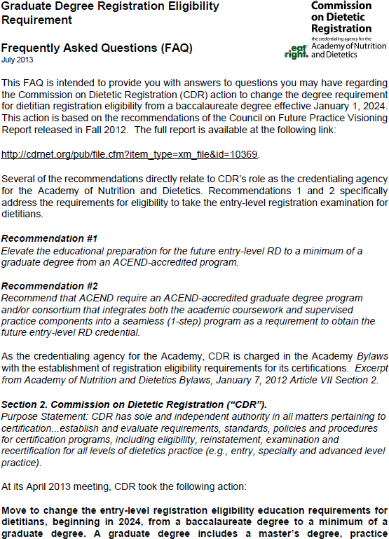

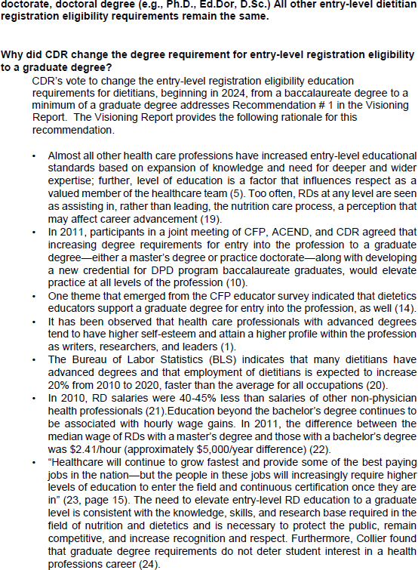

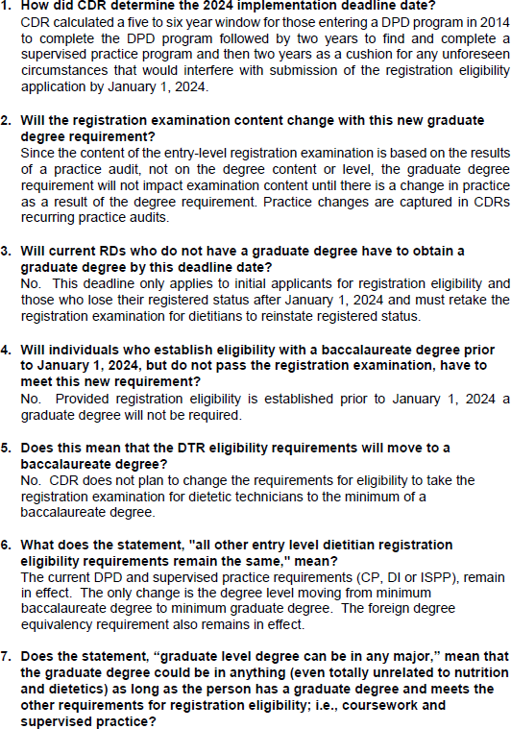

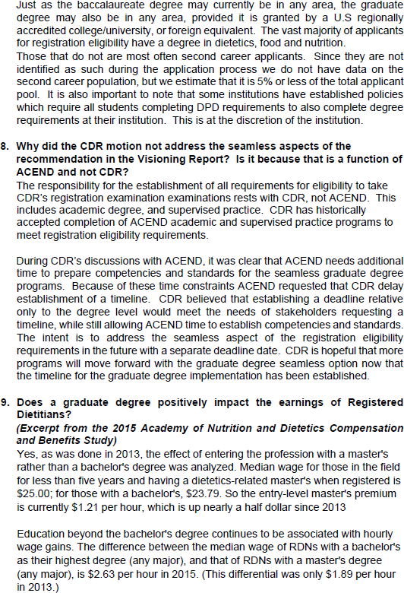

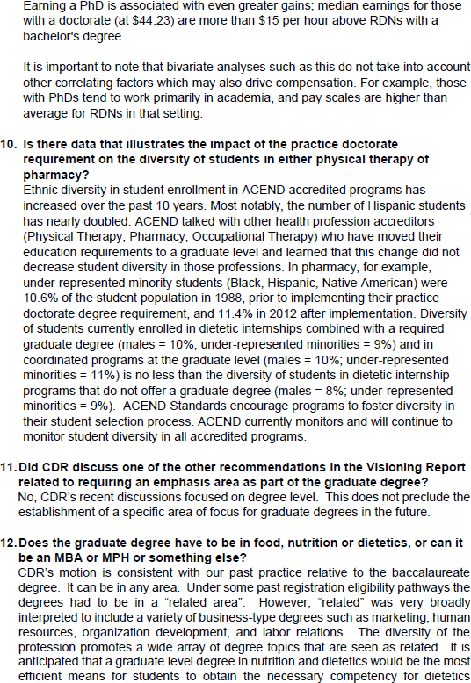

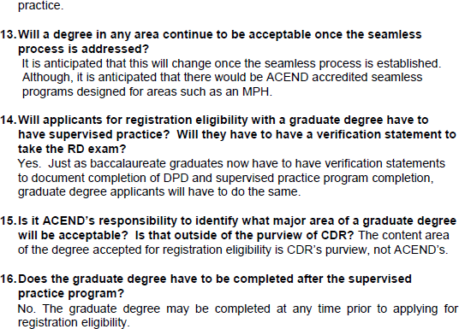

Appendix C: Routes to Meeting Eligibility Requirements for the Registration Exam for Dietitians PRIOR TO January 1, 2024
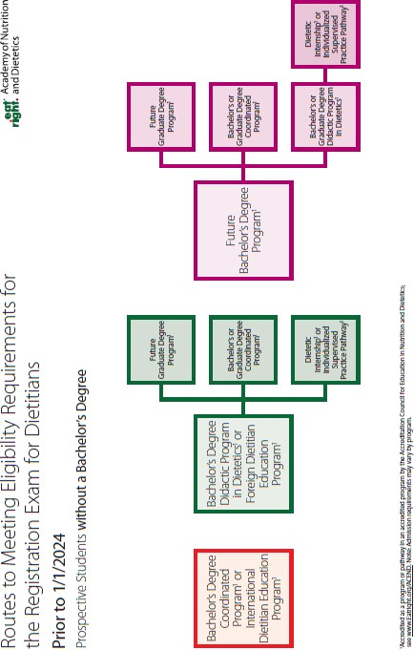

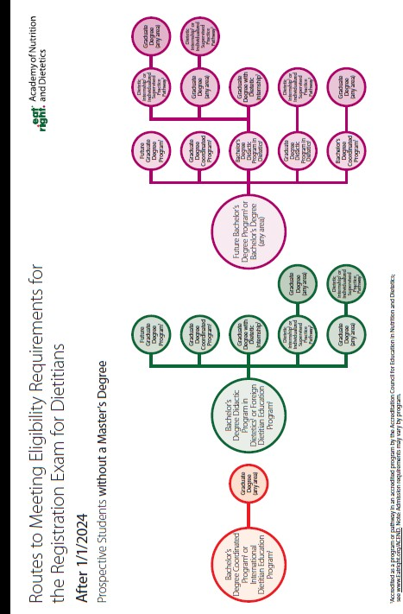
Appendix D: Routes to Meeting Eligibility Requirements for the Registration Exam for Dietitians AFTER January 1, 2024

Appendix E: What Salary Might I Expect as a Registered Dietitian?¹
Plan and conduct food service or nutritional programs to assist in the promotion of health and control of disease. May supervise activities of a department providing quantity food services, counsel individuals, or conduct nutritional research.
National estimates for Dietitians and Nutritionists
Industry profile for Dietitians and Nutritionists
Geographic profile for Dietitians and Nutritionists

National estimates for Dietitians and Nutritionists:
Employment estimate and mean wage estimates for Dietitians and Nutritionists:
Employment (1) | Employment  RSE (3) | Mean hourly  wage | Mean annual  wage (2) | Wage RSE (3)
69,880 | 2.5 % | $ 33.34 | $ 69,350 | 0.6 %

Reference:

1. Bureau of Labor Statistics, Occupational Employment Statistics.
https://www.bls.gov/oes/current/oes291031.htm#nat
Appendix F: Code of Ethics for the Nutrition and Dietetics Profession

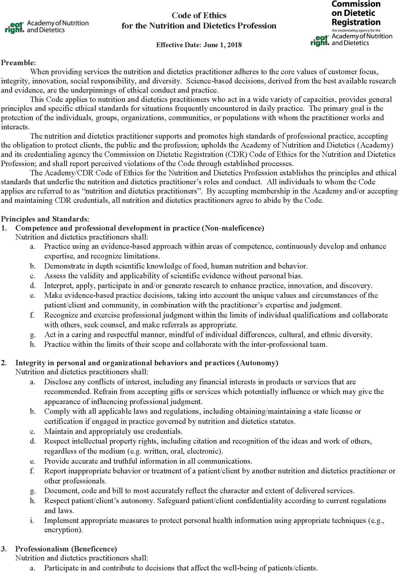

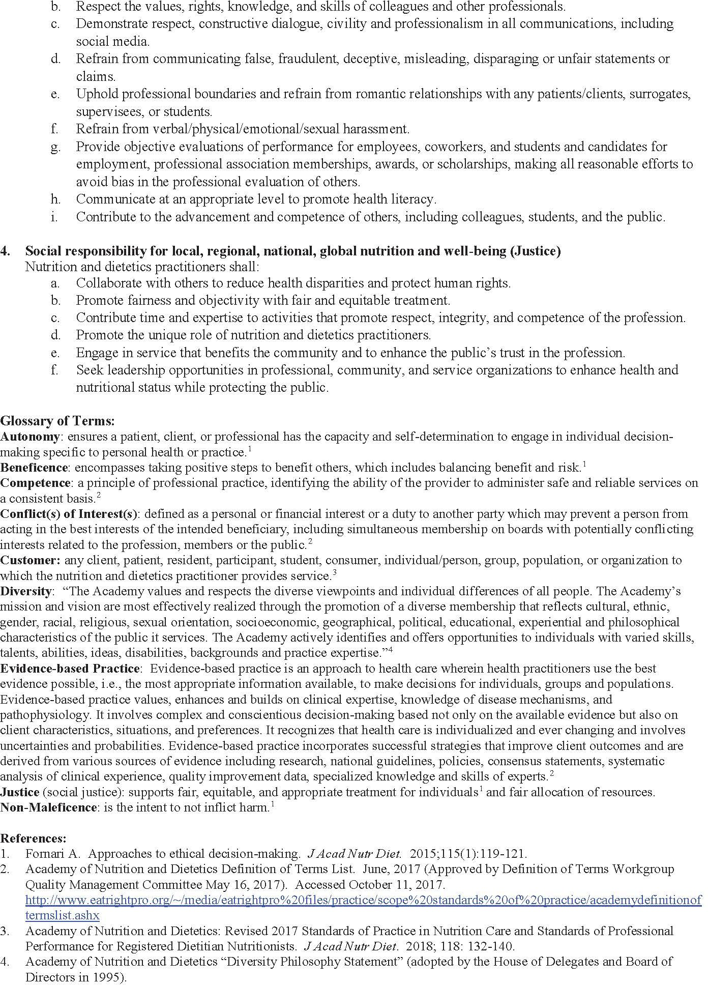

Appendix G: Careers in Dietetics: Becoming a Registered Dietitian Nutritionist

How Do I Become an RDN?
To become a registered dietitian nutritionist, you will need to:
- Earn a degree from an accredited Master's Program and complete an Accredited Supervised Program. Classes vary according to program, but in general, coursework covers subjects that may range from food and nutrition sciences, foodservice systems management, business, economics, computer science, culinary arts, sociology and communication to science courses such as biochemistry, physiology, microbiology, anatomy and chemistry.
- Complete a supervised practice requirement. In addition to earning a MS degree, individuals must complete at least 1,000 hours of supervised practice to gain real-world experience and apply knowledge learned in the classroom to the context of a variety of work settings.
- Pass a national exam for RDNs. Once you complete your degree and supervised practice, you may schedule to take CDR's Registration Examination for Registered Dietitians to become a credentialed as registered dietetics nutritionist. This is called "RDN eligibility," meaning you have completed the requirements to become eligible to take the national exam.
- Meet requirements to practice in your state. Many states have regulatory laws (i.e. licensure) for food and nutrition practitioners. All states accept the RDN credential for state licensure purposes.
- Stay up-to-date in dietetics through continuing education. After successfully passing the national exam and earning the credential, RDNs maintain ongoing professional development in order to stay up to date on the latest research, recommendations and best practices.
Dietetics education programs in colleges and universities are accredited by the Accreditation Council for Education in Nutrition and Dietetics—or ACEND. As an accrediting agency, ACEND makes sure that students preparing for careers as RDNs are getting the education they need to qualify for taking the national RDN exam.
There are several kinds of accredited dietetics education programs—each offering a different experience and “pathway” to RDN eligibility.

Pathway: Coordinated Programs (CP)
Coordinated programs combine classroom learning with supervised practice experiences within one program. When you graduate from a coordinated program, you satisfy both the degree and supervised practice requirements and are eligible to take the national RDN exam. There are coordinated programs at both the bachelor's and master's level.

Pathway: Future Education Model (FEM) Graduate Program in Nutrition and Dietetics (GP)
This pathway consists of graduate-level coursework and supervised experiential learning incorporated into a one graduate degree program. When you graduate from a GP, you satisfy both the degree and supervised practice requirements to be eligible to take the national RDN exam.
Note: It’s important to differentiate accredited GPs from other master’s or doctorate programs that may not include the specific coursework or supervised practice required RDN eligibility. Examples are advanced degrees in disciplines that existing RDNs might pursue to complement their credential but that are not accredited by ACEND for their graduates to be eligible to take the national RDN credentialing exam.

Find out more by going to https://www.eatright.org/become-an-rdn
Appendix H: Careers in Dietetics: Becoming a Dietetic Technician, Registered

To become a nutrition and dietetic technician, registered, you will need to:
- Earn at least an associate's degree and completed an accredited NDTR program. These programs include 450 hours of supervised practice experience in various community programs, health-care and foodservice facilities.
OR
Earn at least a bachelor's degree and complete coursework accredited DPD. Learn more about didactic programs in dietetics or coordinated programs in dietetics.
- Pass a national exam for NDTRs. Once one completes their educational requirements, they may schedule to take CDR's Registration Examination for Dietetic Technicians to become credentialed as a nutrition and dietetics technician, registered.
- Stay up-to-date in dietetics through continuing education. After successfully passing the national exam and earning the credential, NDTRs maintain ongoing professional development in order to stay up to date on the latest research, recommendations and best practices.
Dietetics education programs in colleges and universities are accredited by the Accreditation Council for Education in Nutrition and Dietetics—or ACEND. As an accrediting agency, ACEND makes sure that students preparing for careers as NDTRs are getting the education they need to qualify for taking the national DTR exam.
There are several kinds of accredited dietetics education programs—each offering a different experience and “pathway” to NDTR eligibility.
- Nutrition and Dietetics Technician Programs (DTs) offer associate's degree level coursework and at least 450 hours of supervised practice for NDTR eligibility.
- Didactic Programs in Dietetics Programs (DPDs) offer bachelor's and graduate level dietitian coursework.
- Coordinated Programs in Dietetics (CPs) offer bachelor's and graduate level dietitian coursework.

Find out more by going to : https://www.eatright.org/become-an-ndtr

Appendix I: Dietetics Career Development Guide: How to become a CDM/CFPP

The Certifying Board for Dietary Managers® (CBDM®) is the credentialing agency responsible for establishing and upholding policies for and the administration of the CBDM Certification Program.

A Certified Dietary Manager, Certified Food Protection Professional (CDM®, CFPP®) has the education and work experience to competently perform the responsibilities of a dietary manager and has proven this by passing the nationally-recognized CDM Credentialing Exam and fulfilling the requirements needed to maintain certified status. CDM, CFPPs work together with Registered Dietitian Nutritionists (RDNs) to provide quality nutritional care in a variety of non-commercial settings and perform a myriad of specialized tasks and roles within a foodservice operation.
CDM, CFPPs are experts at managing foodservice operations and ensuring food safety. They are responsible for implementation of menus, foodservice purchasing, and food preparation. They apply nutrition principles, document nutrition information, manage work teams, and much more.
A CDM, CFPP has achieved defined competencies in five key areas:
• Nutrition
• Foodservice
• Personnel and Communications
• Sanitation and Safety
• Business Operations
Find out more by going to https://www.anfponline.org/become-a-cdm/cdm-cfpp-credential

Appendix J: Signature Page

My signature below indicates that I am responsible for reading and understanding the information provided and referenced in this department/program student handbook.

Print Name

Signature

Date

The Food and Nutrition Program will keep this signed document in your advising folder.

