ACPAC Faculty Survey; for 2005-2006, there were 736 9-mo. employees and 42 12-mo. faculty members.

1. Age: The age distribution is approximately normal, with the modal age range of respondents being 50-59, representing 82 of the 237 respondents (34.60%).
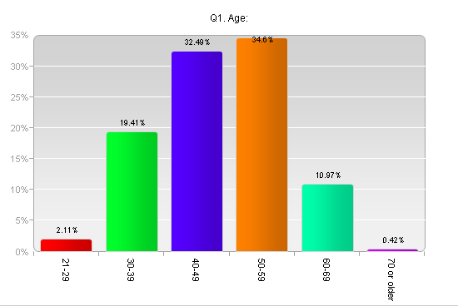

2. Number of years at IUP: This is a random distribution, with the modal category of 0-5 years teaching at IUP. This is 87 of 237 respondents (36.71%). Most of the faculty have 6 years at IUP or more.
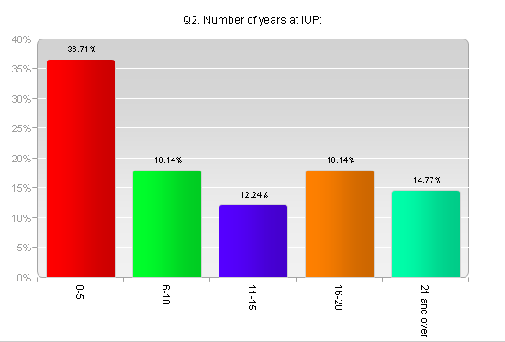

3. Most of the faculty use PC/ Windows. This category is 80.59% of respondents.
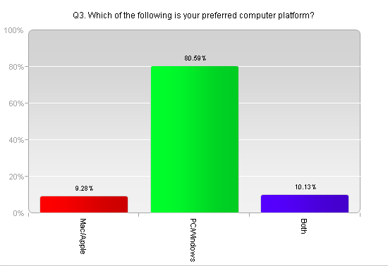

4. The natural sciences and mathematics had the highest response (24.89%) of all the colleges. The was followed by humanities and social sciences (24.47%).
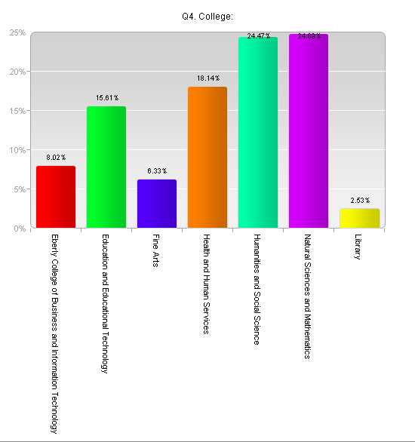

5. On average, the hours a week faculty utilize computers for teaching, research, and leisure to be about equal (33.86%, 33.86%, 32.28%, respectively). For teaching, the modal category is 20 hours per week utilizing computers. For research, 10 hours per week was the modal category. For leisure activities, most faculty spent 5 hours online.
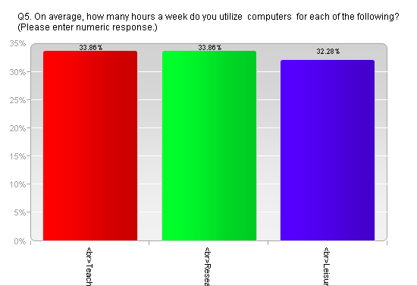

6. On average, the hours a week faculty utilize the internet for teaching, research, and leisure account for approximately equal time (33.76%, 33.91%, and 32.33%, respectively). Most faculty report spending 10 hours per week utilizing the Internet for teaching, 5 hours for research, and 5 hours for leisure.
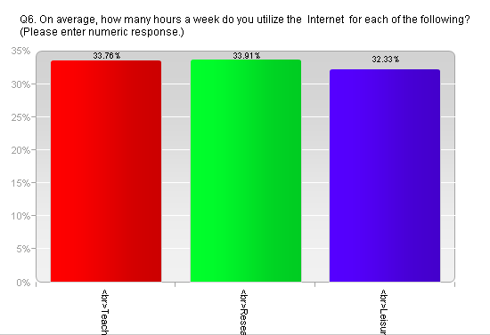

7. It was found that 38.27% of computer work was done in the office, 38.11% was at home, and 23.62% was done in the computer lab or library.
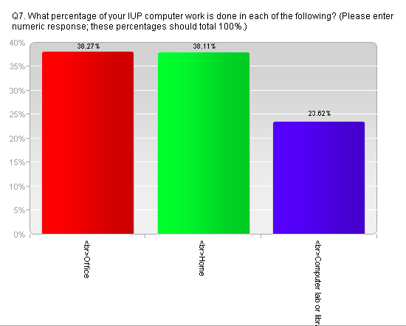

8. It was found 53.28% of faculty Strongly Agree that E-mail is more convenient than most other methods of communication. In addition, 37.99% Agree it is so.
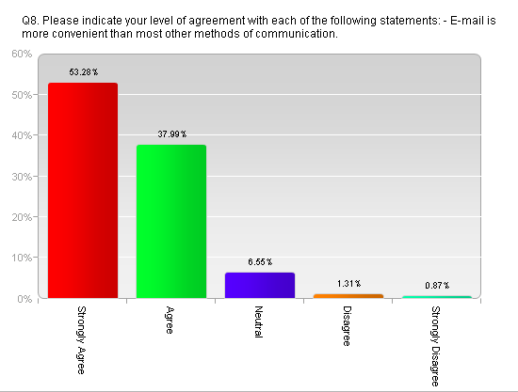

9. 69% of the respondents Strongly Agree that E-mail is the best way to send on message to an entire group of people.
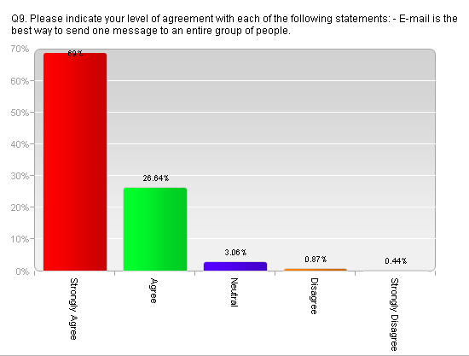
10. It was found that 43.23% of the respondents Strongly Agree that E-mail is an efficient way to communicate with students.
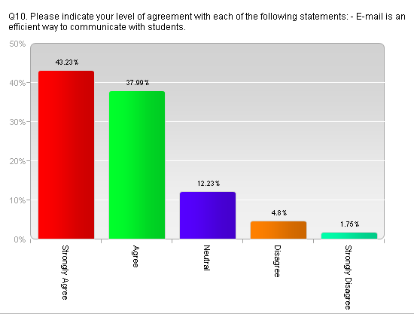

11. Also, 43.23% of respondents Strongly Agree that E-mail is an efficient way to communicate with colleagues.
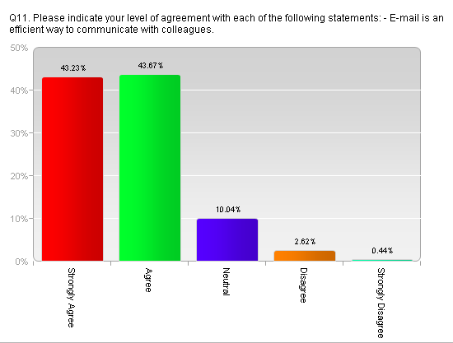

12. 68.88% of respondents Strongly Agree that computers are useful educational tools.
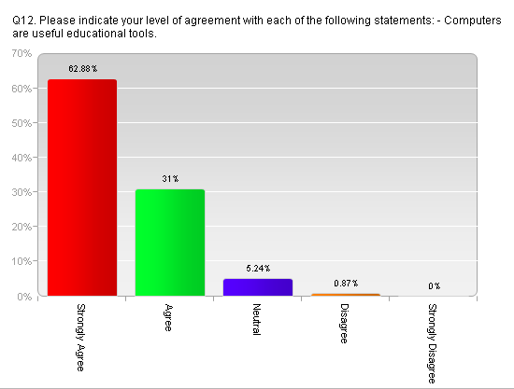

13. It was found that 31.00% of respondents Strongly Agree and 42.36% Agree that computers are improving our educational system.
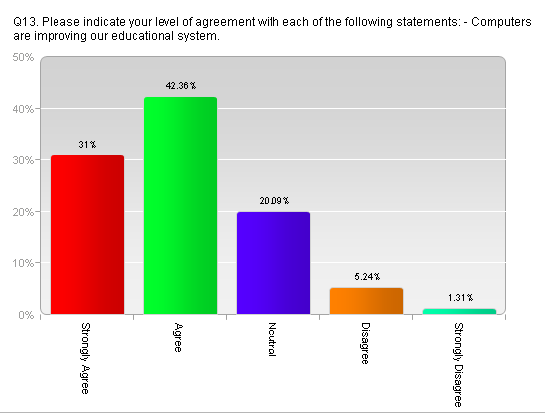
14. It was found that 36.24% of respondents Disagree that computers are negatively affecting the student/ teacher relationship.
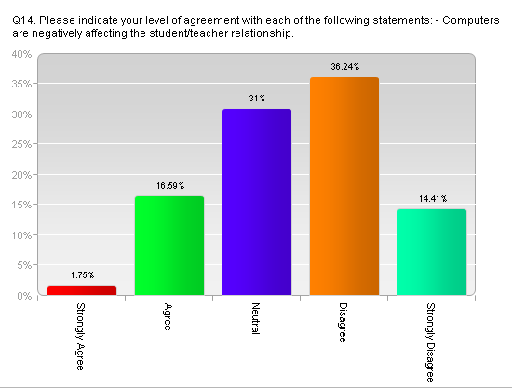
15. Most respondents Agree (49.34%) or Strongly Agree (43.67%) that computers are changing the way we learn and teach.
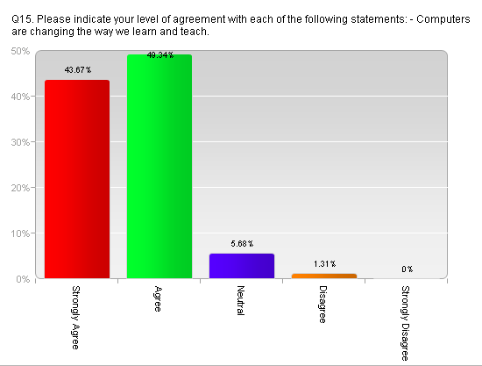
16. Most respondents are Neutral (34.50%) or Disagree (31.00%)
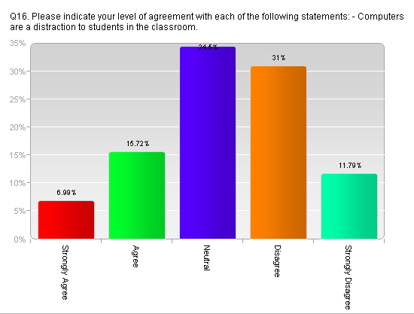
17. The modal category of respondents Disagree (33.19%) that teachers are relying too heavily on computers as a teaching tool.
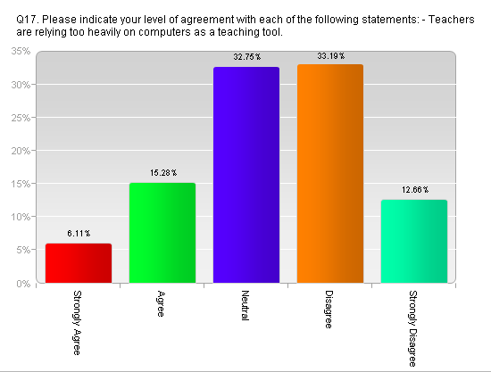
18. The modal response for hours per week using the multimedia equipment installed in classrooms is 6 hours (13.97%). Next was 12 hours (10.92%) and 1 hour (10.92%).
*This graph is unusable.

19. Most said they do not have VPN access to IUP from home (51.97%).
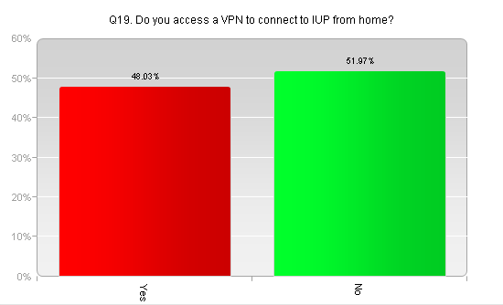
20. Most reported they were Very Proficient (67.25%) or Somewhat Proficient (30.57%) on the their level of proficiency using Microsoft Word.
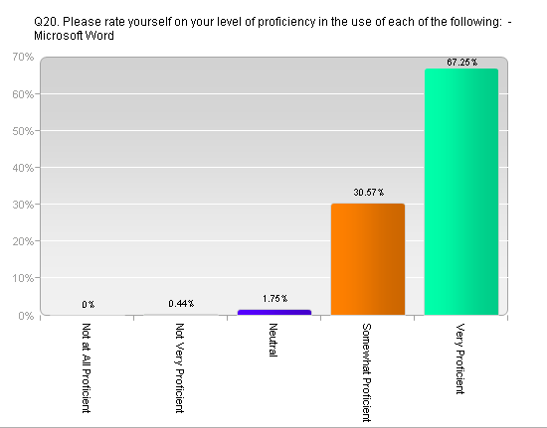
21. Most responded they were Very Proficient (29.69%) or Somewhat Proficient (44.10%) with Microsoft Excel.
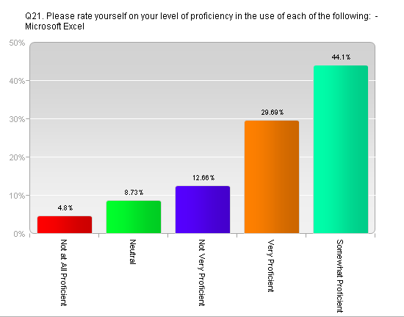
22. Most respondents reported being Very Proficient (42.36%) or Somewhat Proficient (39.74%) with Microsoft Powerpoint.
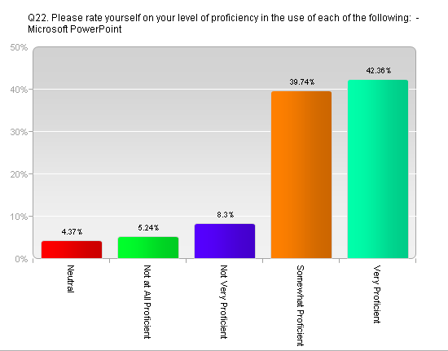
23. Most respondents reported they were Not Very proficient (22.71%) or Not at All Proficient (38.43%) with Microsoft Access.
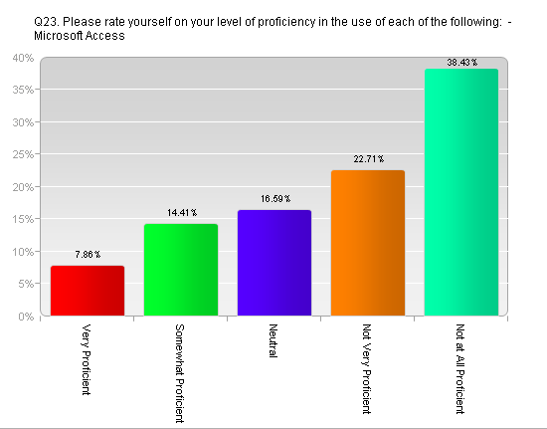
24. Most respondents reported they were Not Very Proficient (20.96%) or Not at All Proficient (39.74%) with Microsoft Frontpage.
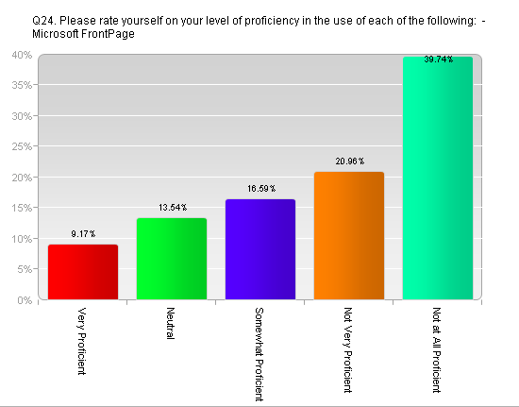
25. Most respondents reported they were Not Very Proficient (21.83%) or Not at All Proficient (37.12%) with Microsoft Publisher.
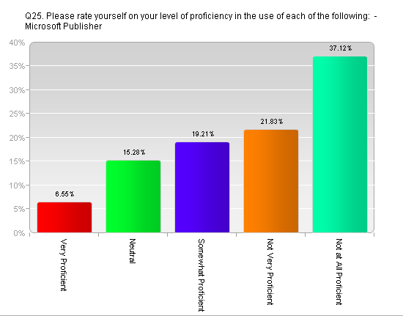
26. Most reported they were Not all All Proficient (41.05%) or Somewhat Proficient (19.65%) with SPSS.
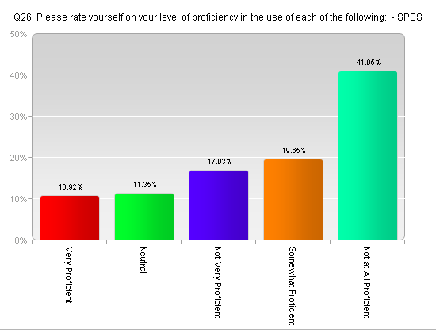
27. Most respondents reported they were Somewhat Proficient (31.44%) or Not at All Proficient (21.83%) with WebCT.
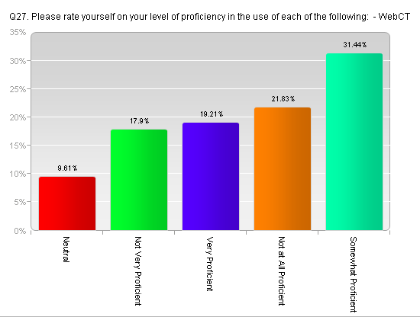
28. Most reported they were either Not at All Proficient (44.10%) or Neutral (19.21%) with Adobe Photoshop Elements.
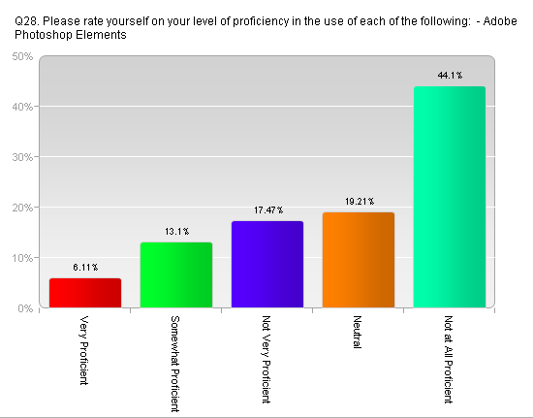
29. Most reported they were Not at all Proficient (43.23%) or Not Very Proficient (19.21%) with Adobe Photoshop.
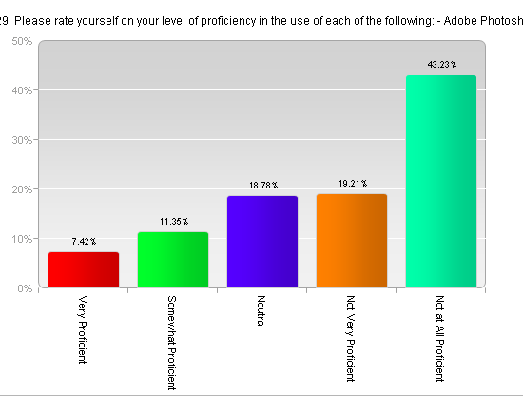
30. Most reported they were Somewhat Proficient (37.12%) or Neutral (20.96%) with Adobe Acrobat.
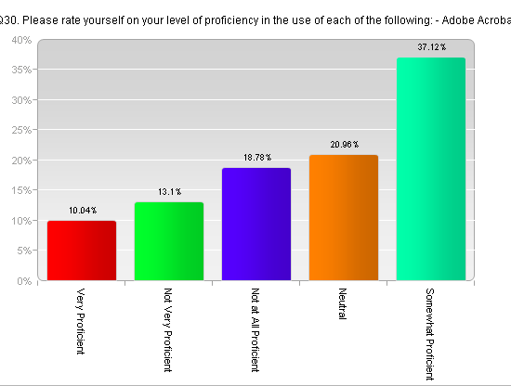
31. Most reported they were Not at All Proficient (51.09%) or Not Very Proficient (23.14%) with Macromedia Flash.
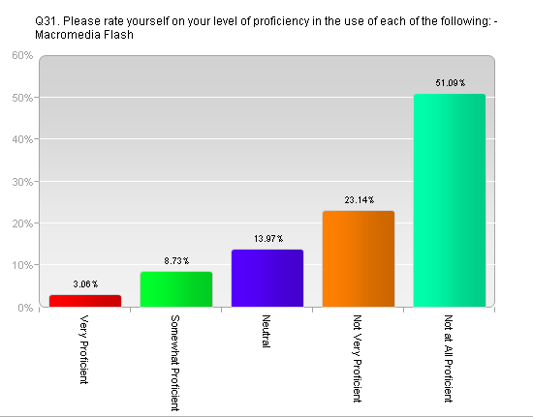
32. Most reported they were Not at All Proficient (71.18%) or Not at All Proficient (17.90%) with Macromedia Authorware.
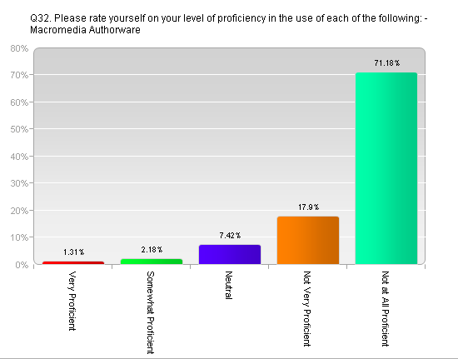
33. Most reported they were Not at All Proficient (64.63%) or Not Very Proficient (19.21%) with Macromedia DreamWeaver.
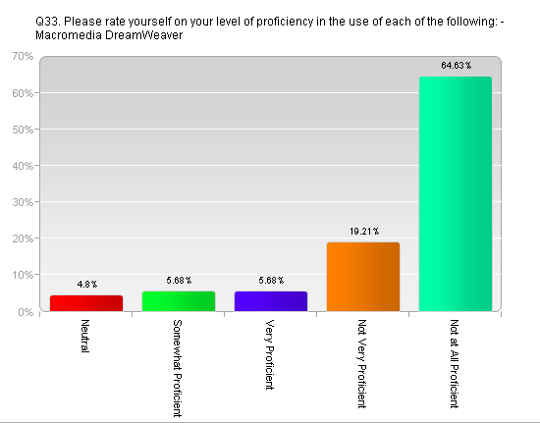
34. Most reported they were Not at All Proficient (69.43%) or Not Very Proficient (16.16%).
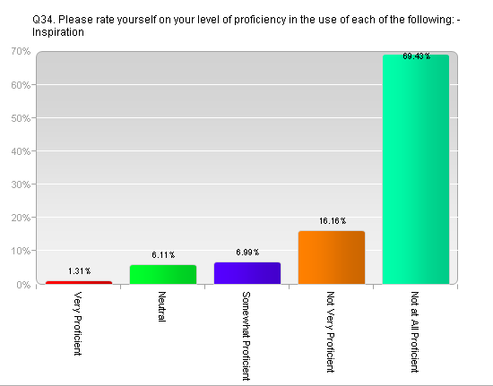
35. Most reported they were Very Proficient (28.38%) or Somewhat Proficient (44.98%) with Digital cameras.
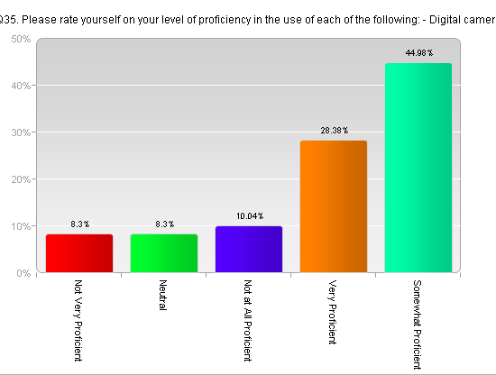
36. Most reported they were Very Proficient (23.14%) or Somewhat Proficient (44.10%) with Scanners.
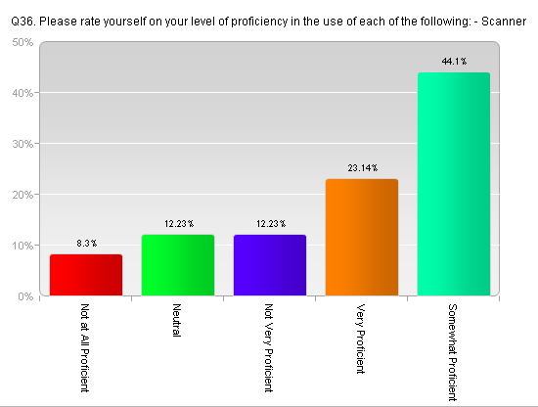
37. Most reported they were Somewhat Proficient (35.37%) or Very Proficient (21.83%) with Video Cameras.
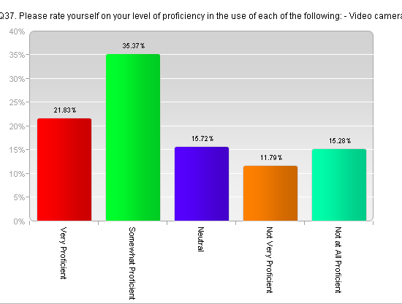

38. Other software/ technology equipment that respondents reported being proficient in that was reported multiple times: Adobe Illustrator, SAS, ArcGIS, Wordperfect, and various musical applications.

39. Most respondents reported that the preferred way of using a new technology was to Experiment and see what happens (31.88%).
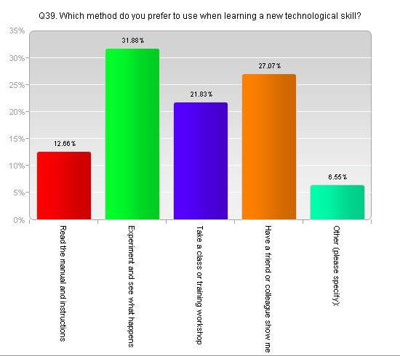
40. When asked ‘What could be done to improve computer support on campus?’, respondents answers multiple times with: more staff, technical support, wireless availability, keep all versions of SPSS the same, conduct workshops, have extended hours for calling in questions, add shortcut keys, encourage tech support to have an active role, have 24/7 support line, and have newer technologies.

41. Respondents reported the following to improve support for teaching and learning tools on campus; most reported: see above, workshops, reliable software, support persons, newest version of WebCT, assistance with instructional design, hardware/ software upgrades, have the best equipment, online tutorials, and seminars.

42. Respondents reported the following should be made to the university computer teaching labs: don’t know, not sure, more open labs, better machines, not charging students for printing, faster machines, updated equipment, increase the hours of service, better maintenance, printing control, and current software.

43. Respondents reported the following should be made to the multimedia equipment in our classrooms: don’t know, everything is fine, none, security locks, upgrading software, have imbedded monitors so as not to obstruct the view in classes, get more dvd players in classes, checks that the equipment work, make YouTube available in every class (some restrictions prevent this), improved audio, update computers, smart boards, airliners, and consistency in equipment.

44. Respondents reported the following are unmet computer or technological needs they have at the present time: don’t know, none, lack of time, insufficient hardware and software, accessing SAS, poorly designed labs, newer computers, upgrades, faculty laptops, industry specific software, smartboards, departmental laptop carts, standard equipment in all rooms, and better voice recognition software. One respondent noted that their department has a $50,000 color printer they don’t use because it’s too much trouble to set up.

45. Respondent reported the following as computer or technological needs envisioned in the future: don’t know, N/A, none, updates, wireless everywhere, faster and cheaper equipment, training for newer technology, sophisticated software, campus wide wireless access, blackberrys, universal portal for access to IUP resources, wireless downloading of video/ audio resources, faculty should be given laptops, weekend training, better equipment.

46. Most reported being either Satisfied (37.78%) or Neutral (18.22%) with the satisfaction with the level of IT support received in the hardware area.
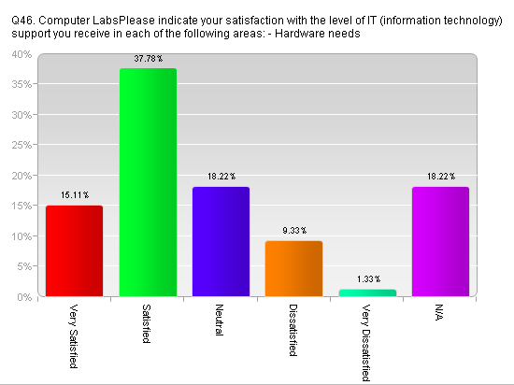
47. Most reported being either Satisfied (38.67%) or N/A (19.11%) with the satisfaction with the level of IT support received in the software needs area.
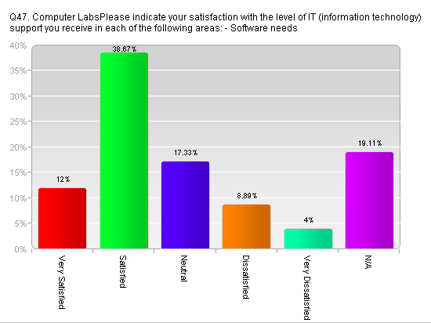
48. Most reported being either Satisfied (29.33%) or Neutral (25.78%) with the satisfaction with the level of IT support received in the general maintenance area.
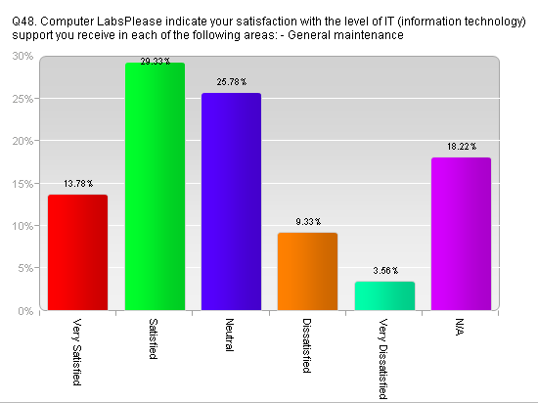
49. Most reported being either Satisfied (42.67%) or Very Satisfied (29.78%) with the satisfaction with the level of IT support received in the hardware needs area.
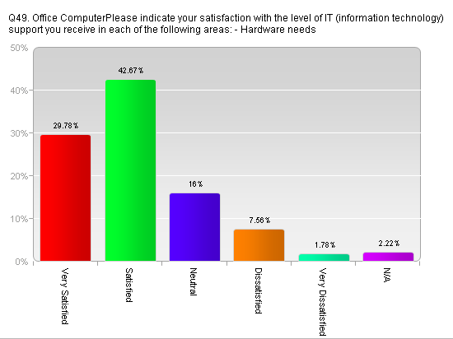
50. Respondents reported their satisfaction with IT in the software needs area, mostly as Very Satisfied (24.89%) and Satisfied (39.11%).
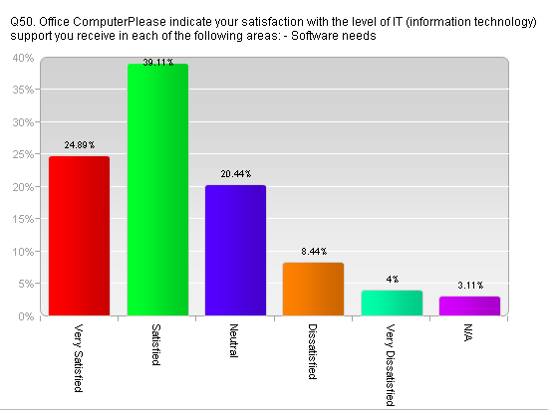
51. Respondents reported mostly that they were Satisfied (43.11%) or Very Satisfied (24.89%) with the level of IT support received in the area of general maintenance.
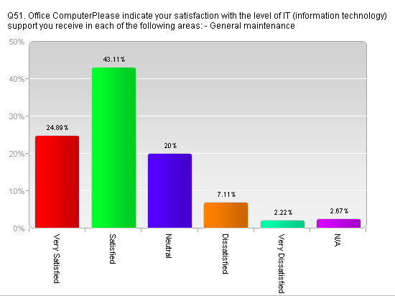
52. Respondents reported mostly that their satisfaction with IT support received in the area of Using or establishing Listservs as Not Applicable (32.00%) or Neutral (28.44%).
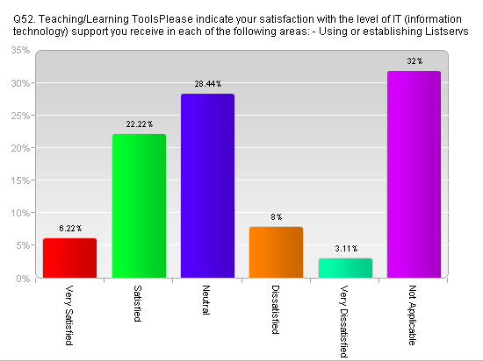
53. Respondents reported the level of IT support received in the Using WebCT area as Satisfied (28.00%), or Neutral (20.00%).
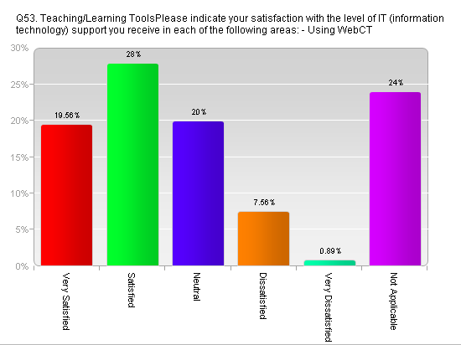
54. Most reported their satisfaction with IT support in the area of Using blogs as Not Applicable (55.56%) or Neutral (30.22%).
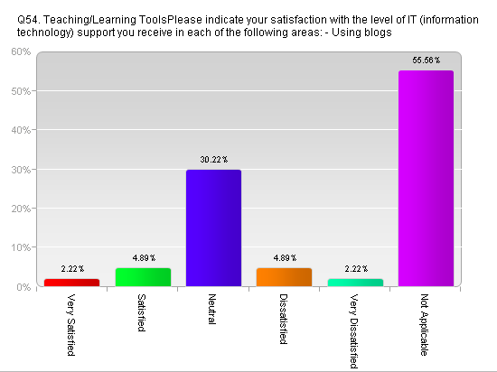
55. Most reported their level of satisfaction with IT support in the area of Using Webcasting: Not Applicable (55.11%) or Neutral (29.78%).
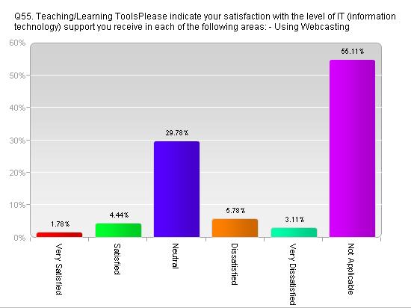

56. Respondents listed other teaching/ learning tools which they have received IT support in using and level of satisfaction as: WebCT-average, satisfied, very satisfied, and fabulous, Smartboard-not much support received for it.

57. In general respondents rated the computer service help received at IUP as Good (43.30%) or Excellent (21.07%).
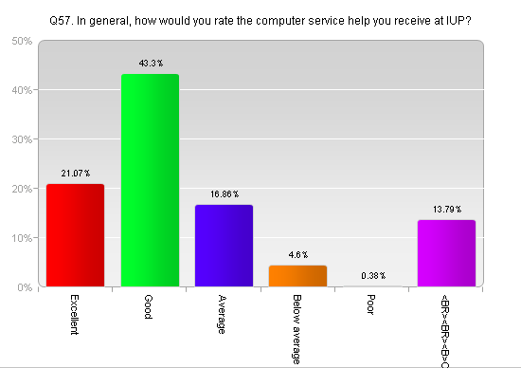
58. Respondents most frequently answered teaching online courses at IUP with: WebCT, Powerpoint/ Critical essays, distance ed. courses. Others reported that WebCT is a horrible production. The majority have not taught an online course at IUP.
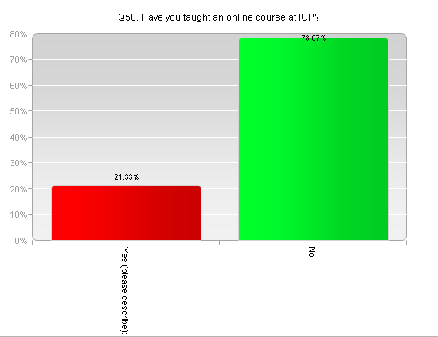

59. When asked ‘Are you considering teaching an online course at IUP within the next few years’, most answered in the affirmative (51.56%).
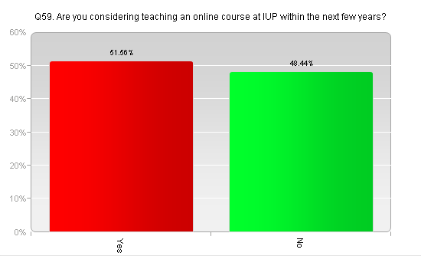
60. When asked ‘What might IUP do to make online teaching more attractive?’, most respondents reported the following: don’t know, N/A, more pay, more assistance, individual assistance, 24/7 support, recruit students outside of IUP, upgrade WebCT, support in designing the course, develop a mechanism to verify student identity, in-person testing, assuring academic integrity, offer equal pay for online classes, hold seminars on how to take a paper class and transform it into a virtual class.

