URSA Enhancements
Faculty and Advisor Services – Obtain E-mail Lists for Students
IT Services is pleased to announce new functionality to the URSA “Obtain E-mail Lists for Students” option. Currently, Faculty and Advisors can produce E-mail lists of students by term and campus for an individual advisor by class level, for a program of study by class level, for a course-section, and for students who applied for graduation by level and department. The new enhancement allows the users to compose and send an email after selecting the population of students.
Please review the screens below for an illustration of this new enhancement.
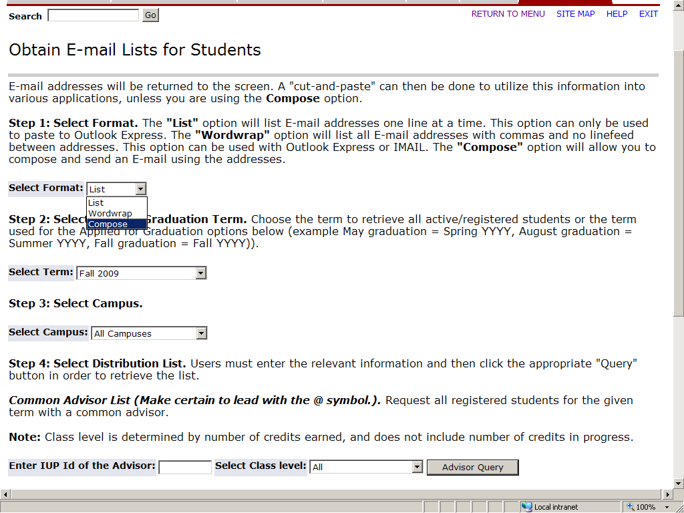
Below is the screen that is displayed when Compose is the format selected. The user can compose their message and send it to the recipients listed. The message is sent to all recipients in the BCC: with the user copied.
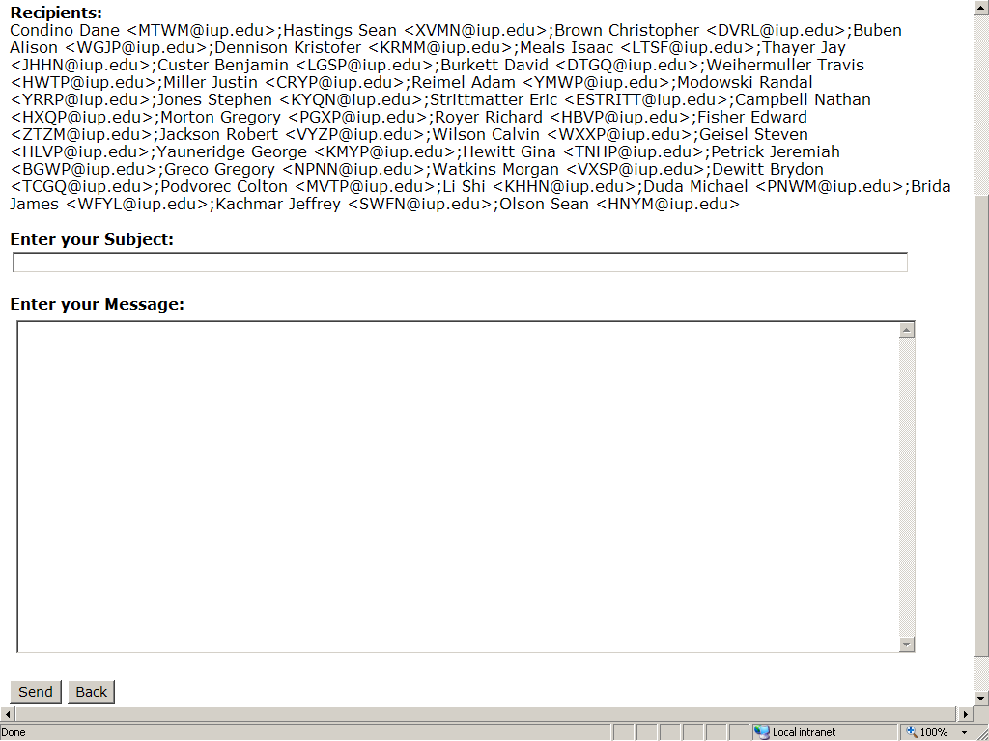

All recipients will be listed in wordwrap format.

