How to Complete the Correct CITI Ethics Trainings

Log into the CITI website from the IUP IRB Online Research Ethics Training website
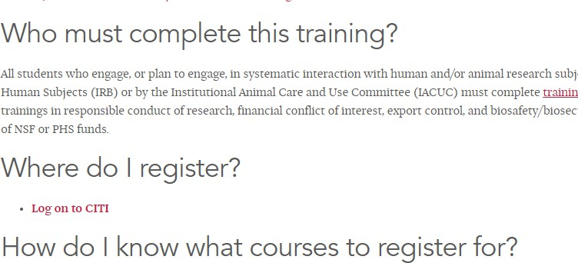

- Once on the CITI website, click on “Select Your Organization Affiliation.”
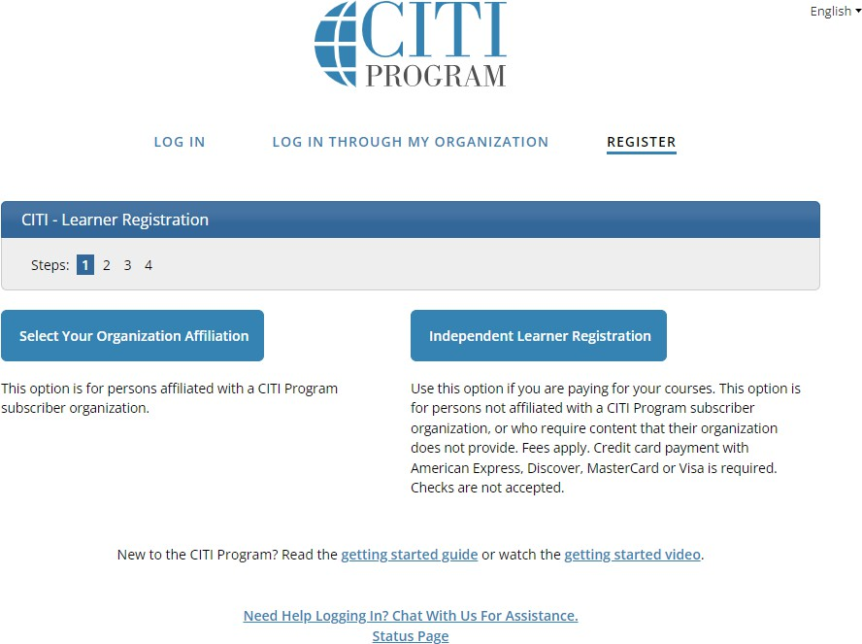

- On the next screen, begin typing “Indiana University of Pennsylvania” in the search box. After a handful of letters, Indiana University of Pennsylvania should appear.
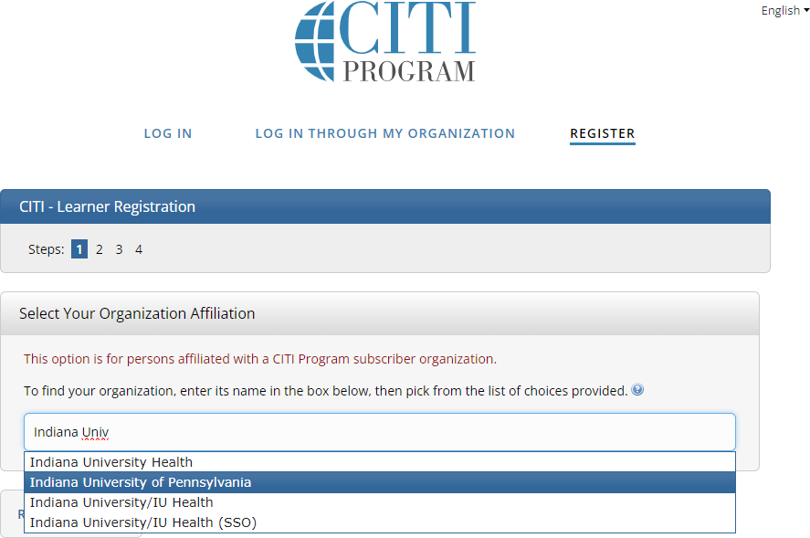

- Select “I AGREE to the Terms of Service and Privacy Policy for accessing CITI Program materials” and “I affirm that I am an affiliate of Indiana University of Pennsylvania.” Then click “Create a CITI Program account.”
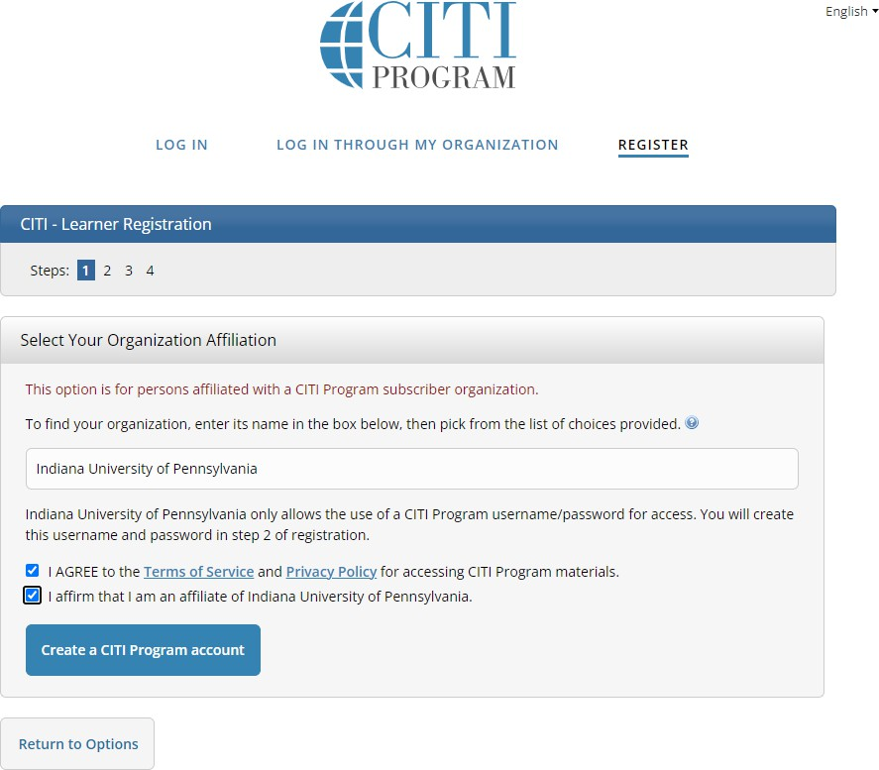

- Enter your Personal Information. We encourage you to use your IUP email; however, you can use another email if you wish. CITI’s website is not integrated with IUP’s directory information. Click “Continue to Step 3.”
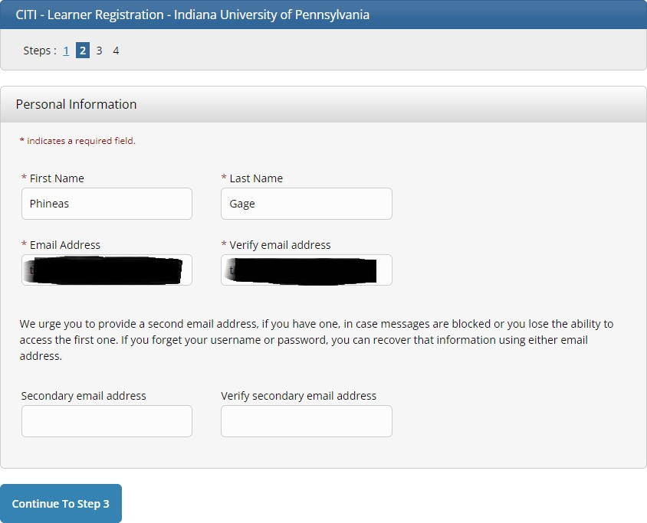

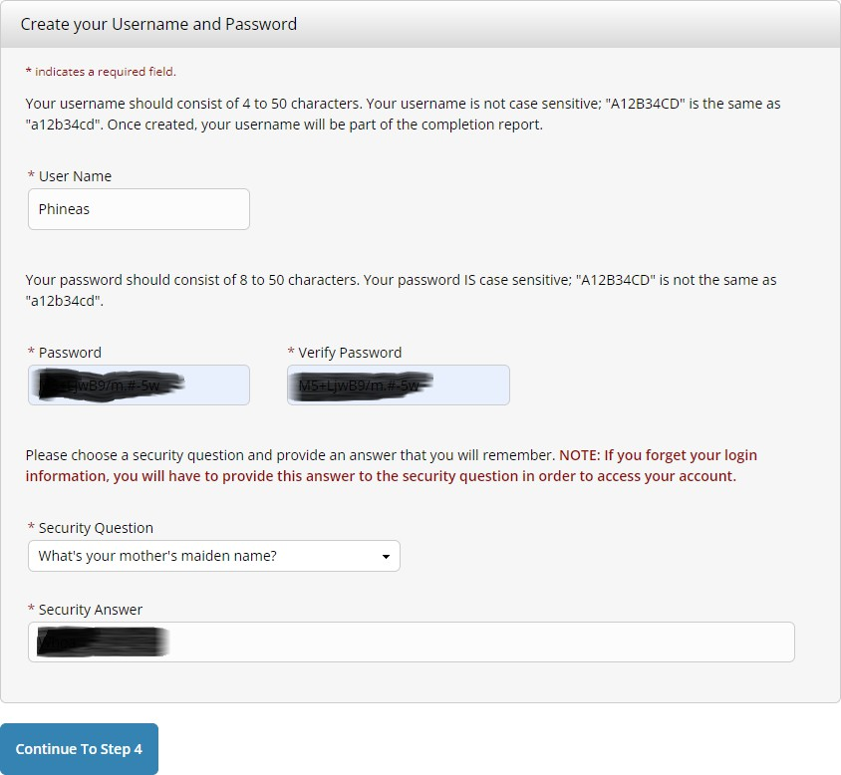
- Create your Username and Password. Then click “Continue to Step 4.”

- Complete the required “Country of Residence” question and the final question (either response is acceptable). Then click “Finalize Registration.”

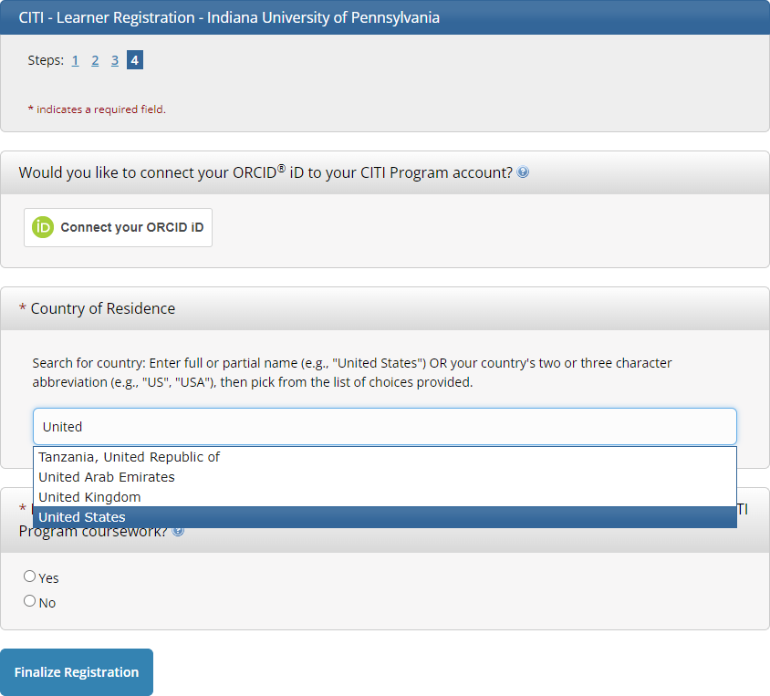

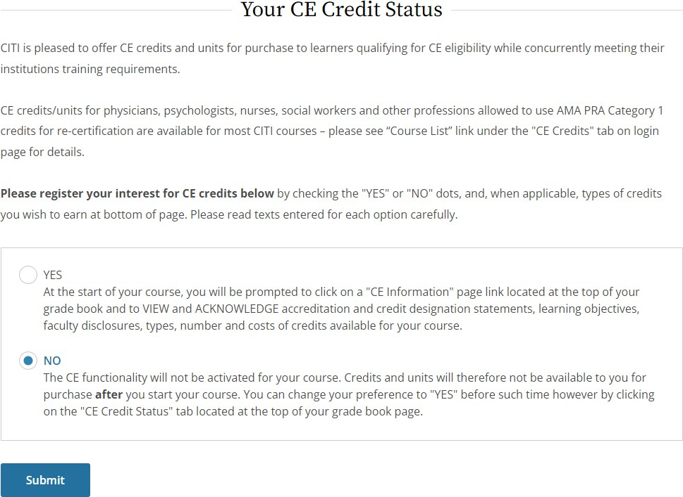
- Choose whether you want to pay for CE credits. IUP does not require you to pay for credits, so unless your Advisor tells you otherwise, select “NO.” Then click “Submit.”

- Complete the next screen to indicate your affiliation to IUP. Responses will vary depending on your Role, College, Department, and IUP email address. Then click “Submit.”
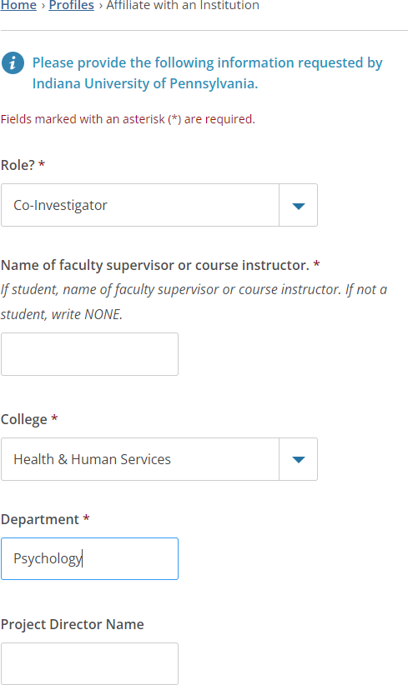
- Under Question 1 on the “Select Curriculum” page, select Option 2 “Social, Behavioral, and Educational Researchers” if you are working with human subjects and unless you are told by your Advisor to select a different option. If you are working with animal subjects, select Option 4 “No human research subjects course needed at this time.”
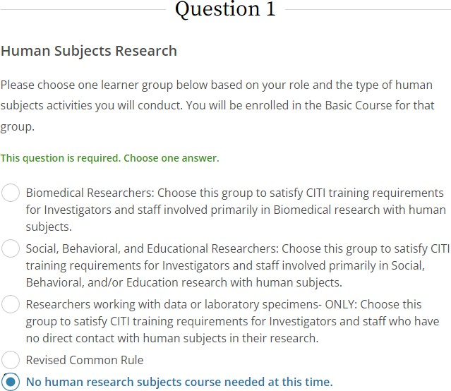
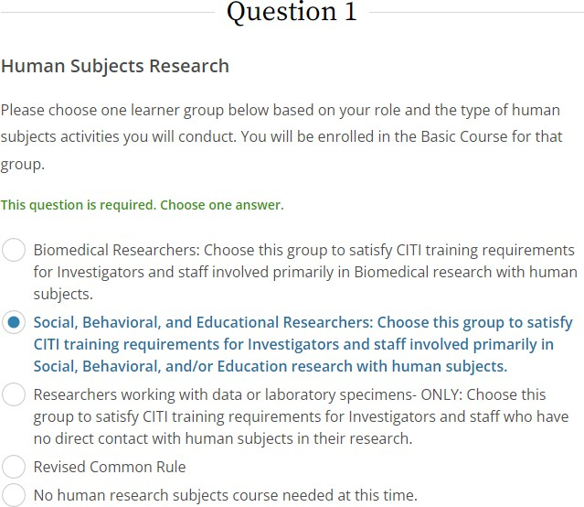

- Under Question 2 on the “Select Curriculum” page, select “Not at this time, Thank you.” Select this option unless your Advisor tells you otherwise as this applies to specific externally funded projects.
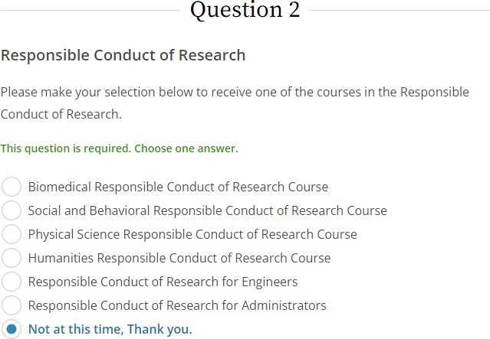

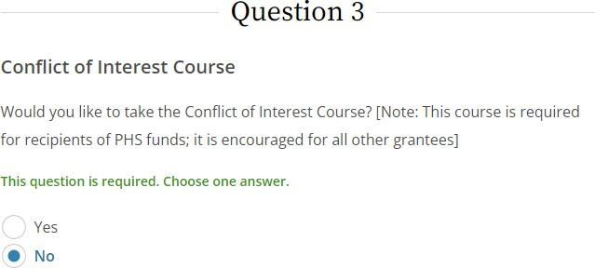
- Under Question 3 on the “Select Curriculum” page, select “No.” Select this option unless your Advisor tells you otherwise as this applies to specific externally funded projects.

- Under Question 4 on the “Select Curriculum” page, select “No, thank you” if you are working with human subjects or one of the other options if you are working with animal subjects. Check with your Advisor as necessary.

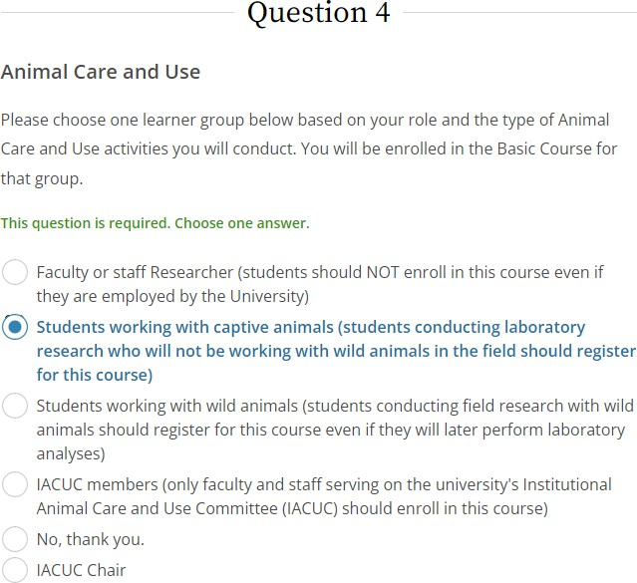
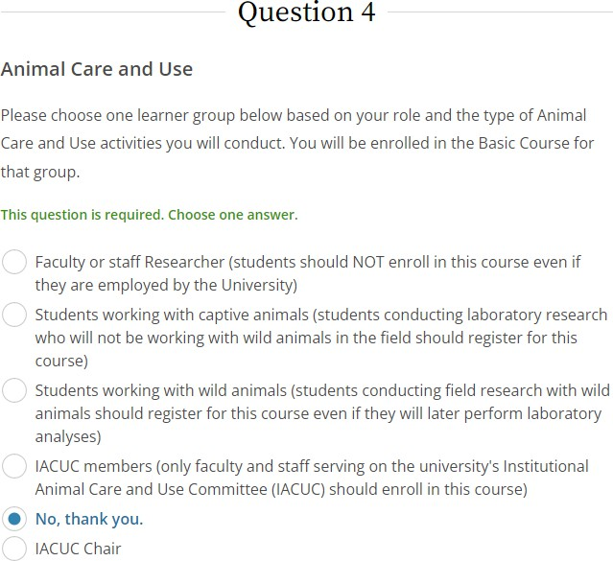

or

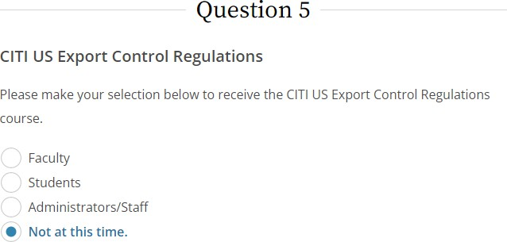
- Under Question 5 on the “Select Curriculum” page, select “Not at this time.” Select this option unless your Advisor tells you otherwise due to international travel or working with international collaborators.

- Under Question 6 on the “Select Curriculum” page, select “No, thank you.” Select this option unless your Advisor tells you otherwise as this applies to specific externally funded projects.
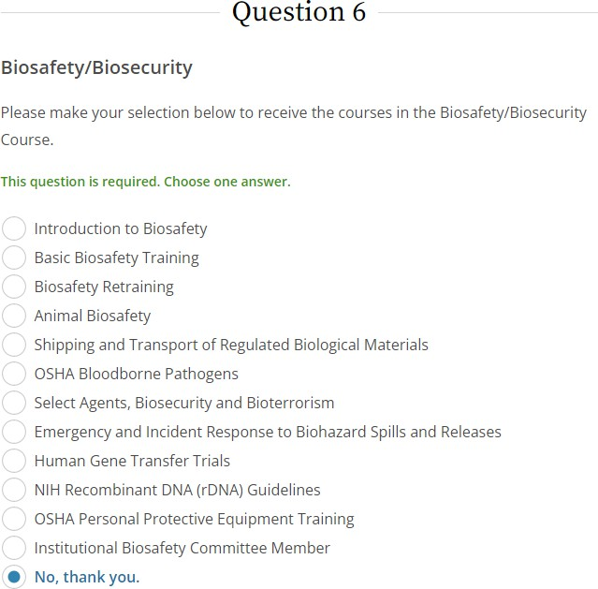

- Under Questions 7 on the “Select Curriculum” page, select “Not at this time.” Select this option unless your Advisor tells you otherwise.
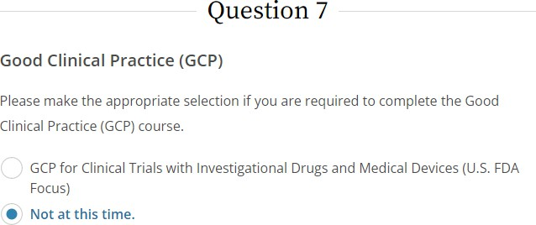

- You can now begin any of the Courses to which you have been assigned. Completion can be accomplished across multiple days. You do not need to complete them all in one session.
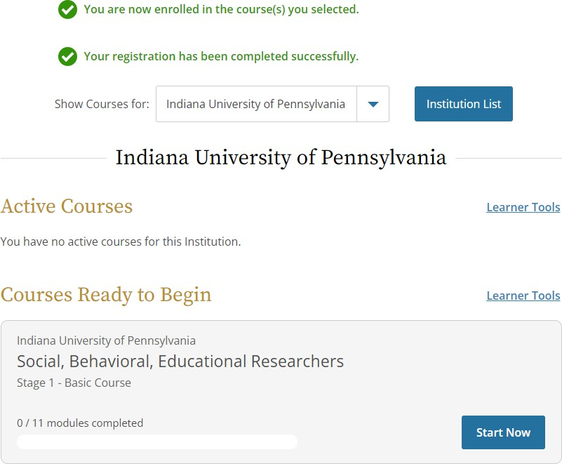

- Upon completing a Course, you will receive a completion certificate. Save that for when you need to provide those certificate(s) to the IRB/IACUC.
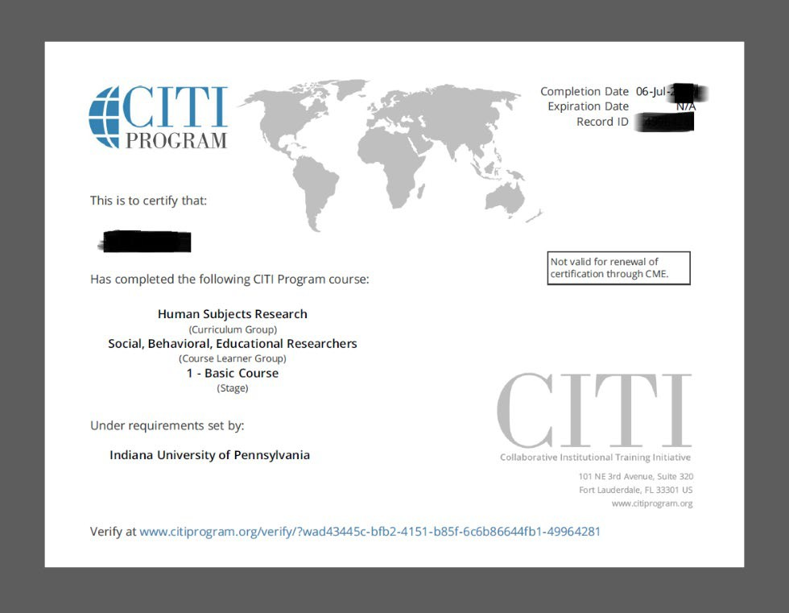
(the image above is one example; your certificate(s) may be somewhat different)

