REQUEST FOR CHECK DISBURSEMENT THE FOUNDATION FOR IUP
Complete for Check requests only
Complete for Check requests only

Suite 419, Sutton Hall

DATE OF REQUEST :

FUND NUMBER: FUND NAME:

SIGNATURES OF AUTHORIZED FUND AGENT:
(Must be signed by at least two fund agents to be processed)
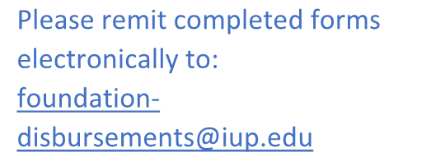
1.
Please remit completed forms electronically to:
foundation- disbursements@iup.edu
(print) (sign)
2.
(print) (sign)
3.
(print) (sign)
AMOUNT OF DISBURSEMENT: $ ISSUE PAYMENT TO:
NAME: BANNER ID:

BUSINESS or HOME ADDRESS (check will be mailed to this address):

PURPOSE OF DISBURSEMENT (Be specific. Must align with fund purpose).

READ CAREFULLY:
- Please Submit completed forms electronically to: foundation-disbursements@iup.edu
- Upon Submission, please include this disbursement request along with proper documentation including all invoices and receipts. Payment will NOT be made without proper documentation to support this request.
- Requests CANNOT be processed without TWO authorized fund agent signatures. Authorized signature cannot be same as payee.
- Checks are issued every Friday (Deadline for weekly submission is Tuesday by 4:30 pm unless otherwise advised).
- Checks will be mailed directly from the Foundation office to all individuals, businesses, and organizations.
- IUP Faculty/Staff – Checks can be picked up in the Foundation office. *If not picked up by 10:00 am on Friday, the check will be mailed to the address listed on the check. If picking up, please note this below:

Will pick up, please contact:
(name & email, or phone number) Revised 11/11/24

