IUP
EBERLY COLLEGE OF BUSINESS AND TECHNOLOGY ORGANIZATIONS

Created by: Garet Weston

QUICKEN HOW TO
This is a step by step training manual for Quicken – Personal Finance, Money Management, Budgeting, Financial Management, Budget Planner, Money Manager, Free Budget Software for the organizations here at IUP.

Contents
Overview 3
Objectives 4
Pre-Training To Do’s: 5
1. EDIT BUTTON 5
2. PREFERENCES 6
3. CALENDAR AND CURRENCY 6
4. FISCAL YEAR AND AUGUST 7
Lesson 1: Setting Up Your Account 8
1. HOME TAB 8
2. ADVANCED SETTINGS 8
3. ENTRY METHOD 9
4. ACCOUNT NAME 9
5. ENTERING THE ENDING DATE AND ENDING BALANCE 10
6. ACCOUNT ADDED 10
Lesson 2: Set Up Your Bills and Income 11
1. HOME TAB: 11
2. ADDING A BILL 11
3. ADD A BILL REMINDER: 12
4. SPECIFYING A DATE: 13
5. AMOUNT DUE: 13
6. WHICH ACCOUNT: 14
7. ADD A CATEGORY, TAG or MEMO: 14
8. FINALIZING THE EXPENSE: 15
9. FINISHING THE EXPENSE: 15
Lesson 3: Adding Income to Your Account 16
1. ADDING INCOME: 16
2. FROM: 16
3. SPECIFYING A DATE: 17
4. AMOUNT RECEIVED: 17
5. WHICH ACCOUNT: 18
6. ADD A CATEGORY, TAG or MEMO: 18
7. FINALIZING THE INCOME: 19
8. FINISHING THE EXPENSES AND INCOME: 19
9. CHECKING YOUR EXPENSES AND INCOME 20
Lesson 4: Adding Expenses and Revenues to your Register 21
1. ADDING EXPENSES AND INCOMES TO THE REGISTER: 21
2. CONFIRMING THE TRANSACTION: 21
3. CHECKING THE TRANSACTIONS: 22
Lesson 5: Adding Expense or Income Separately 23
1. ADDING AND EXPENSE OR INCOME: 23
Lesson 6: Changing the Date Range on the Home Tab 24
1. WHERE TO FIND THE DATE RANGE OPTION: 24
Lesson 7: Creating a Budget 25
1. HOME TAB: 25
2. GET STARTED BUTTON: 25
3. NAMING AND CHOOSING THE TYPE OF BUDGET: 26
4. CHECK YOUR BUDGET: 26
5. ADDING A CATEGORY TO THE BUDGET: 27
6. SPECIFYING MONTHLY AMOUNT: 27
7. CHECKING YOUR BUDGET: 28
Lesson 8: Building Reports 30
Conclusion 32

Overview
Within this step by step training manual, I will be covering the different aspects that you need to know in order to record all your transactions that occur within your organization. This software will make it much easier for you and your organization to have better records of your money throughout the school year, and will help you with the auditing process.
This training will start off by adding an account to Quicken and training you to add your expenses and income throughout the year. Also this software will allow you to start a budget that takes your monthly spending and creates a projected forecast for your organization. When the year is about to end and it is time for the auditing process, Quicken allows you to quickly build reports that will ease the auditing process for you and your organization.

Objectives
- By the end of this step by step how to manual, the organizations will be able to define the different components that are involved with Quicken.
- By the end of this training manual, the officers will be able to handle the basics functions in Quicken.
- By the end of this training manual, the officers will be able to compare their expenses and incomes to the Quicken Software and reach the same cash balance.
- At the conclusion of this training, the officers will be able to break down income and expenses that they enter into the Quicken software.
- At the end of this training, the officers will be able to create reports that show all transactions throughout the year for auditing.
- At the conclusion of this training, the officers will be able to provide sufficient and complete accounting records for their organizations at the end of the school year.

Pre-Training To Do’s:

Before we start the training on how to add an account to Quicken, we must first change the WORKING CALENDAR within the software to the fiscal year of the school year. As you know the school year doesn’t start on January 1st, so we must change the starting date for our account.

EDIT BUTTON
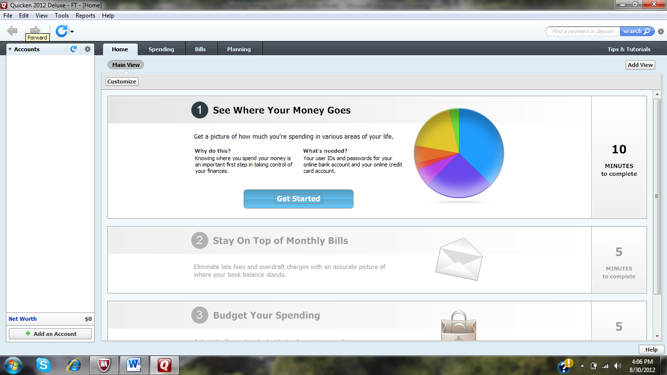
You want to first click on the Edit button at the top left corner of the screen.

PREFERENCES
Next you want to click on the preferences option in the drop down menu.
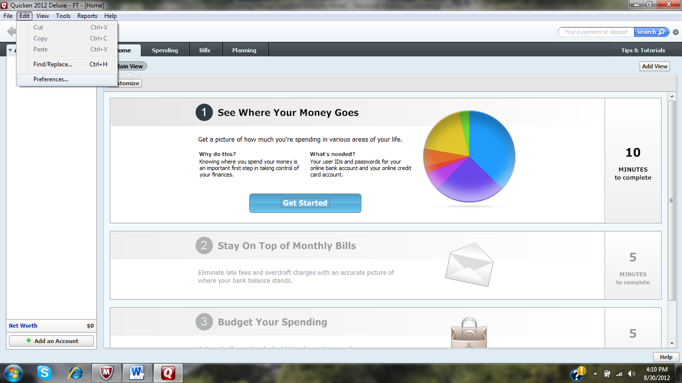

CALENDAR AND CURRENCY
Next you want to click on the Calendar and Currency option in the menu on the left.
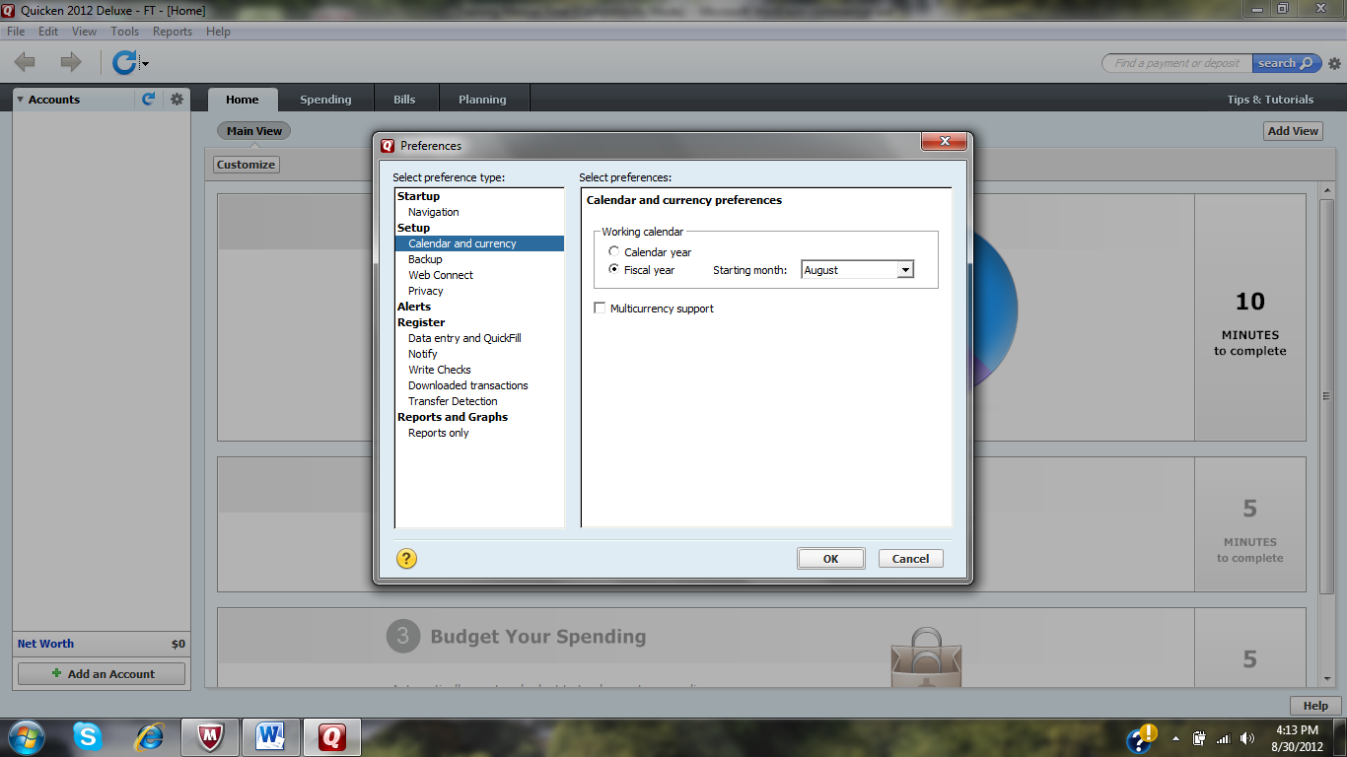

FISCAL YEAR AND AUGUST
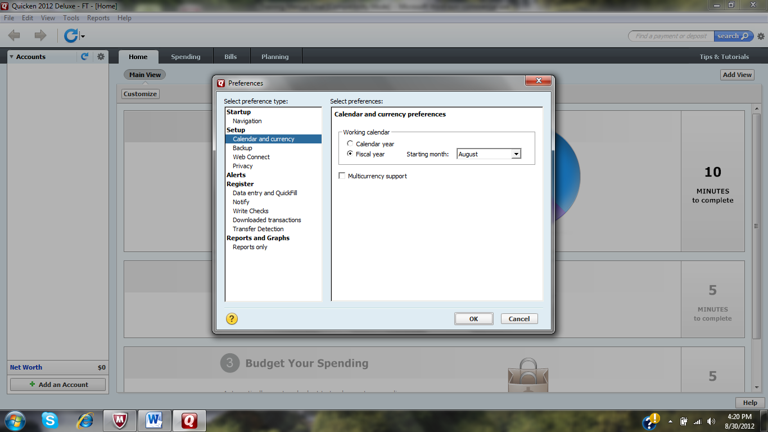
Within the Calendar and Currency screen, we want to select Fiscal Year and select August as our starting month. Again we are doing this because the school year does not start on January 1st and we have to change the starting date for our organization’s account.

- By doing this before we setup our account information within Quicken, it will allow the software to automatically organize your reports with the year starting on August 1st. This we make it much easier for you to print out your reports anytime throughout the year and always have them start from August 1st.

Lesson 1: Setting Up Your Account
When you first download Quicken and open the software your screen will be blank with four tabs at the top: HOME, SPENDING, BILLS, and PLANNING

HOME TAB
You want to click on the HOME screen to bring up the “Get Started” screen. With the HOME screen highlighted, you want to click the “Get Started” button under the See Where Your Money Goes section. Once you click the “Get Started” button, there will be a screen that appears asking to add your primary checking account.
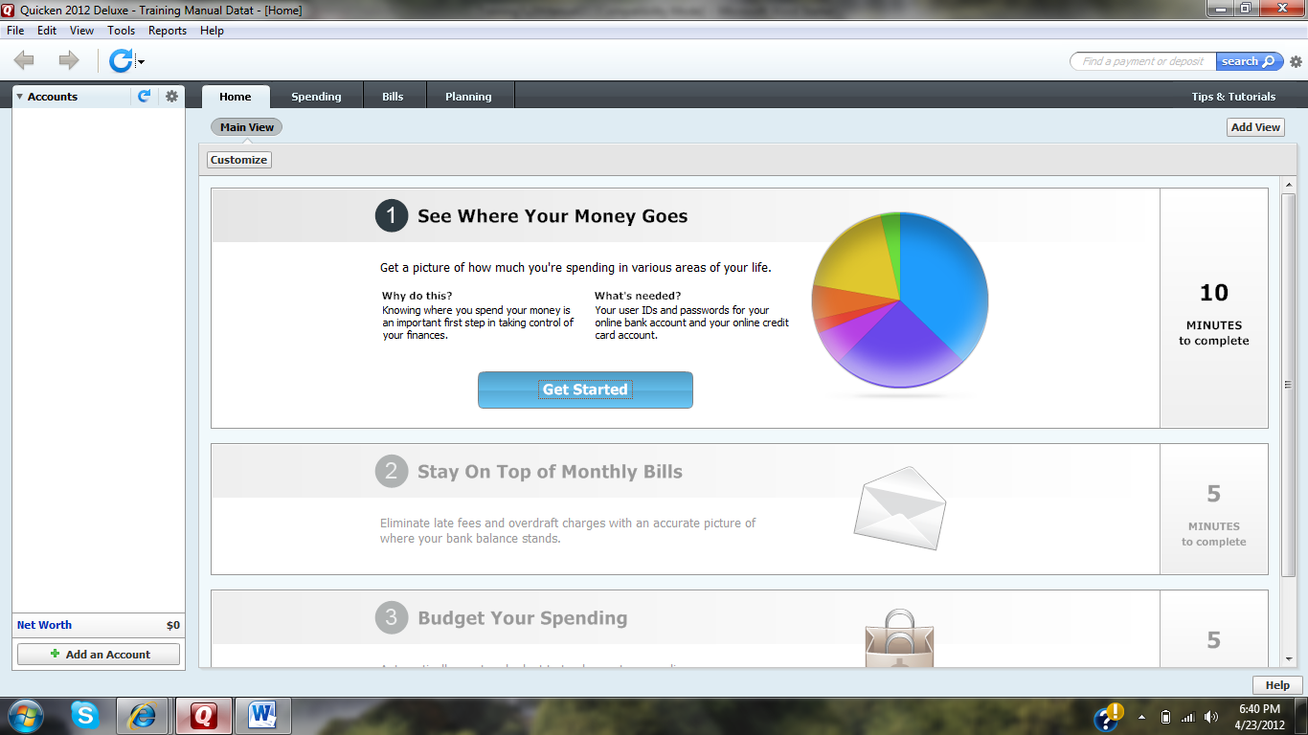

ADVANCED SETTINGS
*ON THIS SCREEN DO NOT ENTER OR SELECT YOUR BANK ACCOUNT. PLEASE SELECT THE ADVANCED SETTINGS AT THE BOTTOM LEFT OF THE SCREEN.

ENTRY METHOD
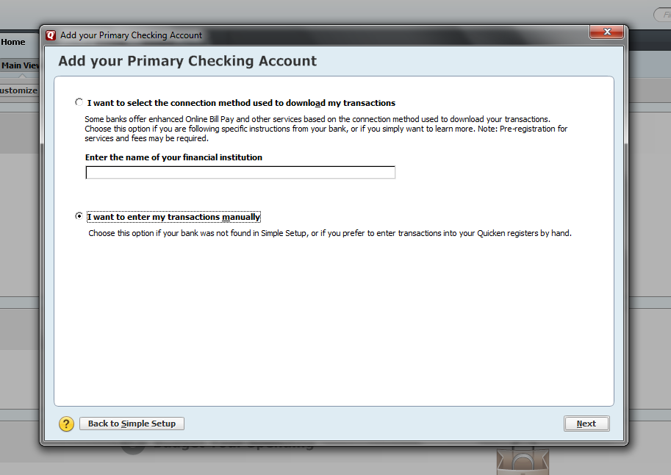
Once you select ‘ADVANCED SETTINGS,’ the next screen will ask you to enter the name of the institution or if you want to enter the transactions in manually. Check the box next to ‘I want to enter my transactions manually.’ And then click NEXT

ACCOUNT NAME
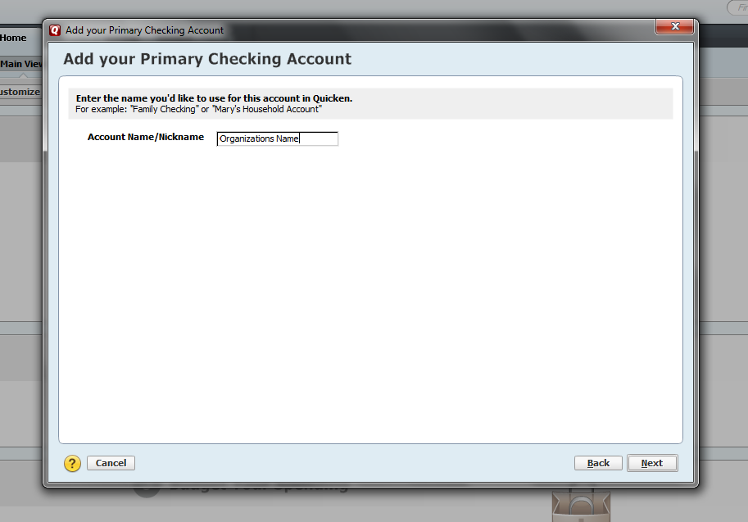
It will then ask you to name your account. This is completely up to the user and can be named anything that you would like to name it. (Suggestion: The name of your organization would work the best) Then click NEXT.

ENTERING THE ENDING DATE AND ENDING BALANCE
The next screen will ask for you to specify when you want the fiscal year of your account to end. This will help Quicken to produce end of the year reports. For most organizations this date will be 8/26/2012. (The day before the start of the school year) Also this screen is asking you to enter the statement ending balance. This amount is the dollar amount that is in your checking account at the very moment for when you are setting this software up. For this training enter $500.00. After you have entered the information, click NEXT.
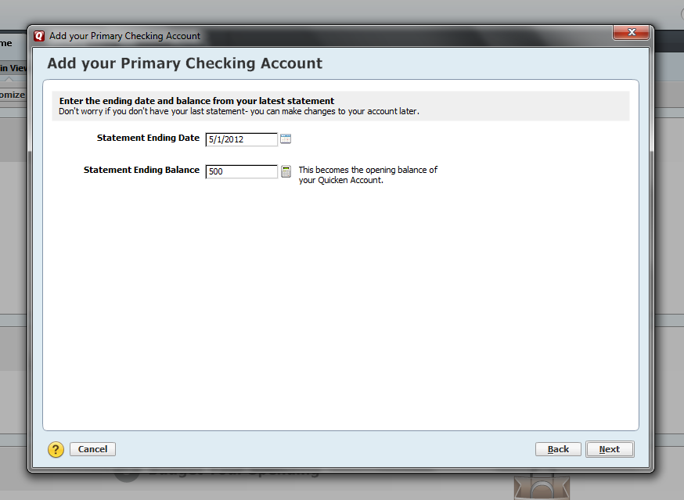

ACCOUNT ADDED
Then next screen will then show that you have added your account and you can click FINISHED .

Lesson 2: Set Up Your Bills and Income
Now that you have your account set up in Quicken your next step is to set up expenses that you may have to pay over the course of the year or any current expenses that you are going to be paying. By setting this up you can avoid missing expenses or incomes throughout the year. This will help you see where your account stands at any point in time.

HOME TAB:
Click on the Home screen and Click “Get Started” in the Stay on Top of Monthly Bills section.
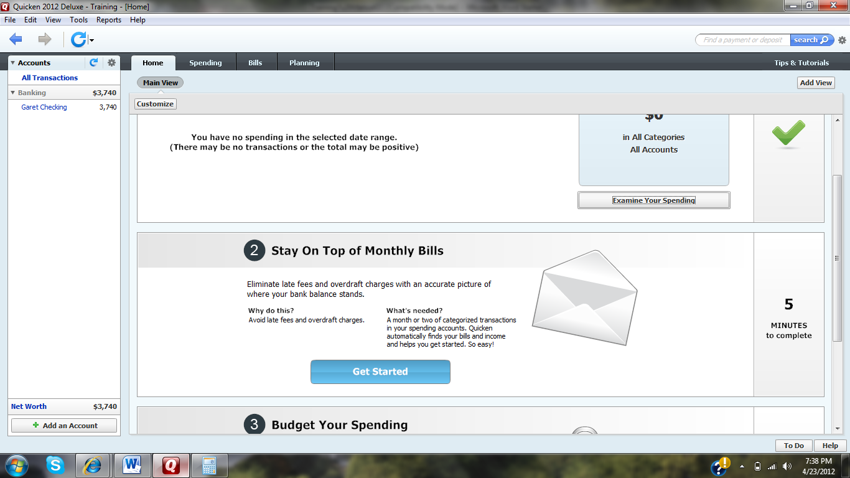

ADDING A BILL
Click the Add a Bill button to add a new expense, you can also click the Edit Button to edit an existing expense that you want to edit.

ADD A BILL REMINDER:
If you are adding a new expense, it will then ask you who you are paying the expense too. For this training enter ‘Staples.’ Once you have filled out the “Pay to” box, click NEXT.

SPECIFYING A DATE:
You must next enter the DATE on which this expense will be due. (Just leave it as today’s date for this training). Also next to the Date Input box; select the link that says (change) to specify how often this expense will be paid. If you will pay this expense every month then choose every month and this will notify Quicken to remind you of this expense each month. If this expense is only a one-time expense or you are not sure when this type of expense will be paid again; select ONLY ONCE. (Most organizations will select ONLY ONCE for the expense that they pay)

AMOUNT DUE:
Enter the dollar amount of the expense that you are paying. Enter $10.00.

WHICH ACCOUNT:
You will then choose the account from which the expense will be taken from. (Choose the account of your organization)

ADD A CATEGORY, TAG or MEMO:
Click on the box that says ‘ADD category, tag or memo.’ This will allow you to place details with the expense for better understanding of the expense when you see it in the register. They will help you identify the expense much easier later in the process of keeping your records. When entering a category, try and pick one that relates closely to the expense. Choose Education/Books and Supplies within the drop down menu. And in the memo box try and describe the expense as well as you can. Then click OK.

FINALIZING THE EXPENSE:
Once you have entered in the entire information, click the DONE button on the bottom right.

FINISHING THE EXPENSE:
As you can see the expense has been placed in your account and will be subtracted from your checking account. To continue click the NEXT button at the bottom right of the screen.

Lesson 3: Adding Income to Your Account

ADDING INCOME:
After you have finished with adding an expense to your account, you can then add any income that your organization has received. Click the ‘ADD INCOME REMINDER’ at the bottom left of the screen.

FROM:
A window will appear asking where the income has come from. Enter in the appropriate description for the income. For this training we will enter Shirt Sales. Then click NEXT

SPECIFYING A DATE:
You must next enter the DATE on which this income will be received. Just leave it as today’s date for this training. Also next to the Date Input box; select the link that says (change) to specify how often this income will be received. If you will receive this income every month then choose every month and this will notify Quicken to remind you of this income each month. If this income is only one-time revenue or you are not sure when this revenue will be received again; select ONLY ONCE. (Most organizations will select ONLY ONCE for the income that they receive)

AMOUNT RECEIVED:
Enter the dollar amount of the income that you have received. Enter $50.00

WHICH ACCOUNT:
You will then choose the account from which the income will be deposited into. (Choose the account for your organization)

ADD A CATEGORY, TAG or MEMO:
Click on the box that says ‘ADD category, tag or memo.’ This will allow you to place details with the income for your better understanding of the income when you see it in the register. They will help you identify the income much easier later in the process of keeping your records. When entering a category, try and pick one that relates closely to the income. Select Other Inc. from the drop down menu. And in the memo box try and describe the income as well as you can. Then click OK.

FINALIZING THE INCOME:
Once you have entered in the entire information, click the DONE button on the bottom right.

FINISHING THE EXPENSES AND INCOME:
Once you have entered in all of your expenses and income and everything is correct, click the DONE button at the bottom of the screen.

CHECKING YOUR EXPENSES AND INCOME
1. After you have finished your expenses and income and have clicked the DONE Button, you want to check your HOME Screen to make sure your expenses and income are correct.
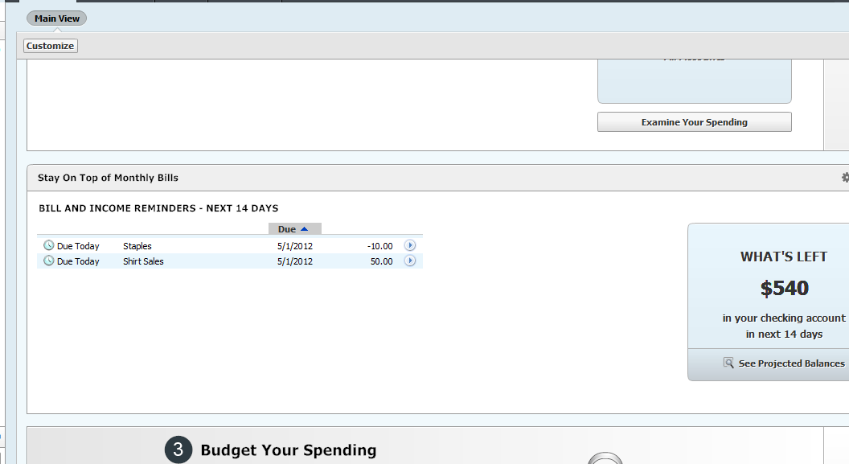

*AS YOU CAN SEE WE STARTED WITH $500.00 AND WE SPENT $10.00 ON SUPPLIES AND WE GAINED $50.00 FROM THE SHIRT SALES WHICH GIVES US A FINAL BALANCE OF $540.00

Lesson 4: Adding Expenses and Revenues to your Register

ADDING EXPENSES AND INCOMES TO THE REGISTER:
On the HOME screen you will see your income and expense that you have added through this manual. In order for them to show up in your register you must tell the software that you have either paid that expense or have physically received that revenue and it has been taken from your account or has been added to your account physically. (This must be done in order to get true results within your reports). To do this you will select the ARROW BUTTON beside the dollar amount of either the income or expense. A pop-up menu will appear and will give you the option to either ENTER INTO REGISTER or SKIP THIS ONE. If you have paid this expense or received this income you will choose ADD TO REGISTER. DO NOT CHOOSE ‘SKIP THIS ONE’ OR ELSE THE TRANSACTION WILL BE DELETED AND YOU WILL HAVE TO ENTER IT IN ALL OVER AGAIN.

CONFIRMING THE TRANSACTION:
Once you have selected ‘Enter into Register, it will then ask you to look over the details of the transaction and you will confirm the transaction by selecting ENTER TRANSACTION.

CHECKING THE TRANSACTIONS:
After you have posted the transactions to your register. You will notice that both transactions have been either paid or received on the left hand side of the screen. ALWAYS CHECK TO MAKE SURE THAT YOUR TOTAL BALANCE EQUALS THE CORRECT AMOUNT AFTER YOU HAVE ENTER TRANSACTIONS TO YOUR ACCOUNT.

YOU HAVE NOW SUCCESSFULLY ADDED AN EXPENSE AND INCOME TO YOUR ACCOUNT BALANCE. FOR FURTHER TRANSACTIONS, GO BACK AND FOLLOW THE SAME STEPS IN LESSONS 3 AND 4 TO ENTER ANY OTHER EXPENSES AND REVENUES THAT YOUR ORGANIZATION HAS PAID OR RECEIVED.

Lesson 5: Adding Expense or Income Separately

ADDING AND EXPENSE OR INCOME:
Instead of always having to enter an expense first then an income as we just did. We can also enter an expense and an income separately. On the right hand side of the Bills section on the HOME screen, there is an options button. Click on the OPTIONS BUTTON and select ADD REMINDER.

*ONCE YOU CHOOSE EITHER BILL REMINDER OR INCOME REMINDER PLEASE REFER TO THE STEPS IN LESSON 3 ON HOW TO ADD A BILL OR ADD INCOME TO YOUR ACCOUNT.

Lesson 6: Changing the Date Range on the Home Tab

WHERE TO FIND THE DATE RANGE OPTION:
When you are on the HOME screen, if you look at the right hand side of the screen you will see an OPTIONS BUTTON for each of the three categories on the screen. If you click the OPTIONS BUTTON, you will be presented an option that says Date Range. If you select that option you can change the date range for what the screen is showing you on the HOME screen. The first picture shows your total spending for the entire year. The second picture shows you the expenses or incomes that you have over the next 14 days.
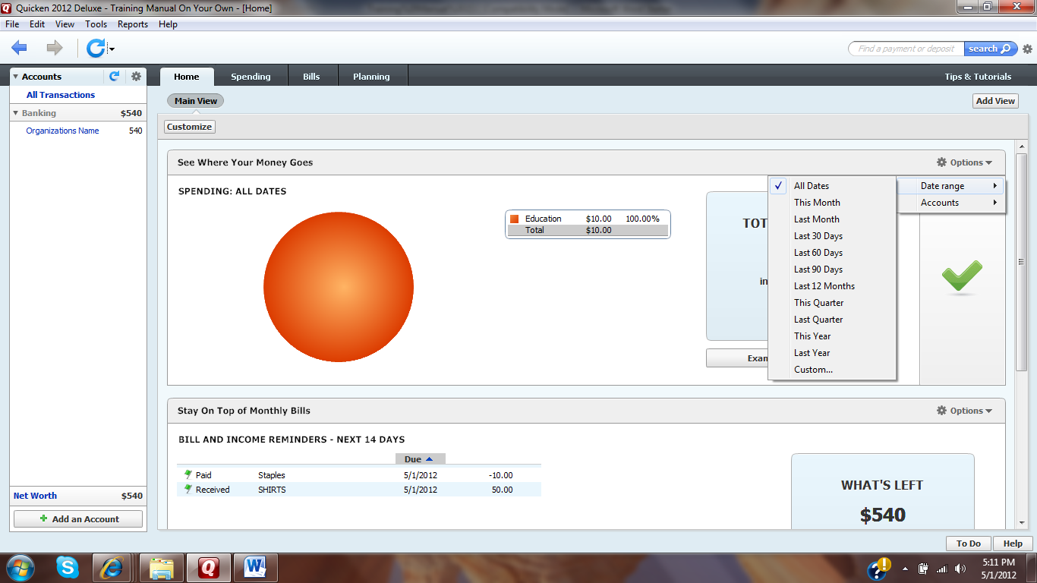

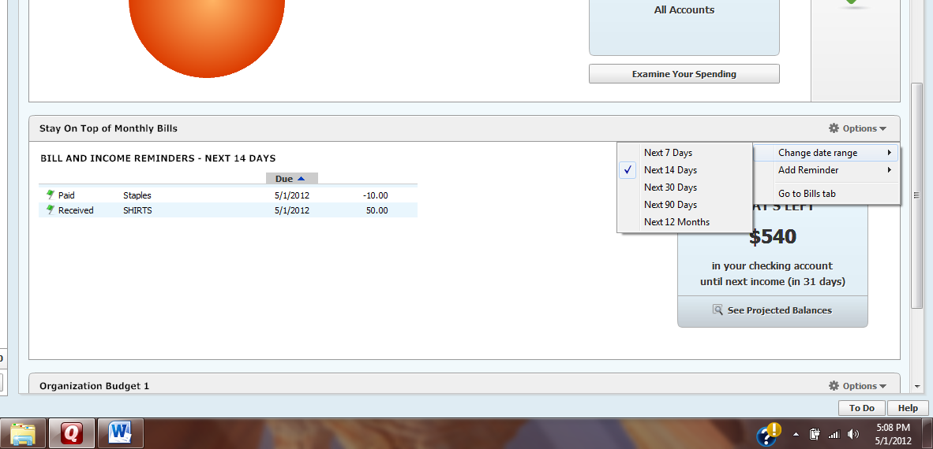

Lesson 7: Creating a Budget

HOME TAB:
Click on the Get Started button under the ‘Budget Your Spending’ section on the Home screen.
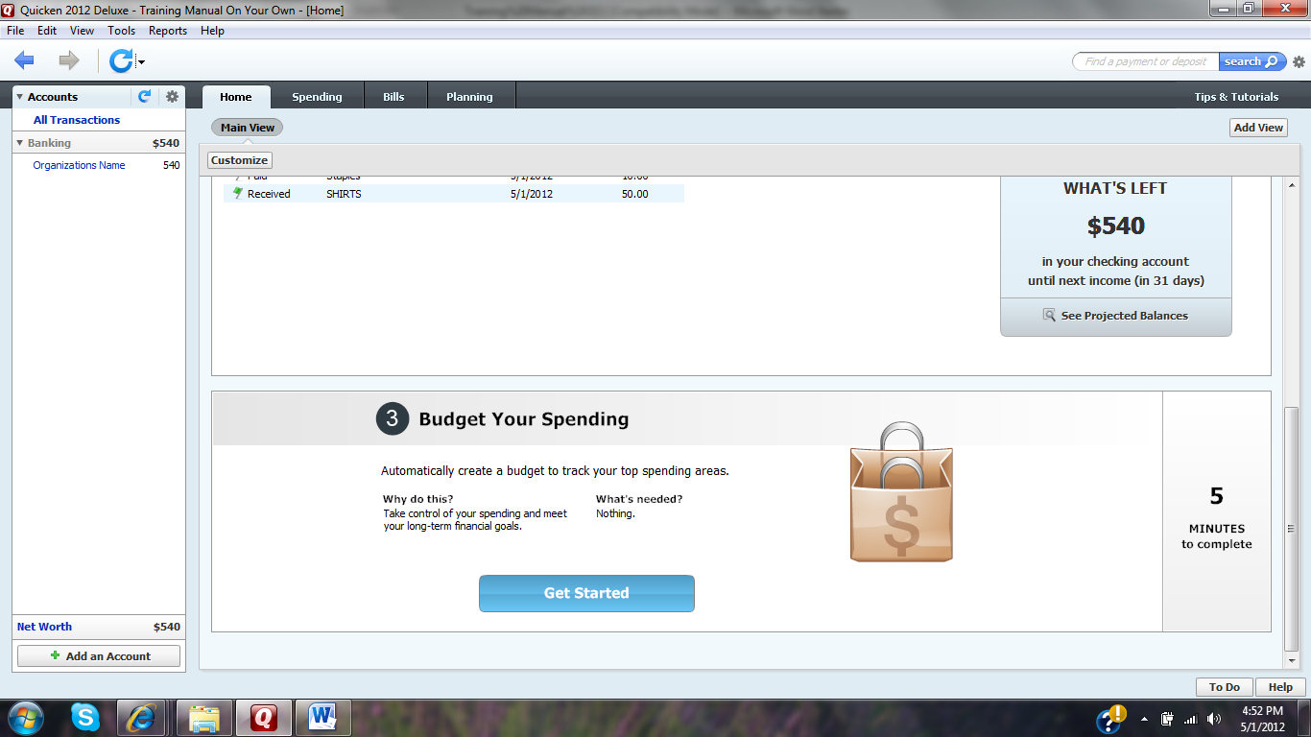

GET STARTED BUTTON:
Click the ‘Get Started Button’ on the next screen.

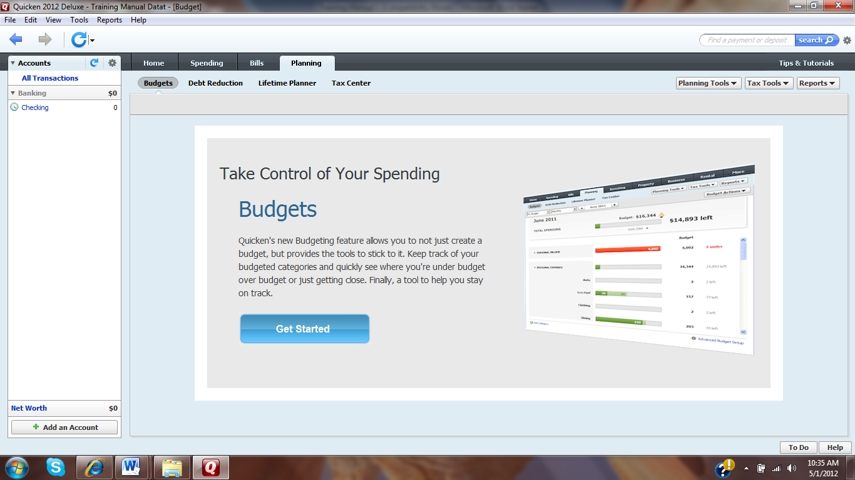

NAMING AND CHOOSING THE TYPE OF BUDGET:
Fill in the ‘Budget Name’ with any name you prefer and choose the automatic budget option and click OK.

CHECK YOUR BUDGET:
Once you click OK, a new screen will appear showing your current budget, your budget will be empty until you add a category to your budget. If you want to add a category to your budget click the ADD CATEGORY TO BUDGET button on the bottom left of the screen.
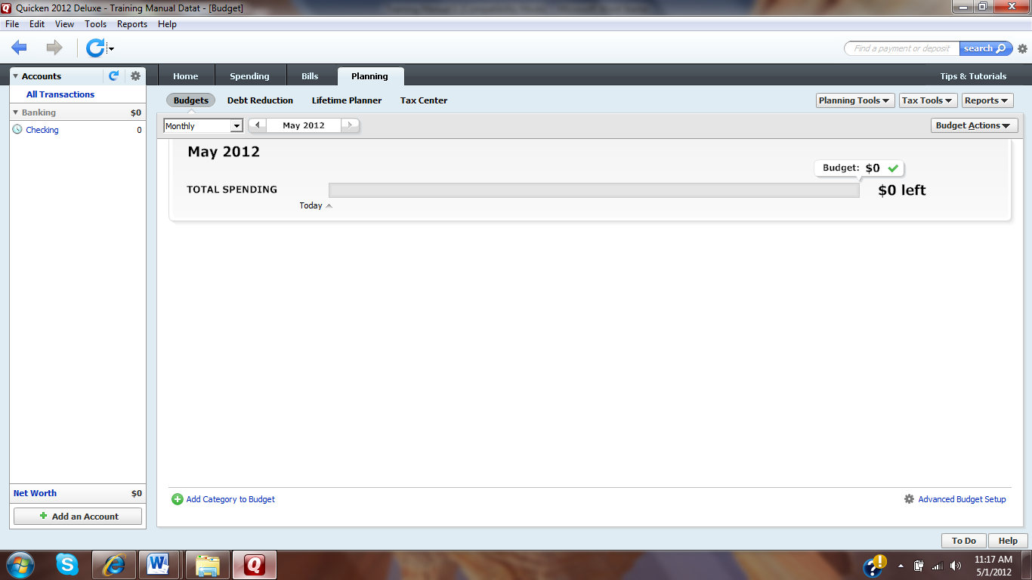

ADDING A CATEGORY TO THE BUDGET:
If you choose to add a category to your budget, a screen will appear asking you to pick a category from a list of incomes and expenses. Please select a description that best describes a category of an expense or income that frequently happens throughout the year for your organization. For this training please select Education/Books & Supplies and then click NEXT.

SPECIFYING MONTHLY AMOUNT:
It will then ask you to enter the amount of money you expect to spend (expense) or receive (income) monthly for this category. Enter the amount that you normal spend or receive each month on a normal basis for this category. Example: If you spent $90.00 last year on Educational/Books and Supplies, then you want to enter $10.00 per month for this expense. ($90.00 / 9 Months in the school year = $10.00 per month) This will help the software create your budget and will allow you to see how much you have left to spend for the remainder of the year if you want to stay within that budget. Once you have completed this screen click DONE.

CHECKING YOUR BUDGET:
Once you click DONE, you will see your new category appear within your budget.
To add the income category, you want to follow the previous steps 5 and 6 that we used to add the expense category. Within the drop-down menu select ‘Other Income’ and enter the amount of $50.00 per month for this training.
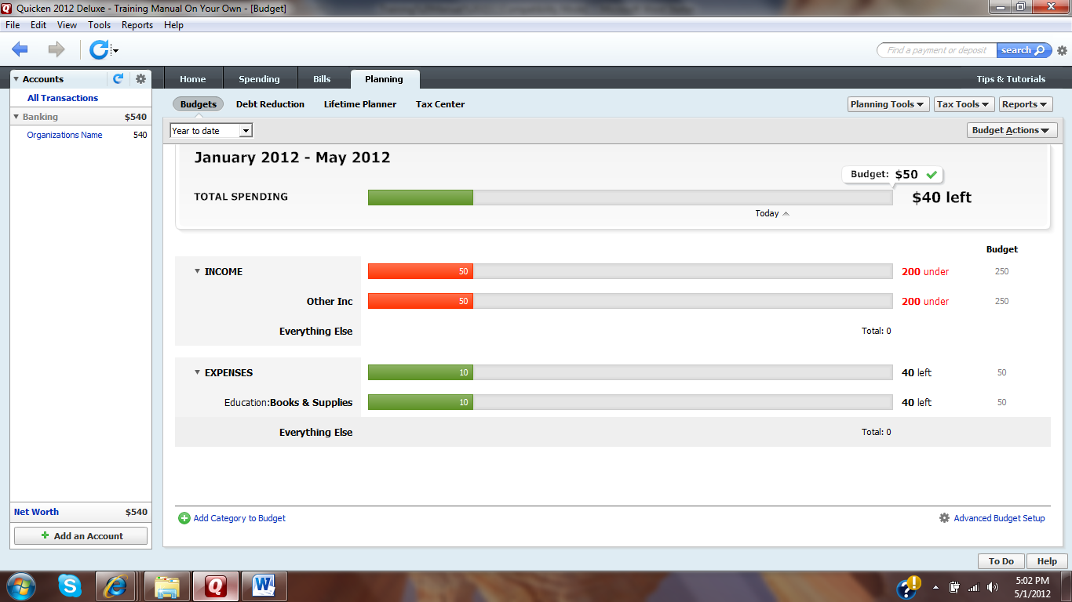
*If you were to add the two categories and change the screen to ‘Year to Date’ this is what your budget would look like. (Due to the time of the creation for this training the months will be different between this example and your screen. Your months will go from January to August.)

Explanation of this Budget:
- As you can see above you have two categories in your budget:
  - Income: (Other Inc.)
  - Expenses: (Education/Books and Supplies)
- Calculation:
  - In the upper left corner of the screen you can change the date range to ‘Year to Date’ which will allow for better understanding of your budget.
  - Income:
    - We entered $50.00 as our projected monthly income. Quicken will assume that you will be making $50.00 per month on throughout the year.
    - $50.00 * 5 Months = $250.00 at the end of May.
(It is calculating it through May because this is when this example was done within Quicken.)
    - The budget is telling us that we are $200.00 under our 5 month projected goal of $50.00 per month in terms of Other Income.
    - $250.00 (projected sales through May) - $50.00 (Revenue from shirt sales) = $200.00 short of our goal.

  - Expenses:
    - We entered $10.00 as our monthly expense for Education/Book and Supplies when creating our budget. Quicken will assume that we will spend $10.00 each month on Education/Book and Supplies.
    - $10.00 * 5 Months = $50.00 at the end of May.
    - The budget is telling us that we are $40.00 under our projected expenses at this point within the year.
    - $50.00 (projected expense through January to May) - $10.00 (the amount spent in May) = $40.00 left over.
When looking at these numbers you must understand how to interpret them. With income you always want to be over the projected dollar amount that you projected at the beginning of the year. On the other hand it is always good to be under the dollar amount that you projected for your expenses.
*In the example above we are behind in our income which will hurt our organization, but we are ahead of our expenses for the year.
*A GOOD UNDERSTANDING OF A BUDGET WILL ALLOW YOU TO PLAN MORE EFFICIENTLY THROUGHOUT THE SCHOOL YEAR FOR YOUR ORGANIZATION.*

Lesson 8: Building Reports
Quicken allows you to build quick and easy reports that show your spending and income for a desired amount of time. This will allow you to make the auditing process much easier at the end of the school year. Some reports that will be useful to you are any of the reports that are under Banking and Comparison sections. To get to these reports you select the Report Tab at the top of screen and select Banking or Comparison. Each of these reports can be easily printed off for documentation.
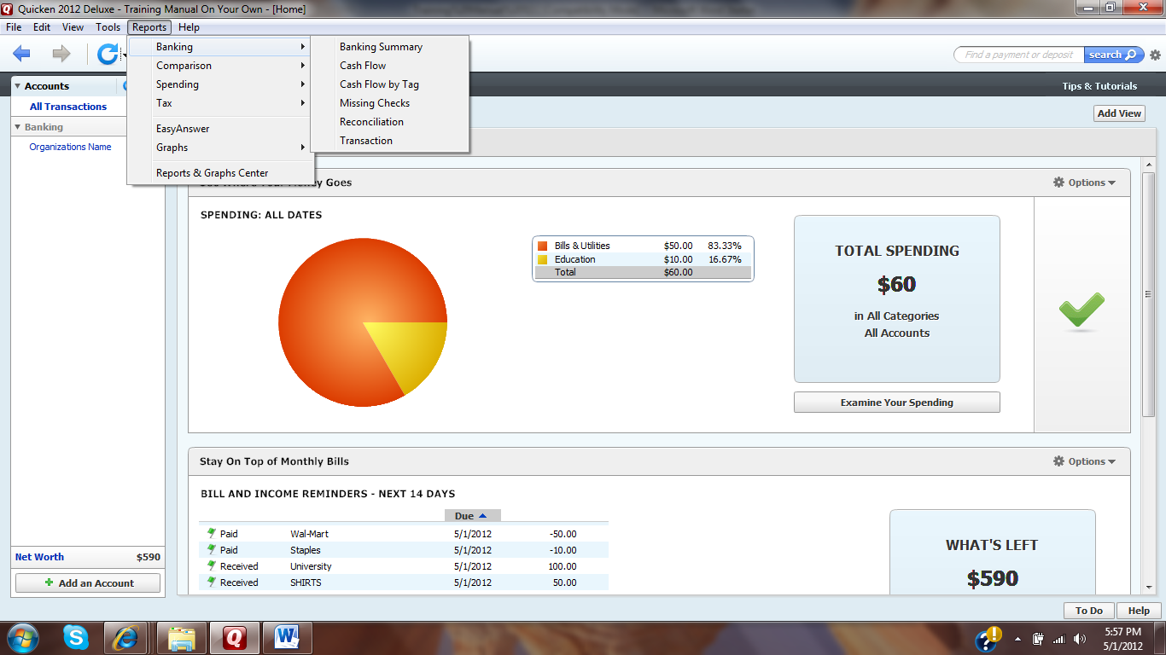

A Banking Summary looks like this:
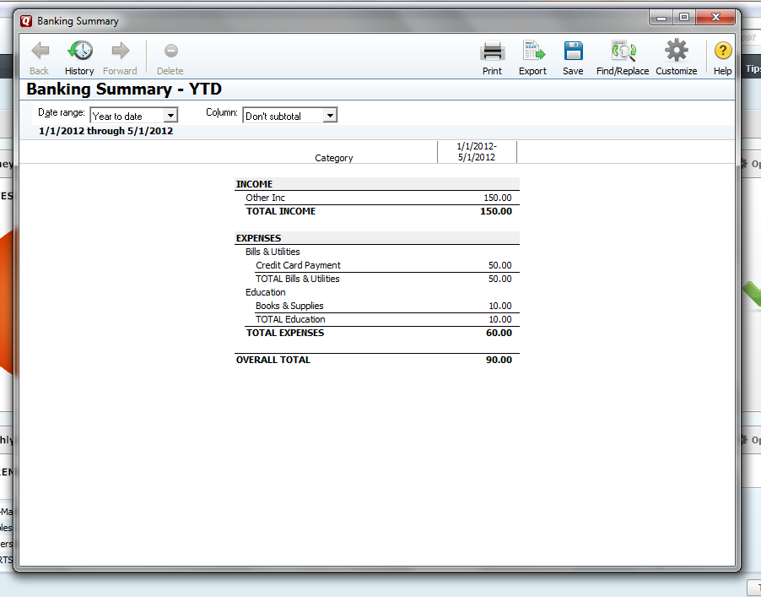
*Again these Reports will allow you to have very reliable documentation for when it is time for auditing.

FOR MORE EXAMPLES OF DIFFERENT REPORTS WITHIN QUICKEN, PLEASE REFER TO THE TRAINING VIDEO ON REPORTS AT http://www.iup.edu/page.aspx?id=21713.
ALSO THERE ARE OTHER CORRESPONDING TRAINING VIDEOS AT http://www.iup.edu/page.aspx?id=21713 THAT RELATE CLOSELY TO THIS TRAINING GUIDE.

Conclusion
Throughout this training you have been able to add an account, Expenses and Income to Quicken. Also you have been able to set up a budget for Quicken and lastly change the dates that show the recent activity that has occurred within your account. This software will help you organize and simply the bookkeeping process for your organization. I hope you enjoyed this step-by-step training manual and have learned the essential task that you will need in order to keep accurate books for your organization.

