Adding a description for a course (SSATEXT)

- Enter SSATEXT in the Search Bar
- Enter the Term and CRN that you would like to add a description to
  - Press “Go” or “Next Section” to access the body of the page
  - Your cursor will start in the Section Text section(outlined in green below)
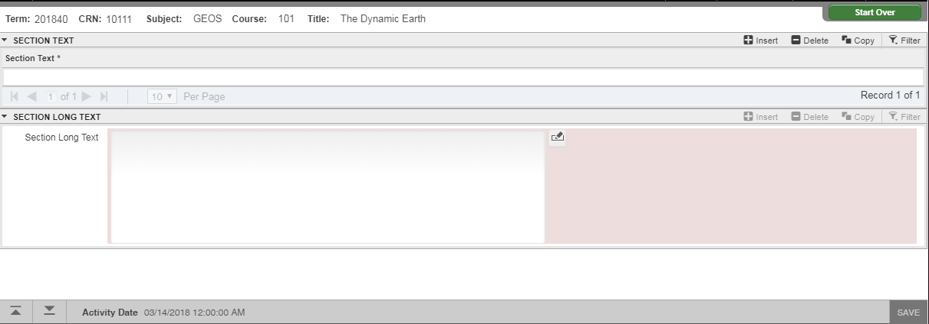
- Begin typing your description in the first line
*Each line has a character limit of 60*
- To add or remove lines;
  - Insert and Delete buttons (outlined in green below)
  - Keyboard arrow keys
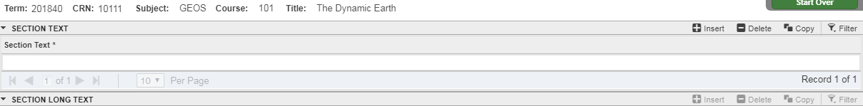
- Once finished entering the description, SAVE
*NOTE: Do NOT use the bottom “Section Long Text” section*

*Quick Reference*
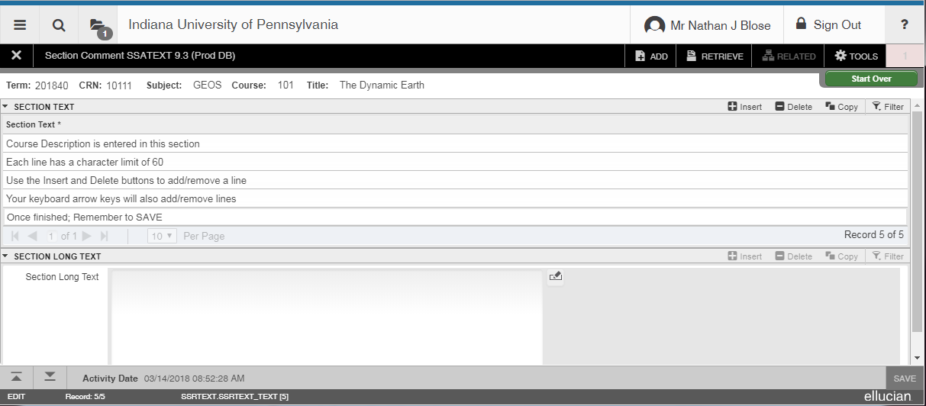
Do NOT use this section, only enter the description above.

