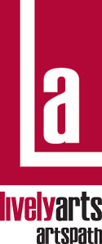
ArtsPath
Arts-In-Education Program

Student/Participant Evaluation Form

ArtsPath recommends and encourages all core group students/participants involved to complete an evaluation form. Host site coordinators should return completed forms to ArtsPath at the conclusion of the artist residency.

Host Site Name: ___________________________________________________________________

Your Name: ________________________________________________ Grade/Age___________
(Optional)

Name of Artist: ___________________________________ Art Form: ____________________

Dates of Residency: ______________________________________________________________

Grades K-4 answer Questions 1-6 on the front
Grades 5-12 answer all Questions.

Please circle the response that best describes your answer. You may write comments to the right of each circled answer.

Comments
1. | Did you like this art form before you met the artist? | Yes | No | Unsure
2. | Do you like this art form now that you’ve experienced it with the artist? | Yes | No | Unsure
3. | Do you think you’d like to continue learning about this art form? | Yes | No | Unsure
4. | Did the artist do a good job of teaching you this art form? | Yes | No | Unsure

- What was your favorite part of what you did with the artist? Why?

- What was your least favorite part of what you did with the artist? Why?

Note: Please read the entire statement; each question has more than one part. If you do not understand the question, your teacher will help you.

- Please comment, on a personal level, how what you experienced with this artist affected your opinion of the art form. Will you look at this art form differently? Do you think you may want to continue studying this art form? Do you think you may want to pursue a career in it?

- Do you feel the artist conducted the residency well? Why or why not?

- Do you have any suggestions that may improve the artist residency? Please offer specific details about activities in this residency that could be done differently, eliminated, or should be expanded upon. Do you feel you spent enough time with the artist?

- Please share anything else you would like to tell us about the artist, the residency, or the arts in general.

Please return this form to: Jeff Wacker, Associate Director, Lively Arts | ArtsPath
Indiana University of Pennsylvania  202 Performing Arts Center  Indiana, PA 15705-1008
Phone 724-357-2787 (ARTS)  Fax 724-357-7899
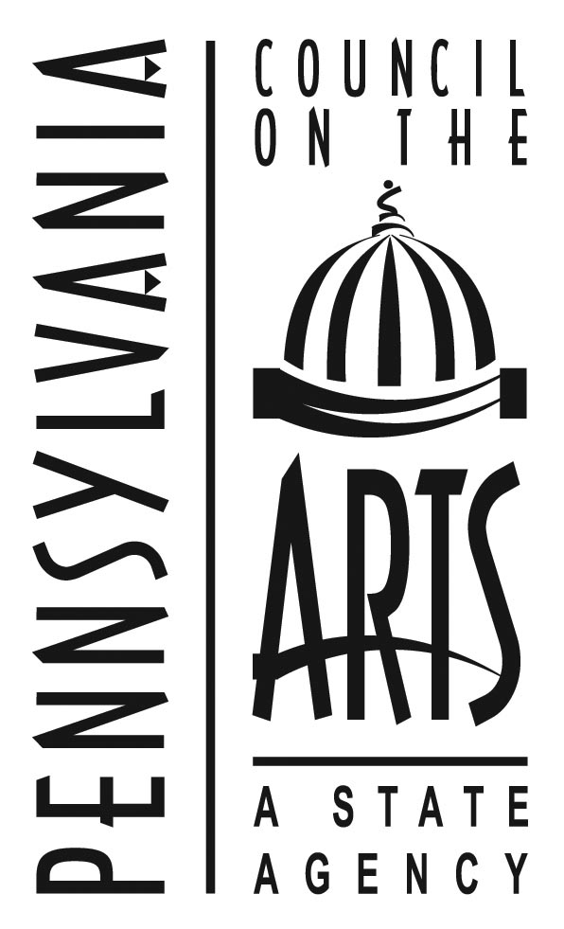
This project was made possible through the AIE Partnership of the Pennsylvania Council on the Arts, a state agency. It is funded by the citizens of Pennsylvania through an annual legislative appropriation and administered locally by ArtsPath through the college of Fine Arts at Indiana University of Pennsylvania. The Pennsylvania Council on the Arts is additionally supported by the national Endowment for the Arts, a federal agency.

