Indiana UNIVERSITy OF PA
Academic Program Review Self-Study

NAME OF PROGRAM(s)

Table of Contents

Composition of Review Team

Chair:

Campus Review Team Members:

External Review Team Members:

I. MISSION

A. Introduction/Program Overview

B. Alignment with Department, College, and University Mission and Goals

C. Progress Since Last Review. Provide a summary of results from previous program strategic goals. (See parts 1 and 2 below)

1. Copy the Five-Year Action Plan table from your last program review. Add a column for results and note which goals were achieved, which were modified,) and which were not achieved.

Action Item | Steps Taken/Progress Reported/Results | Date
2. Provide a written narrative regarding the information provided in the table. If there were challenges in working toward the previous goals or if changes were made due to new priorities emerging since the last review, detail these challenges and changes. Use assessment results where appropriate to support your curriculum revisions or other program changes.

II. PROGRAM QUALITY

A. Program Performance Data.

1. Enrollment, completion, retention, and progression rates This data can be extracted from the I-Report dashboard. Any program without dashboard access should contact the Institutional Research, Planning, and Assessment Office for the necessary data.
2. Program costs and credits. This data can be obtained from the new PASSHE Functional Cost Tool report provided by the Office of Academic Administration.

B. Faculty

1. Summary of full time and adjunct faculty (table suggested)
2. Notable accomplishments (table and narrative suggested)
3. Faculty vita (Place in Appendices)

C. Students

1. Notable Student Accomplishments. Table and narrative recommended
2. Student Characteristics. Describe any current trends in student characteristics or demographics.
3. Graduate Success. Describe the extent to which graduates of the program demonstrate success in their chosen careers. Include any evidence such as certification exams, employer surveys, alumni surveys, etc.

D. Assessment of Student Learning.
1. Assessment Plan for Program Level Student Learning Outcomes (Attach IMPROVE plan)
2. Results of Assessment (Attach IMPROVE and/or internal program documents)
3. WAC Writing Assessment plan (Attach WAC Plan)
4. Results of WAC Writing Assessment (Attach internal program document)
5. Program Learning Outcome Assessment Matrix (Attach in format shown below)

Course Number and Name | PSLO 1 | PSLO 2 | PSLO 3 | PSLO 4
ABCD 101 College Alphabet 1 | Introduced | Introduced*
ABCD 102 College Alphabet 2 | Reinforced | Reinforced | Introduced* | Introduced
ABCD 201 Intermediate Alphabet | Applied* |  | Reinforced | Reinforced*
ABCD 301 Applied Alphabetics |  | Applied | Applied
ABCD 480 Alphabetics in Action |  |  | Applied | Applied
* indicates where assessment data is gathered. Each outcome should be measured in at least one course or program activity, but not every required or elective course has to be used for assessment.
6. Analysis of Student Learning Outcomes
Show how the department has incorporated the results of assessment back into the curriculum or department to improve mastery of program outcomes or writing outcomes. At a minimum, the following questions should be answered:
- Are students meeting the desired learning outcomes at the planned level?
- If not, what should be changed about the program to achieve the desired results?

- Do other departments or non-academic programs support the learning outcomes?
- If so, list the courses or student services they provide and describe how they support the desired learning outcomes.
E. Other Indicators of Program Quality This section allows programs to provide additional evidence of overall quality. Examples include:

- The program's efforts to enhance student learning in the Liberal Studies core curriculum
- Innovative approaches which improve academic advising and retention within the program
- Innovations that enhance faculty teaching effectiveness or pedagogical research
- Advances which promote research excellence for both faculty and students
- Peer comparison that offers quality benchmarks and role models for future initiatives.
- Interrelationships of the instructional program with other programs at IUP
- Ways the program makes the university a desirable place to learn and work.
- Any collaboration or coordination that has occurred either with other State System universities or external to the State System.

F. Program Resources. Provide an analysis of program resources including personnel, physical resources such as office, lab, and classroom space, financial resources, and technology resources.
- Are resources meeting the needs of the program’s goals and objective.
- Are there factors that are contributing to some program goals or objectives not being met?

G. Budget. Overview and analysis of the five-year budget for the review cycle. Describe any budgetary challenges that have impacted program goals and overall program performance. Include all capital investments that have been made for the program/department over the review period. This list should include some or all of the following, as applicable:
- new positions
- educational/instructional technology enhancements, equipment and/or supplies
- facilities/remodeling
- travel
- faculty (conferences, professional development)
- expenditures for students (conferences, professional development, awards, etc.)

III. PLANNING FOR THE FUTURE

A. Looking Forward: Discuss the findings of the self-study in terms of planning for the future. In what ways might instructional, research, and outreach programs be changed or improved within currently available university resources? The following examples could be included to address this criterion:

External Factors:
- Environmental scans or market research that identifies anticipated workforce needs
- SWOT Analysis or analysis of program viability
- Current and future trends in the discipline/field or related discipline/field
Internal Planning
- Program plans for collecting, analyzing, and using institutional information
- Feedback loops that are used to support continuous improvement of learning
- Planning processes that are linked to budgeting processes or system collaborations
- Exploring feasibility of new programs

B. Strategic Goals For the Upcoming Review Cycle Based on the results of the self-study, identify goals for the upcoming cycle.

Action Item | Proposed Date of Completion | How Progress will be measured

IV. External Reviewer’s Report (not included in draft)

Attach the External Reviewer’s Report as a part of the final program report document. Include comments from department in response to this report.

Actions Planned by the University (check all that apply)

Continue Program Continue Program and Revise as Indicated
Place in Moratorium Interim Review
Discontinue Program Reorganization
Pursue Accreditation Other (Please explain below)

Signatures

___________________________________ _________________________
Program Director Date

___________________________________ _________________________
College Dean Date

___________________________________ _________________________
Provost Date

APPENDICES

Please include the following in the appendices to satisfy PASSHE requirements.

A. Program Description (duplicate from catalog)

B. Program Offerings (List all degrees, minors, certificates, etc.)

Degree, Concentration, Minor Or Certificate (list all with each degree awarded) | CIP Code | Credits  Required | Method of Delivery (face to face, online, blended, ITV)

C. Curriculum

- Curriculum Overview (PASSHE example follows)

- Changes in Curriculum since Last Review.
Include the semester and year the change took effect, a description of the change, and the rationale for the change.

- Academic Map / List of all Courses (PASSHE example follows)
Include course label and number (e.g., BIOL 101), title, delivery method (e.g. face-to-face, online, blended, ITV) and whether it is required or an elective. Attach a current syllabus for each required and elective course at the end.

PASSHE Example of Curriculum Overview

SAMPLE PROGRAM
BS Degree

Major and major-related courses (60 credits)

100/200 level prerequisites and requirements 300/400 level requirements
Specialization courses Major electives Seminar
Total

General education courses (42 credits) Wellness
Composition, math, and speech skills Science distribution
Social sciences distribution Humanities distribution Total
15 credits
27 credits
12 credits
3 credits 3 credits 60 credits

3 credits
9 credits
6 credits
12 credits
12 credits
42 credits

Free Electives 18 credits

Total 120 credits

Include all major and major-related courses. If concentrations are offered, please list all courses associated with each concentration.

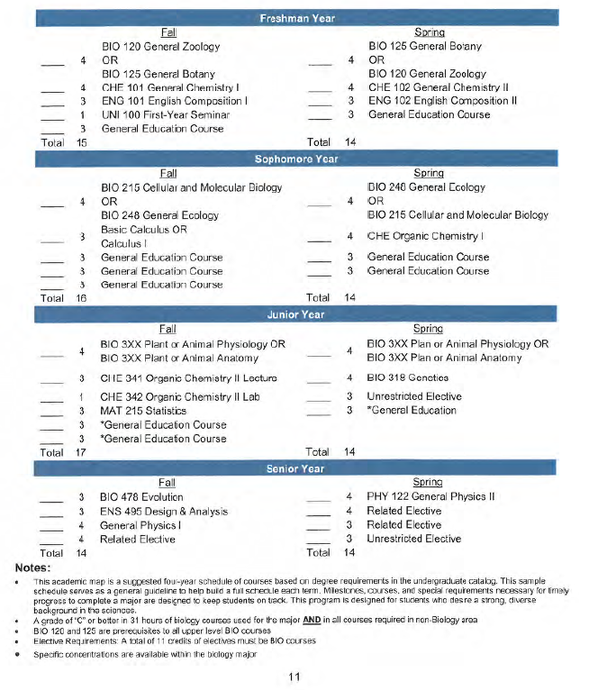
PASSHE Example of Academic Map

